DATA.STAT.750
Exercise set 5

1.
a)
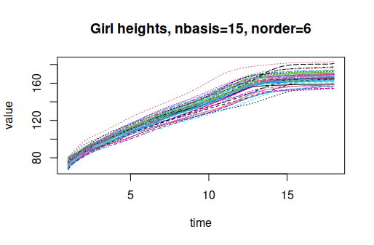

b)
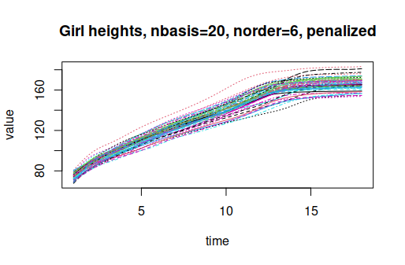

c)
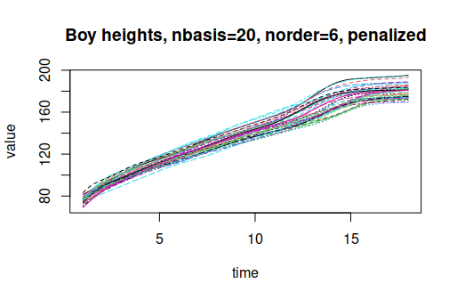

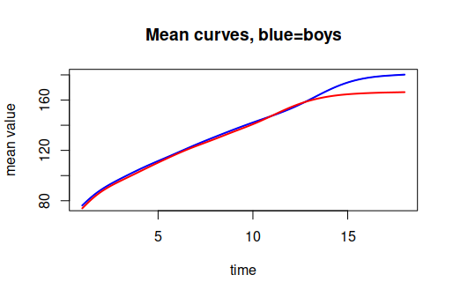

> eval.fd(15, Y2fd.mean)
mean
[1,] 173.9688
> # Girls:
> eval.fd(15, Y1fd.mean)
mean
[1,] 164.605

d)
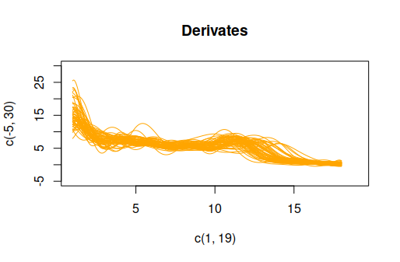
The derivatives tend to shrink to 0 when girls are older than 16 ().

e)
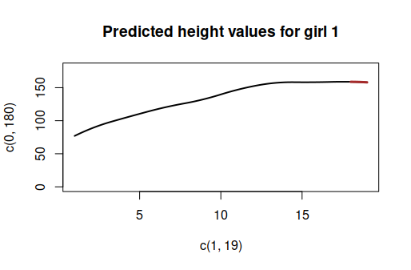

f)
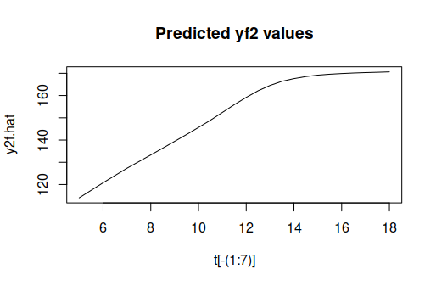
2.
a)
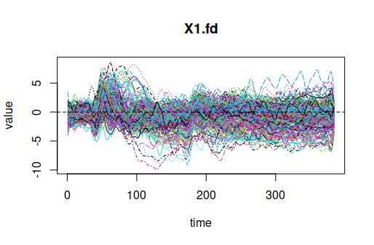

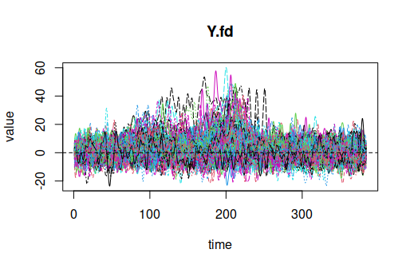

Coefficient estimates can be found from the code.

b)
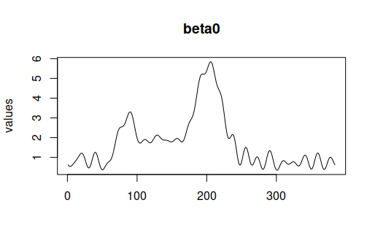

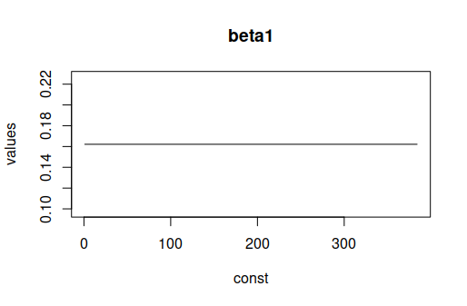

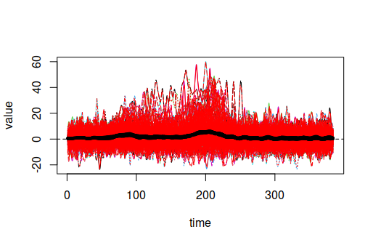

c)
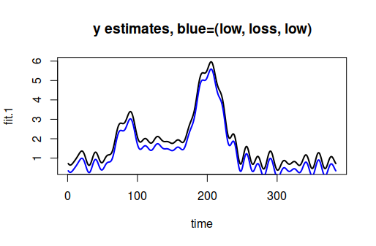

The difference between functional estimates is quite small since I used constant functional models for .

d)
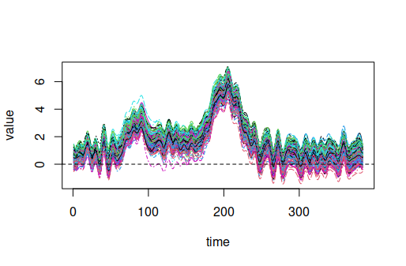

Quite poor fit compared to the observed ’s. Didn’t have time to make better modelling.
3.
a)
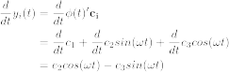
b)
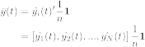
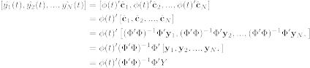
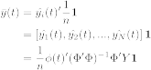

c)
