DATA.STAT.840
Exercise set 7-8.
1)
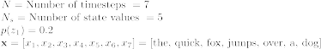

Let’s initialize . Then the probability of the word sequence can be modelled as:
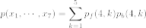.
For we get:
()
()
For we get:
()
()
For we get:
()
()

For we get:
For we get:
()

Therefore,
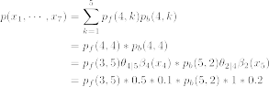

Recursion step 1:
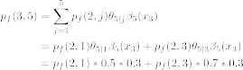

Recursion step 2:
()
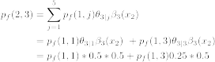
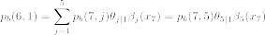
Recursion step 3:
()
2)
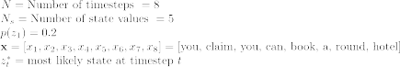
Let’s assume that the algorithm has reached the bottom.
For
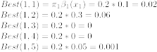
For
()
(
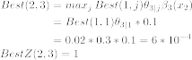
()
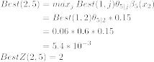
For
()
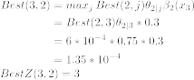
()
()
()

For
()
()
()
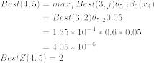

For
()
()
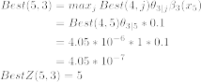
()
()

For
()
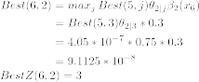
()
()
()

For
()
()
()
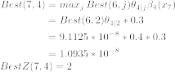
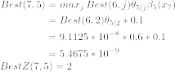

For
()
()
()
()
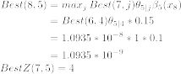

7.3

