Exercises for Lectures 9-10: Information retrieval
9.1
a)
d1: the robot is insightful but you are strong and i may answer and the wise fox is insightful and you are insightful and i am insightful but i will explain the insightful bird
d2: the bird is insightful
vocab: 'a', 'am', 'and', 'answer', 'are', 'bird', 'but', 'cat', 'cautious', 'explain', 'fox', 'friendly', 'help', 'i', 'insightful', 'is', 'may', 'robot', 'strong', 'the', 'they', 'when', 'will', 'wise', 'you'
|vocab| = 25
query = ‘insightful bird’
Term-frequency vector, document 1:
Term-frequency vector, document 2:
Term-frequency vector, query:
Inverse document frequencies (Logarithmic inverse document frequency):
= (0.69314718, 1.38629436, 0.28768207, 0.69314718, 0.69314718,
0.28768207, 0.69314718, 1.38629436, 1.38629436, 0.69314718,
.69314718, 1.38629436, 1.38629436, 0.69314718, 0., 0., 0.69314718,
0.69314718, 0.28768207, 0.28768207, 0.69314718, 0.69314718,
0.69314718, 1.38629436, 0.69314718)^{T}
TF-IDF vector, document 1:
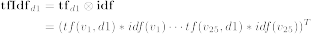
= (0., 1.38629436, 1.15072829, 0.69314718, 1.38629436,
0.28768207, 1.38629436, 0., 0., 0.69314718, 0.69314718,
0., 0., 2.07944154, 0., 0., 0.69314718, 0.69314718, 0.28768207,
0.86304622, 0., 0., 0.69314718, 1.38629436, 1.38629436)^{T}
TF-IDF vector, document 2:
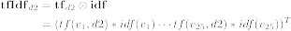
= (0., 0., 0., 0., 0., 0.28768207, 0., 0., 0., 0., 0., 0., 0., 0., 0.,
0., 0., 0., 0., 0.28768207, 0., 0., 0., 0., 0.)^{T}
TF-IDF vector, query:
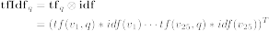
= (0., 0., 0., 0., 0., 0.22314355, 0., 0., 0., 0., 0., 0., 0., 0., 0.,
0., 0., 0., 0., 0., 0., 0., 0., 0., 0.)^{T}
Cosine similarity, document 1 & query:
Cosine similarity, document 2 & query:
Because , document 2 is closer to the query.
b)
Representation of the query:
= (0, 0, 0, 0, 0, 1, 0, 0, 0, 0, 0, 0, 0, 0, 1, 0, 0, 0, 0, 0, 0, 0, 0, 0, 0)^{T}
Unigram probability for the query given document 1:
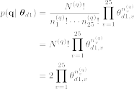
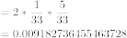
Unigram probability for the query given document 2:
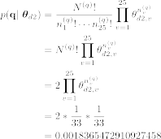
This time document 1 is closer to the query (gives larger probability).
9.2
Let’s model priors with damping factors:
Transition matrix:
