3.
Most likely state sequence is calculated by Viterbi algorithm as follows:
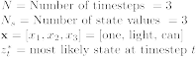

For
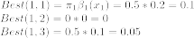

For
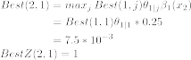
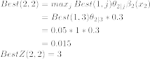
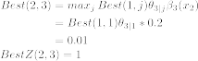

For
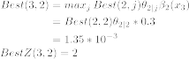
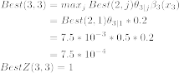

Therefore the most likely state sequence is: = 1, 3, 2

