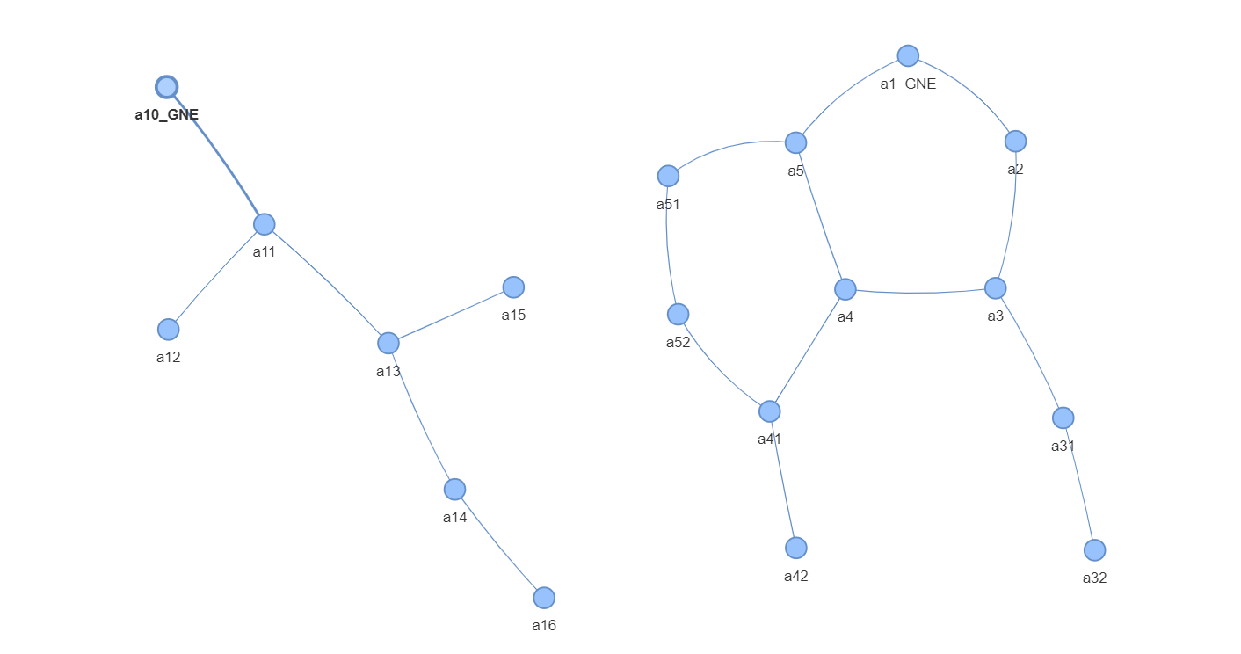

1.

edge_to_remove=('a1_GNE','a2')

edge_to_remove=('a3','a4')

Dependent Nodes:['a3', 'a2', 'a31', 'a32']

2.

edge_to_remove=('a1_GNE','a5')

edge_to_remove=('a3','a4')

Dependent Nodes:['a4', 'a5', 'a51', 'a52', 'a41', 'a42']

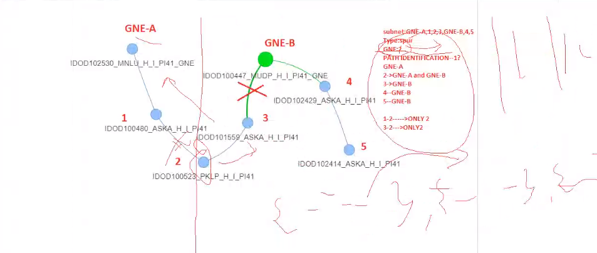

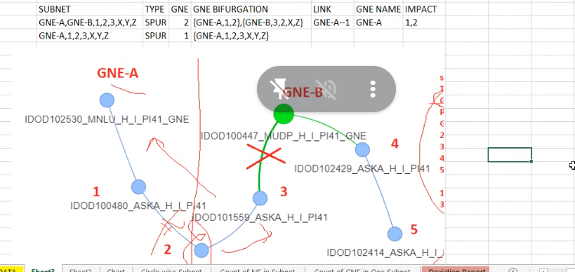

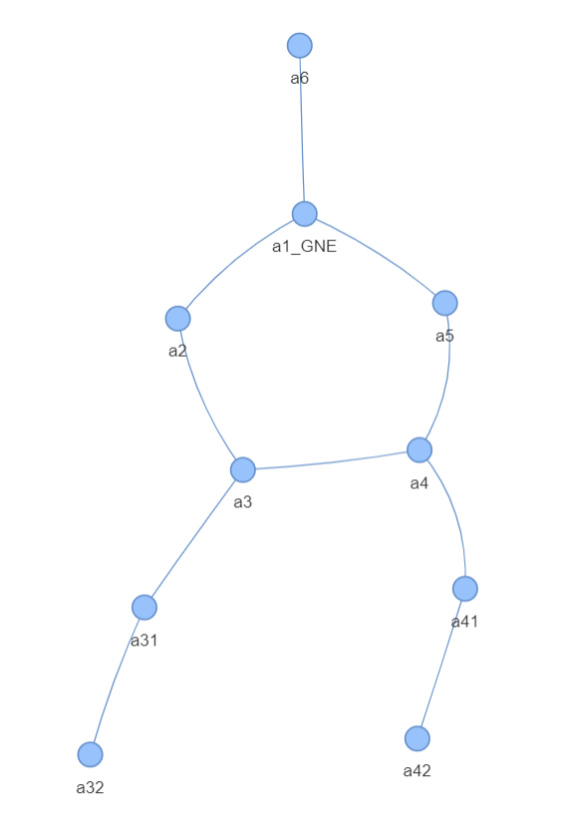

main graphs {'a41', 'a5', 'a3', 'a2', 'a4', 'a32', 'a1_GNE', 'a42', 'a31', 'a6'}

Removed Links: (('a1_GNE', 'a2'), ('a1_GNE', 'a5'))

Dependent Nodes: {'a41', 'a5', 'a3', 'a2', 'a4', 'a32', 'a42', 'a31'}

Removed Links: (('a1_GNE', 'a2'), ('a1_GNE', 'a6'))

Dependent Nodes: {'a6'}

Removed Links: (('a1_GNE', 'a2'), ('a3', 'a4'))

Dependent Nodes: {'a3', 'a2', 'a32', 'a31'}

Removed Links: (('a1_GNE', 'a2'), ('a3', 'a31'))

Dependent Nodes: {'a32', 'a31'}

Removed Links: (('a1_GNE', 'a2'), ('a31', 'a32'))

Dependent Nodes: {'a32'}

Removed Links: (('a1_GNE', 'a2'), ('a41', 'a42'))

Dependent Nodes: {'a42'}

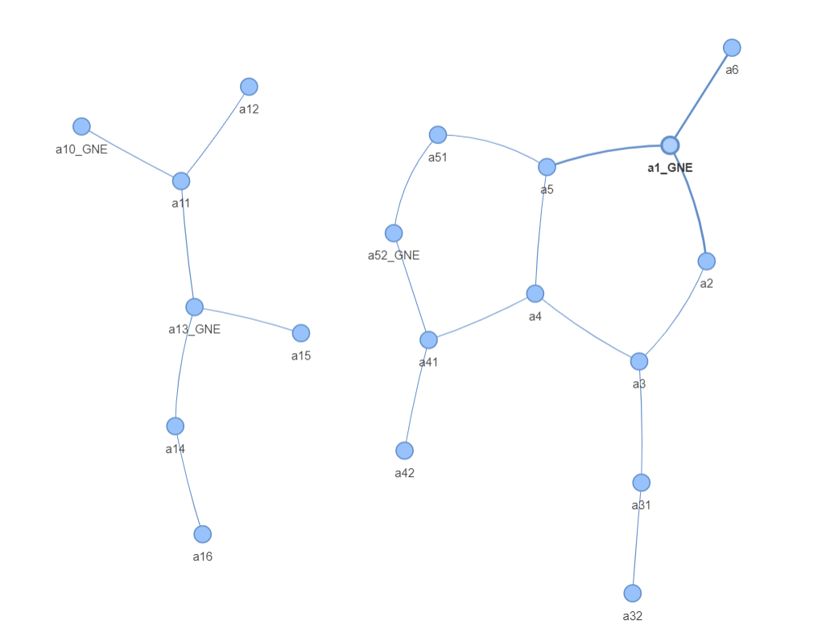

main graphs {'a5', 'a31', 'a42', 'a52_GNE', 'a4', 'a1_GNE', 'a3', 'a6', 'a51', 'a41', 'a2', 'a32'}

ng,sg a52_GNE {'a52_GNE', 'a4', 'a51', 'a42', 'a41'}

ng,sg a1_GNE {'a5', 'a31', 'a4', 'a1_GNE', 'a3', 'a32', 'a6', 'a2'}

ng,sg a1_GNE {'a5', 'a31', 'a4', 'a1_GNE', 'a3', 'a32', 'a6', 'a2'}

Have Ring

Links Down: (('a5', 'a4'), ('a5', 'a1_GNE'))

Dependent Nodes: {'a5'}

Links Down: (('a5', 'a4'), ('a31', 'a3'))

Dependent Nodes: {'a31', 'a32'}

Links Down: (('a5', 'a4'), ('a31', 'a32'))

Dependent Nodes: {'a32'}

Links Down: (('a5', 'a4'), ('a4', 'a3'))

Dependent Nodes: {'a4'}

Links Down: (('a5', 'a4'), ('a1_GNE', 'a2'))

Dependent Nodes: {'a31', 'a4', 'a3', 'a32', 'a2'}

Links Down: (('a5', 'a4'), ('a1_GNE', 'a6'))

Dependent Nodes: {'a6'}

Links Down: (('a5', 'a4'), ('a3', 'a2'))

Dependent Nodes: {'a4', 'a3', 'a31', 'a32'}

Links Down: (('a5', 'a1_GNE'), ('a31', 'a3'))

Dependent Nodes: {'a31', 'a32'}

Links Down: (('a5', 'a1_GNE'), ('a31', 'a32'))

Dependent Nodes: {'a32'}

Links Down: (('a5', 'a1_GNE'), ('a4', 'a3'))

Dependent Nodes: {'a4', 'a5'}

Links Down: (('a5', 'a1_GNE'), ('a1_GNE', 'a2'))

Dependent Nodes: {'a5', 'a31', 'a4', 'a3', 'a32', 'a2'}

Links Down: (('a5', 'a1_GNE'), ('a1_GNE', 'a6'))

Dependent Nodes: {'a6'}

Links Down: (('a5', 'a1_GNE'), ('a3', 'a2'))

Dependent Nodes: {'a5', 'a31', 'a4', 'a3', 'a32'}

Links Down: (('a31', 'a3'), ('a31', 'a32'))

Dependent Nodes: {'a31'}{'a32'}

Links Down: (('a31', 'a3'), ('a4', 'a3'))

Dependent Nodes: {'a31', 'a32'}

Links Down: (('a31', 'a3'), ('a1_GNE', 'a2'))

Dependent Nodes: {'a31', 'a32'}

Links Down: (('a31', 'a3'), ('a1_GNE', 'a6'))

Dependent Nodes: {'a31', 'a32'}{'a6'}

Links Down: (('a31', 'a3'), ('a3', 'a2'))

Dependent Nodes: {'a31', 'a32'}

Links Down: (('a31', 'a32'), ('a4', 'a3'))

Dependent Nodes: {'a32'}

Links Down: (('a31', 'a32'), ('a1_GNE', 'a2'))

Dependent Nodes: {'a32'}

Links Down: (('a31', 'a32'), ('a1_GNE', 'a6'))

Dependent Nodes: {'a32'}{'a6'}

Links Down: (('a31', 'a32'), ('a3', 'a2'))

Dependent Nodes: {'a32'}

Links Down: (('a4', 'a3'), ('a1_GNE', 'a2'))

Dependent Nodes: {'a2', 'a3', 'a31', 'a32'}

Links Down: (('a4', 'a3'), ('a1_GNE', 'a6'))

Dependent Nodes: {'a6'}

Links Down: (('a4', 'a3'), ('a3', 'a2'))

Dependent Nodes: {'a3', 'a31', 'a32'}

Links Down: (('a1_GNE', 'a2'), ('a1_GNE', 'a6'))

Dependent Nodes: {'a6'}

Links Down: (('a1_GNE', 'a2'), ('a3', 'a2'))

Dependent Nodes: {'a2'}

Links Down: (('a1_GNE', 'a6'), ('a3', 'a2'))

Dependent Nodes: {'a6'}

ng,sg a52_GNE {'a52_GNE', 'a4', 'a51', 'a42', 'a41'}

Dont have Rings

Link Down: ('a52_GNE', 'a51')

Dependent Nodes: {'a51'}

Link Down: ('a52_GNE', 'a41')

Dependent Nodes: {'a41', 'a4', 'a42'}

Link Down: ('a4', 'a41')

Dependent Nodes: {'a4'}

Link Down: ('a42', 'a41')

Dependent Nodes: {'a42'}main graphs {'a11', 'a12', 'a10_GNE', 'a15', 'a14', 'a13_GNE', 'a16'}

ng,sg a10_GNE {'a12', 'a10_GNE', 'a11'}

Dont have Rings

Link Down: ('a12', 'a11')

Dependent Nodes: {'a12'}

Link Down: ('a10_GNE', 'a11')

Dependent Nodes: {'a12', 'a11'}ng,sg a13_GNE {'a11', 'a12', 'a15', 'a14', 'a13_GNE', 'a16'}

Dont have Rings

Link Down: ('a11', 'a12')

Dependent Nodes: {'a12'}

Link Down: ('a11', 'a13_GNE')

Dependent Nodes: {'a12', 'a11'}

Link Down: ('a15', 'a13_GNE')

Dependent Nodes: {'a15'}

Link Down: ('a14', 'a13_GNE')

Dependent Nodes: {'a14', 'a16'}

Link Down: ('a14', 'a16')

Dependent Nodes: {'a16'}

Process finished with exit code 0