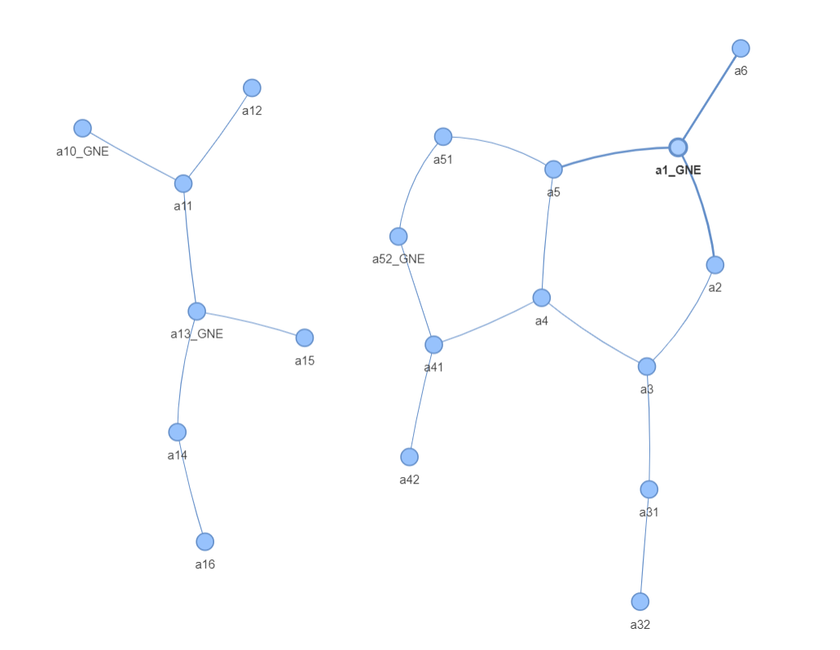
main graphs {'a5', 'a31', 'a42', 'a52_GNE', 'a4', 'a1_GNE', 'a3', 'a6', 'a51', 'a41', 'a2', 'a32'}
ng,sg a52_GNE {'a52_GNE', 'a4', 'a51', 'a42', 'a41'}
ng,sg a1_GNE {'a5', 'a31', 'a4', 'a1_GNE', 'a3', 'a32', 'a6', 'a2'}

ng,sg a1_GNE {'a5', 'a31', 'a4', 'a1_GNE', 'a3', 'a32', 'a6', 'a2'}
Have Ring

Links Down: (('a5', 'a4'), ('a5', 'a1_GNE'))
Dependent Nodes: {'a5'}
Links Down: (('a5', 'a4'), ('a31', 'a3'))
Dependent Nodes: {'a31', 'a32'}
Links Down: (('a5', 'a4'), ('a31', 'a32'))
Dependent Nodes: {'a32'}
Links Down: (('a5', 'a4'), ('a4', 'a3'))
Dependent Nodes: {'a4'}
Links Down: (('a5', 'a4'), ('a1_GNE', 'a2'))
Dependent Nodes: {'a31', 'a4', 'a3', 'a32', 'a2'}
Links Down: (('a5', 'a4'), ('a1_GNE', 'a6'))
Dependent Nodes: {'a6'}
Links Down: (('a5', 'a4'), ('a3', 'a2'))
Dependent Nodes: {'a4', 'a3', 'a31', 'a32'}
Links Down: (('a5', 'a1_GNE'), ('a31', 'a3'))
Dependent Nodes: {'a31', 'a32'}
Links Down: (('a5', 'a1_GNE'), ('a31', 'a32'))
Dependent Nodes: {'a32'}
Links Down: (('a5', 'a1_GNE'), ('a4', 'a3'))
Dependent Nodes: {'a4', 'a5'}
Links Down: (('a5', 'a1_GNE'), ('a1_GNE', 'a2'))
Dependent Nodes: {'a5', 'a31', 'a4', 'a3', 'a32', 'a2'}
Links Down: (('a5', 'a1_GNE'), ('a1_GNE', 'a6'))
Dependent Nodes: {'a6'}
Links Down: (('a5', 'a1_GNE'), ('a3', 'a2'))
Dependent Nodes: {'a5', 'a31', 'a4', 'a3', 'a32'}
Links Down: (('a31', 'a3'), ('a31', 'a32'))
Dependent Nodes: {'a31'}{'a32'}
Links Down: (('a31', 'a3'), ('a4', 'a3'))
Dependent Nodes: {'a31', 'a32'}
Links Down: (('a31', 'a3'), ('a1_GNE', 'a2'))
Dependent Nodes: {'a31', 'a32'}
Links Down: (('a31', 'a3'), ('a1_GNE', 'a6'))
Dependent Nodes: {'a31', 'a32'}{'a6'}
Links Down: (('a31', 'a3'), ('a3', 'a2'))
Dependent Nodes: {'a31', 'a32'}
Links Down: (('a31', 'a32'), ('a4', 'a3'))
Dependent Nodes: {'a32'}
Links Down: (('a31', 'a32'), ('a1_GNE', 'a2'))
Dependent Nodes: {'a32'}
Links Down: (('a31', 'a32'), ('a1_GNE', 'a6'))
Dependent Nodes: {'a32'}{'a6'}
Links Down: (('a31', 'a32'), ('a3', 'a2'))
Dependent Nodes: {'a32'}
Links Down: (('a4', 'a3'), ('a1_GNE', 'a2'))
Dependent Nodes: {'a2', 'a3', 'a31', 'a32'}
Links Down: (('a4', 'a3'), ('a1_GNE', 'a6'))
Dependent Nodes: {'a6'}
Links Down: (('a4', 'a3'), ('a3', 'a2'))
Dependent Nodes: {'a3', 'a31', 'a32'}
Links Down: (('a1_GNE', 'a2'), ('a1_GNE', 'a6'))
Dependent Nodes: {'a6'}
Links Down: (('a1_GNE', 'a2'), ('a3', 'a2'))
Dependent Nodes: {'a2'}
Links Down: (('a1_GNE', 'a6'), ('a3', 'a2'))
Dependent Nodes: {'a6'}

ng,sg a52_GNE {'a52_GNE', 'a4', 'a51', 'a42', 'a41'}
Dont have Rings

Link Down: ('a52_GNE', 'a51')
Dependent Nodes: {'a51'}
Link Down: ('a52_GNE', 'a41')
Dependent Nodes: {'a41', 'a4', 'a42'}
Link Down: ('a4', 'a41')
Dependent Nodes: {'a4'}
Link Down: ('a42', 'a41')
Dependent Nodes: {'a42'}

main graphs {'a11', 'a12', 'a10_GNE', 'a15', 'a14', 'a13_GNE', 'a16'}
ng,sg a13_GNE {'a11', 'a12', 'a15', 'a14', 'a13_GNE', 'a16'}

ng,sg a10_GNE {'a12', 'a10_GNE', 'a11'}

Dont have Rings

Link Down: ('a12', 'a11')
Dependent Nodes: {'a12'}
Link Down: ('a10_GNE', 'a11')
Dependent Nodes: {'a12', 'a11'}
ng,sg a13_GNE {'a11', 'a12', 'a15', 'a14', 'a13_GNE', 'a16'}
Dont have Rings

Link Down: ('a11', 'a12')
Dependent Nodes: {'a12'}
Link Down: ('a11', 'a13_GNE')
Dependent Nodes: {'a12', 'a11'}
Link Down: ('a15', 'a13_GNE')
Dependent Nodes: {'a15'}
Link Down: ('a14', 'a13_GNE')
Dependent Nodes: {'a14', 'a16'}
Link Down: ('a14', 'a16')
Dependent Nodes: {'a16'}
Process finished with exit code 0

