OSUM Model User’s guide

Oregon Department of Transportation
Transportation Planning Analysis Unit

AUGUST 2016

Oregon Small Urban Model (OSUM) User’s Guide

Prepared by:
Transportation Planning Analysis Unit (TPAU), ODOT

Copyright @2016 by the Oregon Department of Transportation. Permission is given to quote and reproduce parts of this document if credit is given to the source. This project was funded in part by the Federal Highway Administration, U.S. Department of Transportation.

For more information, contact:
Alex Bettinardi, P.E.
Oregon Department of Transportation
555 13th Street NE
Salem, Oregon 97301-4178
Telephone: 503-986-4104
E-mail: Alexander.O.BETTINARDI@odot.state.or.us

TABLE OF CONTENTS
TABLE OF CONTENTS i
List of Figures iii
LIST OF TABLES iv
A. Introduction 1
Report Purpose 1
Overview of OSUM Application Process 2
Report Organization and Contents 3
B. Overview of OSUM 5
OSUM Structure 5
OSUM Modules 6
OSUM Capabilities and Limitations 8
C. OSUM Setup and Application 10
Model Installation 10
Directory Structure 12
Model Application 14
Preparation of Input Files 14
Review of Model Parameter Settings 14
Model Processing 17
Reasonableness Checking of Model Outputs 18
Documentation of Model Run 22
D. Network Coding 23
Overview 23
Network Coding in Visum 25
Network Coding Standards for OSUM 26
Roadway Network Validation 29
E. Input Data Preparation 35
Zonal Socioeconomic Data 35
Level-of-Service Data (Network Travel Time Skims) 38
Travel Behavior and Pattern Data 39
External Travel Data 45
F. Trip Assignment 48
Overview 48
Assignment Checks 52
G. Typical Applications 53
Proposed Network Changes 53
Addition of New Roadway 53
Change in Existing Roadway Attributes 55
Proposed Land Use Changes 55
Preparation of Land Use-Related Data 57
Associated Network Changes 58
H. Viewing Model Output 60
Viewing Model Output in Visum 60
Viewing Model Output in R 62
Appendix A OSUM SubModules 64
OSUM Flowchart 64
Appendix B Frequently encountered erroRs 72
Appendix C OSUM Model CONVENTIONS 73
Appendix D Future Household Sub-model 74
Appendix E swim external model 76
Appendix F visitor model 87

List of Figures
Figure 1: Oregon Small Urban Model Structure 7
Figure 2: OSUM Project Directory Structure 12
Figure 3: Comparison of Travel Time Frequency Distributions 20
Figure 4: Visum Link Listing 24
Figure 5: Visum Network Editor 25
Figure 6: Network Check Screen 30
Figure 7: Shortest Path Check Example 31
Figure 8: OSUM Model Warning Pop-up 32
Figure 9: Example of errorReport.txt 32
Figure 10: OSUM Comparison of Trip Generation Summaries 33
Figure 11: Assignment Comparison to the Reference 34
Figure 12: District Bias Input Example 40
Figure 13: Example of OSUM output dist_bias_Report_OD.csv 40
Figure 14: Example of OSUM output dist_bias_Report_PA.csv 41
Figure 15: Example OSUM Special Generator Table 42
Figure 16: Example of CTPP Table 1-062 Editing 44
Figure 17: Conical Congestion Function 49
Figure 18: BPR Congestion Function 50
Figure 19: Tabular Link Data Example 60
Figure 20: Reviewing Link Volumes Versus a Reference 61
Figure 21: V/C Mapper Example 61
Figure 22: Flow Bundle Mapper Example 62
Figure A 1: Oregon Small Urban Model Structure 64
Figure A 2: Household Sub-Model - Worker Distributions 65
Figure A 3: Trip Generation 66
Figure A 4: Trip Distribution 67
Figure A 5: Original External Model 68
Figure A 6: SWIM External Model [optional] 69
Figure A 7: Traffic Assignment 70

LIST OF TABLES
Table 1: OSUM Parameters Stored in Visum 15
Table 2: OSUM Per Lane Capacities 27
Table C- 1: Household Categories 72
Table C- 2: Employment Categories 72
Table C- 3: Trip Purposes 72

A. Introduction

Report Purpose
The purpose of the OSUM User’s Guide is to provide users with instructions on how to apply the OSUM (Oregon Small Urban Model) travel demand-forecasting model. OSUM was originally estimated and calibrated using the 1996-97 eight-county survey in Oregon, which surveyed a wide variety of small towns and communities (areas with a population below 50,000, MPO threshold) in Oregon. The intent of the survey and in the development of OSUM was to have a simple trip-based modeling platform that could be deployed in all small communities (below the 50,000-population MPO delineation) in Oregon. The core modules of OSUM are implemented entirely through a series of script files written in the R statistical programming language. OSUM is a three-step trip-based model, skipping the mode choice step. OSUM trip generation, distribution, and assignment only address person-vehicle trips, which are converted to simply vehicles via occupancy factors prior to the final step, trip assignment. This is a large simplification for smaller urban areas, which greatly simplifies the model development, implementation and reduces over all costs. However, it does mean that areas that utilize the OSUM platform cannot use the transportation model to ask modal shift questions or to answer questions about non-auto modes. This is a very important distinction to be aware of when applying and using OSUM.

The User’s Guide serves an important role in clearly and comprehensively describing the proper model application procedures so that the models are used in a manner consistent with the way they were developed. It can be used as an everyday resource for answers to questions about a wide range of model applications. The User’s Guide is intended for use by modeling practitioners who may or may not have previous experience with OSUM. This includes TPAU staff, MPO and other local agency staff, and consultants. It is assumed that the reader has a basic understanding of travel demand modeling theory and at least some level of experience with general model application and model application software.

For those with no previous OSUM application experience, it is strongly recommended that they read the entire User’s Guide prior to applying the given OSUM model.
Other reports that may be helpful are the Modeling Procedures Manual for Land Use Changes and An Introduction to R. The Modeling Procedures Manual for Land Use Changes report provides guidance on the application of travel models and model output data for the analysis of the transportation impacts of proposed land use changes. The An Introduction to R report provides an introduction to the R language and how to use R for performing statistical analysis and graphics.

Overview of OSUM Application Process
An important decision to make prior to applying one of the MPO models, or any other model, is whether it is the appropriate tool to use. Making the correct decision depends in large part on whether the question to be answered has been clearly identified and the information required to answer the question has been adequately defined. Generally, the model should be regarded as the first option, but other available tools should also be considered. For example, ODOT’s Analysis Procedures Manual (APM) contains guidelines for applying two other forecasting methods referred to as the “Historical Trends” method and “Cumulative Analysis” method.

If optional tools are available, then several factors should be considered in determining which one to use:

- How well the tool will satisfy the data requirements of the analysis, both in terms of the type and quality of the data produced. Information on the capabilities and limitations of OSUM is provided in Section B.
- The level of effort and amount of time required to produce the data. In the case of OSUM, this may include the need to modify the model input data and the availability of qualified staff to apply the model.
- Beyond the data needed for immediate analysis, what is the likelihood that additional data will be required for other analyses? One advantage of models, in general, is that once they have been set up they are relatively easy to apply for different scenarios and different types of output compared to manual methods.

If it has been decided that OSUM is the best tool to use to help answer the question, the next step is to identify the appropriate method for applying the model to produce the information needed. Applying the model in a way that is consistent with its development is essential to avoid incorrect or misleading results. Information on application procedures for two of the most common model uses, the identification of the effects of proposed network changes and land use changes, is provided in Section G.

Once the model application approach has been determined, it is likely that the input data will need to be modified. This may include socioeconomic data, level-of-service (network data), zonal data, or external travel data. Instructions for the preparation of model input data are contained in Section E. Model application may also involve changing specific model parameters, such as vehicle occupancy rates or peaking factors (diurnals), to perform “what if”-type scenario testing. Information on the model parameters is presented in Section C.

Following the modification of the input data, the core submodules of OSUM are processed using a set of model run files. Unlike many other models, the OSUM submodules are not implemented within a proprietary software package such as Emme or VISUM. Rather, they are written in the open source R statistical programming language, requiring the user to have the R software package installed and the OSUM submodule code available on their computer. The R software package is available for free download at the The R Project for Statistical Computing website at: https://www.r-project.org/, while the OSUM run files and submodules can be obtained from TPAU. Although a detailed knowledge of R is not necessary to apply OSUM, an understanding of some of basic commands is helpful for the user to perform reasonableness checking of the submodule outputs.

Although the OSUM submodules are implemented in R, the trip assignment step of the process is performed using the Visum software package. The vehicle trip matrices generated by OSUM for assignment are reformatted and written directly to the Visum version file by the OSUM submodules. OSUM then runs the assignment in Visum with no user control required and pulls the resulting travel time skim matrices back to the R working environment to be processed in the next iteration of the OSUM code. OSUM will iterate several times until the demand and skim matrices no longer differ between successive runs.

The trip assignment results from the final iteration of OSUM processing should be checked by the user for reasonableness. A recommended set of reasonableness checks to be applied are presented in Section F. Once the model output has been verified, it can be used for analysis purposes. Methods for displaying various outputs in R and Visum, as well as producing output not directly retrievable in Visum, are described in Section H.

Report Organization and Contents

The User’s Guide is organized in the order of setting up, applying, and viewing output in OSUM. It is divided into the following sections:

- Introduction
- Overview of OSUM – summarizes the general features and individual submodules of OSUM and describes OSUM’s capabilities and limitations.
- OSUM Setup and Processing – contains information on model installation, the directory structure for OSUM implementation, model processing (including run files, inputs, and outputs), and execution diagnostics.
- Network Coding – describes the general Visum network structure, Visum network editing procedures, network-coding conventions for the OSUM applications, and network validation checks.
- Input Data Preparation - provides instructions for the preparation of socioeconomic, level-of-service, zonal, and external travel data, including data sources and tools and reasonableness checks to verify the accuracy of the data.
- Trip Assignment – describes the linkage between OSUM and Visum for trip assignment, how to set up and run auto assignments, and a set of checks that can be used to validate the reasonableness of the assignments.
- Typical Applications – provides step-by-step instructions for the two most common model applications - developing travel forecasts for proposed land use changes and network changes.
- Viewing Model Output - describes the methods used to view model output in both Visum and R.

B. Overview of OSUM

OSUM Structure
OSUM is a three-step trip-based travel demand model. It was developed by ODOT in a way to fully utilize the data contained in the 1996-97 eight-County Household Activity and Travel Behavior Survey in order to meet the following requirements:

- The planning needs of local jurisdictions to develop a 20-year transportation plan that includes both long-range and short-range strategies/actions that lead to the development of integrated, intermodal transportation system.
- The Transportation Planning Rule (TPR) requirement for the preparation of local transportation system plans (TSPs) that “establish a system of transportation facilities and services adequate to meet identified local transportation needs”.
- Other model uses such as: 1) Preparation of subarea transportation studies in which models are focused for a subarea of a city or county to examine detailed land use or transportation system alternatives; 2) Analysis of the transportation system impacts of large-scale development proposals; and 3) Evaluation of the effects of large-scale transportation projects.

OSUM represents a significant improvement in the modeling capabilities available to smaller Oregon cities prior to its development. Some of the distinguishing features of OSUM are:

- Small, Lightweight Code Base and Input Structure - OSUM models are typically very quick and inexpensive to develop and once established can run scenarios in a matter of minutes.
- Inclusion of five trip purposes compared to the typical three or four trip purposes to more accurately represent differences in trip types.
- Trip distribution using the destination choice model form rather than the conventional gravity model.
- A representation and assignment of all 24 hours of travel and congestion through the day. Large trip-based models typically only model a peak period or a daily assignment to shorten overall run times. Because OSUM runs so quickly, all 24 hours of the day can be assigned, allowing for much better representation of the daily traffic volumes through congested areas or corridors.

OSUM Modules

OSUM comprises the five general modules shown in the OSUM Structure diagram in Figure 1 on the following page:

- Household Sub-Model
- Trip generation
- Trip distribution (destination choice)
- External Model
- Traffic Assignment

Trip assignment is performed outside of OSUM using the Visum software package. Each of the modules is briefly described below. Appendix A – OSUM Submodules, provides the reader with a detailed understanding of OSUM and the how the individual submodules function.

The household sub-model module comprises functions to develop a worker distribution for each TAZ (traffic analysis zone) as well as a joint distribution of workers by household size for each TAZ. This is a required step as the person-vehicle trip rate tables developed from the survey data for OSUM are either rates by household size (school trips – hbsch), rates by number of workers (work trips – hbw), or rates by household size and number of workers (all other trip types – hbshp, hbro, and nhb). The user has the option of inputting a worker-size joint distribution by census block group, which the code will use instead of imputing a worker and worker by size distribution.

The trip generation model estimates daily trip productions using a set of cross-classification models for five trip purposes – home-based work (hbw), home-based shop (hbshp), home-based recreation-other (hbro), non-home-based (nhb), and home-based school (hbsch). For each zone, the number of productions is calculated by multiplying the number of households in each household category by a production rate. The trip productions are input to the trip distribution model.

The trip distribution model distributes the hourly trips to destinations for all trip purposes using a destination choice model, with the exception of hbsch trips, which are distributed using a separate simpler exogenously defined enrollment area allocation method. The trip matrices produced by the trip distribution model are combined with external trips and then to trip assignment. Trip distribution for internal-external (I-E), external-internal (E-I), and external-external (E-E) trips are handled with separate procedures. There are two different external models in OSUM; the user determines which to apply, these options are described in detail in the appendix. The final hourly origin-destination matrices are then set to trip assignment which is run in Visum.

Legend
Figure 1: Oregon Small Urban Model Structure
Model Step
Output
Input
Input from Survey not to be Changed

Household
Sub-Model
Model Inputs
Trip Generation
Trip Distribution
Traffic Assignment
Survey Data
External Model
Standard Reporting and Comparing Results to Reference Case
Input Checks
Traffic Patterns / Trends for
Model Area

OSUM Capabilities and Limitations

To fully realize the benefits of OSUM, it is important to identify appropriate and inappropriate uses of the model.

Historically, travel demand forecasting models have been developed primarily for analyzing future area-wide or system-level travel behavior. Thus, OSUM serves as an excellent tool for supporting the development and update of transportation system plans (TSPs). This includes testing of alternative transportation system and land use scenarios as well as policy analysis. There are also many other uses of OSUM that can support a wide range of transportation planning and analysis activities. Some examples of these are:

- Preparation of subarea transportation studies. For this application, the model’s zone system and network are refined within a subarea to increase the accuracy of the forecasts for the subarea.
- Analysis of the transportation impacts of land use changes. Forecasts can be produced for land use changes ranging from regional alternative land use scenarios to smaller-scale development proposals.
- Evaluation of the effects of larger-scale transportation projects. The model can be used to estimate how future travel patterns may be affected by transportation improvement projects. The model can also be used in the assessment of the benefits and environmental justice impacts of these projects. Example improvements include additional travel lanes or extensions of existing roadways or new roadways. Smaller-scale improvements such as intersection turn lanes cannot be reflected in the model, however.
- Performance-based planning. Traffic forecasts can be used as the basis for computing many performance measures to assess the relative effectiveness of transportation system and facility alternatives. Example measures include the number of congested lane miles and vehicle hours of delay.
- Identification of traffic distribution patterns. Information about the distribution of traffic for proposed development projects can be used for the preparation of traffic impact analyses. Model volumes developed through select link analysis can be used to develop distribution percentages for the proposed project. Alternatively, the percentage of total trips from a proposed project using a particular facility improvement can be determined using select link analysis for such purposes as fair-share cost assessment.
- Support for regional emissions and air quality analysis. VMT and speed data from the model can be used as inputs to air quality software packages such as MOVES.
There are also specific applications for which OSUM is not well-suited. Generally, these are transportation planning and analysis tasks requiring data that the model has not been calibrated or validated or designed for or that is too detailed to be reliably estimated by the model.
For instance, OSUM does not model any mode besides personal vehicles. OSUM also does not model commercial vehicles/freight and visitor travel with much detail or at all, limiting their use in policy analysis. Additionally, employment forecasts do not receive as much scrutiny by the local jurisdictions as the population forecasts, which must match state long-term forecasts by the Office of Economic Development (OED). Several other examples of areas to use the model cautiously, if at all follow:

- Travel Demand Management (TDM) planning. There is frequently the need to know how much trip making could be reduced, particularly SOV trips, through workplace TDM strategies such as preferential parking for ridesharers, subsidies for transit riders, transportation allowances, and parking management programs. OSUM cannot provide this information because it does not model modes.
- Use of model v/c estimates for facility planning/design. A standard model output used for the comparison of transportation system alternatives is link volume/capacity (v/c) ratios. The volumes are taken directly from the model (without post-processing) and the capacities are those used within the traffic assignment. Therefore, the link v/c ratios are only rough approximations of congestion levels. These are suitable for system-level analysis, but are too coarse for detailed facility design. The model volumes can be used to develop post-processed volumes, however, which can be input to traffic operations software to produce more accurate estimates of v/c ratios and other operating characteristics used in the design process.
- Use of “raw” model volumes. Model volumes can be used to develop post-processed volumes, but they should never be used directly for facility planning/design analyses. An example of an inappropriate model use would be to input forecast turning movement volumes from the model directly into an intersection LOS analysis package. The proper process for applying model volumes can be found in the APM at: http://www.oregon.gov/ODOT/TD/TP/pages/apm.aspx.
- Use of “raw” speed data. Link speeds can be derived from model travel times and distances. The OSUM models were not calibrated/validated to produce accurate speed data, however. Therefore, the speed estimates must be adjusted prior to use in other applications. This includes regional air quality and emissions analysis.

C. OSUM Setup and Application

Model Installation

While OSUM itself is open source and available to those interested, it is important to highlight that OSUM relies on licensed proprietary software, Visum, for traffic assignment calculations in OSUM, data management of spatial inputs, and visualization of the model outputs. Therefore, while OSUM itself is free for anyone to download and install, the actual operation of OSUM will require users to acquire a valid Visum license (currently Visum 15). The OSUM setup is installed in the following sequence of steps.

- The first step in installing OSUM is to obtain a copy of the all of the files required to run the model from ODOT’s website at: https://github.com/TPAU/OSUM. The files are contained in this git hub repository and include:

- Five folders:
  - data
  - Instructions
  - ParameterFiles
  - rcode
  - visum
- OSUM ‘run_model’ script (R script, other scripts in ‘rcode’ folder)
- Shortcut to open R software program

These files should be stored in a new project folder set up to store all of the files associated with the OSUM project application. Note: Additional folders/files are created when the model is run.

- The R software package must be downloaded and installed in order to run the OSUM code. The software is available free-of-charge from the R Project for Statistical Computing website at: http://www.r-project.org/. The appropriate release of the software to be downloaded can be identified by reviewing the R shortcut in the main OSUM directory. Currently OSUM has been built and tested with R 3.2.4, but older and newer versions of R should also work.

- A special R software package or library called “rcom” must also be downloaded from the R website. This package is used to read and write Visum matrices into/out of OSUM directly from/to the Visum database. The rcom library is downloaded in the following steps (these steps only need to be completed once for a given R install, but will need to be repeated every time a new version of R is installed):

- Open R
- In the R console, type the following lines:
options(install.packages.check.source = "no")
install.packages(c("rscproxy","rcom"),repos="http://rcom.univie.ac.at/download",lib=.Library,type="win.binary")
library(rcom)
comRegisterRegistry()
- The rcom package is automatically downloaded and installed. The installation is permanent; i.e., it must be performed only once for a given R version/install.

- In addition to R, the software package “statconn” needs to be installed (http://www.statconn.com/products.html#statconnDCOM). Statconn used to be a free add-on to R when OSUM was originally linked to Visum. Statconn has recently become licensed software that must be purchased. Statconn works with the rcom library in R and is required for the R to Visum connection / communication. ODOT has purchased statconn and has licenses to install statconn on the machines that will run OSUM. Users of OSUM outside of ODOT will likely need to follow the link above to acquire their own statconn license. The following instructions can be used by ODOT staff to setup statconn (these instructions should only have to be completed once for a given machine.
  - Install statconn
The executable file is on the only drive at : \\s6000e\6420only\Tools\ModelingTools\r\statconn
The file is named: statconnDCOM_x64_3.5-1B2_Commercial.exe
  - Copy license file (ODoT.lic) from only drive to statconn install directory.
From: \\s6000e\6420only\Tools\ModelingTools\r\statconn
To: C:\Program Files\statconn\DCOMx64

- Additionally, as noted above, a user will have needed to acquire and install a valid Visum license. The OSUM setup is currently configured to operate with Visum 15, however future iterations will likely work with newer Visum versions as they are released.

Visum, Statconn, R, and the rcom library are all required to run OSUM. There are three other optional libraries that a person may add on depending on if they want to run other features in Visum. The three optional libraries are:

- tcltk – is a library that allows for pop-up windows in R. In the “input check” section of OSUM pop windows will appear if issues are found and if this library exists in R. An “errorReport.txt” file is also generated. If the “tcltk” library does not exist in R, then only the error report text file is generated (no pop-ups).
- xtable – is a library that allows x to write tables to html. In the final reporting section of OSUM, OSUM generates a handful of diagnostic plots to html for the user to review in “runReport.html”. If the “xtable” library has been loaded in R a series of results in table format will also be added to the “runReport.html”.
- doParallel – if the optional SWIM external model is used the doParallel library is required to run that component of OSUM.

Directory Structure
An OSUM project directory contains the following folders and files shown in Figure 2:

Figure 2: OSUM Project Directory Structure

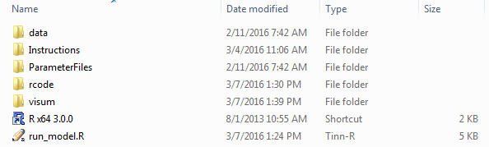

There are two files and five folders. The two files are the R software shortcut and the “run_model.R” script. All that a user needs to do to run OSUM, is double click the r shortcut (assuming that R and the supporting software has been setup correctly as defined above) and then drag the “run_model.R” into the open R window. The “run_model.R” script has all the commands needed to read in all inputs and load in the correct model code to run the given the model successfully. The following text briefly describes the contents of the five folders and how each supports the model run.

The data folder contains all of the input files used by the model, with the exception of spatial data (network and land use) and associated travel time matrices, which are all stored in Visum (see visum folder). All of the files are in CSV (comma-separated values) format. They contain a variety of input data ranging from utility equation coefficients and trip generation rates to time of day factors and district flow adjustment. These files are discussed in more detail in the Inputs/Outputs section below. They are read-in for input to the OSUM submodules and used through-out the OSUM run. When the OSUM run is finished a copy of the R workspace is saved that has all the input data stored in it (along with the output data). This includes input data from the “data” folder as well as inputs from Visum. That workspace is saved in the “visum” folder and has the same name as the Visum version file stored in that folder, except that instead of ending with the “ver” extension the file name ends with the “Rdata” extension.

The Instructions folder simply has instructional documents and reference material to help better understand the construction and operation of OSUM.

The ParameterFiles folder contains the four parameter files that have been pre-defined for OSUM. Parameter files in Visum can be thought of like macros for Emme. However, Visum’s parameter files are in a binary format, which makes them less flexible than Emme’s text file format used for its macros. The four parameter files contained in this folder are called through-out the OSUM run and are used to run different assignments and calculate and save travel-time skim matrices.

The rcode folder contains all of the program files (R scripts) required to run the model. These files are R script files in text format containing the functions that implement each of the OSUM modules. During model execution, the required files are read from the rcode folders as needed. The rcode folder also includes a script file for controlling the order of execution for the submodules and several files containing functions used at various points for input data processing, matrix balancing, and transferring matrices and information to and from the Visum database.

The visum folder only needs to contain the Visum database, which contains the model network and zone (spatial) information, as well as a number of global inputs / parameters. The OSUM specific global settings and parameters are stored in Visum under the “Network” menu, “Network settings”, and then the “User-defined attributes” tab. These parameters and optional settings are described in additional detail in Section E. The visum folder may also contain a “gpas”. This folder has several graphic parameter templates for Visum, which help to quickly toggle between different ways to view information in Visum and assess the network coding and outputs. OSUM is coded to point the user’s Visum instance to this (\visum\gpas) folder location which makes viewing OSUM results in Visum almost fully seamless. Having this optional folder in the visum folder will be of great benefit to anyone running Visum.

The output from the OSUM submodules is written into 4 locations within the OSUM folder structure. Likely the most important output for a user will be the “runReport.html” file which is generated in the base directory (note that the parameters stored in Visum must be correctly pointed to a valid OSUM reference run for this diagnostic file to be created). When the “runReport.html” file is generated, the plots that are embedded in that html are also stored in a “runReport” folder that is created in the base directory.

Another important location for outputs is the “Rdata” file that is created in the “visum” folder. This file is a copy of all the inputs, mid-step data, and outputs that occur in an OSUM run; it is a copy of the OSUM R workspace. At the end of the OSUM run the workspace is saved with the file name of the Visum version file that was run, so the “Rdata” set file that is created will have the same name as the version file, except it will end with a “Rdata” extension instead of the “ver” extension. The “visum” folder will also have a handful of other files that are generated during a run that will be described in greater detail in Section H. Lastly, some diagnostic files are also written out to the “data” folder, these will also be described in greater detail in Section H.

Model Application
Performing an OSUM model run involves the following basic steps:

- Preparation of input files, Land Use and Network Data
- Review of model parameter settings
- Model processing
- Reasonableness checking of model outputs
- Documentation of model run

Preparation of Input Files
For typical model applications, most of the input files do not need to be modified. Some of the data items may need to be changed, however, to reflect the specific characteristics of the scenario being analyzed. The files containing the inputs most likely to be changed are described in Sections D and E. These include the Visum version file (visum folder), which would be modified to reflect assumptions about future land uses, and the various inputs associated with roadway network changes. All monetary units (income distributions for OSUM) are expressed in 1995 dollars.

Beyond the version file, a user should only infrequently need to update or edit the csv files in the “data” folder. One example of a potential change in the “data” folder would be changes to the external model such as revised AADT (actually AWDT, it’s correctly labeled in the SWIM external model input) or growth rates at external stations.

Review of Model Parameter Settings
The preparation for a model run also includes reviewing and modifying as needed the values of the model parameters stored in Visum under the “Network” menu, “Network settings”, and then the “User-defined attributes” tab. These parameters contain; model constants (i.e., inputs that are not a table or matrix), flags for options features, and file pointers to reference runs to compare with.

Most of the parameter values shown in Table 1 do not need to be changed. Values would typically only need to be changed under the following circumstances:

- Parameters defining the scenario to be analyzed - for example, testing a different peak/analysis hour or a change in intra-zonal travel time.
- Parameters defining characteristics that are specific to the model run, such as the year being run or the reference scenario to compare to;
- Testing different options in OSUM. OSUM has been setup and standardized around ~12 different areas. Consequently, there are many different options that can be applied that were developed as improvements or as special treatments for a specific area. These optional features can be toggled on or off for testing, but as a general rule, features that were set in model development need to kept as-is during model application. The model would likely no longer be calibrated if an OSUM feature was applied in an application that wasn’t applied during development, calibration, and documentation.

Table 1: OSUM Parameters Stored in Visum
Setting | Description | Default Value
CITY | Required – The area of the model, required for documentation purposes | Varies by model
YEAR | Required – documents the year being tested / modeled, impacts the external volumes if using the SWIM external model. | Varies by model
AM_PEAKHOUR | Required – The hour to be used for congested travel time matrices in OSUM. In many OSUM, this is actually the PM peak-hour (poor naming of the field/parameter). | Varies by model
PEAKHOUR | Required – The analysis hour. This is the assignment that OSUM ends with, therefore leaving the analyst with the assignment results of the hour of interest. | Varies by model
HHTRIPRATE | Required – The minimum number of vehicle person trips. OSUM will boost hbshp, hbro, and nhb trips to achieve this target per household if trip generation does not achieve this value. This is one of the more influential inputs in OSUM and should not be altered unless the user knows what they are doing. | 9.2
TERMINALTIME | Required – This specifies the access and egress time that is assumed for every OD pair in the model. | 1.5 or 2 (minutes)
REFERENCE | A path and file name pointer for the reference R dataset that the given run should be compared to. (not required but highly recommended) | Varies by model
Optional Parameters
FUTURE_HH_PREPROCESSOR | If this field exists and is to be used it needs to be set to either “new” or “orig” (note, caps doesn’t matter). See Appendix D for more information. | FALSE or N/A
FUTRAVTHHSIZE | This parameter needs to exist if FUTURE_HH_PREPROCESSOR is “new” or “orig” exists. This is a single value that is calculated by taking the total future population for the given area minus the group quarters population and then divided by the total households for the given area. | N/A
MULTICLASSASSIGNMENT | This is strictly a user preference. If the user would like a multi-class assignment to be the last assignment run in OSUM (the last assignment run, so the assignment left for the analysts initial review of the results), the mark this field “TRUE”. | FALSE or N/A
NETCHECKMINSPEED | The default minimum speed in OSUM is 20 mph. Any link with a speed lower than 20 will generate a warning flag to the user each time OSUM is run. If the area legitimately has free flow speeds below 20, then one can set a new min here (like 10) so that the flags won’t pop-up. | 20 or N/A (mph)
NETCHECKMAXSPEED | The default maximum speed in OSUM is set to 65 mph for interstates (functional class / planning number = 1) and 55 mph for all else. Any link with a speed greater than these values will generate a warning flag to the user each time OSUM is run. If the area legitimately has free flow speeds above 65 or 55 mph (off interstate), then one can set a new max here (like 75) so that the flags won’t pop-up. This was specifically added to accommodate the eastern Oregon speed increases. | 65 or N/A (mph)
TT2NEARESTZONEFACTOR | This factor is a number that should be between 0 and 1, but is not limited by the code in anyway. In almost all OSUM applications this has been set to 0.5. Therefore if this factor is not provided, the default in the code is 0.5. A factor of 0.5 means that the intra-zonal travel time for a given zone will be half the travel time to its nearest zone. The option to change this factor was added for Astoria, as the Astoria implementation set this value to be 0.6, so the intra-zonal travel time for a given zone was 60% of the travel time to its nearest zone by travel time. The user is not advised to change this value or use this function, but it is available for special cases like Astoria. | 0.5 or N/A
TT2INTRAZONAL | If TRUE, then the terminal time (set above as “TERMINALTIME”) will be added to the intrazonal travel time as well as the interzonal travel time. The default in OSUM is to not apply the terminal travel time to intrazonal trips (the diagonal of the demand matrix). With this flag set as “TRUE” the “TERMINALTIME” value will be added to all cells (including intrazonal) of the peak and off-peak travel time matrices. | FALSE or N/A
ASTORIA_NHB_PROD | If TRUE, then the non-home based production allocation code that was developed for the Astoria model will be used in place of the standard OSUM code. The difference is that in the Astoria implementation special generators were removed from the size variable (employment and households) for non-home based production, so if applied zones with special generators will get less non-home based trips. | FALSE or N/A
External Model Parameters
ASTORIAEXTERNALMODEL | If TRUE, then the code runs the external model section of code that was specifically developed for the Astoria model. Note that if the user has the SWIMEXTERNALMODEL attribute set to TRUE as well, the SWIM external model will run, and the Astoria model will not, so if this is desired, ensure that the SWIMEXTERNALMODEL flag is not in use. | FALSE or N/A
SWIMEXTERNALMODEL | If TRUE, then all the SWIM external model inputs need to exist as well as the 2 flags / fields that are described immediately following. See Appendix E for more information. | FALSE or N/A
EXT_MODEL_DATA_FILENAME_PATTERN | This will only be used if the SWIM external model is being implemented. This should not be changed from the default of “_outputs” without good reason. | “_outputs” or N/A
EXT_MODEL_DISAGGREGATE_METHOD_NUMBER | Allows the user to change the way land use is used for weighting and adjusting SWIM patterns. Should not be changed without good reason. | 4 or N/A
Visitor Model Parameters
VISITORMODEL | If TRUE, then the code runs a second instance of OSUM, running only for visitors in the model (as opposed to residents). In order for this to run a “data_visitor” folder must exist, which contains all the same inputs as are in the “data’ folder but specified for visitor travel and “V” household zonal inputs in the Visum version file (“VHH”, “VHHS*”, and “VHHI*”). See Appendix F for more information. | FALSE or N/A
V_ SWIMEXTERNALMODEL | If TRUE, this variable runs the SWIM external model for the visitor run of OSUM. If this is set to TRUE the user needs to make sure that the inputs required for the SWIM external model exist in “data_visitor” | FALSE or N/A
V_HHTRIPRATE | If this is set to a non N/A value the visitor trip generation will be “boosted” to the V_HHTRIPRATE value provided times the total number of V_HHs input into Visum (the total number of visiting “households”. | N/A
V_FUTURE_HH_PREPROCESSOR | Applies the future household preprocessor logic if set to “orig” or “new” (note that caps don’t matter, also it is not advised to apply this for the visitor model). | FALSE or N/A
V_FUTRAVTHHSIZE | This parameter needs to exist if V_FUTURE_HH_PREPROCESSOR is “new” or “orig” exists. This is a single value that is calculated by taking the total future population for the given area minus the group quarters population and then divided by the total households for the given area. | N/A
VISITORS_CONSIDER_ CONGESTION | If this value is set to “FALSE”, then the visitors will make destination decisions without considering congestion. The visitors will see an uncongested travel time matrix in the destination choice component of OSUM. If this value is set to anything else besides “FALSE” visitors will get the congested matrix just like “resident” trips. | N/A
SAVE_VISITOR_ROUTING | If set to “TRUE”, OSUM will save out a separate Visum version file that has just the visitors assigned, so that they can be easily reviewed and visualized on the network. | N/A

Default values are provided in the table for most parameters. It should be noted that only “required” parameters (in bold) will always be present in an OSUM version file. All of the other settings are “optional” and the code assumes a default if they are not present. So if a parameter in Table 1 is desired, but it does not exist in the version file, a user should go to “Network” menu in Visum, and then select “User-defined attributes”. A window will appear and in that window the user should select “Network” in the drop-down “Network objects” list. Once selecting “Network, the user can “Create” the parameter desired. When creating a parameter, the “Attribution ID”, Code”, and “Name” fields all need to be written in all-caps and typed exactly how the parameter is identified in Table 1, otherwise the OSUM code will not recognize it. Once the parameter(s) is created it can be adjusted with the other parameters under the “Network” menu, “Network settings”, and then the “User-defined attributes” tab.

Model Processing
Once the version file, input files, and parameter settings file have been prepared, model processing involves the application of the OSUM modules within the R environment and performing trip assignments in the Visum software.

To apply the model, the user double-clicks on the R shortcut located in the project directory. This starts the R GUI, which opens up an R console where the user types commands and results can be reviewed and analyzed. The model is run in the R workspace that is opened with the R console from the shortcut. To run OSUM, simply drag the “run_model.R” script into the open R window (workspace). The Visum assignment portion of the run is called by the R-script. A valid Visum license is required for the assignment step and OSUM to run fully.

Processing Errors

Processing errors do not commonly occur when running OSUM because the R script files have been extensively debugged. Errors may occur, however, particularly with initial model runs for new installations of OSUM. Additionally, errors related to proper setup of all software and libraries, are common when running OSUM for the first time on a given machine.

To identify where the problem is occurring, it is helpful to run the model incrementally by copying steps of the “run_model.R” run files into the R workspace one-by-one rather than attempting to run the full model script in a single pass. If this is done and the problem still can’t be identified, then portions of the R code for individual OSUM submodules (rcode directory) can be copied into the workspace and run in smaller and smaller increments until the problem is isolated.

Once the problem has been located, the cause of the problem is not always obvious from the error message generated by R. For help in interpreting common error messages when running OSUM, a list of frequently encountered errors is contained in Appendix B. Other useful resources on R error messages and the R language in general can typically be found by searching the issue in google or at:

- https://www.r-project.org/
- http://www.burns-stat.com/

If the problem still cannot be resolved using these sources of information, the TPAU staff person responsible for the model should be contacted.

Reasonableness Checking of Model Outputs
It is important to perform reasonableness checks of the model output at several key points in the model application process prior to trip assignment so that potential errors can be detected as soon as possible.

Depending on the type of application, checks of the OSUM output should be performed following the execution of the trip generation, trip distribution, mode choice, and peaking and demand matrices modules. All of the checks involve the comparison of the model output from a scenario to the output for a reference scenario, to determine if the differences are consistent with the expected levels of change. Because in most instances the models are applied for future year scenarios, the reference scenario is often the future “No-Build” alternative.

Trip Generation Checks

For the trip generation module, trip productions per household should be checked if a change has been made to the total households for a zone or subset of zones. This value should be similar to the trip productions per household for the same zones prior to the change or similar zones if there were no households previously. Significant differences could indicate that the number of households was miscoded or the household distribution data items (cross-tabulation shares by income and size) were omitted or incorrect for the zones.

Trip Distribution Checks

Several checks can be performed to verify the reasonableness of the model’s trip distribution estimates in response to changes in land use or network assumptions. The first check is to produce trip length frequency distributions by trip purpose using both travel time (minutes) and distance (miles) as the unit of impedance. These distributions show the percentage of trips within each travel time or distance interval for all zones or a subset of zones. Differences in the distributions between the test scenario and reference scenario can indicate whether land use or network changes have been properly reflected by the model. For example, a land use scenario that shifts trip productions closer to trip attractions would be expected to shift the distribution of the hbw trips into the shorter travel time and distance intervals, resulting in a lower average travel time and distance. These plots are generated at the end of OSUM if a user specifies a valid reference pointer in the parameter settings, discussed in Table 1. An example of this type of plot or analysis can be seen in Figure 3 (if a reference is identified, this figure and many other helpful figures will be created and saved in “runReport.html”).

Figure 3: Comparison of Travel Time Frequency Distributions
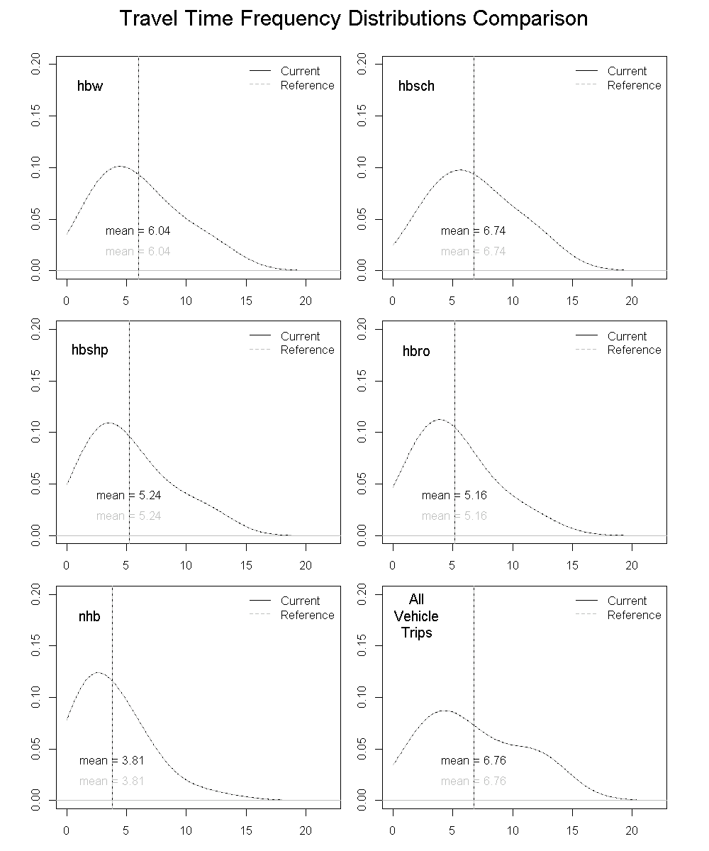

A second trip distribution check is for origin-destination patterns, in which the volume and/or share of trips between districts is examined. Generally, this is applied for larger scale land use or network scenarios that may affect the regional distribution of travel. To apply this check, the modeling area is divided into districts and the number and share of trips between the districts is summarized in a table. An example of differences between origin-destination patterns would be the distribution of trips for a roadway capacity enhancement scenario compared to that of a reference scenario. The number of trips between widely separated districts would expected to be lower for the reference as compared to the capacity enhancement scenario because of the assumed improved travel times between districts under the capacity enhancement scenario.

Another check on origin destination patterns is the orientation ratio. This measures the propensity of trips from a production area (or zone) to an attraction area and is defined as follows:

- The numerator is the trips to the attraction area from the production area divided by the sum of all trips to the attraction area; and
- The denominator is all trips from the production area divided by all trips in the region.

If, for example, there are 300 trips from District A to District B, and 800 total trips produced in District A, 100,000 total trips attracted to District B, and 750,000 total regional trips, the orientation ratio for District A to District B would be computed as:

(300/100,000) / (800/750,000) = 2.81

An orientation ratio with a value of less than 1.0 indicates that the production area is less oriented to the attraction district than the region as a whole. An example of this might be a low-income residential area located adjacent to a “tech center” area. Conversely, an orientation ratio with a value of greater than 1.0 indicates that the zone is more oriented to the attraction area than other zones in the region. The orientation ratio can be calculated at the zonal level or a mixed zonal and district level, as desired.

Assignment Checks

The assignment results in Visum should be compared to a set of reference volumes for comparison. An example of a common issue is at the external locations of the model. The external station locations offer an isolated location where the link volumes should be exactly what the user has coded as the daily (or hourly) volume in the external model. If these do not match the inputs given, that is a clear sign of an issue, and one that has been commonly over looked in the past. If the external locations look fine, the analyst should also review assignment difference between the new run and a reference run to see where the differences are (OSUM loads reference volumes into Visum automatically if a reference is identified in the parameter settings). Larger differences in assignment between the two should be justified. As an example, if a user adds new network elements or land-use, the network immediately adjacent to those changes should see the greatest assignment differences.

Documentation of Model Run
The final step in model application is to document the application process, including such information as input data preparation, network changes, if any, and a summary of the application results. This should be treated as a formal documentation exercise and following the technical memo template as established by TPAU (or similar). For TPAU employees this template can be found at: \\s6000e\6420only\Templates\DocumentsAndFigures TechMemo_Template_Interoffice.doc

Example memos from previous projects can be found at: \\s6000e\6420only\Templates\Modeling\Application_TechMemo_Examples

D. Network Coding
OSUM uses Visum for the assignment of trips to networks, data management, and for user analysis of model result. Since network coding, a critical model input, is performed in Visum, this overview summarizes Visum attributes and terms. Further and full detail can be found in the PTV VISUM 15 MANUAL.

Many other helpful resources and Visum tutorials can be found in this directory after installation of Visum: C:\Users\Public\Documents\PTV Vision\PTV Visum 15

This directory has wealth of information to a person who wants to learn Visum. Of specific interest to those just getting started please refer to:
- \Tutorial_FirstSteps\Readme_FirstSteps_ENG.pdf, and
- \Tutorial_Quickstart\Visum_Quickstart_ENG.pdf

Overview
The OSUM network structure stored in Visum includes the TSys/Modes/Demand segments, Nodes, Links, Zones, Connectors, and Turn elements. Matrix-related data are also considered part of the network in Visum. These include both demand matrices (input Origin-Destination (O-D) matrices) and skim matrices (matrices calculated via “skims” across a loaded network).

TSys/Modes/Demand segments define which types of vehicles are allowed on a link. In Visum there is a three class hierarchy. This hierarchy exists for people to model complex transit operations and scenarios. Since OSUM simply models vehicles, each of the steps in this hierarchy are essentially the same thing. For simplification this can be thought of as a mode. However it is important to note that in Visum, “modes” aren’t coded on links, “transportation systems” (or TSys) are allowed or not allowed and certain modes are allowed to use certain transportation systems. Further, modes aren’t assigned to O-D matrices. O-D matrices are linked to demand segments of a give mode. Again, in OSUM this is simplified as the TSys, mode, and demand segment are all “C Car”, but the distinction between the three is still important to understand.

Nodes may correspond to an intersection or shaping point. Nodes must exist to form a link. It is important to remember that in Visum Nodes and Zones are different objects.

All links defined in Visum fundamentally have to have a starting and ending node and have both (two) directions. In Visum if a link is one-way the direction not allowed is restricted from all modes (or transportation systems) as opposed to the link not existing. It is also important to remember that in Visum links and connectors are separate objects.

Zones represent the point (centroid) of a given TAZ as well as the spatial boundary of the zone. Additionally all of the zonal attribution is stored in Visum and can be accessed, edited, and visualized spatially.

Connectors are very simple objects in Visum. They represent a zone loading points on to the network. Connectors are not intended to represent actual roads or access points; those should be captured with actual nodes and links.

Turn movements are represented at nodes. A turn is a node triplet that defines a turning movement at an intersection, where a via-node is the intersection node, from-via is the first (incoming) link of the turn and via-to is the second (outgoing) link of the turn.

Both input and calculated matrix information can be in the “Matrices” window in visum. Visum allows for many simple matrix operations to be completed in Visum. Complex matrix editing and work can be completed internally through python scripting or externally in packages like R.

An object “list” (attribute table) is stored within the Visum database for each network element. An example attribute list for network links is shown below in Figure 4.

Figure 4: Visum Link Listing

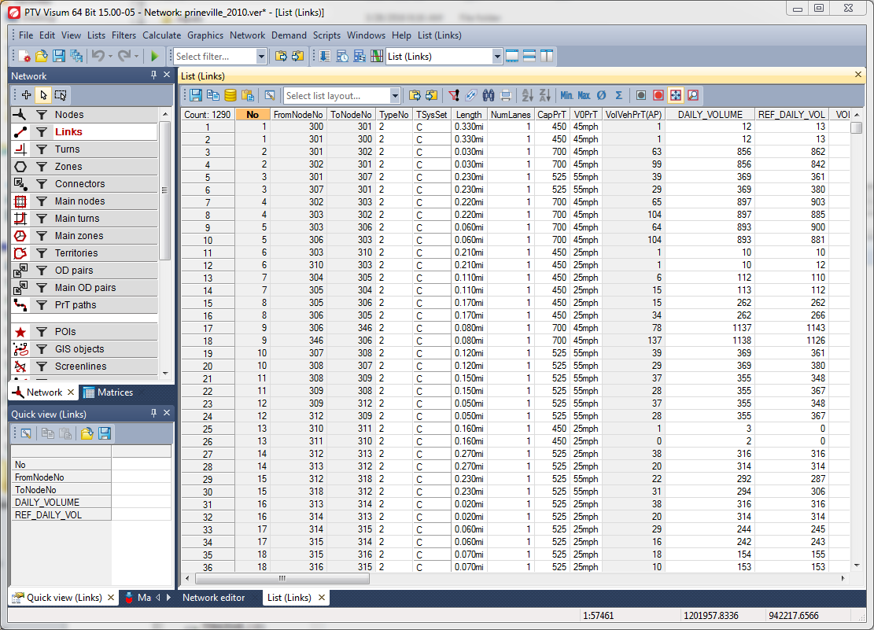

Network Coding in Visum
Network coding in Visum is completed using the Network Editor GUI (although network edits can also be batched in via text or shapefiles for more advanced users). The Network Editor is the standard window that appears when first opening Visum.

In addition to the main Network Editor screen (which is the primary screen that displays the network), there is also a Network toolbar that contains the majority of the tools and functionality that need to be used for editing. The Network toolbar has a toggle switch for each network object. To work on a specific object (for example links) a user must first choose that network object. In Figure 5 below “Links” is highlighted. At the top of the Network toolbar are three buttons; add (create mode), select (edit mode), and multi-select (spatial section mode). Most users will only use the add and select (edit) functions. For users just getting familiar with Visum, it is highly recommended to utilize the available tutorials and references linked at the beginning of this Network Coding section.

Figure 5: Visum Network Editor
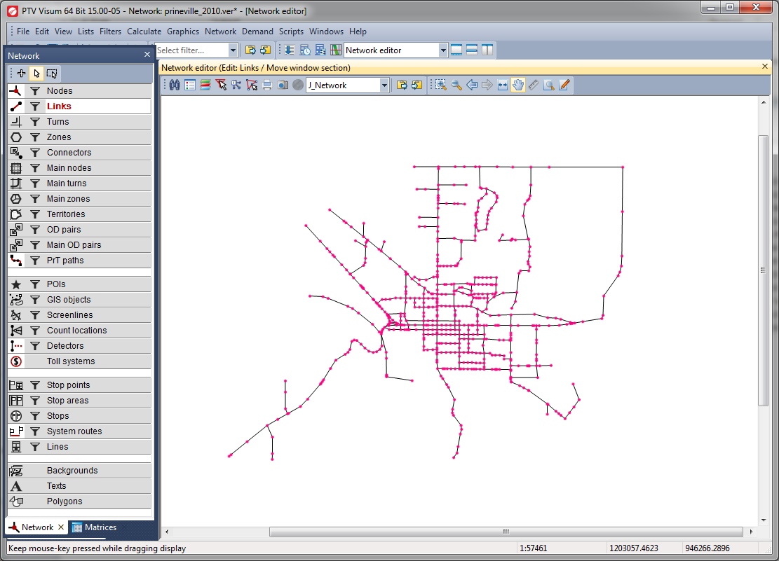

Network Coding Standards for OSUM

Roadway Network Coding
A user would be making network coding modifications in model scenarios where future or hypothetical network changes are to be tested or represented, such as a new roadway or a change in the features of an existing roadway. Depending on the type of change, this may require modifications to the network structure or the attributes of the network elements (nodes, links, connectors).

Network changes must always be considered within the context of the network that is being edited (the reference network) in order to maintain consistency and confidence in the model results. Therefore, it is essential that the user be familiar with the reference network and model development documentation in order to understand the network coding approach used in the development of that specific model.

Nodes
Node modifications include adding a new node or deleting or changing the location of an existing node in the network. Before adding new nodes, the user should refer to the applicable model development report for the given OSUM model for information on the node numbering conventions used in the network.

When adding a regular node, an unused node number from the next unused node number range should be selected. For example, if the highest existing node number is 2047, then the node number for the new node should be 2100. In this example if a model request required 9 new nodes and the highest existing node number was 2047, then the new 9 nodes would use a series of 2101-2109. If a second project that was building off of this revised network had another 17 nodes that series could go from 2201-2217.

Node coding must capture where signals exist, and would ideally include all control type identification. To do this capture the control type in Visum under the node attribute “ConrolType”. The options for this attribute in Visum are: Uncontrolled, Two-way stop, Two-way yield, Signalized, All-way stop, and Roundabout.

Links
New links may need to be added or existing links modified or deleted from the network for an application. The following attributes must be coded when adding links in an MPO model networks:
- TSysSet - must allow “C” if vehicles are allowed
- TypeNo - volume-delay function, vdf, reference; 1 for signal approach, 2 all else
- Length - Visum will calculate the length, but this should be checked. Users should add shaping points to represent the true shape / length of the link
- Lanes (or NumLanes in Visum) – number of through lanes, not turn lanes. Does not include two-way center turn lanes, if present
- v0-PrT (free flow speed for vehicles) - This is typically posted speed
- CapPrT (hourly section or direction capacity) - note that in Visum the capacity field is the capacity for the direction or section, so it needs to be coded as the hourly per lane capacity multiplied by the number of lanes.
- PlanNo (or Planning Number) – this field is used to capture the functional class
  - Interstate / Freeway
  - Principal Arterial
  - Minor Arterial
  - Collectors
  - Local
30. Ramp

To code link attributes for new or revised links, it is generally a good practice to copy and paste the attributes from a similar, nearby link to the new link as a starting point. The specific characteristics of the new link can then be reflected by modifying the copied attributes. This is most easily completed using the Quick view toolbar. Refer to Visum references and tutorials for information on using the Quick view toolbar.

The capacities are obtained from a look-up table in which capacity values are defined by facility type/area type or facility type/speed. The capacity values are defined below in Table 2.

Table 2: OSUM Per Lane Capacities
Functional Class | Plan No | TAZ Area Type (Density)
Functional Class | Plan No | 1 (CBD) | 2 (Fringe) | 3 (Urban) | 4 (Rural)
Interstate/Freeway | 1 | 1900 | 1900 | 1900 | 1900
Principal Arterial | 2 | 700 | 800 | 850 | 950
Minor Arterial | 3 | 575 | 625 | 700 | 760
Collector | 4 | 450 | 500 | 525 | 650
Local | 5 | 400 | 450 | 500 | 625
Ramps | 30 | 700 | 800 | 850 | 1000

When coding the network one should be aware of the automated network checking that occurs during each OSUM run. The following flags are setup to automatically generate for every OSUM run if any of the following are true:
- Links with more than 3 lanes
- Links with speeds less than 20 mph (unless “NETCHECKMINSPEED” is set to different minimum speed, see Table 1 in Section C for more detail)
- Links with speeds greater than 65 mph for interstate and 55mph for non-interstate (unless “NETCHECKMAXSPEED” is set to different maximum speed, see Table 1 in Section C for more detail)
- Links with a PlanNo (functional class) that is not a number in the list above
- Links that have a speed less than 30mph but a capacity greater than 1000
- Links that fall outside of the low (Area Type 1) and high (Area Type 4) boundaries of per lane capacity by functional class, as established by the table above.

If any of these guidelines is broken, the user will get a message in the file “errorReport.txt”, informing the user of the links that have broken a given rule and the rule(s) that has been broken. While these errors or issues will not stop the run, they should be properly addressed prior to using any of the results from the scenario. A user should never use the results from OSUM if the OSUM run is generating an “errorReport.txt” file or if errors or warnings are being written to the command line in the open R window.

When adding or modifying links, the link geometry should be traced over background GIS maps of the roadway network. Shapefiles and ArcGIS maps such as Bing Maps and OpenStreetMap can be added to the Visum workspace by simply toggling on or off the “Enable / disable background map” button (globe icon). Note, in order for this feature to work, the proper projection must have been identified for the Visum workspace. This can be set by clicking on:
- the “Network” menu
- then choosing “Network settings”
- then clicking the “Scale” tab
- then going to the “Spatial reference system” section of the window
- choosing “From file”
- and then navigating to the correct projection.

Shapefiles for Oregon models are almost always in the Oregon Geographic Information Council’s (OGIC) Lambert projection, which can be found under “Projected Coordinate Systems” and then ‘State Systems”, after clicking on the “From file” browser button.

Connectors
The location of connectors should always be revisited when changes to the local development pattern or local street network are made. New connectors should be coded according to the following conventions:

- The connection points to the network should reflect realistic traffic loading points for as much of the zone as possible based on the distribution of development and configuration of the local street system within the TAZ.
- The use of network intersections as connection points should be avoided.
- The minimum number of connectors should be used, while maintaining a realistic representation of traffic loading.
- There should not be more than one connector in any primary direction (example - East), except in very unique circumstances.
- Centroid connectors should not cross zone boundaries or geographical features, like rivers (referred to as “tunneling”).

Turns
Turns are coded in the OSUM to define prohibited intersection turning movements. Turn penalties or impedance are not currently being used for estimating intersection delay.

Zones
If a new zone centroid is added, such as for zone disaggregation, it should be located at the estimated center of trip activity for the zone. Zone boundaries should always be added as well, for this reason it is usually easiest to import zone changes in with a shapefile. If doing so, always save-out current zone x-y coordinates so that the centroid locations are not lost. This is important because zone centroids are always set as the geographic (not activity) center of each zone when imported from a shapefile. Zones have an extensive amount of attribution; revisions to attributes are covered in Section E.

Roadway Network Validation
- Review coding changes

Checks should be performed to determine if the roadway network changes were properly coded. An initial check is to verify that the intended network changes were actually made by reviewing the network topology and link attributes that were changed. While this step may seem simple, it is a very important quality control step to perform and typically ends up saving time in the long run.

- In Visum use Calculate -> Check Network (configure check parameters as shown in Figure 6)

After the network changes specific to a given model application are reviewed and compared, the next step is to verify that the network still meets basic connectivity and routable properties. As an example, all zones must be connected to the network, and roads in the model should not dead-end. To perform this network check, complete the following steps:

Figure 6: Network Check Screen
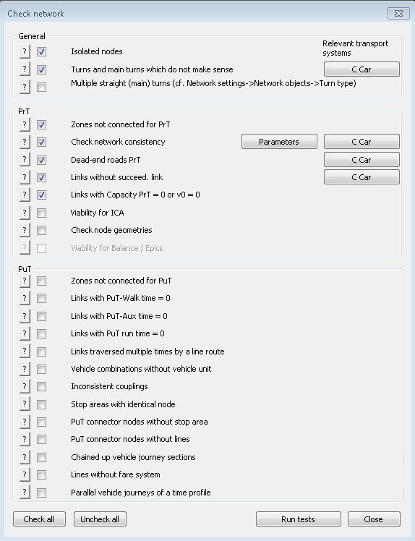

- Shortest Path Search

It can be common for a network to meet network check criteria but still have coding inconsistencies or irregularities. As an example, TPAU has run into issues where pre-defined link types were inadvertently coded to not allow the auto / car mode. These link types have then been accidently used in creating new links. As Visum creates these links all turns to and from the new link are blocked to auto, since the new link does not allow auto. The coder corrects the link attribute, allowing auto to move on the link, but neglects or is unaware that all of the turn restrictions need to be removed to allow autos to use the links. This affect can be seen below in Figure 7. Therefore, running several Visum shortest path searches over the areas with new network edits is highly recommended. To run a shortest path search use Graphics -> Shortest path search. Then follow the GUI to conduct shortest path searches across the region.
Figure 7: Shortest Path Check Example
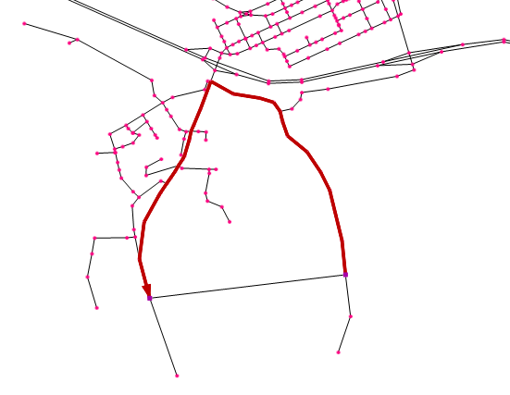

- Post-Model run

When OSUM runs several network checks are automatically run. The network check process generates pop-up windows and an “errorReport.txt” file if any network inconsistencies are found that do not align with OSUM coding conventions. Examples of issues reported in the pop-up windows and “errorReport.txt” file can be seen below in Figure 8 and Figure 9. Further, any reporting to the R window should be reviewed, understood, and addressed if needed. Issues reported to the R window can signify a network coding or input issue. Finally, the “runReport.html” that is generated at the end of the OSUM run is another important file to review (see example Figure 10) that can potentially help identify network coding or input issues.
Figure 8: OSUM Model Warning Pop-up
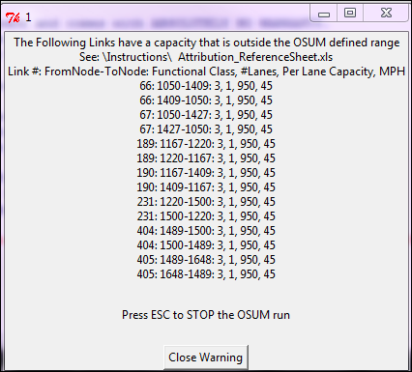

Figure 9: Example of errorReport.txt
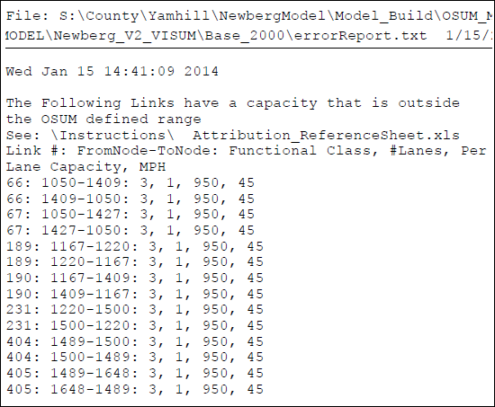
Figure 10: OSUM Comparison of Trip Generation Summaries
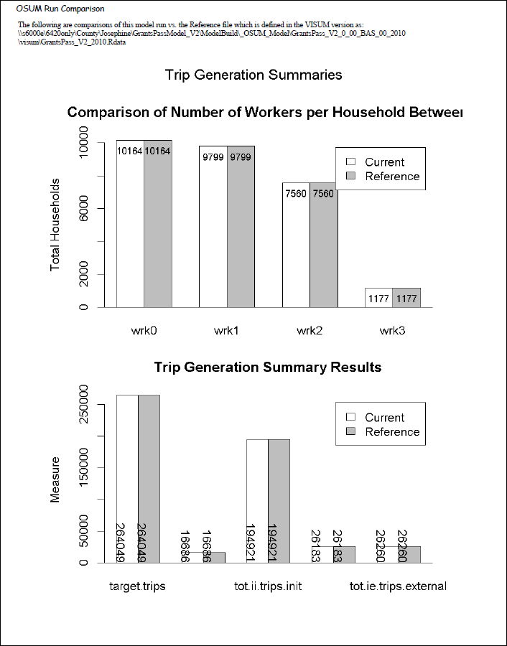

- Link Assignment Checks

After OSUM successfully runs and any errors identified in the run process have been addressed, one of the final checks to conduct is if the new link assignment meets basic expectations. As an example, a new by-pass would be expected to pull a sizable share of traffic from the existing route. If the amount of traffic diverted is not believable (as an example, almost all or almost none of the traffic), then a network coding error is likely the culprit, and the network review or validation process should start back at the first step. Below, in Figure 11, an example of a reasonable assignment re-route can be seen.

Figure 11: Assignment Comparison to the Reference
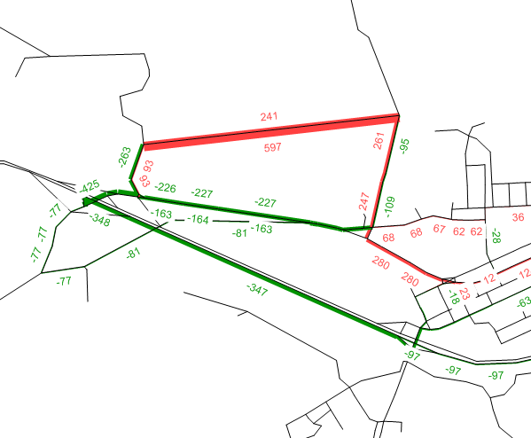

E. Input Data Preparation
Most of the OSUM input data files do not and should not be changed for model application. Depending on the type of application, however, specific files may need to be modified to reflect the scenario being tested.

There are four broad categories of input data:
- Zonal socioeconomic data (stored in Visum zone attributes)
- Level-of-service data (network skims stored in Visum)
- Travel behavior and patterns data
- External travel data

In the following sections, information is provided on the input files within these categories that the user can edit and how to prepare the data. All of the input files are stored in the “data” folder of the OSUM project directory, with the exception of the zonal socioeconomic and network data which is stored in the zone attribution of the Visum version file.

Zonal Socioeconomic Data
Socioeconomic data consists of information related to the households and employment by type for each TAZ stored within the Visum version file under the zone attribution (zone list). The following is a brief description of OSUM’s land use inputs:

Zone Field Description
TAZ TAZ number (Visum also has the “NO” zone number field, TAZ and NO must be kept identical)
HH Total number of households
POP** Total population (includes group quarters population in the base year)
GQPOP** Group quarters population (typically only captured for the base year)
AHHS** Average household size ((POP-GQPOP)/HH) [base year formual]
BG* Block group associated with TAZ (numeric data type) [only required if census worker distribution is to be used, which is an optional input)
HHI1 Percent of households in household income class 1 ($0-15k) [$1995]
HHI2 Percent of households in household income class 2 ($15-25k) [$1995]
HHI3 Percent of households in household income class 3 ($25-40k) [$1995]
HHI4 Percent of households in household income class 4 ($40k+) [$1995]
HHS1 Percent of households in 1 person households (size class 1)
HHS2 Percent of households in 2 person households (size class 2)
HHS3 Percent of households in 3 person households (size class 3)
HHS4 Percent of households in 4+ person households (size class 4)
HHREF* Total number of households in the Reference (or base) year [only required if the “Orig” (original) future household logic is applied]
VHH* Total number of visitor households [only required if the visitor model is applied]
VHHI* The percent of households in each of the four income classes for visitor households [only required if the visitor model is applied. Note that this is four separate fields VHHI1 – VHHI4]
VHHS* The percent of households in each of the four household size categories for visitor households [only required if the visitor model is applied. Note that this is four separate fields VHHS1 – VHHS4]
EMP Total employment
AGRI** Agriculture employment (NACIS 000000–219999)
INDY** Industrial employment (NACIS 310000–339999 & 511000–512999)
RETL Retail employment (NAICS 440000–459999)
SERV Service employment (NAICS 515000–569999 & 620000–819999)
EDUC** Education employment (NACIS 610000–619999)
GOVT** Government employment (NACIS 92000–929999 & 491110)
OTHR** All other employment (NACIS 220000–239999 & 48000–499999 & 999999)
SCHE School enrollment (K-12)
COLE** College enrollment
DISTRICT District (aggregation of TAZs to larger areas, used by dist_bias.csv)
AREATYPE* Area type (1=CBD, 2=CBD fringe, 3=urban res., 4=rural) [code does not use, this field is only for documentation and for spatial reference in determining the correct capacity for a new or revised link]
* = optional OSUM fields, not used or required if using default OSUM settings
** = a field required [or strongly suggested] for documentation and input development purposes, but not required or used in the code at any point.

Beyond just knowing the input fields, there are some important contextual details in regards to how each of these fields should be developed. In regards to the income and size fields, it is essential that household distribution (income and size) data be developed and provided for all TAZs that contain households. Ideally household income and size distributions should be developed for all TAZ, but it is essential to the operation of OSUM that distributions exist for any TAZ with households. Additionally, the distribution data by household size (“HHS1 – HHS4”) and income (“HHI1 – HHI4”) must sum to 1.0 (100%).

Without this data, the OSUM code will zero-out the number of households in this zone in the household cross-classification step the OSUM household sub-module. If the household distribution data is not already included for a TAZ (e.g., new household are added to a previously zero-household TAZ), then it should be copied from a similar (typically neighboring) TAZ and pasted into the appropriate fields. The household distribution should also be reviewed if households are being added to or subtracted from a TAZ to determine if the distribution will continue to accurately represent the new household total. If there is a question about this procedure, the TPAU project manager responsible for the model should be contacted.

The OSUM setup contains seven employment field however only two of those category / fields are used; retail and service within the model calculation (the total employment is also used in the model). The fields along with the associated industry classification (NAICS) codes are described above. To identify the category that a specific type of employment falls into, descriptions of the NAICS codes can be found at: http://www.census.gov/eos/www/naics/.

There is also the “EMP” field which represents total employment (employees) during an “average” travel week of the year (typically spring or fall, or the entire year can sometimes be averaged). The “EMP” field should also be adjusted for scenarios with different employment forecasts.

School enrollment for all K-12 schools is captured in the “SCHE” field. Note that because it is difficult to gather enrollment for all schools, this is typically limited to just public school enrollment (unless a private school(s) of significant size and is regionally significant is in the model area).

The district field is linked with the “district_bias.csv” input and can be used to easily total trip ends between aggregated zone groupings or used to target an area of the model for an artificial increase or decrease in the number of trips (like the use of a special generator). This field is discussed in greater detail in the “district_bias.csv” discussion in the “Travel behavior and pattern data” section.

OSUM automatically checks for errors in zonal fields in the InputCheck.R script, which is executed by run_model.R after the inputs are read in but before the modules of OSUM have been started. Checks are made for the following errors (note that this list “live” and is appended with additional checks as they become identified to ODOT staff):

- Household distribution percentages do not sum to 100%.
- The districts in the “DISTRICTS” field have been coded consistently with “district_bias.csv”

If the optional field “BG” (block group) exists, the following additional checks are made:
- Block group number is not provided.
- Block group numbers for all TAZs are the same (meaning that likely a rounding error in Excel has removed all detail in the block group numbers).

There are also two checks for input files, which are described below (in addition to the network checks described in Section D):
- In the external model a user specifies the total volume of daily traffic at each external location (station) and the external-to-external (EE) percentage of the daily traffic for each external station, which is used to calculate an EE-volume at each external station. If any one external station has an EE-volume that is greater than all other EE-volumes combined, then the external model cannot close (balance) as there will be no way for the one primary (largest) external station to receive enough EE volume from the other available external stations to meet the EE demand of the primary external station.
- A check to verify that the land use associated with a given special generator in “spec_gen.csv” (an optional file) exists in the land use fields in Visum (Employment, household, and school fields). The code subtracts land use identified with special generators out of the total land use for a zone (so that trips are not double counted), so if the special generator file has a greater value for retail employment, as an example, than the RETL field in Visum for the given zone, then the code will fail. This warning provides an explanation for that code fail.

There are also a handful of checks that are recommended to be completed related to the “documentation” fields that are included in the TAZ file. These checks are not completed in the code because they are not critical to the operation of the internal models and equations in the OSUM code, however these checks are important to help verify that in land use inputs were developed thoughtfully and faithfully. Further these checks provide a level of quality control and review on the model inputs that should be completed before running the model. The following list is not meant to be comprehensive, but does give an initial good start at checks to be conducted and considered.
- POP is expected to always be greater than HH for everyone. A similar check is that AHHS should always be greater than 1.
- HH * AHHS should be within 10% of POP by zone. If not, review all the demographic fields for identified zones and determine the cause.
- The number of total households to the number of total employment should be roughly equivalent. If the difference is outside ~10%, the cause should be investigated and understood.
- The seven employment categories should always sum to the total employment field by zone.

Level-of-Service Data (Network Travel Time Skims)
Changes to the highway network must be reflected in the appropriate level-of-service data files (travel time skims) that are input to the model. Level-of-service refers to the characteristics of travel by mode between zone pairs, in the case of OSUM, peak and off-peak travel times between zone pairs.

Reasonableness checks for the level-of-service data (travel times) can be performed by developing a matrix histogram of zone-to-zone impedances or distribution curves using the density function in R. Potential problems may be reflected in unexpectedly large values or concentrations of zone pairs within lower or higher impedance intervals (a formation of an unexpected hump in the curve. This type of reasonability check is generated automatically when the OSUM user has specified a “reference” OSUM run to compare to. When a reference run is specified (see Table 1 in Section C), OSUM’s “runReport.R” script is run at the end and compares the current OSUM run to the reference generating a series of plots and comparison output in the html file “runReport.html”. This html is generated at the end of a successful OSUM run that contains a reference pointer to an existing OSUM R dataset. Figure 3 in Section C shows an example of the plot that is generated that can be used for the review of the travel time (level-of-service) data.

Travel Behavior and Pattern Data
The following inputs cover the travel behavior data developed from household travel surveys, along with several other inputs developed from count distributions/information and other travel data trends such as district-to-district flows and areas sensitivities to travel time. They are broken into three categories; “Inputs that Could Change by Model Application”, “Inputs that Could Change by Model Area, but Likely Won’t Change by Project/Application”, and “Inputs Based on Household Behavior Survey Data”.

It is important to be aware that it would be very unusual for any of the inputs in the second two categories to be altered (changed) for a given project.
- Inputs that Could Change by Model Area, but Likely Won’t Change…
- Inputs Based on Household Behavior Survey Data
These input files are typically only adjusted during a specific area’s model development and calibration process and would not be altered again after calibration is finalized. Inadvertently changing these files could fundamentally change the model and create a version of the model that is no longer calibrated and therefore no longer representative of known travel conditions for the given area. In short, don’t alter that sub-set of input files without a strong understanding of what is being altered and why, or specific direction from a project manager.

Inputs that Could Change by Model Application

Table Name: district_bias.csv
Table Description: District bias is used when a zone or group of zones needs to be weighted higher than other zones in destination choice. In the example provided below, a given zone or set of zones has been coded as district 1 in the Visum version file “DISTRICT” zone field. In district bias the districts can be weighted by trip type. In the example, work trips (hbw) were made twice as attractive as they would normally be in the destination choice model. All other trip types were left with a multiplier of 1 in this example. Also note that the district 1 has an external (ext) factor of 100. Unlike the internal trip types (hbw, hbsch, hbshp, hbro, nhb), biasing external trips is an additive factor, not a multiplier. This was done because the internal trips use a destination choice model, where external trips are based solely on the size factor (households and employment) of the zone. In this example, “ext” = 100, is like adding one-hundred extra employees to district 1 to attract more external-internal trips to district 1.

Figure 12: District Bias Input Example
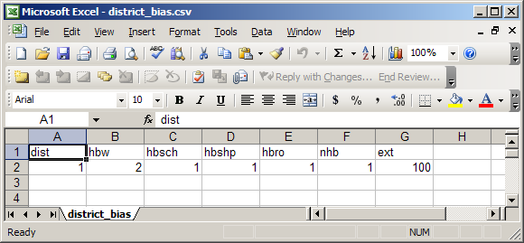

Using the district bias input does not hard code a specific number of trips to a given zone, like the special generation input (discussed next), so it can take several iterations of adjusting the district bias factors in order to get the measured or estimated number of trips to a district. In order to help the user adjust the district-bias two district-bias outputs are produced in the “visum” directory, these outputs are “dist_bias_Report_OD.csv” and dist_bias_Report_PA.csv”.

Figure 13: Example of OSUM output dist_bias_Report_OD.csv
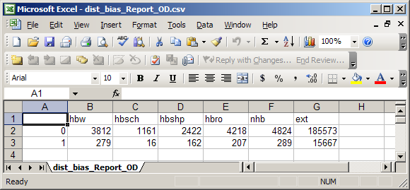

Both of these outputs report vehicle trips by trip type and district. The “PA” table shows users the vehicle trips being attracted to the district. The “OD” table has the total vehicle trip ends for each district. The sum by district is the daily volume entering, leaving, and traveling within the district. The two tables allow for quick assessments and adjustments to be made to the district bias input to achieve known or estimated trip totals.

Figure 14: Example of OSUM output dist_bias_Report_PA.csv
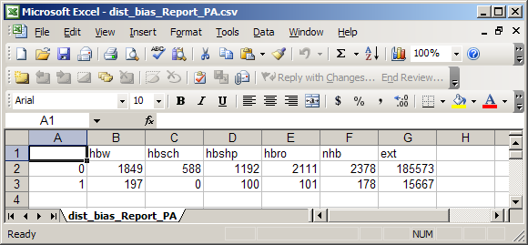

Table Name: spec_gen.csv [optional, file does not need to exist]
Table Description: The “spec_gen.csv” file is used to specify special generators. Only one special generator per zone is allowed. Each special generator needs to have a primary trip purpose, a number of two-way trips (often from ITE trip rates), the amount of employment, households, and/or school enrollment within the zone that this special generator accounts for, and the percent of trips that come from within the model area. When the special generator is applied to a zone, it is equivalent to hard coding a set number of daily trip ends to that zone. Note that there are most likely other land uses in a special generator zone, so the total daily trips for a zone with a special generator will likely be higher than the number of trips coded into “spec_gen.csv”. If all of the employment, households and school enrollment for that zone are coded into the special generator, then the daily trip end total coded into “spec_gen.csv” will be the daily amount for that zone.

Figure 15: Example OSUM Special Generator Table
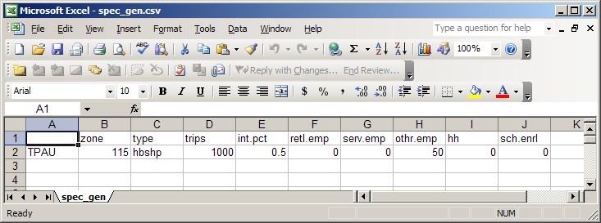

Both “dist_bias.csv” and “spec_gen.csv” have a similar effect on traffic patterns. It is advised that “dist_bias.csv” be used for most cases, as it is reactive to changes in the model, where using “spec_gen.csv” will always return the same number of trips (hard coded) regardless of how land use or the network is changed.

The land use fields housed in the Visum version file (along with the network parameters), “district_bias.csv”, and “spec_gen.csv” are all of the inputs that will typically change from model application to application. The rest of the inputs should remain constant and will likely remain constant between projects. These additional, rarely touched, inputs are described in sections below.

Inputs that will Change by Model Area, but Likely Won’t Change for Model Projects

Table Name: census_block.csv [optional, file does not need to exist]
Table Description: Census block data is an optional input used to adjust future year scenario household distributions if “FUTURE_HH_PREPROCESSOR” is toggled to “orig” or “new” in Visum. In order to estimate distribution of new households by household size in the future year, a process of estimating the distribution using base year block data and smoothing regressions is used. The input data is all the census blocks for the model area with their household size distribution and their corresponding TAZ.
BLOCK 15 digit block ID (numeric data type)
TAZ TAZ number (The TAZ that contains most of the households in that block)
HHS1BASE Total 1 person non-families in base year
HHS2BASE Total 2 person non-families and families in base year
HHS3BASE Total 3 person non-families and families in base year
HHS4BASE Total 4+ person non-families and families in base year
POPBASE Total population in base year (Does not include group quarters population)

Table Name: district_time_adj.csv
Table Description: These factors scale district to district travel times for all trip purposes. Values are only entered for the district to district pairs that are affected. All other district/district combinations are set to 1 in the distribution model. The final effect on travel time depends on these values in combination with the global_time_adj.csv values (described next). The larger the number the larger the time penalty will be for the given district to district pair(s).

Table Name: global_time_adj.csv
Table Description: These factors scale travel time matrices globally in trip distribution. They are used for calibrating travel time distributions by trip purpose. The default is 1 for no scaling. If set to zero time is not a factor in destination choice.

Table Name: retention.csv
Table Description: Retention factors – The retention factors are multiplier factors that can be applied in trip distribution to trips generated within the model area. Generally they are left at 1 to retain all internally generated trips within the model. The IE, EI, and EE trips are dealt with separately.

Table Name: size_inc_seed.csv
Table Description: Regional joint distribution of households by size and income. The two-way distribution of household size and income for each TAZ is calculated through an iterative proportional fitting (two-way balancing) of margin (row and column) control totals and a seed matrix. The TAZ data represents the row and column controls for each zone and a regional seed is created from Public-Use Microdata Samples (PUMS) data. This seed is a two-way distribution created for the Public-Use Microdata Area (PUMA) that the model falls in. For information on the seed see “pums2000.pdf” found in the “Instructions” folder.

Table Name: workershh.csv [optional, file does not need to exist]
Table Description: In OSUM there is a pre-processor to trip generation that calculates workers distributions for each TAZ based on income and size characteristics. This model has hard coded relationships in determining the worker distribution by zone. These relationships come from the household survey findings. OSUM allows for known census household size by number of worker data to be used in the model in place of the survey relationships if desired. The census data format came from the Census Transportation Planning Package (CTPP) table1-062. When the data is exported from CTPP, it must be slightly edited, by deleting the selected/highlight columns and rows highlighted in the screen shot below.

Figure 16: Example of CTPP Table 1-062 Editing
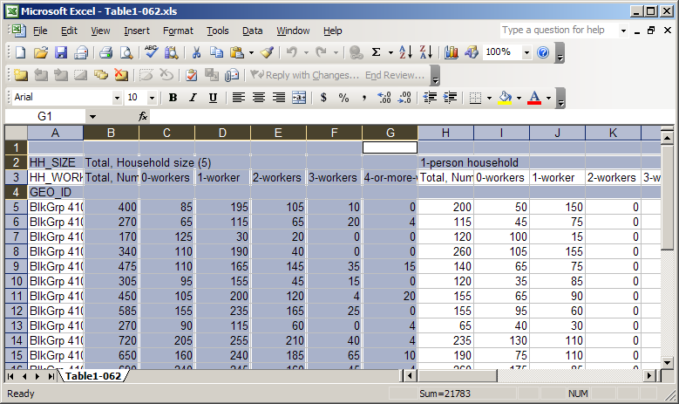

Once deleted (also empty cell A3) save the table as “workershh.csv” under the “data” folder (see example workershh.csv in the data folder). If OSUM sees that this optional file exists, it will read it in and use the census data for the worker distribution. If this file is named incorrectly, or not in the “data” folder, OSUM will use the developed relationships that exist in “hhsubmodel.R” to create a worker distribution.

Inputs Based on Household Behavior Survey Data

Table Name: directional.csv
Table Description: Directional factors for internal trips. These directional factors were estimated from the household survey. They were then adjusted to balance to 50% ap / 50% pa (p = production, a = attraction) in conjunction with the diurnal factors (described next). They were adjusted by distributing the difference within the peak hours and the offpeak hours. These factors are usually left unchanged.

Table Name: diurnal.csv
Table Description: Diurnal factors for internal trips. These diurnal factors were estimated from the household survey. They were then adjusted to balance to 50% ap / 50% pa in conjunction with the directional factors. They are adjusted by distributing the difference within the peak hours and the offpeak hours. These factors are usually left unchanged.

Table Name: hbw_rate.csv
Table Description: Home-based work daily person-vehicle trip rates. Developed from household travel survey data and trends, usually left unaltered.

Table Name: hbsch_rate.csv
Table Description: Home-based school daily person-vehicle trip rates. Developed from household travel survey data and trends, usually left unaltered.

Table Name: hbshp_rate.csv
Table Description: Home-based shop daily person-vehicle trip rates. Developed from household travel survey data and trends, usually left unaltered.

Table Name: hbro_rate.csv
Table Description: Home-based recreation/other daily person-vehicle trip rates. Developed from household travel survey data and trends, usually left unaltered.

Table Name: nhb_rate.csv
Table Description: Non-home-based daily person-vehicle trip rates. Developed from household travel survey data and trends, usually left unaltered.

Table Name: occ.csv
Table Description: Vehicle occupancy factors for internal trips by purpose. These factors are left unchanged and were calculated from the household survey.

Table Name: size_coeff.csv
Table Description: Size utility coefficients for internal trip distribution. These destination choice size coefficients were estimated from the household survey relationships and are usually left unchanged.

Table Name: time_coeff.csv
Table Description: Time utility coefficients for internal trip distribution. These may be adjusted by model area to match average trip length statistics. These time coefficients were initially calculated from the household survey.

External Travel Data
The basic external model in OSUM is fairly simplistic. Methods for allocating the external station ADT among E-I, I-E and E-E shares include the Modlin and Huff Probability methods, which rely on traffic counts, largely ignoring economic and geographic factors. With the Modlin approach [NCHRP 365], the number of trips between stations is estimated based on the percentage of through trips at the destination station, route continuity between the two stations, and the ADT at the destination station.

The Huff Probability Model, similar to a gravity model estimates trips between subregional zones based on the population in the destination zone, a dispersion factor, and the distance between zone pairs.

Both of these methods (or a third comparable method of developing the data) are used to create the following two input files for the external model. The third required input to the external model, “ext_diurnal.csv”, comes straight from each of the external station count profiles captured from representative count data or local knowledge.

Table Name: ext_traffic.csv
Table Description: External station volumes and splits. ext_traffic.csv and ext_seed.csv are generally estimated using Modlin method. External traffic represents the ADT at each external station and the percent of that ADT that is through trips. This input can be calculated using the Modlin (NCHRP 365) method or the Huff model. Both of these methods can be calculated using R scripts available on request. The volume for each external station in this input needs to be growth for the given future year that is being run. So if a different future year is being tested than the one that the given model application is built off of, the user needs to be aware that the volume will need to be grown or reduced depending on which new year is being tested / modeled.

Table Name: ext_seed.csv
Table Description: Seed matrix for distributing external-external trips. The ext_seed.csv matrix can be calculated using the scripts used to calculated ext_traffic.csv. Note that the numbers coded in ext_seed.csv are not the OD volumes for EE pairs, they simply provide the relative percentages. The volumes come from “ADT” in ext_traffic.csv and the input EE splits.

Table Name: ext_diurnal.csv
Table Description: Diurnal factors for external trips. From counts at external stations, or estimated based on similar external stations.

Optional SWIM External Model

OSUM has the option to use the SWIM external model in place of the default model (described above). If the model has been set up with “SWIMEXTERNALMODEL” equal TRUE, then the previously described external model inputs do not need exist, but the SWIM external model inputs will need to be in place. The external travel information that a user may need to adjust in the SWIM external model includes; the total number of vehicles entering and exiting at external stations for both autos and trucks, future annual growth rates, and hourly share of daily travel at each external locations.

The O-D trip patterns for these trips, including E-E trips draws from the Oregon Statewide Integrated Model (SWIM2), which has a larger understanding of long distance travel. Changes to this data would be required only in special circumstances. An example of this would be to test a large-scale land use proposal within a portion of the modeling area that may alter the number and/or composition of trips at an external station. Another example might be to address a large-scale rural development outside the model area that would alter the direction of external trips. In the latter case, an update could benefit from an alternate SWIM model run to identify new long distance travel patterns outside the local model area.

Information on future volumes at external stations on state highways can be obtained from ODOT’s Future Volumes Table at:
https://www.oregon.gov/ODOT/TD/TP/Pages/Data.aspx

Additional approaches exist for developing future volumes for external station locations not covered by the Future Value Tables (above). Volumes for these locations can be estimated from a base year traffic count using a linear traffic growth rate based on historical traffic volumes or a growth rate from a nearby state highway. Growth rates can also be obtained from SWIM2 runs for the area and can be compared to the future volume table growth rates and or historic growth rates obtained from counts.

A more complete description of the SWIM external model and all the inputs and output files that it generates can be found in Appendix E.

F. Trip Assignment

Overview

OSUM trip assignment is a key step in the model application process in which the zone-to-zone travel flows (trip tables by purpose) produced by the R-scripts are converted into network flows (link volumes), with the resulting travel times used as an input to the next iteration of model feedback process. Vehicle hourly assignments are run automatically by the OSUM runModel.R script as a part of the full model application process.

The assignment and skimming in Visum is all handled by the Visum “procedure” files stored in the “parameterFiles” folder. It is advised that a user load these several procedure files into Visum by hand to learn and understand what they contain. These are the files that OSUM calls to run assignment and collect travel time information from Visum, so it is important that every OSUM analyst knows about these files and how they operate.

Volume-Delay Functions

The link travel times produced within the auto assignment are calculated by one or more volume-delay functions (VDFs). The times are calculated as a function of link attributes, including volume, lanes, lane capacity, and link type, which are identified by keywords within the VDFs. In the network, a VDF index is specified for each link. When a traffic assignment is performed, this index is used to retrieve the corresponding VDF. The same function may thus be used for several links. An auto VDF must be a positive, non-decreasing function of auto volume (keyword = volau).

There are many types of VDFs that can be used within travel forecasting models. Usually, these functions are expressed as the product of the free flow time multiplied by a congestion function f(x):

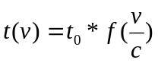
where:
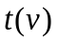 = total link travel time
= zero-volume travel time (free-flow time)
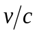 = volume/capacity ratio

As an example, the type of VDF referred to as the conical volume-delay function has the following general form:

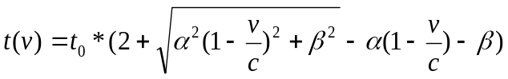
where:
= a positive number greater than 1 which controls how quickly the congestion effects change when capacity is reached
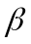 = 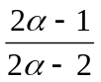

The effects of the congestion function within this equation are shown below:
Figure 17: Conical Congestion Function
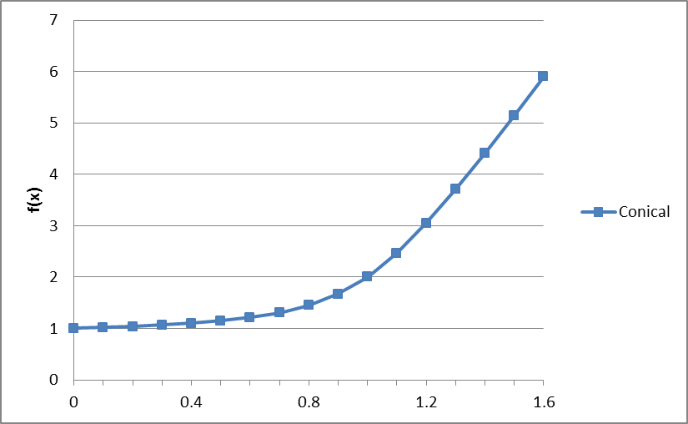

As can be seen, over the range of v/c ratios between 0 and 1 congestion builds gradually, with a degradation of travel speed of roughly twice the travel time once the maximum capacity is reached. Beyond capacity, congestion increases more rapidly so that at a v/c value of 1.5, travel time is roughly 5 times greater than the free flow conditions. This means that in relatively uncongested conditions (v/c < 0.85), traffic will tend to follow the more direct paths between origin and destination zones, with little diversion to alternate routes. As the v/c ratio increases, however, particularly for values over 1, there can be much more “spreading” of traffic if viable alternate routes exist.
This effect is accentuated with VDFs that become very steep beyond capacity which can cause a significant amount of path-switching between assignment iterations. The Bureau of Public Roads (BPR) function is currently assumed in all the OSUM models that TPAU currently operates. An example of this type of function:

Travel time =(60 * length / free flow speed) * (1 + 0.05 * (v/c) ^ 10)
where:
v/c = the modeled volume capacity ratio for a given link

The equation above is specified for link segments that approach signalized intersections. The following variant of that equation is used for all other links:

Travel time =(60 * length / free flow speed) * (1 + 0.2 * (v/c) ^ 10)

These BPR VDFs is shown in Figure 15 below. The BPR equations specifically used in OSUM and their history are described in greater detail in the “Instructions” folder (within the OSUM directory) “vdf_Equation_Background.pdf” document.

Figure 18: BPR Congestion Function
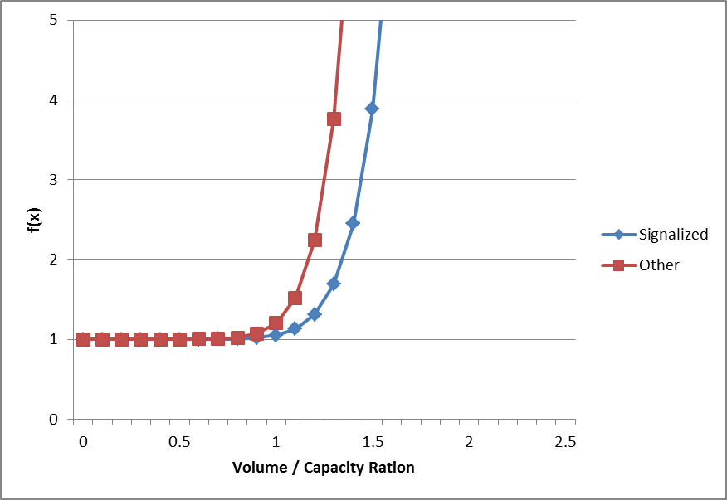

Multiclass Assignment

Another assignment technique that is an available option in the OSUM models is multiclass assignment. With this technique, several classes of users can be assigned to the network simultaneously. This allows a class of users to be assigned to a restricted network and/or face different network attributes (e.g., costs, speeds), or the user’s desire to keep track of the assignment of a specific demand class (e.g., by purpose, externals). In OSUM a user can toggle “MULTICLASSASSIGNMENT” to TRUE, and be left with a peak hour multiclass assignment by trip purpose at the completion of the OSUM run.

Auto Assignment in Travel Time Feedback

Within the overall OSUM application process, an iterative auto assignment is run in the last step of the run_model.R script for the purpose of generating an auto travel time matrix that is used in the next iteration of processing. Prior to the next iteration, the travel times from the previous iteration are compared to those from the current iteration. If the times differ by greater than a specified amount, the model is run for another iteration, up to a maximum number of iterations or as specified by the user. The default stopping criteria are summarized below:

- The percent root mean square error (% RMSE) for the sum of the travel times for each zone for the current iteration compared to the previous iteration is less than or equal to 1%; or
- The maximum relative difference in the sum of the travel times for each zone for the current iteration compared to the previous iteration is less than or equal to 1%; or
- The number of iterations that the model has run is less than 10.

Trip Assignment Validation

Once an assignment has been completed, checks must be performed to determine if the assignment results are consistent with the changes that have been made to the network and/or land use data. The general approach for the checks is to compare the current assignment results to those for similar scenarios that have been determined to be reasonable. Depending on the scale of the change, different checks can be performed at the regional, subregional, or corridor/subarea level.

Assignment Checks
For assignments, checks that can be performed at the regional and subregional level include:

- VMT per capita
- Total VMT by functional classification
- Average congested speeds by functional classification
- Changes in volumes across screenlines, cutlines, and cordon lines
- Ensuring that links that connect to external stations have volume that match the external station input, or the external volume expected.
- Reviewing connector volume changes. No large changes should be seen, accept for zones that had a significant land use input change.

As an example, the comparison of an assignment for a “No-Build” or financially constrained scenario having limited capacity improvements to the assignment for a “Build” scenario with significantly increased network capacity might be expected to show:

- Higher VMT per capita due to the diversion of traffic to more circuitous routes as drivers try to avoid congestion.
- Higher VMT and higher average congested speeds on lower-classified roads due to traffic diversion.

These effects would be stronger in the more congested areas.

Examples of corridor/subarea-level checks for assignments reflecting network changes are:

- Volume comparison maps showing actual volumes, volume differences, and the percentage change in volumes.
- Comparison of facility travel times.

An assignment check that should be performed for land use changes is a flow bundle analysis and volume maps for the TAZs containing the land use changes. This check is done to verify both the volume and orientation of traffic associated with the changes. The same type of volume difference maps used for network changes can also be used for land use changes to determine if the volumes for the “with land use change” scenario are reasonable compared to those for the “without land use change” scenario.

G. Typical Applications
The most common model applications are for the development of travel forecasts for proposed changes to the network and land use. This section provides guidelines for these types of applications, together with several specific example applications.

Prior to starting the application process, it must be decided if the proposed change is “modelable”, i.e., can the change be reflected by the transportation supply and land use characteristics included in the model. An example of a roadway network change that cannot be represented in the model is the addition of intersection turning lanes. This is because a turn lane is below the level of detail of the network coding. The user must also avoid using a coded network attribute as a surrogate for the actual change. For example, increasing the directional capacity of a link to account for the presence of intersection turn lanes would not be appropriate, because the model has not been developed or validated in this way. TPAU project managers in charge of the respective OSUM model should be contacted if there is a question about whether or how a change can be represented in the model. Other cautions are noted in Section B under ‘OSUM Capabilities and Limitations.’

If it is decided that the proposed change can be represented in the model, the next step is to review the applicable model development report to determine if there are any special application procedures that should be followed, beyond the standard practices described in this document. This is necessary to ensure consistency between the model application results for the proposed change and those for the reference scenario.

Proposed Network Changes
The basic procedures for applying the model for the addition of a new roadway and a change in an existing roadway characteristic are described below. The addition of a new roadway may include an entirely new facility or the extension of an existing facility. A change in an existing characteristic refers to a coded node or link attribute, such as speed or capacity. All of the coding operations included in the steps below are performed in Visum. Previously Section D provided further guidance for roadway network changes in the section “Network coding standards for OSUM models.”

Addition of New Roadway
- Review the existing network coding in the vicinity of the change.
The review of attributes such as link speed, capacity, VDF, number of lanes, functional class, roadway geometry, and centroid connectors in the vicinity of the change will provide an understanding of how the new roadway should be coded to maintain consistency with the reference scenario.
- Turn on a base map.
When adding or modifying links, the link geometry should be traced over a background GIS map of the proposed roadway network.
- Code any additional nodes needed to represent the new roadway.
In some cases, such as the extension of an existing road between two other roads, there may be existing nodes that can be used. If new nodes are needed, however, the node attributes must be coded as described in the applicable model development report.
- Code the links for the new roadway.
Links are added between nodes to define the new roadway. If the change is a roadway extension, then the Copy Attributes and Paste Attributes feature can be selected from the Quick view window to copy the attributes from an existing link along the roadway to the new link. If an entirely new roadway is being added, this feature can also be used to copy the attributes of a similar, nearby link as a starting point, with modifications made to the copied attributes to reflect the specific characteristics of the new roadway, if necessary.
- Review nearby centroid connectors.
Centroid connectors may need to be added that link the new roadway to the adjacent TAZs. If so the guidelines presented in Section D should be followed, as well as any other conventions described in the applicable model development report. The attributes values of an existing connector can be copied and pasted directly for new connectors.
As a part of this step, the existing centroid connectors for the zones adjacent to the roadway should be examined to determine if adjustments are necessary. An adjustment would be needed, for example, if a new connector changed the traffic loading pattern of a TAZ such that an existing connector is no longer needed.
- Perform coding checks.
Depending on the extent of the change, network validation checks should be performed as discussed in Section D. For minor changes, such as adding a single link for a roadway extension, these checks are probably not necessary. For larger-scale changes, such as adding a subarea network in an undeveloped portion of the modeling area, these checks must be performed.
- Run the model; perform reasonableness checks.
The extent of the network change will also determine whether a full model run or only the traffic assignment step should be performed. The key factor in this decision is whether the change is large enough to affect the trip distribution pattern. An example of such a change would be the addition of a major new highway corridor or significant improvement of an interchange that might affect level of service across the region. This type of change could significantly reduce travel times between large portions of the modeling area, thus increasing the likelihood of trips between these areas. For small-scale changes, such as the example above of adding a short roadway extension, the travel time changes would be too small to affect trip distribution. In this case, only a new traffic assignment step would be needed using the same vehicle trip matrix as for the reference scenario, along with the revised network. TPAU project manager responsible for the given OSUM model should be contacted if there is a question about the need for a full model run or just a new traffic assignment. When in doubt, just re-run, since OSUM only takes a matter of minutes to complete a full run and converge.

Change in Existing Roadway Attributes
- Review the current coding of the attribute to be changed.
As with the new roadway scenario, the review of the link and node attributes and geometry of the coded network in the focus area will provide an understanding of how the change should be coded to maintain consistency with the existing network.
- Identify the link and/or node revised attribute value to reflect the change.
- Code the revised value for the identified links and/or node attributes.
- Perform coding checks.
These may or may not be necessary depending on the extent of the change.
- Run the model; perform reasonableness checks.
The need for a complete model run or only a new traffic assignment will also be determined by the extent of the change. A large capacity increase along a major corridor would likely necessitate a complete model run. A minor change to a lower-level facility would require only a new traffic assignment.

Proposed Land Use Changes
Unlike network changes, for which the model application process is fairly clear-cut, the approach taken for land use changes can vary depending on the details of the proposed change. Therefore, a fair amount of judgment is usually required in identifying the appropriate application method.

To assist in the decision about how to apply the model for a proposed land use change, information is provided below for four common categories of proposed land use changes:

- Site development proposals
- Proposed zoning changes
- Comprehensive plan updates
- Proposed land use changes within Interchange Management Areas

The discussion covers the areas of:

- Preparation of land use-related data
- Associated network changes
- Partial vs. full model run
- Model focusing

There are a number of other model application issues that may also need to be considered. Information on these topics can be found in the Modeling Procedures Manual for Land Use Changes.

Site development refers to the development of individual sites or parcels of land. Generally, more detailed information is known about the characteristics of proposed site developments than other types of land use changes, such as the particular type of retail or industrial use or even the future occupant of the site. The time frame for development is also usually shorter. Depending on the size of the development, this may be only 1 – 2 years. The keys for effectively applying models for site developments are:

- Having an adequate understanding of the trip characteristics of the proposed development.
- Providing input data to the model that accurately describes the development within the parameters of the model.
- Applying the model in a manner that is consistent with the character of the development and at the proper level of resolution.
- Producing the type of output needed for the analysis and in the required format.

Zoning changes, for purposes of this discussion, do not include changes with site development proposals attached to them. The area of a proposed zoning change may be quite small, but is usually larger than that of a site development proposal, and may be substantial. Fewer details may be known about the ultimate uses of the rezone area, and the proposal may result in a greater mix of future uses. The time frame for development with a zoning change can range from short-term to long-term.

Comprehensive plan updates are generally the largest type of land use change considered by local jurisdictions, with potentially the largest impacts to the transportation system. The time frame for development is usually mid- to long-term. Information about the development that will occur with a comprehensive plan change is usually very general, corresponding to the broad land use categories contained in the comprehensive plan. For model application, more and broader assumptions about the proposed change may need to be made, such as:

- Supporting transportation network
- Need for modification of the TAZ system (and/or centroid connectors)
- Regional jobs-housing balance impact to trip distribution (and trip lengths)
- Need for adjustments to the regional population and employment totals and household size
- External trip making and impacts in the allocation of internal trip ends
- Need for special generators

The development of these assumptions may require significant coordination with multiple local agencies, as well as consultation with the ODOT project manager or model application requestor about model changes and assumptions.

Land use changes within Interchange Management Areas are different from the other types of changes not because of their character or size, but due to their location. Because traffic operations within interchange areas tend to be more complex, different analysis methods may need to be used. This, in turn, may require different model outputs. Such studies may want to consider adding greater TAZ system detail within the interchange area to allow the identification and tracking of trips to/from specific areas of development and more refinement to the roadway network to support the more detailed traffic analysis that is typically performed for interchange areas.

Preparation of Land Use-Related Data
For general planning purposes, land use quantities for proposed land use changes are specified in different units than what is needed for the model. For site developments, land uses are usually defined in terms of the number of dwelling units for residential uses and building square footage for non-residential uses. For zoning changes and comprehensive plan amendments, fewer details may be known about the ultimate uses of the development area. The land uses may be identified in more general terms, such as gross acres of land by zoning or comprehensive plan category.

In either case, the land use quantities need to be converted for model use into the number of households by socioeconomic category for residential uses and employment by type for non-residential uses. Similar conversion processes are used for both types of changes, but are slightly different due to the different level of detail of the base data.

For site developments, the future forecast of land use translates into demand for travel. The general process for residential uses is to apply a vacancy rate to the dwelling units to obtain an estimate of the number of occupied units, which is assumed to be roughly equal to the number of households. Non-residential land uses are converted to employment by type by applying employee densities to the square footages and then allocating the employment to the appropriate category.

The conversion process for zoning changes and comprehensive plan amendments involves additional front-end steps to estimate the number of future dwelling units and building square footages from general land use quantities, such as gross acres of land by zoning category or comprehensive plan category. Assumptions about the percentage of land to be set aside for public uses, such as streets, must be applied first to obtain estimates of net developable acres. Following this, density assumptions can be applied to the estimates of net developable acres (i.e., dwelling units per acre for residential uses and floor-area ratios for non-residential uses) to derive estimates of the number of dwelling units and building square footages. In some cases where development takes place in isolated parts of an existing zone with significantly different roadway access points, there may be a need to split the zone and update centroid connections appropriately, or provide multiple centroid connectors. The remaining steps of the process are identical to those for proposed site developments.

Following the conversion of land use data into households and employment by type, the corresponding fields in the TAZ.csv file for the “changed” TAZ(s) need to be modified:

- Total households – “HH”
- Employment by type – “EMP”, “RETL”, “SERV”

Other data in the TAZ.csv file that may need to be changed are the household distribution fields (“HHS1 – HHS4” and “HHI1 – HHI4”). If the values for these are blank or they do not represent the expected household distribution for the “changed” TAZ(s), then the values for a similar TAZ needs to be copied.

Other land-use related data that may need to be modified are:

- Special generator file – spec_gen.csv file
- The district bias settings – district_bias.csv file

Either of these files could be altered if a given land use had conditions that warranted special treatment of the given zones. As with most of this work, it is advised to work with the project manager on the correct mix of use of these files.

Associated Network Changes
In addition to the land use quantities that will determine the future travel demand generated by the proposed change, the network that will support the proposed land uses must also be represented in the model. For smaller land use changes, the network reflected in the reference scenario may be adequate. For larger land use changes, however, particularly those located near the periphery of an urban area where the existing network may be sparse, there may be a need to define additional transportation facilities.

If the proposed change is for a site development, the project proponent will sometimes provide information on the planned facilities. In many cases, however, there will be no information about the network changes that need to be coded in the model. Therefore, an important issue is how to identify these changes.

It is not possible to define a step-by-step process for the identification of network changes because many of the decisions will depend on location-specific conditions. However, there are several general factors that should be considered. These are:

- Structure of the existing network near the area of the proposed change.
- Planned improvements included in the local transportation system plan.
- Level of refinement of the surrounding TAZs.
- Level of detail required for the model outputs.
- Network coding conventions for the model.

For defining the future reference network that will be used as the starting point for identifying the network changes, it is important to check with ODOT and local transportation system providers about the improvements that will likely be implemented by the end of the planning period. In addition, ODOT, the local jurisdiction, and the project proponent (if applicable) should all participate in the identification of the network changes.

Another network element that should be considered in connection with proposed land use changes are centroid connectors. If the proposed change would result in a shift in the distribution of development within a TAZ, then the loading points for traffic from the TAZ onto the network may change. If the current coding does not accurately reflect this loading, then the existing connectors may need to be modified or new connectors may need to be added.

H. Viewing Model Output
Once a model run has been completed, there is a variety of ways to view the model output. Traffic assignment results can be viewed within Visum. Output from the OSUM modules can be viewed using R commands and in the “runReport.html”. In the sections below, examples of how to display commonly-viewed outputs in Visum and R are presented.

Viewing Model Output in Visum
- Tabular Link Data
Link data can be viewed in a table format using lists-> network-> links

Figure 19: Tabular Link Data Example
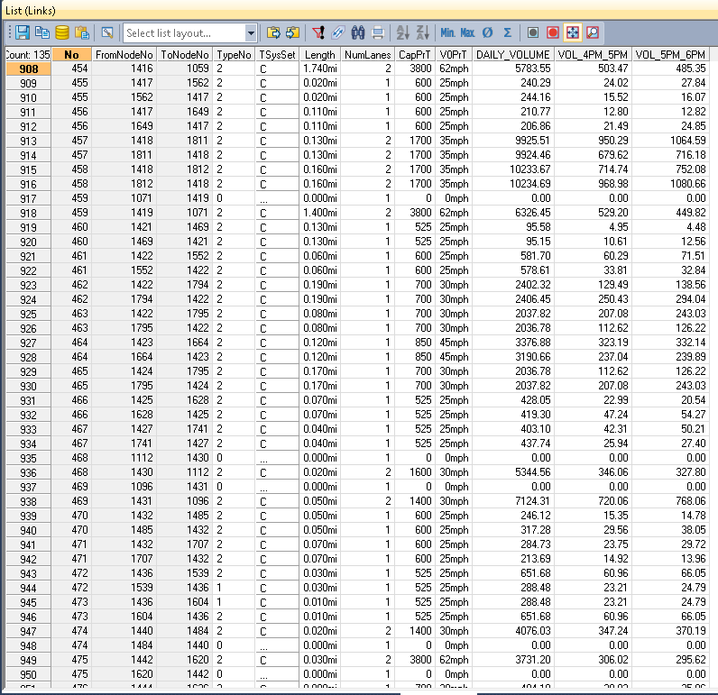

- Volumes and link attributes on the network
Model run results are typically reviewed by comparing a current runs volumes versus that of a reference. Additionally, the current runs volumes and attributes can be viewed individually as well.

Figure 20: Reviewing Link Volumes Versus a Reference
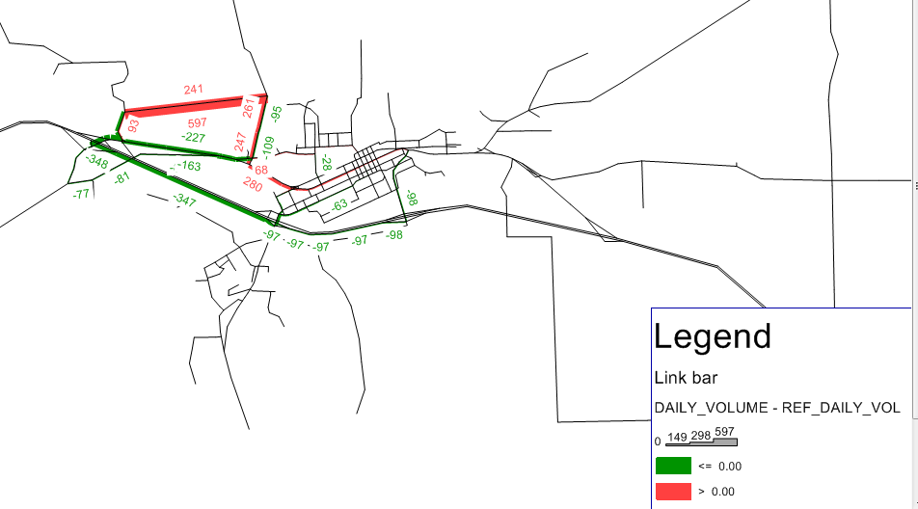

- v/c on the network
Volume to capacity (v/c) plots are commonly used to understand where “choke points” or bottlenecks are on the network. This can be espeically helpful in project or alternative type screening.
Figure 21: V/C Mapper Example
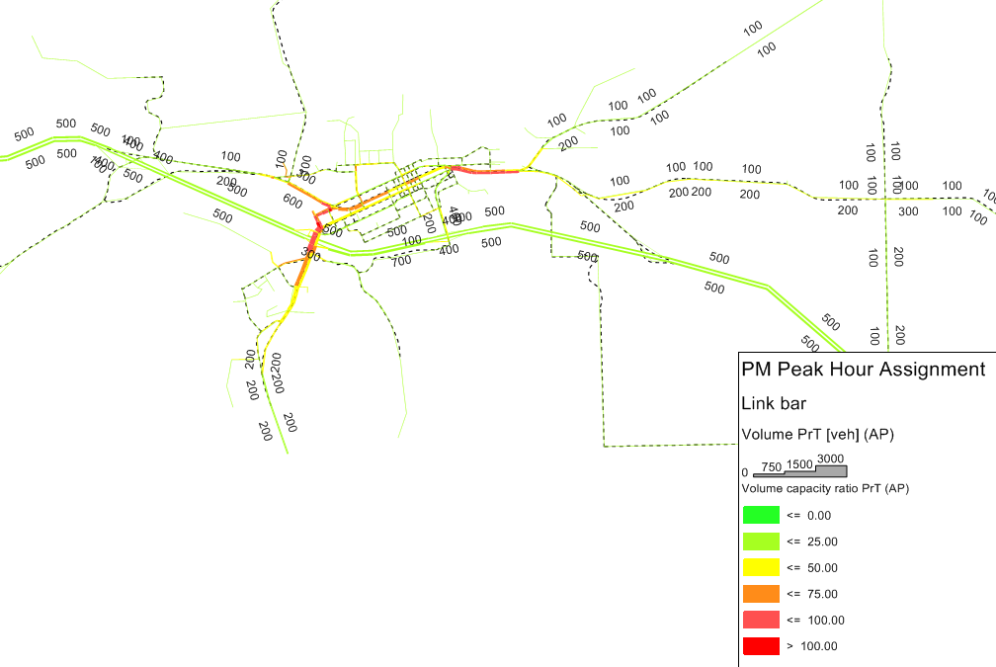
- Flow Bundle (or select link) Results
One of the best ways to understand a new roadway (link) or land use (zone) project is to run a flow bundle analysis on the area in question. This can be easily done by using Graphics -> Flow bundle and using the GUI to select areas on the network and running the flow bundle analysis.

Figure 22: Flow Bundle Mapper Example
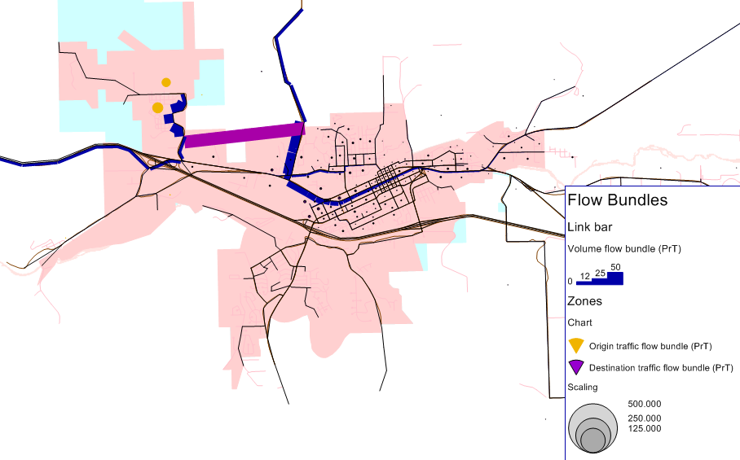

Viewing Model Output in R
R has many functions, libraries, and tools for reviewing and analyzing data. Likewise, there are approximately 50 R objects created and saved by OSUM in the R workspace that can be reviewed. There are endless ways to review and assess the quality of an OSUM run in R, the following just represents a couple of commonly used highlights:

- The OSUM object ‘trip.prod’ represents all of the information that comes out of the trip generation step in OSUM. A simple ‘str(trip.prod)’ code can allow a user to quickly assess the health of an OSUM’s trip generation step. Likewise, using ‘trip.prod$trip.data’ provides a high-level summary of what is occurring in trip generation at a model-wide level. It should be noted that this information is also plotted and reported in the “runReport.html”.
- Similar to ‘trip.prod’, ‘trip.dist’ provides all the data that is produced in the trip distribution step of OSUM. The call ‘trip.dist$summary.int.stats’ can be used to get a high level understanding of what is occurring in trip distribution (number of trips and trip travel time lengths by purpose).

These two OSUM R objects represent the most common OSUM data to review in R.

Appendix A OSUM SubModules

OSUM Flowchart
As described in Section B, the general structure of the MPO models follows the basic three-step process consisting of trip generation, trip distribution, and trip assignment. The three steps are carried out within the following five main OSUM modules:

- Household Sub-Model
- Trip Generation
- Trip Distribution
- External Model
- Traffic Assignment

The traffic assignment step is performed separately within Visum. The overall processing flow within OSUM is illustrated in Figure A-1. Each module is illustrated on the following pages with a flow chart describing processing steps and inputs and outputs.

Legend
Figure A 1: Oregon Small Urban Model Structure
Model Step
Output
Input
Input from Survey not to be Changed

Household
Sub-Model
Model Inputs
Trip Generation
Trip Distribution
Traffic Assignment
Survey Data
External Model
Standard Reporting and Comparing Results to Reference Case
Input Checks
Traffic Patterns / Trends for
Model Area

Figure A 2: Household Sub-Model - Worker Distributions

Census Block HH Size - Distributions

Joint Distribution of Workers Distribution by Household size for Each TAZ
Optional Future Logic
Future HH Size at TAZ Level

Census Block Distribution creates HH-Size trend lines for the model area
Future Avg. HH-Size creates model wide HH-Size Distribution from Trends
Trends used to find “average” HH-Size Distributions for each zone
HH-Size-Dist by TAZ is iteratively altered to reach Model wide HH-Size-Dist, while holding number of HH per zone true.
Two options – Either Average household size is totally recalculated, or only new households have a new size distribution added to the old.
Future Model Area
Avg. HH Size

Standard Logic
HH-Size – Distributions
at TAZ Level

[Optional] Reference (Base) HH by TAZ

Number of HH by TAZ

Calculate Number of Worker by TAZ

Hard coded worker per income group joint distribution is applied to the number of HH by income to create a Worker Distribution for all TAZ.
HH-Income Distributions By TAZ

or
Optionally
(Future or Base)
Number of Workers by Household size from BlkGrp CTPP
The Block Group Distribution is applied to all zones within that Block Group creating a distribution by TAZ
Workers Distribution for Each TAZ
HH-Income/Size – Distributions
at TAZ Level

Total Households
by TAZ

or
Figure A 3: Trip Generation

Home based work
Trip Rate

Regular and Special Generator Trips by TAZ by Type by Hour (+ summary data)

Calculate Internal Trips with Survey Data
Each Types Trip rate is multiplied by the appropriate distribution as dictated above to get total trips by type for each zone
The Retention factor is then multiplied to the trips by type to reduce trip rates for types that are leaving the model area more than average.
Calculates a total internal trip sum for the model area
Adjust Internal Trips to Account for Underreporting
Sums the total internal trips, special generator internal trips and internal trips destine to external stations to determine if avg trips per HH has been reached
If there are not enough internal trips to reach the avg internal trip rate hbshp, hbro, and nhb are proportionally adjusted so that the avg trip rate is reached
No adjustment is made if more than the average is generated.
Optionally
Special Generators

External Station Traffic Volumes and Characteristics
Workers Dist by TAZ

HH by Size by TAZ

Joint Distribution of Workers Distribution by Household size for Each TAZ
Home based School
Trip Rate

Home based Shopping
Trip Rate

Home based Rec/Other
Trip Rate

Non-Home based
Trip Rate

Internal Retention Percentage by Trip Type (Normally 100%)
Avg. Trips / HH for all types (9.2)

Optionally
Special Generators

Diurnal Factors by Trip Type

Service Emp
By TAZ

Retail Emp
By TAZ

HH By TAZ

Allocate Non-Home Base and Convert Trips to Trips by TAZ by Type by Hour
Use Employment (minus special generator employment) and HH data to assign nhb production zones (Utilities for nhb trip allocation are hard coded)
Diurnal factors are used to convert daily person trips by type to hourly trips by type by TAZ
Trip Distribution
Figure A 4: Trip Distribution

List by type for the combinations of PA vs OD, Person vs Vehicle, Hourly and Daily

Optionally
Special Generators

Peak Travel Time (Traffic Assignment)

Service Emp
By TAZ

Retail Emp
By TAZ

HH By TAZ

Calculate II Person and Vehicle Trip Distributions By Purpose and Hour
For loop works through all 24 hours and trip types to apply Trips to the Trip Probabilities, to form hourly PA matrices (At this step Special Generator Trips are applied to the attraction end of their respective zones)
The Directional Factor is then applied to form hourly OD matrices by Type
Then Occupancy rates are applied to turn person ODs to vehicle ODs
Lastly hourly data is summed to daily data
Total Emp
By TAZ

School Enrollment by TAZ

Occupancy Rate by Type

Off-Peak Travel Time (Traffic Assignment)
Size Utility
Coefficients
Time Utility
Coefficients
Optionally
Global Time Adj.

Optionally
Dist. Time Adj.

Optionally
District Bias

Calculate Peak and Off-Peak Distribution Probabilities by Trip Purpose
The function takes the size (employment, HHs, and school Enrollment) of each zone, and the travel time zone-to-zone matrix (respectively) and uses the Size and Time Coefficients to Generate the Distribution that sets the Proportion of the number of trips for each zone to all other zones.
If Special Generators are used, the employment from those generators are removed from the total, as Special Generators follow a different distribution and are accounted for in the next step.
The three remaining Inputs will influence the Distribution if used:
- Global Time Adj., will change the effect of time on Trip Type(s)
- Dist. Time Adj., can adjust the Distribution for set OD pairs
- District Bias can be used to increase the attractiveness of a zone or set of zones, and can be used in place of Special Generators.
Directional (%) by Type

Trips by TAZ by Type by Hour

Optionally
Special Generators

Original External Model
Figure A 5: Original External Model

24 vehicle ODs by Hour, Daily OD, and Peak ODs by Trip Type for Traffic Assign.

Daily Person PA (Trip Distribution)

Give External Trips Directionality (optionally) and Complete vehicle OD Matrices
EE, EI, and IE hourly vehicle matrices added to II to get complete OD
“Post Processing” Script option, adjusts External distribution to match the directionality of count data. This contains “switches” for whether given external stations should have the EE volumes adjusted or not.
External Diurnal

Calculate External-External Vehicle Trip Distribution by Hour
Using the EE Seed as a starting point the function iterates on the matrix using the EE AADT as the controls for the rows and columns. This establishes the daily EE.
The Diurnal is then applied to the daily EE to get hourly EEs
Optionally
Special Generators

External (EE) Seed

External Station AADT

External Station EE % of AADT

External Station EI & IE % of AADT

Calculate EI and IE Vehicle Trip Distribution by Hour
If Special Generators exist, the percentage of trips attracted from external locations is assigned to the EI first, based on the EI ADT at the stations
All remaining EI trips are assigned based on the employment of a zone and any district bias that has been applied.
IE trips are distributed based on Total HHs. (NOTE: Astoria treats EI and IE differently, using travel time to influence distribution, where the previous logic assumes that travel time to external trips is negligible)
The EI and IE daily Matrices are halved and added together to get an OD
The Diurnal is then applied to the daily EI and IE ODs to get hourly ODs
Service Emp
By TAZ

Retail Emp
By TAZ

HH By TAZ

Total Emp
By TAZ

Optionally
District Bias

Hourly Vehicle II (Trip Distribution)

Optionally
Directional (%) by Ext Sta.

SWIM External Model [optional]
Figure A 6: SWIM External Model [optional]

24 vehicle ODs by Hour, Daily OD, and Peak ODs by Trip Type for Traffic Assign.

Vehicle PA matrices by purpose & TOD

SWIM Zone to TAZ Crosswalk

Create a Weighted SWIM Trip Table – Adjusted to Local Land Use Assumptions
First TAZ Pop and Emp totals are calculated to match JEMnR implementation of this external process. Employment is internally adjusted for set zones, if district bias or special generators or used.
An adjusted SWIM trip table by time of day and purpose is produced that captures local land use. Both local production (households) and attraction (employment and population) weights are used to adjust the trip table.
This step also produces the EE, EI, and IE percentages and outputs to be used in trip generation, comparison to other model runs, and general info.
Optionally
Special Generators

Time of Day Periods (24hrs)

IPF Weighted SWIM Trips (PAs) to Volume Controls (ODs)
External station auto and truck volumes by direction are grown analysis year and are multiplied by hourly factors to get controls by station, by direction, by mode (auto/truck), by hour.
The PA matrices provided from the step above are then ipf’d to the controls
If special generators were “removed” from local employment totals, those “known” external trips are added back in – propionate to the total volume at each external station.
Household size distribution

HH By TAZ

Total Emp
By TAZ

Optionally
District Bias

Area (OSUM) Trip Table Subset(s) from SWIM run

Auto and Truck Volumes, EE%, EI%, and IE%

External Station auto and truck AADTs, year, growth rate, and hourly factors

Vehicle PA matrices by purpose and TOD

Add SWIM External Output Back into OSUM Model Flow
The detailed information from SWIM is collapsed into vehicle matrices and combined with the internal information within the “trip distribution” module
Land Use Weighting Factor and External Station Volume Control Reporting Files

Traffic Assignment
Figure A 7: Traffic Assignment

Travel Determination Hour OD (usually AM or PM peak)

Running Traffic Assignment on All OD Matrices

Once Trip Distribution has Converged and the final set of Matrices have been calculated, all of the 24 hour OD Matrices, the Daily Matrix, and OD Matrices by Trip Type for the Peak Analysis Hour are set to the traffic assignment software to develop traffic patterns and trends for the model area.
Run Traffic Assignment for Travel Determination Hour

It is assumed that Peak Hour Traffic will pick where they work and shop based on one of the congestions levels that they will drive through. This is typically the AM peak, the assumption that people will pick their destinations based on the travel time to get to a location as opposed to the return travel time. This hour is set by the user (AM_PEAKHOUR) and is used in the traffic assignment software (VISUM) to get a peak travel time matrix. The terminal time is set during model development and represents the time to travel to and from one’s vehicle (unlocking, starting the car…)
Trip Distribution Convergence Process

The peak travel time matrix is sent back through Trip Distribution and the External Model until and acceptable Root Mean Squared Error from the previous run is reached (travel times are forced to convergence using a averaging method).
Traffic Patterns and Trends for Model Area
24 vehicle ODs by Hour, Daily OD, and Peak ODs by Trip Type

AM_PEAKHOUR

PEAKHOUR

Terminal Time

Appendix B Frequently encountered erroRs
Error: “Cannot access software protection device”
Resolution: Indicates a problem with Emme license. Establish license and re-run. May also indicate that emme bank file is write protected.

Error: “”
Resolution: Emme bank file (/emm4/databank/Emme bank) is write protected. Right click file to remove the read-only protection, given you have sufficient access rights to this file. Re-run.

Error: “Databank already in use”
Resolution: Emme bank is being used by another process. Close the other process and re-run.

Warning: “IPF did not converge”
Resolution: IPF processes in the trip generation and externalModel_SWIM modules did not converge correctly, most likely due to incorrect user inputs (e.g., external model selectlinks.csv). This does not stop the model run, but may compromise the integrity of the model results and should be investigated.

(To be populated based on future model user experiences)

Appendix C OSUM Model CONVENTIONS
The following tables summarize the categories used in the OSUM Model.

Table C- : Household Categories
Household Category | Values
Income (1995$) | < $15K, $15-30K, $30-60K,$60K+
Household Size | 1,2,3,4+
Workers Per Household | 0,1,2,3+

Table C- : Employment Categories
Code | Emp Description | SIC codes (2000 census) | NAICS codes (2010 census)
RETL | Retail | 52-59 | 44-45
SERV | Service | 70-89 | 515-56, 62-81

Table C- : Trip Purposes
Trip Purposes | Description
HBW | Home Based Work
HBSHP | Home Based Shop
HBRO | Home Based Recreation and Other
HBSCH | Home Base K12 School
NHB | Non-Home Based

Appendix D Future Household Sub-model
On December 20th, 2012 it was determined that the future household (“future_hhs.R”) module was too problematic to keep and that this process was better handled during input generation as opposed to in the model. Because of this the “scenario” input and R object that defined whether or not this module should be run was removed from OSUM. Additionally, since all runs would be “base” in this use, “base” and “futr” naming was removed from the TAZ input. As of this point OSUM only has one set of household and employment information; it no longer has a base and future set. Removing the “scenario” input/object required small updates to every script in OSUM; “run_model.R”, “hhsubmodel.R”, “inputCheck.R”, “Model_Inputs.R”, “trip_distribution.R”, and “trip_generation.R”.

On February 20, 2013 it was determined that there may be a need for some model areas to continue using the future household module, even if most applications didn’t. So for this reason, the “future_hhs.R” was built in as an optional preprocessor to the household size data / distributions. The code was not revisited or cleaned as it is only to be used in cases where the issue of fewer households in the future than in the base for a given zone is not present (the current logic can create negative households in the future if a zone has less households in the future than in the base).

The code now uses a flag kept in the VISUM version file under Network -> Network Parameters -> User defined attributes and is called - FUTURE_HH_PREPROCESSOR. The code used to call the “future_hhs.R” script when scenario was set to “future”. Now the “future_hh.R” script is called when the new preprocessor flag is set to either “ORIG” or “NEW”, any other value will not cause the script not to be run. If the script is run, then the “census_block.csv” needs to exist in the data folder – as this is a requirement for the future household logic. Additionally, the user needs to specify the Network parameter – “FUTRAVGHHSIZE”. This is a single value that is calculated by taking the total future population for the given area minus the group quarters population and then divided by the total households for the given area. The user has the ability to turn on two different sets of future household preprocessor logic. They can either use the original (“orig”) logic or the “new” logic, each is described in the following text.

The “orig” logic is the original future household logic constructed in 2002 and last updated in 2004. It uses the base household distributions and then creates a shifted demographic for the additional households to be added to any given zone. It shifts the demographic based on an area wide average future household size that is an input to the model – “FUTRAVEHHSIZE” (see above). There is an issue with this approach, where any zone that loses households between the base and the future has the chance to go to negative households when the new “future” distributions are applied. Therefore a new logic was written in 2007 that addressed this (see below). In order for the “ORIG” logic to run the base year households need to be provided. OSUM no longer requires this as an input, but this optional pre-processor step does. To simplify the code updates in V2, the code refers to the “HH” field found in VISUM, as “hhbase”. Because of this the optional base household field required for this pre-processor could not be called “hhbase”. Instead, if the user wants to turn on the “ORIG” flag, they need to create the field “HHREF” in VISUM and populate it with the base year HH for each zone. With this and the inputs identified above the preprocessor will run the original logic.

The “NEW” logic was written in 2007, it was meant to remove the issue of potentially negative households and therefore removes the reference to base year or reference households. It no longer adds new distribution to the old distribution it simply shifts the whole household distribution still based on the total areas average household size, which an input is specified above. Because of this the “HHREF” field is not required for this logic, but the other inputs (network parameter - FUTRAVTHHSIZE and the census block data set) are still required. Again, this logic can be activated by changing the FUTURE_HH_PREPROCESSOR flag to “NEW”.

Note that the choice of whether a model uses the “ORIG”, “NEW”, or neither of the future household sub-model code is a choice made during model development. When the original model development process needs to make a determination on what the appropriate logic is to apply for the given OSUM area. This is not a change that should be made for a given model application. So this section is more for informational purposes than to provide guidance on how to pick the appropriate logic. Choosing the appropriate logic should have occurred before the model was released for applications/use.

Appendix E swim external model
The SWIM External Model was originally developed for JEMnR (Joint Estimated Model in R, used for the MPO areas, which ODOT operates). The concept is that a given urban model area is “cut” out of the larger StateWide Integrated Model (SWIM) area. The trends from SWIM provide the best source of information for how passenger cars and long-distance freight travel to, from, and through the “cut” area. When a “cut” boundary is created, a process is run in SWIM to create a subset of the full SWIM car and truck tables. The subset includes all the trip ends that travel in, to, from, or through the cut area. This provides the basis for the trends for the external model for the given local urban model, the “cut” area.

It is very important to understand that SWIM is only providing trends, or travel distributions. It is not providing raw results or volumes that would be fed directly into the local model. There are several reasons why raw SWIM output is not used:
- SWIM is a model for statewide policy. The small and medium sized external stations to an urban area are not calibrated to high precision in SWIM. These external points may have smaller volumes, but the small external volume, might be very influential to the network and zones that are in close proximity to the given external station. For this reason and others, external volume control totals are still provided. The control totals dictate the total volume at an external station by time of day, while the SWIM results provide the zone to zone trip patterns and distribution (what % of the trips go to zone A vs B).
- SWIM is a policy tool that requires that land use be modeled and integrated with transportation and the economy. This means that SWIM is modeling more than just the transportation element that our urban trip based models capture. SWIM is also modeling the land use that would accompany the given transportation and economic scenarios. Because of this SWIM’s land use is not “set” or dictated like in OSUM and JEMnR. OSUM and JEMnR require that the dictated land use for a given scenario be adhered to. This inconsistency explains the second reason why SWIM’s raw volumes / results cannot be fed directly into the urban models – because the land use doesn’t match. Before SWIM’s trends can be used, the trip tables are first re-weighted by SWIM-to-local land use factors, so that the number of trips to a given zone represents the local measured or asserted land use, as opposed to the modeled land use in SWIM.
- SWIM is a stochastic model, meaning that each run of SWIM will provide slightly different results. To get a good “average” set of external trends, multiple sets of SWIM output need to be averaged together.

All of these reasons explain why SWIM is used for trend information (that cannot be obtained from other sources), and while control totals are still needed in the SWIM external model process. The following explains the volume control file and the other SWIM external model input files that are needed to use and operate the SWIM external model.

Inputs in the “data” folder –

…_year_outputs.zip – This zip file is the resulting set of subarea trip tables obtained from the “cut” area in SWIM. There could and should be multiple SWIM subsets, so that a good average can be obtained. The person doing the SWIM cut will name this zip file. The format of the name goes; “select_link” _ SWIM scenario name _ SWIM year pulled _ “outputs.zip”. This is an example of a full file name – “select_link_ExternalModel_Reference_2009_outputs.zip”, where “ExternalModel_Reference” is the name of the SWIM scenario where the subset trip table was pulled and 2009 is scenario year (SWIM produces trip table data every 3 years, so a 2010 run might pull a 2009 SWIM trip table and a 2012 from the same scenario).

When the code is run three files which are variations of “_outputs” file are created:

…_year_outputs.RData – This R dataset is an exact duplication of the csv tables kept in the zip file (described above), except in R format. It can take a measurable amount of time to unzip the csv tables, so the first time the zip file is referenced the contained csv files are unzipped and stored in an R dataset, then each future run the code recognizes that the R dataset exists and skips the unzipping and reading process and just loads the R dataset. The code looks for new zipped datasets with the “_outputs.zip” naming convention. So if a new zipped data set is added to the “data” folder, the code will automatically create an R dataset copy and use the newly added datasets, along with any existing dataset to create the average trends.

externalPA_ZnZnTdMd.Rdata – This 4-D PA (Production – Attraction) array is a mid-step product of the SWIM external model (not an input). This is a weighted and averaged PA array where all of SWIM’s trends have been averaged across scenarios (as provided), weighted to the local land use and distributed to the local zone structure (note that SWIM has much larger zone aggregations than the local model will have, so a disaggregation process is needed. The Zone-to-Zone (ZnZn) PA matrices are provided by Time-of-day (Td) and Mode (Md). For OSUM there are 25 time-of-day periods, 24 for each hour of the day and one daily summation. The Mode dimension captures passenger vehicle travel and truck travel. However, for OSUM the external model produces six “mode” categories, as purpose is combined with mode; five auto purposes (hbw, hbshp, hbro, hbsch, nhb), and just one truck purpose – truck. This results in 25x6 (150) different “slices” of the PA matrix. Currently, OSUM collapses the auto purposes, so that just mode information exists (auto and truck), and then utilizes the auto and truck patterns at each of the external stations for each period. So 150 “slices” exist for the analyst to refer to, but OSUM only uses 50 (25x2) PA slices.

externalOD_ZnZnTdMd.Rdata – This is a 4-D OD (Origin – Destination) matrix, it is very similar to the PA matrix above, however, it has gone through the final step of adjustment process which is to factor SWIM trends to external station volume control totals by auto and truck. This is the data that is ultimately used in OSUM.

swimControls.Rdata – This file needs to match the SWIM dataset that was provided. It provides OEA (population) and OED (employment) land use controls for the state for the base and future years (currently to 2040 – it would be extrapolated beyond that until further future projections are provided from OEA / OED). These land use controls are necessary to adjust SWIM’s modeled land use to state consistent projections for the entire model area, not just the local model area. Without this file, the user would have to generate population and employment controls for the entire state (as opposed to just the TAZ file for the local model), which would be an over burdensome task. Hence the existence of this one file, for all Oregon urban model areas to use.

Those five files are exogenous or internal to the process. The following inputs are ones that the user must create and/or manipulate to use or alter the external model (along with several output files that are copies of these input files that are written out from the code with additional internal calculation fields for assessing the model run):

TOD_Periods.csv – This file is used to define all the periods in the model. In the case of OSUM there are 24, one for each hour of the day. This is a crosswalk between the local assignment periods and the full-day trip table in SWIM by minute. The four fields in this file are “Period”, “StartTime”, “EndTime” and “Description”. OSUM’s “hour_1” period starts at 0 ends at 59 and is described as “12am to 1am”. The hour_24 period starts at 2300 ends at 2359 and is described as “11pm to 12am”. Note that both OSUM and JEMNR have a “daily” assignment period, however the user should not specify this period. The code assumes that a daily must be calculated and defines the “daily” to ensure that it is set up correctly. The code defines daily as follows, “daily” 0 to 2359 “all times of the day”.

selectLinks.csv – This is the main file that a user will access to edit the external model. This is the file that is used to provide external station controls for all external stations in the model. This file is also the crosswalk between the local model and SWIM, so for documentation the SWIM links that are used to represent each of the external stations is also included in this file. Controls can be set for both the “IN” and “OUT” directions of each external station, creating 2 rows for each external station. So the number of total rows in this file is 2 times the number of external stations. The following are the fields (columns) contained in this input and how each is used or defined.
- FROMNODE and TONODE – these two fields are for documentation purposes only. They define the FROM and TO node of the SWIM link that was chosen to represent the local external station. An additional note for context – when the subarea is defined in SWIM it must be a totally closed loop, meaning that a fictional closed loop must be able to be drawn through all the links identified in this file, without crossing over an unidentified link. The impact of this, is that when this link crosswalk is first being developed, it may requiring either editing (addition / subtraction) of SWIM network, or adding or subtracting local external stations. Either way, by the end of the crosswalk set-up both the SWIM network and the external stations in the local model must match 1-to-1 at the local model boundary (internally, there can and will be differences due to scale and detail).
- DIRECTION – This field defines if the row of information (and the identified SWIM link) is inbound or outbound, where “IN” would be the direction entering the local model and “OUT” would be exiting the local model. All controls in the SWIM external model are specified by direction.
- STATIONNUMBER – This is the external station number. Each external station should be repeated twice, once for each direction. Note that this numbering system needs to match the external station numbering (zones) as defined in the model network.
- AutoAWDT and TruckAWDT – These fields represents the daily auto and truck control (total) value for each direction of each external station. If only the total volume is known at the external, then the total volume should be put in the AutoAWDT field and either a zero or an NA should be put in the following field – TruckAWDT. An NA value signals to the code to use the SWIM truck percentage, zero would mean all the volume is assumed to be auto. The reason to specify the auto truck split is because trucks have different origins and destinations than autos. SWIM has truck and auto patterns so these differing patterns are used to help better distribute the control volumes at each external station. By putting a zero in the TruckAWDT field the assumption is that all the traffic from the given external station direction has the distribution of passenger car travelers, which may or may not be correct. If truck volume is not known and the user wants truck volume, but does not want to use SWIM’s split (by setting NA); other information and/or judgment can be used to split the total volume into auto and truck. The AutoAWDT and TruckAWDT fields need to sum to the daily total volume for each given direction for each given external station. As is discussed in the “selectLinks_Report.csv” description, the user can run the model once, and have the SWIM auto and truck splits reported back via the “Report” file. The SWIM truck splits can then be used as additional information in manually setting the best split.
- AWDT_YEAR – this is the year of the AutoAWDT and TruckAWDT fields. For future year runs, the auto and truck daily volumes can either be projected up externally to the model and put in this file, or the user can leave the base year totals and let the growth rate field grow the volumes to whatever future year is being modeled. Note that due to this external model set up, it is critical that the user specify the year being modeled in the VISUM file under Network -> Network Settings -> User-defined attributes -> YEAR.
- GrowthRate – This field is used to set the by direction annual growth rate for each external station (although it is highly recommended that the user keep the growth rate the same for both directions of any given external station). The GrowthRate field is applied whenever the AWDT_YEAR field and the model specified year differ. So if for say the AWDT_YEAR field was set at 2035 for future years, but an interim year of 2020 was being run, then the external model would use the growth rate to lower the 2035 control total to 2020. This setup helps ensure that all inputs are properly documented. The user cannot just specify total volume controls. They must also specify the year those controls represent and the growth rate that was established for each external station. For calculating the growth rate the user must use the equation being used in the model, which is – (1 + (growth rate * (Model year – AWDT_YEAR field))). This equation calculates the multiplier for the volume controls at each direction for each external station, which is then applied to both the Auto and Truck controls to get the controls for the given year being modeled. So the input in this field needs to match the form of the equation, so for 2% annual growth, the input in this field should be 0.02. Again, this documentation structure and logic help remove user error where volume controls from the wrong year are applied.
- Period fields – As is discussed below, the “TOD_Periods.csv” file defines all time-of-day periods in the model. Each period defined in the TOD file needs to have a period factor field defined in the selectLinks.csv. For OSUM, all 24 hours of the day are created and assigned, and therefore 24 period factor fields need to exist in the selectLinks.csv. As an example, the first period in OSUM is “hour_1”, so the “selectLinks.csv”, as a field “hour_1_DirPdFactor”. Note that the “_DirPdFactor” can be revised or removed, the code only looks for the names from the “Period” field in the TOD file. In this case, the first Period in the TOD file is “hour_1”, so the code looks for the field that starts with this character string. If it does not exist the code will fail. Note that the period name from the TOD file needs to start the field name in the selectLinks.csv. Any additional naming can follow, but the period name must lead the field name in the selectLinks.csv. In OSUM, since all 24 hours of the day are assigned and are defined as periods, all the period factors should sum to 1.00. So each period factor should represent the percentage of daily traffic that occurs in the given period (where 5% would be coded as 0.05). These factors should come from the counts that occurred at the external stations and they can and should vary by direction. Note that the factors are applied to each direction independently, so each direction’s (row’s) period factors should sum to 1.00 across all 24 periods in OSUM. For those use to the older OSUM and JEMnR model implementations, this can be thought of as a merging of the external station diurnal files (ext_diurnal.csv for OSUM) and the “sledge hammer” approach that was developed for first JEMnR and then OSUM, where the period external volumes started at a 50/50 split, entering volume equaled exiting volume for all periods, but then factors were used to have the period entering and exiting flows re-weighted so that they matched the direction count information at each external station. Now the directional specific diurnal factors are just applied in this input file, for a clean and better documented process and input set.
- Optional fields – The above fields are the required fields for the model to run. However, the code finds all of these by name, so there is no harm in moving their relative position or in adding additional fields. Adding additional documentation fields is highly encouraged and recommended, as long as the new documentation fields for a specific development / implementation are explained in documentation or a readme (meta-data). Here are some of the recommended documentation fields:
  - HWY_MP – This documents the highway and MP of the external station, which can be used to pull historic count information, TVT information, FVT, possibly ATR information and lots of other information that can be used to create the control totals and growth rates
  - TVT_Volumes – for every external station, the HPMS dataset should be reviewed to compare what average volumes are being report on the given segment (where available)
  - TVT_Year – Provide the year the TVT volumes came from
  - FVT – If the external station is on the state highway system then it will have a future year volume projected by historic information. This should be used for analysis and in future year development
  - Growth rate fields – Growth rates can be obtained and calculated from historic sources, the statewide model and others. All work done should be documented here. With the final growth rate that is determined and set being captured in the “GrowthRate” field, which is the field actually used by the model.

selectLinks_Report.csv – This file is created by the code. This report file provides the user with some of the internal calculation results to help assess if the model is running correctly. This report file has all the fields used by the code (so not all the documentation fields provided in the input file) and as ordered by the code (so ordering might change from the input file). In addition to the used input fields, some additional internally calculated fields are also appended. Here is a description of all the fields.
- station – this is the “STATIONNUMBER” field which comes first in the dataset within the model and is renamed to “station” to create consistency with both OSUM and JEMnR internal naming in the code.
- DIRECTION – same field from the input
- AutoAWDT and TruckAWDT – these will differ from the input if TruckAWDT was coded as NA. If NA, then the total volume in Auto will have been split to auto and truck using the auto / truck percentages found in SWIM
- AWDT_YEAR – the year representing the volumes in AutoAWDT and TruckAWDT.
- Period Factor fields – all the period factor fields from the input, however these fields will be named with only the part of the field name that matches the “Period” name in the TOD file. Any extra field description in the name from the selectLinks.csv input file will be dropped in this report file.
- GrowthRate – the GrowthRate field from the input
- SWIMauto, SWIMtruck, and SWIMtrkPct – the SWIM auto and truck daily volumes by external station by direction prior to being adjusted to the control totals. From SWIMauto and SWIMtruck, the SWIM truck percentage (SWIMtrkPct) is calculated. This is what is used to split the total volume if NA is coded in the “TruckAWDT” field.
- daily_auto and daily_truck – these fields are the final daily control totals for the model, by external station and direction. The daily external station volumes found in the assignment results should match the summation of these two columns, by external station by direction. These fields are derived by factoring up the AutoAWDT and TruckAWDT fields using the GrowthRate field and the following equation - (1 + (growth rate * (Model year – AWDT_YEAR field))). For every period being run, the period factors in the Results table are multiplied by these two fields to get the period specific control totals.

SWIM_Local_TAZ_CW.csv – This is the zone crosswalk between SWIM zones and the local model zones. There are four columns in this crosswalk; SWIMZONE, LOCALZONE, SWIMPCT, and LOCALPCT. The purpose of this file is to disaggregate the trip pattern information at the larger SWIM zones (SWIM’s “alpha” zones, used for trip assignment) down to the smaller local zones, in this case the TAZs for the given OSUM model. If a SWIM zone overlaps with a local zone to any degree then that SWIMZONE-LOCALZONE pair needs to be captured in this file. There should be no duplicate SWIMZONE-LOCALZONE pairs. All SWIM zones who’s centroid falls within the fictional closed loop that is created by the subarea cut for the local model area needs to be represented in this crosswalk by at these one link to a local zone. All local zones represented in the model network (internal not the external stations) need to have at least one link to a SWIM zone. There are two fields that provide the quantity of representation that each local zone has with a given SWIM zone. The first field is “SWIMPCT”. This field was used in development and is being retained as a legacy, but will likely never be used. It represents the percentage of a given SWIM zone’s traffic that would be allocated to a local zone. It is a fairly brute force method and requires a special toggle in the inputs to be set for it to be used, so it will likely never be used. The primary input of interest is “LOCALPCT”. This field represents the percentage of the local land use that falls in a given SWIM zone. This field works by multiplying this percentage to the Population and/or Employment fields from the local TAZ information (note that OSUM does not have a population field, so the code calculates it on the fly by multiplying the households by the size distribution). The LOCALPCT field needs to sum to 1.00 for each local zone. The code is set up to have the LOCALPCT field represent just population, just employment, or an “activity” combination of both employment and population, where the combined activity would be (2 * employment) + population, a fairly standard measure. This final “activity” representation of the local land use is the default and the setting that will most likely be used by all implementations, unless someone has documented a specific adjustment for a given implementation. Therefore the LOCALPCT field should be developed using this activity measure, so for each SWIM and Local zone pair the percentage of the local zones activity that fell within that zone pair (SWIM zone) would be captured for the given zone pair combination. There are automated processes set up to develop this crosswalk and once it is developed it likely will not need to be altered. Please consult SWIM staff for assistance in developing this crosswalk.

SWIM_TAZ_CW_Report.csv – This report file is a copy of the “SWIM_Local_TAZ_CW.csv”, with five additional appended fields (to the original and unaltered 4 fields, making 9 fields). The five appended fields are defined here:
- LOCALPOP – is the TAZ Population multiplied by the LOCALPCT field. For OSUM, the TAZ population is internally calculated by multiplying the TAZ household totals [HH} by the household size distribution [HHS1-4] (4+, is assumed to be 4 people as a rough approximation – although it will be slightly low).
- LOCALEMP – is the TAZ Total Employment [EMP] multiplied by the LOCALPCT field
- County – This field represents the County that the SWIM TAZ (or alpha zone) is tagged with. This field can server as a quick quality check to make sure that all of the local zones are associated with expected counties.
- AtrFac and ProFac – These abbreviations stands for “Attraction Factor” and “Production Factor”. After all the trips have been weighted at the SWIM level, the trip ends need to be disaggregated to the Local TAZ level. This “Crosswalk” file is used to disaggregate all SWIM zone trip ends to Local TAZ Production and Attraction trip ends. The AtrFac field is calculated by taking the specific activity for a SWIM zone – Local TAZ pair (where activity is defined by one of the four input choices as described above and below, typically employment *2 + population, or LOCALEMP *2 + LOCALPOP) and dividing it by the total activity associated with the given SWIM Zone represented in the specific zone pair. This produces the local zones share of activity for trip attracted to a given SWIM zone. The ProFac is similarly calculated except instead of “activity” the production equation is based simply on population. So the ProFac is calculated by taking the specific population (LOCALPOP) for a SWIM zone – Local TAZ pair and dividing it by the total local population associated with the given SWIM Zone represented in the specific zone pair. Note that these factors are not used to re-weight the SWIM trip table, those factors are described in the next “Report” file. These factors are simply used to disaggregate or distribute the larger SWIM zone trends down to the smaller local zones. Which factor (production or attraction) is chosen to disaggregate the specific trip (the code loops through all SWIM trips in the weighted SWIM trip table) depends on the “home” location of the trip. If the trip’s home zone is within an alpha zone that falls within the model boundary that it is disaggregated using the “ProFac”. Conversely, if the “home zone” is outside the model area (not represented in the land use crosswalk file), then the attraction factor is applied. Note that the home zone has nothing to do with the ends of the trip, it is where the home zone is for the household, or trucks originating point for the tour. After the correct type of factor is chosen, the code then uses that factor for the specific zone that the specific end(s) of the given trip fall in. So say, the home zone is internal – zone 100. Then it would be determined that the “ProFac” be used for the given trip disaggregation. The trip goes from external station 1 to SWIM zone 2300. SWIM zone 2300 is associated with internal zones 203, 204, 205. All of their production factors would some to 1.00, and the single weighted trip would be disaggregated to 3 trips, each of which would get a share of the total weighted trip given their production factor (percent of the population) for that alpha zone. So if their shares were 0.2, 0.3, and 0.5, respectively, and if the weighted trips from external station 1 to SWIM zone 2300 for a give purpose was equal to 10 trips, then the result would be 2 trips 1->203, 3 trips 1->204, and 5 trips 1->205.

This report file is solely used for disaggregating weighted trips to local zones. The next file is the copy of the table used to weight the SWIM trips based on land use.

SWIM_TAZ_LUadj_Report.csv – This report file can help the user understand how much land use weight adjustment has been applied to the original or raw SWIM subarea trip table. At this point it is important to remember that SWIM models land use. Land use (like population and employment) are not inputs to SWIM. So due to the fact that SWIM models land use, it is expected that the land use results in SWIM will not match the land use assumptions developed for the local model implementation. Before SWIM’s trends can be used to provide travel pattern information, the travel patterns must first be weighted to align SWIM’s resultant land use with the land use assumptions of the given local model scenario. If this was not done, then as an example, SWIM’s travel trends would be totally ignorant of the planned Mall that was to be constructed in a hypothetical scenario and the external trips that should be drawn to that large new Mall would not be present in the results because SWIM’s land use did not capture the theoretical new mall. So this is a very important and critical step in the process. There are 9 fields in this report file that is a copy of the table used by the code in weighting. The 9 fields are described here:
- TAZ – Is the SWIM TAZ. All SWIM’s internal TAZs (currently 2948) are included in this file, because all TAZ’s need to be weighted to land use assumptions. For all areas outside of the local model area, the developed land use controls assume that all projects run by ODOT want to conform to the OEA and OED county population and employment projections. All TAZ’s internal to the local model area (which are identified in the “SWIM_Local_TAZ_CW.csv” file) use the local model inputs as opposed to County level controls. However, the County controls are held to, so land use within the local model area should not surpass the county controls that the model falls within, or the external model will likely fail – the solution maybe be to provide a new set of county controls in the “swimControls.Rdata” input.
- County – this is the county that each SWIM TAZ falls in. This field is used to sum and allocate the county controls.
- SWIMPOP – the raw total population by SWIM TAZ for the given model year the SWIM data came from.
- AdjustPop – the calculated total population for the given SWIM zone for the local model year. This population could either be derived from the County controls, or the local model TAZ totals for the SWIM zone, depending on whether the SWIM zone falls within or outside of the local model boundary.
- SWIMEMP – the raw total employment by SWIM TAZ for the given model year the SWIM data came from.
- AdjustEmp – the calculated total employment for the given SWIM zone for the local model year. This employment could either be derived from the County controls, or the local model TAZ totals for the SWIM zone, depending on whether the SWIM zone falls within or outside of the local model boundary.
- Atr – This abbreviation stands for “attraction”. This is the total adjusted attraction for the given SWIM zone. The attraction calculation methodology is based on which disaggregation method is chosen. Atr can either be population, employment, or “activity” which is employment * 2 + population. Note that if a user chooses the “SWIMPCT” disaggregation method, there is no matching consistent attraction calculation methodology, so the recommended methodology, “activity” is used to calculate this.
- AtrFac – the Atr attribute is calculated using the adjusted population and employment fields. The AtrFac field takes the Atr field and divides it by the “raw” SWIMPOP and SWIMEMP fields. SWIMPOP and SWIMEMP are used to calculate the “raw” attraction value using the same methodology as is used to calculate the Atr field. The most typical case will be where “activity” is used to calculate the Attraction Factor. In this case the “AtrFac” field would be equal to (AdjustEMP * 2 + AdjustPop) / (SWIMEMP * 2 + SWIMPOP).
- ProFac – the Production Factor is calculated using the population of a zone. So the production factor is simply the division of the AdjustPop and SWIMPOP fields – AdjustPOP / SWIMPOP.

As is introduced this table is then used to re-weight the “raw” subarea trip table out of SWIM. There are four weighting steps:
- First an initial weight is given to all the “raw” trips. To do this the first the trip tables are subset to just auto modes (Drive alone (DA), Shared ride 2 (SR2), Shared ride 3+ (SR3P)). Each trip record is then given a weigh of “1” for DA, “0.5” for SR2, and “0.3” for SR3P. Truck records get an initial weight of 1.
- A production weight is first applied to ensure the right trip generation for the system. The “Home Zone” is used to identify the correct “Production Factor” to use (the ProFac field above) and then each trip weight gets multiplied by the trip’s home zone production factor. After this factor is applied the weights are summed to the home zone and this Production total by SWIM zone is saved as the “trip generation” to be conserved (this production adjustment step is not done for trucks).
- An attraction weight is then applied. The destination of the trip is used to pick the appropriate attraction factor (AtrFac). The appropriate attraction factor is then multiplied through to adjust each trip to the attractions. This step is performed for the truck trips as well, no further adjustment is made to the truck trip adjustment weights.
- The attraction adjustment step will change total production. So the weighted trips are again summed to the home zone (the production zone). This is new home zone total is divided by the control obtained from step 2 above. This creates a last factor at the home zone level to reapply to the weights to bring the production (trip generation) back the desired totals.

After this step the trips are summed up to unique zone-to-zone pairs, by home zone, purpose, and time-of-day (period) (the aggregation of like trips is done to save computing time). These similar trips are then disaggregated to local zones (as described above using the land use crosswalk), and then the disaggregated trip matrices (by purpose/mode and time-of-day) are multiplied and 2-D balanced to match the volume controls set in the selectLinks.csv.

Those are all the SWIM external model inputs and outputs contained in the “data” folder. To run the SWIM external model there are a handful of settings and flags that need to be turned on in the VISUM file under Network -> Network Settings -> User-defined attributes,

- SWIMEXTERNALMODEL – If this field does not exist, create it, and then set equal to “TRUE” to run the external model. To run, all the inputs described above will need to exist and be set up correctly as well as the VISUM fields listed below.
- EXT_MODEL_DATA_FILENAME_PATTERN – this field is provided to allow for some flexibility in the naming of the SWIM subarea cut file for the given model area. The current default is “_outputs”. When the external model code runs it will look for any files in the “data” folder that end with either “_outputs.zip” or “_outputs.Rdata”. If a zip file exists but no Rdata file, the code will create the Rdataset. Once the Rdataset exists the zip file can be deleted, however it is good practice to keep a copy of the zip for documentation and potentially ease of use / reference, since the zip file holds the csv cuts from SWIM. While one could change the unique “_outputs” identifier, this field should not be changed from the default of “_outputs” without good reason.
- EXT_MODEL_DISAGGREGATE_METHOD_NUMBER – This field has to be an integer - 1, 2, 3, or 4. This value should not be changed from the default - 4 without good reason. The part of the model that deals with reweighting the SWIM travel patterns to local land use uses this input. Each value, 1-4, will have the code apply a different land use crosswalk methodology, as described below:
  - SWIMPCT – setting value to “1” will have the code use the “SWIMPCT” field in the “SWIM_Local_TAZ_CW.csv” file. The “LOCALPCT” field will not be used. As described in the section detailing this file, this is somewhat of a brute force method, and requires that the user keep the SWIMPCT field up-to-date with all land use changes, assumptions, and projections at the local level.
  - LOCALPOPSHARE – setting value to “2” will use the “LOCALPCT” field in the “SWIM_Local_TAZ_CW.csv” file. The “SWIMPCT” field will not be used. When calculating how much land use is in a local zone for the purposes of distributing SWIM trips to the local zones, only the local population will be used (as opposed to population and employment), this option was put in for testing purposes, it is not recommended that this option be employed.
  - LOCALEMPSHARE – setting value to “3” will use the “LOCALPCT” field in the “SWIM_Local_TAZ_CW.csv” file. The “SWIMPCT” field will not be used. When calculating how much land use is in a local zone for the purposes of distributing SWIM trips to the local zones, only the local employment will be used (as opposed to population and employment), this option was put in for testing purposes, it is not recommended that this option be employed.
  - LOCALEMPSHARE – setting value to “4” will use the “LOCALPCT” field in the “SWIM_Local_TAZ_CW.csv” file. The “SWIMPCT” field will not be used. When calculating how much land use is in a local zone for the purposes of distributing SWIM trips to the local zones, both the local employment and population will be used to calculate a “activity” representation of land use, where the “activity” of a zone is equal to (2 * employment) + population, a fairly standard measure of activity for travel modeling. This is the recommended setting and therefore the value should not be changed from the default - 4 without good reason.
- YEAR – for your typical OSUM run this is just for documentation, but the code still requires it to exist (although it doesn’t check it’s accuracy). However if the SWIM external model is employed, then this is a very important required input as the year field is used in comparing;
  - The Local model year to the SWIM model year – these will likely not be the same and some adjustment will need to occur because of it, and
  - The external station control volume years to the actual year being run. If the years are not equal the growth rate will be used to adjust the external station volume controls to the year being run using the Growth Rate information provided with the external station input file – selectLinks.csv

After setting all of these files and inputs the external model will run and provide the local model area with the external trip pattern information provided by the StateWide Integrated Model (SWIM).

Appendix F visitor model
In April 2016, TPAU agreed that the best way to address the summer visitor model in the Newport OSUM build was to create a separate OSUM run that only had visitors coded. This was required because visitors would not be expected to make school and work trips like the local residential households would make. There was no ability in OSUM prior to allow for certain households to have different trip behavior and characteristics, so the easiest solution was determined to be running resident and visitor OSUM models separate from one another and then combining the total travel demand in assignment.

This concept is possible without any code modifications; however it creates a very manual, time-intensive, and messy error-prone process. Therefore, additional code (“visitorModel.R”) was written to allow a user to turn on this ability and have all the manual steps coded in R, which works to greatly minimize user error.

The code works by running trip generation for residents then visitors, running trip distribution to convergence for both residence and visitors (weaving them together in each iteration), and then doing a final assignment with the final demand product by hour for both visitors and residence.

In order for this feature to run, the user must duplicate the “data” folder and call the copy “data_visitor”. All of the inputs in the data folder should be reviewed and customized to the extent possible for visitors. This is specifically important for the external model. In the case of Newport, the SWIM external model was used for residence. However, SWIM does not provide any information or trends on how visitors might travel (SWIM is an average weekday model with no visitor component). Therefore, in the Newport example it was important that the SWIM external model be turned off for the visitor component of Newport and the default OSUM external model be re-instated (again, just for the visitor data folder, the resident portion of Newport still utilized the SWIM external model. An important aspect here is that the external volume and trends for each external station need to be split in some fashion between resident external travel and visitor external travel. This is a decision that is made outside of the existing external models (it dictates the inputs to the external models, the external models do not have any information to inform this split).

Once the “data_visitor” folder is established the user also needs to go into the Visum version file and create a “VHH” field, which contains the number of visiting households by TAZ, and “VHHI*” and “VHHS*” fields (8 in total) that dictate the household size and income assumed for the visiting households – Noting that this data may not be possible to develop, and therefore some sort of average or model wide assumption might need to be applied.

With these inputs created the visitor model component to OSUM should run. The user does have a handful of other options that can be toggled on or off in the Visum version file. They are as follows:

- V_SWIMEXTERNALMODEL – this runs the SWIM external model for the visitor component if SWIM external is used in the resident porition of the model (will not run for the visitors if residence are not using SWIM external). This feature is not advised, but can be used if special conditions justify it’s use.
- V_HHTRIPRATE – If a system total of visitor trips is desired, this boosting factor can be used. If it is used the total number of visitor trips will be boosted to the sum of the “V_HH” field times this value. Note that if the trip generation rates stored in “data_visitor” combined with the “V_HH” and their demographics creates more trips than is specified by the “V_HHTRIPRATE” input, there is nothing in the OSUM code that will reduce the trips to this total, meaning that there could be more visitor trips in the OSUM model than the “V_HHTRIPRATE” might cause an analyst to anticipate. Always use with knowledge of how OSUM operates and review and check the resulting output.
- V_FUTURE_HH_PREPROCESSOR – Set to true if the future household process is to be used on the visitor model. This is not advised (if a user wants a different future distribution for visitors, just change it in the VHHI* and VHHS* fields). Further, no application currently exists with this configuration, so it has not been tested and may not be fully setup correctly. So use with great caution.
- VISITORS_CONSIDER_CONGESTION – is a setting that can be toggled to false (default true) if the user would like to assume or test what happens if visitor do not consider travel time. This could be a valid test or assumption. Taking the Newport example, it is easy to imagine that a family visiting Newport from California might not care if it takes 30-60 mins to get to the specific beach or museum that they wanted to see, even if it is just a few miles away. They already traveled hundreds of miles with the plan to see certain things (maybe with pre-purchased tickets), and so summer congestion might not impact their destinations at all.
- SAVE_VISITOR_ROUTING – a simple feature that generates an extra version file with a “_visitorResults” in the file name. This extra version file has just the assignment data for the visitor part of the model. The standard version file will have the combined result of both the residence and the visitors.

R is supported by The R Project for Statistical Computing at: https://www.r-project.org/.
Oregon Department of Transportation, Modeling Procedures Manual for Land Use Changes, (2012).
R Core Development Team, An Introduction to R.
Oregon Department of Transportation, Analysis Procedures Manual
Oregon Land Conservation and Development Department, OAR 660-012-0005, (2006).
For more information on model application procedures for land use changes, see the ODOT Modeling Procedures Manual for Land Use Changes, (2012).
Oregon Department of Transportation, Analysis Procedures Manual
A general note about CSV files is that users should be cautious and diligent when editing text files in Excel. A number of issues have been identified with the use of Excel, including the unintended removal of significant digits and the addition of empty columns and rows.
Travel Model Improvement Program, Travel Model Validation and Reasonableness Checking Manual, Second Edition, (2010).
Found for most people in their install files directory, C:\Program Files\PTV Vision\PTV Visum 15\Doc\Eng. Help can also be found in the Visum help menu or through on-line searches.
Oregon Department of Transportation, Modeling Procedures Manual for Land Use Changes, (2011).
“Similar” means a TAZ with household demographics comparable to those of the household types that would be expected with the proposed land use change.

