  - MATRICA- Human–AI collaboration in literature reviews
Matrica: A Workflow for Recording Human Decisions in AI-Assisted Literature Reviews

1. Abstract
Artificial intelligence is increasingly used across literature review activities, including searching, screening, evidence extraction, and synthesis. However, evaluating only the accuracy or efficiency of individual AI supported tasks provides limited insight into how researchers exercise judgment across the review process. It can also obscure the intellectual work involved in defining scope, selecting evidence, resolving uncertainty, correcting AI suggestions, and determining which claims are justified.
This paper presents Matrica, a workflow prototype designed to record selected relationships among research intent, AI suggestions, human decisions, and downstream research artifacts. Matrica records actor-marked screening decisions, selected user edits and justifications, assistant action outcomes, project snapshots, and step level stale state warnings. These mechanisms make parts of the human–AI interaction inspectable, but the current implementation does not yet provide immutable passage-level evidence provenance or fine-grained dependency tracking.
The paper makes both a conceptual and an artifact-based contribution. It presents Matrica as an implemented research assistant that automates selected literature review activities within a nine-stage, human-controlled workflow. By maintaining structured research state and recording selected relationships among source evidence, AI suggestions, human decisions, and downstream research artifacts, Matrica makes the review process more traceable, inspectable, recoverable, and open to systematic evaluation. Its contribution therefore lies in both the design principles and the software artifact. Together, these elements provide an operational foundation for evaluating appropriate reliance, error correction, and substantive human contribution in AI-assisted literature reviews.
Keywords: human–AI collaboration; literature reviews; provenance; human agency; evidence synthesis; research workflows; Design Science Research

2. Introduction

Generative AI is increasingly being investigated as support for systematic-review activities, particularly title-and-abstract screening and structured data extraction [1-3]. This development does not imply that researchers must use AI or that established review methods are obsolete. Literature reviews still require a connected sequence of activities, including defining the review scope and eligibility criteria, constructing documented searches, screening records, extracting evidence, appraising studies, and synthesising findings [4, 5]. The growing volume of research and the workload associated with these activities nevertheless create practical reasons to explore carefully bounded AI assistance [6, 7].

General-purpose chatbots and answer-oriented research tools can support searching, summarising, analysing, and drafting, but they usually organise work as conversations or generated reports rather than as a persistent, structured review project [8-10]. Specialist review systems support structured tasks or multistage workflows, including screening, extraction, and evidence organisation [6, 11-13]. Existing evaluations, however, have focused mainly on output accuracy, workload reduction, reproduction of completed reviews, or agreement with expert outputs. Evidence also shows that performance varies with retrieval coverage, available source material, task formulation, prompts, models, and evaluation settings [3, 12, 14-20]. Because review stages are connected, weaknesses can propagate: incomplete retrieval constrains screening, screening errors constrain extraction, and weak extraction undermines synthesis and subsequent gap analysis.

A further issue concerns scholarly contribution and accountability. When AI-generated outputs are transferred between chat, search, spreadsheet, and writing tools, the connections among source evidence, system output, researcher decisions, and final research artifacts can disappear. A completed review may therefore provide little indication of whether the researcher examined the evidence, corrected an AI suggestion, justified an important decision, retained uncertainty, or critically shaped the resulting synthesis. Human-in-the-loop approaches commonly require verification and expert adjudication [21-23], while recent AI-specific reporting guidance proposes documenting the tools used, their role at each review stage, and the form of human validation [24]. Such disclosure is necessary, but it does not by itself show how the researcher’s judgment shaped the review. The relevant question is therefore not simply whether researchers should or should not use AI, but whether AI-assisted research preserves enough process evidence for the researcher’s substantive participation to be examined.

Matrica was developed to address this problem. It is an implemented, open-source research assistant that organises literature-review work into a nine-stage, human-controlled workflow. The workflow connects research definition, search, screening, evidence matrices, synthesis, gap identification, and final research-question development through a shared structured project state. AI can assist with selected activities, while the researcher retains control over the evidence schema, selection criteria, screening decisions, matrix content, interpretations, and final choices. Matrica also records selected relationships among AI suggestions, human edits, justifications, evidence inspections, and downstream artifacts. These records allow researchers and reviewers to examine not only the final output but also how it was produced and how the researcher participated in its development.

This paper makes three contributions:

It presents a workflow model that integrates AI assistance into literature-review production while preserving human control and research-process visibility.

It provides an implemented software artifact that connects review stages through structured state, evidence matrices, traceable decisions, and peer-review access.

It provides a basis for evaluating the workflow at two distinct levels including the reliability of AI-assisted research outputs and the substantive contribution of the researcher who uses them.

These contributions position Matrica not as a replacement for researcher judgment, but as infrastructure for making AI-assisted literature reviews more structured, traceable, and open to evaluation.

3. Background and Related Work

3.1 Literature Reviews as Structured Research Workflows

Systematic and structured literature reviews are produced through a sequence of interdependent decisions rather than a single act of searching or summarisation. Researchers define the review question and eligibility criteria, construct and document search strategies, screen records, extract comparable data, appraise evidence, and synthesise findings [4, 5]. Each stage produces an intermediate research artifact, such as a search strategy, screening record, extraction table, or synthesis, that influences the stages that follow. A literature-review workflow should therefore preserve the connections among these artifacts and the decisions through which one stage informs the next.

Evidence matrices provide a practical structure for organising these relationships. By applying a common set of fields or analytical dimensions across studies, a matrix supports systematic comparison and evidence synthesis [21, 25]. AI can assist by recommending matrix fields and extracting candidate values, but generated entries must remain open to inspection because extraction performance varies across evidence types and research contexts [16, 19]. The matrix is therefore more than a presentation format: it is the point at which source evidence, structured analysis, AI assistance, and researcher judgment are brought together.

Traceable workflow records can also support research reporting. PRISMA 2020 asks authors to report how studies were identified, selected, appraised, and synthesised, including the use of automation tools [26]. The proposed PRISMA-trAIce extension adds more specific reporting items for AI-assisted reviews, including tool identification, the stage and purpose of AI use, human validation, and the distinction between AI and human screening decisions [24]. Software can help capture and export this information, but it cannot by itself establish the methodological validity of a review. For Matrica, the practical implication is that the workflow should preserve reusable records of searches, screening decisions, evidence extraction, and synthesis while leaving methodological responsibility with the researcher.

3.2 Capabilities and Limitations of AI Across Review Stages

AI can support different activities across the literature-review workflow, but its role and reliability vary by stage. During planning and retrieval, language models can help refine broad topics, expand search terminology, and generate candidate queries [27, 28]. These functions can accelerate exploration, but they do not establish that a search is complete.

Screening and data extraction have received greater attention because they can be represented as comparatively structured tasks. AI can assist with classifying titles and abstracts, prioritising records, and extracting predefined fields [15, 18, 23, 29, 30]. However, performance varies across datasets, eligibility criteria, evidence types, and model configurations. False exclusions are particularly consequential because they remove studies from all subsequent stages. Extraction is generally more reliable for explicit and consistently reported information than for narrative, contextual, or interpretive fields [16, 19, 31]. For these activities, uncertain cases, unsupported values, and disagreements should remain available for human review.

> AI can also assist with evidence organisation, matrix completion, and preliminary synthesis [25, 27, 32]. These activities require comparison across studies and interpretation of incomplete or conflicting findings, and their reliability is less easily represented by a single classification score. The system may generate candidate themes, gaps, or research questions, but the plausibility of such outputs does not establish that they follow from the underlying evidence. Downstream proposals should therefore remain connected to the intermediate evidence and decisions from which they were produced and should be treated as researcher-reviewed outputs rather than established findings.

The general pattern across the literature is not that AI has a uniform capability across the entire review. It is better suited to supporting repetitive and structured activities than to independently resolving methodological or interpretive questions. This distinction motivates a stage-specific model of assistance in Matrica: AI generates candidates, classifications, and draft analyses, while the researcher controls the review criteria, evidence structure, treatment of uncertainty, interpretation, and final research decisions.

3.3 Positioning Matrica Among Research AI Systems
Research AI systems differ in the type of research activity they primarily support and in the form in which they organise their outputs. Some systems are centred on source-grounded document analysis, some on answering research questions through web or academic search, and others on structured evidence-review tasks. To clarify Matrica’s position, Table 1 compares four representative systems with Matrica in terms of their primary emphasis and the main structure through which research work is organised. The comparison is conceptual rather than a benchmark of product quality or accuracy.
Table 1. Positioning of Matrica among representative Research AI systems
System | Public emphasis | Positioning for Matrica
Gemini Notebook (formerly NotebookLM) | Source-grounded question answering over user-selected materials, with inline citations and derivative artifacts such as briefings and study guides [9, 33]. | Matrica uses source-grounded assistance within a staged literature-review project whose searches, screening decisions, matrices, and downstream artifacts share structured state.
Perplexity Research | Iterative web retrieval and synthesis presented as a cited research report [10]. Independent studies discuss useful discovery support alongside variation in relevance and research suitability [8, 34]. | Matrica organises work around a persistent review workflow and intermediate research artifacts rather than primarily around a generated answer or report.
Elicit | A guided systematic-review workflow covering paper collection, screening, and full-text data extraction [13]. Independent studies report useful extraction support but insufficient retrieval sensitivity to replace conventional searching [12, 14, 35]. | Elicit is the closest workflow-level comparator; Matrica places additional emphasis on shared state extending from research definition through matrices, gap proposals, and final design, together with selected records of human intervention.
Consensus | Academic search and paper-grounded AI summaries, including cross-paper synthesis and evidence-agreement views [36-38]. | Matrica is organised around the development and review of a literature-review project rather than an evidence answer to a single query.

The comparison positions Matrica as workflow infrastructure rather than as another search engine, chatbot, or answer-generation system. Its principal unit is the evolving literature-review project rather than an individual conversation, answer, document collection, or evidence table. Matrica does not claim that its individual functions are unique. Its contribution lies in connecting these functions within one structured process and retaining selected records that allow the development of the review and the researcher’s participation to be examined.
3.4 Human–AI Interaction, Appropriate Reliance, and Contribution
Human–AI interaction research uses appropriate reliance to describe whether people accept useful or correct AI advice while rejecting advice that is incorrect or insufficiently supported [39]. In literature reviews, models and researchers contribute different capabilities. Models can process and organise large document collections, whereas researchers define the review scope, interpret methodological and contextual differences, judge the consequences of uncertainty, and remain accountable for the final conclusions [28, 30, 35]. Human involvement should therefore be understood as part of knowledge production rather than as a final error correction step.
Supporting appropriate reliance requires users to understand the basis and limitations of AI output. Explanations may influence reliance, but their presence does not guarantee that users will accept and reject AI advice appropriately [39]. General human–AI interaction guidance recommends communicating system capabilities, presenting relevant context, supporting correction, and allowing users to reject or modify system actions [40]. In literature-review work, these principles imply that researchers should be able to inspect the evidence and criteria behind important outputs, preserve uncertainty where necessary, and revise or reject AI suggestions without losing the earlier research context.
These requirements also affect how researcher contribution should be understood. Human contribution cannot be established merely by adding an approval step, nor can it be measured by counting clicks, edits, or confirmations. It consists of consequential intellectual and methodological decisions, such as defining the analytical scope, selecting relevant evidence, interpreting ambiguity, revising unsupported claims, and determining which conclusions are justified. The significance of these actions depends on their methodological quality and their effect on the resulting evidence claim.

To examine this contribution, this paper distinguishes three related forms of provenance. Evidence provenance identifies the source material supporting a value or claim; process provenance identifies the activities through which that value or claim was produced; and contribution provenance identifies how the researcher evaluated, changed, or used the available evidence and AI assistance. This distinction builds on general provenance models that relate entities, activities, and responsible agents [41], while contribution provenance is introduced here as a Matrica-specific extension for examining human participation in AI assisted research. Where feasible, these records should be captured during the research process because later descriptions may not accurately reconstruct the evidence, system output, decision, and justification available at the time.These principles provide the conceptual basis for Matrica’s human-control and review mechanisms. Matrica records selected consequential decisions and justifications alongside AI-assisted research artifacts so that an independent reviewer can examine how the researcher participated in producing the review. The reviewer evaluates the recorded reasoning and interventions without replacing the researcher’s decisions. The specific mechanisms through which Matrica implements this approach are described in Section 5.

3.5 Summary of the Literature Gap

Existing evidence supports carefully bounded AI assistance for selected review tasks, particularly screening and structured extraction, but does not establish uniformly reliable end-to-end autonomy across review types [1, 3, 14, 18, 42]. Performance depends on evidence access, review criteria, prompts, models, thresholds, and adjudication. The design problem is therefore not simply whether AI is present, but how its use can be organised so that evidence, uncertainty, and researcher decisions remain inspectable.

This gap motivates Matrica’s positioning as a provenance-aware, matrix-centred, and human-controlled workflow. The present paper describes the framework and implements artifact, future empirical work should evaluate output reliability, error detection, appropriate reliance, recovery from change, and the visibility of substantive human judgment.

4. Research Methodology

4.1 Design Science Research and Study Status
The study follows the six activities of Design Science Research Methodology (DSRM): problem identification and motivation; definition of solution objectives; design and development; demonstration; evaluation; and communication [43]. DSRM is appropriate because the research problem concerns both an observed weakness in current practice and the construction of a socio technical artifact intended to address it. The artifact includes the workflow, state representation, interface rules, provenance records, reviewer pathway, data services, and evaluation boundary.
Prior studies show that AI reliability varies across literature-review stages and that human verification remains necessary [1, 14-19, 44]. Matrica’s problem identification therefore focused on two related weaknesses. Errors can propagate through connected review activities, while the human decisions that identify or correct those errors are often difficult to reconstruct. Three design objectives followed. First, the workflow should preserve structured records of searches, screening decisions, and extracted evidence so that downstream outputs can be inspected. Second, it should distinguish AI suggestions from human decisions and record consequential inspections, corrections, and justifications for later review. Third, it should support recovery when upstream work changes through saved project states and visible warnings on later stages. These objectives translate the identified problems into requirements that can be implemented and evaluated.

> Within the DSRM process, this study covers problem identification, the definition of solution objectives, and the design and development of an executable Matrica prototype. The study does not include a documented application of Matrica to a completed literature review, an adjudicated benchmark, or an observed user study. Accordingly, this paper reports the implemented artifact and defines the boundary of the claims that can currently be made; demonstration in use and empirical evaluation remain future work.

4.2 Requirement Derivation
The three design objectives described above were operationalized as seven artifact requirements covering research structure, process traceability, human control, and recovery from change. Table 2 defines each requirement and the corresponding behavior expected from the implemented workflow. These requirements guide the design of Matrica and provide the criteria used later to examine whether the intended mechanisms were implemented.
Table 2. Literature-derived design requirements
ID | Requirement | Operationalization
R1 | Structured intent | Capture the domain, population, focus, method, review type, and user-defined boundaries in a reusable Research Profile.
R2 | Explicit process state | Persist the outputs of nine workflow stages as addressable fields in a shared project snapshot.
R3 | Transparent selection | Expose queries, filters, screening criteria, include/exclude/uncertain states, reasons, and decision actor where implemented.
R4 | Comparable evidence | Organize papers and optional systems against a user-controlled matrix schema with cell-level evidence metadata.
R5 | Observable human agency | Record selected user edits, choices, justifications, evidence-view events, assistant-action outcomes, and peer comments.
R6 | Recoverable change | Provide undo/redo, autosave, restorable project snapshots, and visible step-level staleness after confirmed back-navigation.
R7 | Evidence aligned outcomes | Carry structured matrix and synthesis state into gap analysis, final topics, research questions, study design, and export.

Together, R1–R7 define Matrica as a structured and human-controlled research workflow rather than a collection of independent AI functions. The requirements connect research intent, evidence selection, matrix construction, and downstream outputs while keeping consequential decisions visible and supporting recovery when the project changes. R5 has a specific role within this structure: it requires human control to be represented through selected decisions, corrections, and justifications rather than assumed from the presence of an editable interface. These records make researcher participation available for later examination, but the methodological quality of that participation must be evaluated separately.

5. The Implemented Matrica Workflow

5.1 Nine-Stage Workflow and Control Pattern
Matrica implements an ordered but revisable sequence of nine stages:
- Chat and Define Topic
- Matrix Initial
- System Review
- Explore and Search
- Select Paper
- Matrix Table
- Synthesis
- Gap and Statement
- Final Question
The sequence converts a broad interest into structured intent, an analytic schema, a retrieval and screening record, comparable evidence, and a defensible question. Figure 1 shows the implemented path.
Define Topic

Matrix Initial
System Review
Explore & Search
Select Papers

Final Question
Gap Statement
Synthesis
Matrix Table
Human contribution across: Define; Select; Inspect; Edit; Justify; Confirm; Review

Figure 1. Implemented nine-stage Matrica workflow. AI proposes or classifies within stages; the researcher defines, selects, inspects, edits, justifies, and confirms the research state.
The common interaction pattern is proposed inspect decide record. AI services can generate topics, queries, classifications, matrix content, synthesis blocks, gaps, and final artifacts. The user may select, edit, skip, replace, or request regeneration. The application then persists the resulting project state and, for selected consequential actions, adds a journal entry. This pattern makes a distinction between a model suggestion and the current user-controlled state.

5.2 Research Profile
Stage 1 uses a conversational assistant to elicit five canonical fields including, domain, population, focus, method, and review type. The fields are stored separately from the chat transcript and passed forward through a serialized research context. The user can edit any field directly. Profile edits create audit entries containing the previous and new values, allowing later review of how the project's framing changed.
The limited field set is a pragmatic implementation choice rather than a universal ontology of research intent. It provides stable context for downstream prompts but does not replace a registered review protocol. More detailed eligibility boundaries, dates, languages, and search limits are represented in later stage specific structures.

5.3 Matrix-First Schema Definition
Stage 2 asks the user to define the shape of the analysis before evidence extraction. The system recommends literature matrix columns and, when enabled, system comparison columns. The user can add, remove, and regenerate suggestions, provide optional reasons for schema changes, and keep the system matrix disabled when product or platform comparison is irrelevant.
The current implementation persists the active columns, recommendations, and column descriptions in project snapshots. It also records selected schema changes in the decision journal. It does not yet maintain a separate immutable schema version identifier on each matrix cell. Accordingly, recoverability is provided through snapshots and undo or redo rather than a fully normalized version graph.

5.4 System Review
Stage 3 recommends databases, AI tools, or other systems relevant to the Research Profile. Each item contains a name, description, category, vendor, URL where available, AI origin marker, and selection state. Users can select recommendations or add a custom system. These choices contribute to the optional system matrix and reveal which external systems the researcher considered relevant to the comparison.
The stage is analytically distinct from scholarly retrieval. A database, an AI assistant, and a review platform organize different research objects and should not be treated as interchangeable evidence sources. Recording the user's selection helps explain why a later comparison matrix contains a particular system set.

5.5 Topic, Query, and Search Construction
Stage 4 generates topic candidates grouped by population, design, risk, and review types. Cards retain a rationale, tags, confidence level, and whether the suggestion directly matched the profile or was inferred. Users select, edit, or add topics. Selected topics inform query generation, which records query text, target databases, quality score, priority, result count, and a stale flag.
Search filters include year range, open access only status, preprint exclusion, and language. User changes to filters and selected query edits can be journaled. The system therefore exposes important upstream choices that would otherwise disappear behind a search button. Current query history is represented through project snapshots and journal entries rather than a separate per query version table.

5.6 Retrieval, Citation Chasing, and Deduplication
The backend searches OpenAlex and PubMed through source specific adapters. PubMed abstracts are recovered through E-utilities, while OpenAlex inverted abstracts are reconstructed from indexed positions. The system translates filters separately because OpenAlex relevance search and PubMed Boolean syntax do not behave identically. Search responses retain the query used, sources searched, total counts, and structured paper metadata.
Citation snowballing uses a verified OpenAlex work resolved from a DOI, PMID, OpenAlex identifier, or exact normalized title. The result model marks whether a paper entered through database search, snowballing, or upload. Deduplication uses normalized DOI first and normalized title second and duplicate records are merged so that, for example, an abstract available from one source can enrich the retained record. The implementation records aggregate duplicates removed and PRISMA-oriented identification counts, but it does not preserve a complete user visible lineage of every merged duplicate record. That remains an extension for stronger provenance auditing.

5.7 Protocol Based Screening
Stage 5 requires an explicit set of inclusion and exclusion criteria. Default exclusion categories prevent an AI or human exclusion from being recorded without an available reason structure. Papers can be included, excluded, or marked uncertain or pending. The result record stores the status, exclusion criterion, free text screening reason, and whether the current decision was made by AI or a human.
The AI classifier is instructed to use the supplied criteria and can fetch a real abstract when the local record is insufficient. An uncertain AI result is routed into the review list as pending rather than silently excluded. Users can override AI decisions, clear AI made screening decisions while leaving human decisions intact, add notes, and move papers among states. This actor distinction is one of the clearest operationalizations of human contribution. The final inclusion set can be inspected together with who made each current decision and why.

5.8 Literature and System Matrices
Stage 6 creates one literature row per retained paper and, optionally, one system row per selected tool or platform. Columns are user controlled. AI autofill runs concurrently across rows and returns a value, evidence type, extraction method, confidence score, and confidence level. Each cell also includes an AI origin flag, source reference field, and human verification field in the typed state model.
The current interface displays cell content and provides an on-demand evidence and reasoning popover. Opening that view is journaled as an AI explanation and evidence interaction. However, the present autofill path initializes the source reference field as empty, and the popover's explanation and sources are generated on demand rather than stored as immutable source spans. The implementation therefore supports inspection and records that inspection occurred, but it should not yet be described as complete passage level provenance or as a fully implemented verification checkbox workflow. Section 10 treats this as a priority limitation.
Users may also upload PDF or text files or provide a URL or DOI. The backend extracts PDF text, resolves OpenAlex metadata, attempts open access PDF retrieval, and uses Europe PMC full text XML as a biomedical fallback. Failures fall back to available abstract evidence rather than being presented as equivalent full text extraction.

5.9 Evidence Synthesis
Stage 7 generates themes from the literature and optional system matrices. Each theme stores coverage, paper count, linked literature columns, linked system columns, and blocks for focus, patterns, unclear findings, missing evidence, or a user created custom analysis. Users can edit block content and change which columns inform a theme, with selected changes recorded in the journal.
This design keeps the matrix as the central comparison surface. It does not prove that a generated synthesis claim is supported by every relevant cell. Rather, it narrows the input to structured columns and carries the chosen evidence dimensions forward, making the basis of a theme more inspectable than an unconstrained request over an undifferentiated document set.

5.10 Gap Identification
Stage 8 represents gaps as dense, thin, ignored, weak design, uncertain, or no theory dimensions and supports gap analysis for individual literature or system columns. The user selects candidate gaps and edits an overall gap statement. Journal entries can preserve the earlier and revised statement together with a justification.
The workflow explicitly separates a research gap from a missing cell. Sparse or absent evidence may indicate a genuine knowledge gap, inadequate searching, unsuitable schema design, or inaccessible full text. The user remains responsible for deciding which interpretation is defensible and whether additional retrieval is necessary.

5.11 Future Research Question, Study Design, and Structure
Stage 9 generates final topic candidates and alternative research questions from the selected gap and synthesis state. It retrieves a maintained catalog of study designs, uses the model to explain matches, and constructs a topic-specific paper structure from reporting-guideline anchor sections. Users choose the final topic, question, and design and can edit or reorder generated sections.
This stage demonstrates why upstream provenance matters. A polished question is not independently valid; it inherits the scope, search, selection, and extraction decisions made earlier. Matrica retains those upstream objects in the same project snapshot so that a reviewer can inspect the route to the final choice.

5.12 Cross-Cutting Human-Control and Contribution Model
Figure 2 summarizes how Matrica separates AI proposal, human intervention, recorded state, and evaluation. AI-origin markers identify generated suggestions. Screening records distinguish AI and human actors. Assistant proposed changes are restricted to an opt in catalog of typed actions, validated against current entity identifiers, and displayed as pending cards that the user can Apply or Skip. Their outcomes remain applied, skipped, or failed. Selected user actions create journal entries with stage, entity, previous or new values, details, optional justification, and time. Evidence view events show where the user requested support. A token-based reviewer workspace exposes each stage's results and journaled operations for comment without allowing the reviewer to alter the owner's decisions.

Reviewer evaluates
Result quality
Critical thinking
appropriateness

System records
State
Actor
Reason
Prior/New value
Time
status

Human interaction
Select
Inspect
Edit
Justify
Apply/Skip
override

AI proposes
Topic
Query
Classification
Cell
Synthesis
gap
Interpretation remains necessary
An event trace documents participation, but methodological quality depends on the decision, evidence, and consequence

Figure 2. Contribution observability in Matrica. The record supports reconstruction and evaluation of human involvement but does not convert activity counts into a measure of intellectual quality.
Undo or redo retains up to 30 client states during a session. Autosave writes through to local browser storage and to a durable SQLite-backed project store, with local storage providing an offline fallback. A confirmed return to an earlier workflow stage marks later stages stale without deleting their content. This provides a useful step level warning, but it does not yet implement a fine grained artifact dependency graph. Current staleness is based on workflow position and back-navigation; automatic propagation from every upstream field edit to precisely affected downstream artifacts remains future work.
Taken together, these mechanisms make human contribution more visible than a final report alone. They still require interpretation. A long journal can document activity without demonstrating good reasoning, while a concise intervention may be decisive. Future evaluation should therefore assess the appropriateness and consequences of human actions rather than merely their frequency.6. System Architecture and Implementation

6.1 Runtime and Deployment Architecture
Matrica is implemented as a browser-based client and API service that can be deployed with Docker Compose. The frontend uses React 19, TypeScript 6, and Vite 8 and is served through Nginx. Nginx hosts the single page application and proxies API requests to a FastAPI backend. The backend uses Pydantic request and response models, asynchronous HTTP calls for external scholarly services, and the OpenAI Responses API for model assisted stages. The default model is configurable through an environment variable.
The deployment separates user visible project data from the API key. Credentials remain in the server environment and are not included in exported project reports. The application can operate with local browser persistence when the server store is temporarily unreachable, while server-side project snapshots support recovery and reviewer sharing.
Browser client
React + TypeScript | nine workflow screens | typed reducer | confirmation cards | exports

API and orchestration
FastAPI | stage routers | structured request/response models | OpenAI Responses API |exports

Evidence and document services
OpenAlex | PubMed | citation snowballing | PDF/URL ingestion |Europe PMC fallback

State, review, and observability
Local snapshots | SQLite projects/analytics | peer-review tokens | decision journal

Figure 3. Implemented Matrica runtime architecture and data flows.

6.2 Frontend State and Interaction Architecture
Nine lazily loaded screen components are routed from a shared AppProvider. AppState is a typed representation of the entire project, including the Research Profile, schema, systems, topics, queries, search results, screening protocol, matrices, themes, gaps, final options, decision journal, and persistence metadata. A reducer applies discrete actions such as updating a profile field, excluding a paper, adding a matrix column, selecting a research question, or restoring a prior state.
The reducer architecture provides two safeguards. First, updates are expressed as named actions rather than arbitrary component mutation, which makes them testable and eligible for audit entries. Second, AI operable actions are opt in. Only action types tagged for chatbot use are included in a generated catalog. Before dispatch, the client checks required payload fields and rejects identifiers that do not exist in the current state. Potentially broad operations such as clearing all results, creating a new session, or restoring arbitrary state are not exposed to the assistant catalog.
The user interface adds a confirmation boundary. The assistant returns a conversational reply plus zero or more structured proposed actions. Each proposed action appears with Apply and Skip controls. The client stores pending, applied, skipped, or failed status. This ensures that conversational language alone does not silently change the research project and makes the user's decision to accept or reject an AI action visible.

6.3 Backend Research Services
The FastAPI backend is organized into routers for chat and profile formation, topic generation and reasoning, query generation, system recommendation, search, paper recognition, screening, matrix generation and ingestion, synthesis, gap analysis, final questions and study design, project storage, reviews, and analytics. Each stage validates structured inputs and parses model output into typed responses.
Retrieval uses OpenAlex and PubMed. Source-specific query preparation preserves differences between their search semantics, while filters are translated to each provider. PubMed XML is parsed to obtain real abstracts. OpenAlex supplies bibliographic metadata, abstracts where available, and citation networks. DOI and title-based deduplication is implemented on both server and client paths. Paper ingestion accepts files and URLs or DOIs, PDF extraction uses pypdf, and open-access recovery checks OpenAlex locations and Europe PMC.
Screening accepts explicit inclusion and exclusion criteria and returns include, exclude, or uncertain plus a rationale and criterion identifier. Matrix services generate schemas, fill paper and system rows, retrieve on-demand evidence explanations, and accept document ingestion. Later services receive structured matrix and profile state rather than relying only on conversational history.

6.4 Persistence, Recovery, and Staleness
Client snapshots serialize the current project into a SessionSnapshot containing every workflow stage and the decision journal. Changes are autosaved after a short debounce to local storage and written through to the backend project endpoint. The server stores full JSON snapshots plus list metadata in SQLite. Existing local sessions are migrated to the server when possible.
Undo and redo use bounded in memory state stacks. Session restore loads a complete snapshot. Back-navigation requires confirmation and marks every later workflow step stale while keeping existing content visible. Visiting a stale step clears its current stale marker. This implementation supports recovery and warns about broad downstream risk, but it does not calculate field-level dependency edges or prove that a stale result is incorrect.

6.5 Decision Journal and Human-Contribution Instrumentation
The decision journal records three classes of events including user operations, user decisions with optional justification, and views of AI evidence or explanation. Automatic entries cover profile changes, initial schema choices, system and topic selection, search filters, searches, screening decisions made by the user, synthesis evidence column changes, and final selections. Stage components add more specific entries for query work, matrix schema changes, synthesis and gap edits, and evidence inspection.
Screening provenance is partly stored directly on each paper through screenedBy, screeningReason, exclusionReasonId, and uncertainty state. Matrix provenance is partly stored on each cell through AI origin, confidence, evidence type, extraction method, source reference, and verification fields. Assistant action status provides a third record of human agency. These structures make it possible to reconstruct multiple kinds of intervention, although their coverage is not yet exhaustive or normalized into one event schema.

6.6 Peer Review, Analytics, and Export
The peer review subsystem creates revocable bearer token links. The reviewer receives a redacted project snapshot organized by all nine stages and can comment on each stage's result and on recorded user or AI evidence operations. Reviewers cannot include, exclude, approve, or replace the user's decisions. Comments autosave, can be submitted, and are displayed to the owner with invitation status.
Workflow analytics use SQLite in write ahead log mode and per-thread connections. Middleware records instrumented API calls, durations, status codes, and inferred stage when a session identifier is available. Client events add session start, step changes, time on step, and periodic visible-tab heartbeats. The analytics dashboard exposes funnel, timing, regeneration, and potentially stuck session views. These facilities could support future evaluation, but existing operational logs are not analysed as participant evidence in this paper.
Export supports Word, browser-generated PDF, BibTeX, RIS, literature-matrix CSV, and PRISMA-flow CSV. The report export carries the Research Profile, topics, queries, retained papers, matrix, synthesis, gaps, questions, study design, and final structure. PRISMA-oriented CSV output includes identification counts, duplicate removal, screening totals, exclusion-reason breakdowns, and eligibility criteria.

6.7 Implementation Verification
Table 3 summarizes the inspected implementation and verification boundary. All automated checks were executed against the repository revision identified in Section 4.3.
Table 3. Implemented components and technical verification
Component | Implemented mechanism | Verification evidence
Client workflow | Nine React/TypeScript stages, typed reducer state, assistant action confirmation, decision journal, undo/redo, exports, reviewer and analytics views | 42 frontend tests passed across five files; TypeScript project check completed; production bundle built successfully.
API and research services | FastAPI routers for generation, OpenAlex/PubMed search, citation chasing, screening, matrices, synthesis, gaps, final design, projects, reviews, and analytics | 77 backend tests passed, including search, screening, review, agreement, and database concurrency coverage.
Persistence and review | Local and server snapshots, SQLite project store, revocable review links, reviewer comments, WAL-mode analytics | Verified by source inspection and included backend/frontend test coverage; not evaluated with external users in this paper.
Evidence and contribution controls | Actor-marked screening, cell metadata, evidence-view journaling, optional justifications, AI action Apply/Skip status, step-level staleness | Mechanisms present in typed state and interfaces; passage-level immutable provenance and fine grained dependency propagation remain incomplete.

Technical verification confirmed that the Matrica prototype can be built and executed. The backend passed 77 automated tests, the frontend passed 42 tests across five files, the TypeScript project check completed without errors, and the production client bundle was built successfully. These results verify the implementation of the principal software mechanisms described in this section.

7. Discussion

7.1 Design Outcomes

The design process produced seven requirements and an implemented nine-stage artifact. Matrica combines shared structured state, stage-specific services, actor-marked screening, evidence matrices, assistant-action confirmation, selected decision records, snapshots, peer-review access, analytics, and export. These outcomes demonstrate the implementation of the proposed workflow mechanisms; they do not establish improvements in review accuracy, usability, appropriate reliance, or scholarly contribution, which require future application and empirical evaluation.

7.2 From Avoiding AI to Governing Its Use

The increasing use of AI in literature reviews changes the design question from whether AI should be used to how its use should be governed. This does not imply mandatory adoption. It requires researchers to disclose the role and limitations of AI assistance, define where human judgment remains necessary, and provide enough process information for readers and reviewers to understand how the research outputs were produced.

Governance also requires a deliberate division of work between the model and the researcher. Models may assist with high volume activities such as retrieval, classification, extraction, and drafting, while researchers remain responsible for scope, eligibility criteria, uncertainty, interpretation, and final claims. Matrica represents this division through structured project state and selected interaction records, allowing reviewers to examine which activities were automated and where human judgment shaped the review. The purpose is not to count how often a person interacted with the system, but to make responsibility and substantive contribution visible.

7.3 Human Contribution Is More Than Approval
Human-in-the-loop systems can overstate control when the loop consists of repeated confirmation. Matrica attempts to broaden the visible human role by capturing framing, schema, selection, evidence inspection, justification, correction, and final choice. The peer reviewer is instructed to assess the user's critical-thinking process and cannot silently substitute independent decisions.
Nevertheless, observability is not equivalent to quality. More interactions may indicate diligence, confusion, poor interface design, or unnecessary friction. A researcher who correctly rejects one consequential false exclusion may contribute more than another who approves hundreds of routine cells. Future evaluation should therefore combine event traces with task context, expert judgment, and interviews. Contribution should be interpreted through the decisions made and their evidential consequences.

7.4 Reliability, Control Cost, and Appropriate Reliance
Explicit artifacts, prompts for reasons, confirmation cards, and stale warnings create interaction cost. That cost is justified only if it reduces consequential errors, improves recovery, makes reporting easier, or supports better peer scrutiny. These interaction costs have not yet been measured. Future empirical work should examine time, actions, edits, workload, error detection, and output quality to determine whether the additional interaction requirements are justified by better review outcomes or stronger process accountability.
Uncertainty and provenance cues must be actionable. An uncertain screening decision should route a record to human judgment or better evidence. An evidence view should allow comparison with a source. A skipped assistant action should leave the project unchanged. A stale step should reveal why its validity is in question. The current implementation satisfies these principles unevenly: screening and action confirmation are relatively explicit, while matrix provenance and stale dependencies need further engineering.

7.5 Implications for Research AI
Four implications follow. First, Research AI should represent the researcher's epistemic work, not only model output. Second, provenance should be layered: source, transformation, and contribution provenance answer different questions. Third, evaluation should test the workflow in which outputs are used, because a model's task accuracy does not reveal whether users notice its failures. Fourth, implementation papers should distinguish an intended mechanism from a verified feature and a verified feature from an empirically beneficial outcome.

For reporting, researchers should disclose evidence sources, search dates and filters, model and product versions, relevant prompts or decision rules, the stages at which AI was used, human adjudication, missingness, and the nature of human corrections [24, 26]. Matrica can capture part of this information, but a final review remains responsible for presenting it in accordance with the applicable reporting and methodological guidance.

8. Limitations and Ethical Considerations
The first limitation is the absence of summative empirical evaluation. The repository and its automated tests were inspected, but no adjudicated benchmark or participant study was available. Passing tests demonstrate implementation integrity within their coverage; they do not demonstrate review validity, usability, or improved human reasoning.
Second, provenance coverage is incomplete. Matrix cells contain structured metadata, but the current autofill path does not persist immutable source passages, and the evidence popover generates reasoning and source suggestions on demand. A future implementation should store source identifiers, exact spans or page locations, retrieval time, transformation method, model and prompt version, and human verification event together. Until then, a generated explanation must not be treated as equivalent to primary evidence.
Third, contribution logging is selective. The decision journal covers important edits, selections, screening decisions, justifications, and evidence views, but not every consequential action is represented uniformly. Some provenance lives in entity fields, some in journal entries, and some in assistant-action status. A normalized event model would improve completeness and analysis. Conversely, more logging raises privacy and surveillance concerns and should be limited to methodologically justified events with user disclosure and consent.
Fourth, retrieval is centered on OpenAlex and PubMed. Their disciplinary coverage, metadata, and query semantics differ, and neither substitutes for a review specific multi database search. Citation snowballing and uploads can extend the corpus, but coverage still depends on identifiers and accessible metadata. Open access full text is incomplete, and PDF extraction can lose tables, images, equations, and layout-dependent meaning.
Fifth, model output depends on provider, model version, prompt, temperature, context, and safety behavior. Confidence fields are not calibrated probabilities. Refusals and missing output may be non random [31]. Commercial products and external APIs also change, so evaluations must record dates, versions, tiers, and failures rather than treating runs months apart as equivalent [20].
Sixth, schema first matrices can improve comparability while narrowing attention. Researchers may privilege what fits the columns and overlook emergent concepts. Synthesis and gap generation inherit search omissions, screening errors, and extraction weaknesses. Human verification reduces but does not eliminate these risks, and a person may reinforce rather than correct a model’s bias.
Ethically, the workflow may contain unpublished research plans, participant or clinical information, copyrighted full text, and API credentials. Users require clear disclosure of what is transmitted to external services, how long it is retained, and what appears in reviewer links or exports. Review tokens are bearer credentials and must be revocable, protected, and scoped. Logs should support accountability without becoming an unnecessary repository of sensitive behavioral data.

Finally, automating screening, coding, and discussion may also change how researchers develop familiarity with a literature and negotiate interpretations. This possibility has not been evaluated in the present study. Future work should therefore examine learning, critical engagement, and accountability in addition to speed and output accuracy. Human control is meaningful only when users have access to evidence, authority to disagree, and enough time to exercise judgment.

9. Conclusion
The increasing use of AI in literature reviews creates a practical governance problem. Researchers need support for time consuming activities without losing the connections among source evidence, AI generated output, human judgment, and final research claims. When these relationships are fragmented or invisible, it becomes difficult to reconstruct how a review was produced and to assess the researcher’s substantive contribution.
Matrica provides a human-controlled, matrix centred framework for organising this process. Its nine-stage workflow connects research definition, retrieval, screening, evidence organisation, synthesis, gap identification, and research question development through a shared structured project state. Selected AI suggestions, researcher decisions, edits, justifications, evidence inspections, and reviewer comments are retained alongside intermediate research artifacts. The contribution of Matrica therefore lies not in another isolated AI function, but in making the literature review workflow and the division of work between AI and the researcher visible, traceable, and open to evaluation.
The next step is to apply Matrica in documented literature-review projects and evaluate how the workflow performs in practice. Future work should examine whether it supports reliable review outcomes, clearer researcher accountability, effective recovery from changes, and meaningful independent review. It should also strengthen source-level evidence provenance and the tracking of dependencies among research artifacts. These findings will guide the continued development of Matrica as a framework for accountable human–AI collaboration in literature reviews.

Software and Data Availability

The Matrica source code is available in a public repository and archived at the permanent release identified in [45]. The implementation described in this paper corresponds to revision 9e30bc4.

References
[1] R. L. Fleurence, R. Qureshi, R. Aggarwal, et al., "The use of generative artificial intelligence in systematic literature reviews: A rapid review of the literature," Value in Health, online ahead of print, 2026, doi: 10.1016/j.jval.2026.06.012.
[2] D. Scherbakov, N. Hubig, V. Jansari, A. Bakumenko, and L. A. Lenert, "The emergence of large language models as tools in literature reviews: A large language model-assisted systematic review," Journal of the American Medical Informatics Association, vol. 32, no. 6, pp. 1071–1086, 2025, doi: 10.1093/jamia/ocaf063.
[3] J. Clark, B. Barton, L. Albarqouni, et al., "Generative artificial intelligence use in evidence synthesis: A systematic review," Research Synthesis Methods, vol. 16, no. 4, pp. 601–619, 2025, doi: 10.1017/rsm.2025.16.
[4] J. P. T. Higgins, J. Thomas, J. Chandler, M. Cumpston, T. Li, M. J. Page, and V. A. Welch, Eds., Cochrane Handbook for Systematic Reviews of Interventions, version 6.5, updated Aug. 2024. Cochrane, 2024. [Online]. Available: https://training.cochrane.org/handbook
[5] E. Aromataris, C. Lockwood, K. Porritt, B. Pilla, and Z. Jordan, Eds., JBI Manual for Evidence Synthesis. JBI, 2024. [Online]. Available: https://synthesismanual.jbi.global
[6] X. Mao, T. Leelanupab, M. Potthast, H. Scells, and G. Zuccon, "AiReview: An open platform for accelerating systematic reviews with LLMs," in Proceedings of the 48th International ACM SIGIR Conference on Research and Development in Information Retrieval, 2025, doi: 10.1145/3726302.3730133.
[7] T. H. Wyatt, H. Carter-Templeton, J. Wrigley, et al., "Supporting literature reviews: A comparison between human and generative artificial intelligence screening for a scoping review," Computers, Informatics, Nursing, online ahead of print, 2026, doi: 10.1097/CIN.0000000000001587.
[8] K. Osadcha, M. Osadcha, N. Shumeiko, and V. Proshkin, "AI chatbots in research practice: Possibilities for searching and analysing scientific sources," Information Technologies and Learning Tools, vol. 113, no. 3, pp. 191–210, 2026, doi: 10.33407/itlt.v113i3.6614.
[9] Google, "Learn about NotebookLM," NotebookLM Help. [Online]. Available: https://support.google.com/notebooklm/answer/16164461?hl=en [Accessed: Aug. 21, 2026].
[10] Perplexity Support, "How does Perplexity work?" Perplexity Help Center, updated May 1, 2026. [Online]. Available: https://www.perplexity.ai/help-center/en/articles/10352895-how-does-perplexity-work [Accessed: Aug. 21, 2026].
[11] C. Cao, R. Arora, P. Cento, et al., "Automation of systematic reviews with large language models," medRxiv preprint, version 4, May 4, 2026, doi: 10.1101/2025.06.13.25329541.
[12] N. Bernard, Y. Sagawa Jr., N. Bier, et al., "Using artificial intelligence for systematic review: The example of Elicit," BMC Medical Research Methodology, vol. 25, art. 75, 2025, doi: 10.1186/s12874-025-02528-y.
[13] J. Byun, "Introducing Elicit Systematic Review," Elicit, Feb. 20, 2025. [Online]. Available: https://elicit.com/blog/systematic-review/ [Accessed: Aug. 21, 2026].
[14] O. Lau and S. Golder, "Comparison of Elicit AI and traditional literature searching in evidence syntheses using four case studies," Cochrane Evidence Synthesis and Methods, vol. 3, e70050, 2025, doi: 10.1002/cesm.70050.
[15] F. M. Delgado-Chaves, M. J. Jennings, A. Atalaia, et al., "Transforming literature screening: The emerging role of large language models in systematic reviews," Proceedings of the National Academy of Sciences, vol. 122, no. 2, e2411962122, 2025, doi: 10.1073/pnas.2411962122.
[16] T. Oami, Y. Okada, K. Maeda, and T. Nakada, "Performance of large language models and prompt engineering strategies for data extraction in systematic reviews," Frontiers in Digital Health, vol. 8, art. 1799623, 2026, doi: 10.3389/fdgth.2026.1799623.
[17] A. Bayani, L. P. E. Ewane, D. S. O. dos Anjos, M. Mac-Seing, and J. N. Nikiema, "Leveraging open-source large language models (LLMs) in scoping reviews: A case study on disability and AI applications," International Journal of Medical Informatics, vol. 204, 106048, 2025, doi: 10.1016/j.ijmedinf.2025.106048.
[18] H. Chen, Z. Jiang, X. Liu, et al., "Can large language models fully automate or partially assist paper selection in systematic reviews?" British Journal of Ophthalmology, vol. 109, pp. 962–966, 2025, doi: 10.1136/bjo-2024-326254.
[19] H. Mahmoudi, D. Chang, H. Lee, N. Ghaffarzadegan, and M. S. Jalali, "Critical assessment of large language models' (ChatGPT) performance in data extraction for systematic reviews: Exploratory study," JMIR AI, vol. 4, e68097, 2025, doi: 10.2196/68097.
[20] A. M. O'Connor, J. Clark, J. Thomas, et al., "Large language models, updates, and evaluation of automation tools for systematic reviews: A summary of significant discussions at the eighth meeting of ICASR," Systematic Reviews, vol. 13, no. 1, art. 290, 2024, doi: 10.1186/s13643-024-02666-2.
[21] A. Ye, A. Maiti, M. Schmidt, and S. J. Pedersen, "A hybrid semi-automated workflow for systematic and literature review processes with large language model analysis," Future Internet, vol. 16, art. 167, 2024, doi: 10.3390/fi16050167.
[22] B. Baranker, A. Kapoor, and S. G. Sampath, "The STARR protocol: An automated LLM methodology for enhanced systematic literature review screening," Authorea preprint, 2025, doi: 10.22541/au.174897564.48312932/v1.
[23] S. Wang, H. Scells, S. Zhuang, M. Potthast, B. Koopman, and G. Zuccon, "Zero-shot generative large language models for systematic review screening automation," in Advances in Information Retrieval, LNCS 14608, pp. 403–420, 2024, doi: 10.1007/978-3-031-56027-9_25.
[24] D. Holst, K. Moenck, J. Koch, O. Schmedemann, and T. Schüppstuhl, "Transparent reporting of AI in systematic literature reviews: Development of the PRISMA-trAIce checklist," JMIR AI, vol. 4, e80247, 2025, doi: 10.2196/80247.
[25] H. Hashimoto, K. Shinoda, H. Yokono, and A. Aizawa, "Automatic generation of review matrices as multi-document summarization of scientific papers," in Proceedings of BIRNDL@SIGIR 2017, CEUR Workshop Proceedings, vol. 1888, pp. 69–82, 2017.
[26] M. J. Page, J. E. McKenzie, P. M. Bossuyt, et al., "The PRISMA 2020 statement: An updated guideline for reporting systematic reviews," BMJ, vol. 372, n71, 2021, doi: 10.1136/bmj.n71.
[27] M. M. Mtotywa, J.-L. J. Mowers, W. Ndou, T. V. Q. Moleko, and M. J. Ledwaba, "Artificial intelligence in literature review synthesis: A step-by-step methodological approach for researchers and academics," Informatics, vol. 13, no. 3, art. 43, 2026, doi: 10.3390/informatics13030043.
[28] N. Breznau and H. H. V. Nguyen, "An introduction to generative artificial intelligence for academics," F1000Research, vol. 14, art. 655, version 2, 2026, doi: 10.12688/f1000research.166513.2.
[29] R. Luo, Z. Sastimoglu, A. I. Faisal, and M. J. Deen, "Evaluating the efficacy of large language models for systematic review and meta-analysis screening," medRxiv preprint, 2024, doi: 10.1101/2024.06.03.24308405.
[30] E. Guo, M. Gupta, J. Deng, Y.-J. Park, M. Paget, and C. Naugler, "Automated paper screening for clinical reviews using large language models: Data analysis study," Journal of Medical Internet Research, vol. 26, e48996, 2024, doi: 10.2196/48996.
[31] A. Derdouri, T. Oyama, Y. Murayama, and Y. Masago, "LLM-assisted screening and extraction for systematic reviews: Workload reduction and refusal-driven missingness in a land-use evidence synthesis," Research Square preprint, version 1, 2026, doi: 10.21203/rs.3.rs-9582053/v1.
[32] M. Taherinezhad, S. Maier, G. Vitagliano, F. Pierri, and S. Feuerriegel, "AutoSynthesis: An agentic system for automated meta-analysis," arXiv:2607.15247, 2026.
[33] Google, "NotebookLM is now Gemini Notebook," Jul. 16, 2026. [Online]. Available: https://blog.google/innovation-and-ai/products/gemini-notebook/notebooklm-gemini-notebook/ [Accessed: Aug. 21, 2026].
[34] A. Roy, "Product review: Perplexity," Journal of the Canadian Health Libraries Association, vol. 46, no. 2, pp. 47–52, 2025, doi: 10.29173/jchla29877.
[35] F. Hilkenmeier, M. Pelzer, C. Stierle, and J. Fink-Lamotte, "Evaluating the AI tool Elicit as a semi-automated second reviewer for data extraction in systematic reviews: A proof-of-concept," Social Science Computer Review, advance online publication, pp. 1–17, 2025, doi: 10.1177/08944393251404052.
[36] A. Elechko, "How Consensus Works," Consensus Help Center, Jun. 22, 2026. [Online]. Available: https://help.consensus.app/en/articles/9922673-how-consensus-works [Accessed: Aug. 21, 2026].
[37] A. Faix, "Consensus: Using AI to analyze scientific literature," Library Trends, vol. 73, no. 3, pp. 344–354, 2025, doi: 10.1353/lib.2025.a961198.
[38] O. E. Apata, O.-M. Kwok, and Y.-H. Lee, "The use of generative artificial intelligence in academic research: A review of the Consensus app," Cureus, vol. 17, no. 7, e87297, 2025, doi: 10.7759/cureus.87297.
[39] M. Schemmer, N. Kühl, C. Benz, A. Bartos, and G. Satzger, "Appropriate reliance on AI advice: Conceptualization and the effect of explanations," in Proceedings of the 28th International Conference on Intelligent User Interfaces, pp. 410–422, 2023, doi: 10.1145/3581641.3584066.
[40] S. Amershi, D. Weld, M. Vorvoreanu, et al., "Guidelines for human–AI interaction," in Proceedings of the 2019 CHI Conference on Human Factors in Computing Systems, art. 3, pp. 1–13, 2019, doi: 10.1145/3290605.3300233.
[41] T. Lebo, S. Sahoo, and D. McGuinness, Eds., "PROV-O: The PROV ontology," W3C Recommendation, Apr. 30, 2013. [Online]. Available: https://www.w3.org/TR/2013/REC-prov-o-20130430/
[42] J. Huang, H. Lai, W. Zhao, et al., "Large language model-assisted risk-of-bias assessment in randomized controlled trials using the revised risk-of-bias tool: Evaluation study," Journal of Medical Internet Research, vol. 27, e70450, 2025, doi: 10.2196/70450.
[43] K. Peffers, T. Tuunanen, M. A. Rothenberger, and S. Chatterjee, "A design science research methodology for information systems research," Journal of Management Information Systems, vol. 24, no. 3, pp. 45–77, 2007, doi: 10.2753/MIS0742-1222240302.
[44] R. Qureshi, D. Shaughnessy, K. A. R. Gill, et al., "Are ChatGPT and large language models 'the answer' to bringing us closer to systematic review automation?" Systematic Reviews, vol. 12, art. 72, 2023, doi: 10.1186/s13643-023-02243-z.
[45] TPP Projects, "Matrica," GitHub repository, revision 9e30bc4, Jul. 26, 2026. [Online]. Available: https://github.com/TPP-PROJECTS/Matrica/tree/9e30bc4

Appendix A. Matrica Interface and Workflow
This appendix links the workflow and implementation mechanisms described in Sections 5 and 6 to their visible interface controls. The screenshots are illustrative project views captured from the Matrica interface; they document how researchers move through the structured workflow and inspect or revise AI-assisted outputs. They do not extend the implementation or evaluation claims made in the main text.

A.1 Interface Map
Stage | Interface area | Principal record or control
1 | Chat & Define Topic | Research Profile fields and topic-framing dialogue
2 | Matrix Initial | Researcher-controlled literature and system matrix schemas
3 | System Review | Selected comparison systems and researcher additions
4 | Explore & Search | Topics, Boolean queries, search limits, and database results
5 | Select Paper | Protocol, include/later/exclude decisions, reasons, and citation chasing
6 | Matrix Table | Paper/system rows, custom columns, AI-origin metadata, and evidence inspection
7 | Synthesis | Theme coverage, linked matrix dimensions, and editable analyses
8 | Gap & Statement | Coverage gaps, selected gap dimensions, and edited gap statement
9 | Final Question | Chosen topic, research question, study design, and paper structure
Table A1. Interface stages and the principal research record or control exposed at each stage.

A.2.1 Structured Intent and Shared Workflow Shell
The opening workspace captures the research profile before later stages are used. The persistent stage navigation keeps topic definition, matrices, search, screening, synthesis, gap analysis, and final question development within one project context.

Figure A1. Research Profile and the persistent nine-stage workflow shell.

A.2.2 Protocol-Based Screening Workspace
The screening workspace places protocol fields and include, later, or exclude actions beside each candidate record. Researcher decisions and reasons are retained as structured workflow records rather than disappearing into a chat transcript.
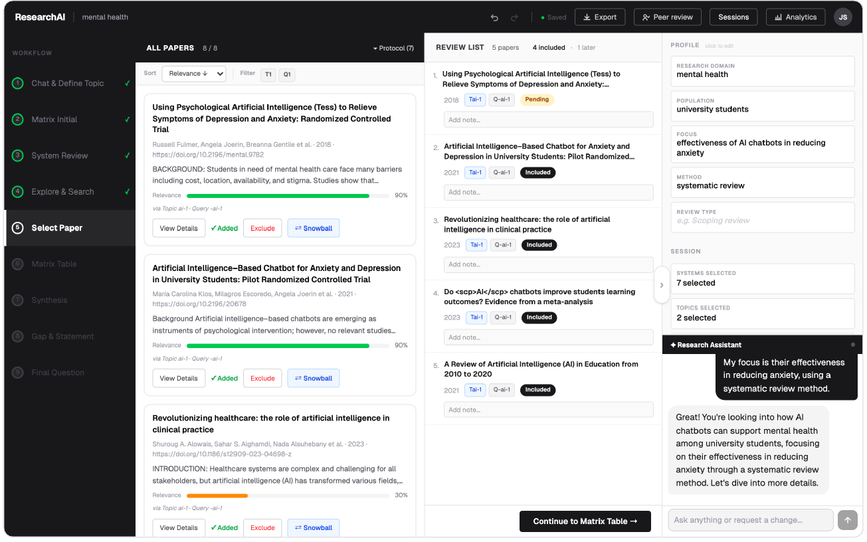
Figure A2. Screening workspace with protocol controls and explicit researcher decisions.

A.2.3 Evidence Matrix and Inspection Controls
The literature matrix aligns studies against researcher-defined dimensions. Cells can be edited and inspected so that extracted values remain connected to evidence and to the researcher’s corrections.
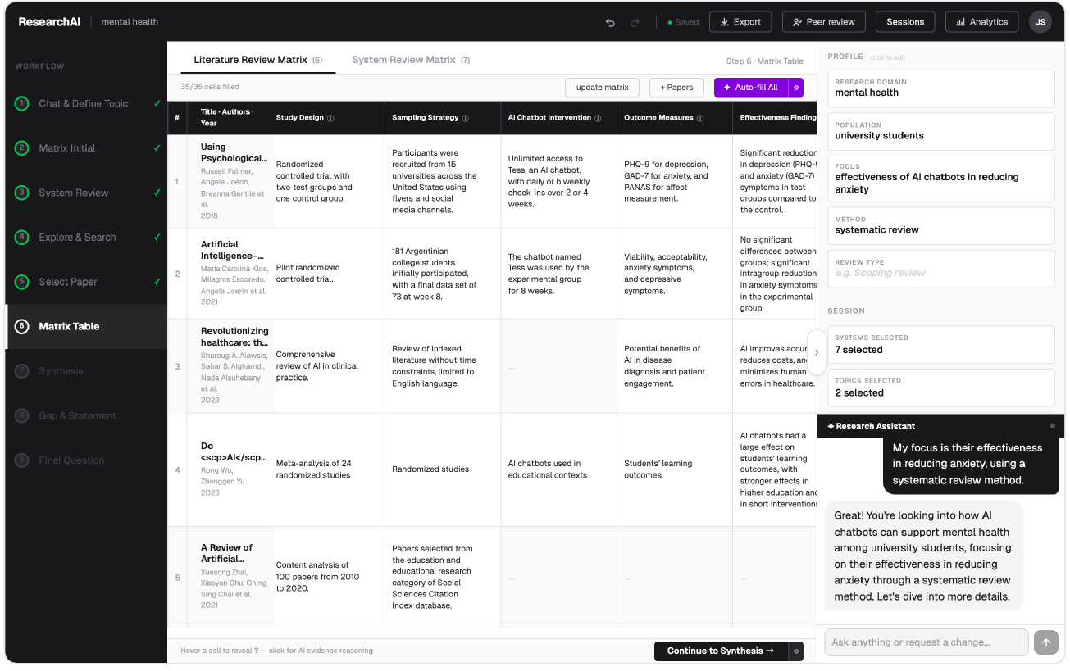
Figure A3. Literature Review Matrix with editable structured evidence fields.

A.2.4 Final Research Outcomes
The final stage consolidates the selected research topic, research question, study design, and proposed paper structure. These outputs remain downstream of the recorded search, screening, matrix, synthesis, and gap-analysis artifacts.
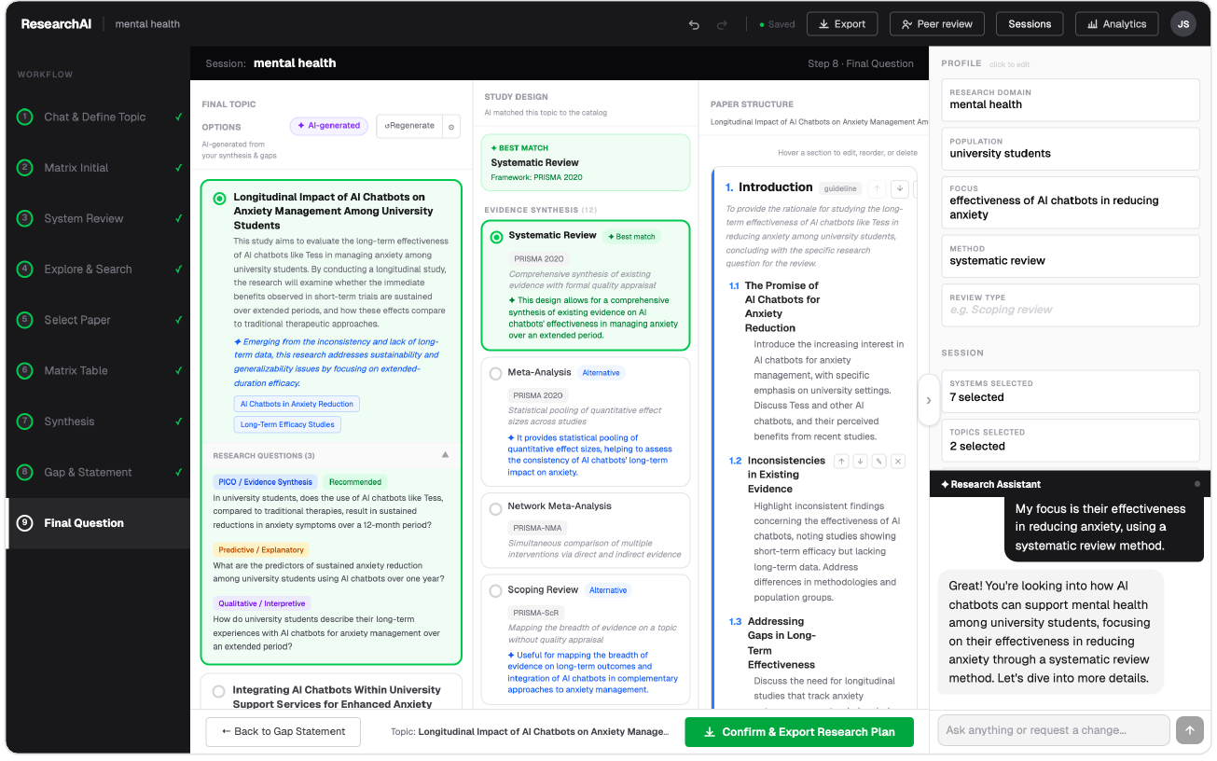
Figure A4. Final Question workspace linking the selected outcome to study design and paper structure.

A.2.5 Peer-Review Access
The peer-review interface exposes the project for independent inspection without transferring ownership of the researcher’s decisions. It supports review of the recorded process and artifacts rather than treating the final narrative as the only output.
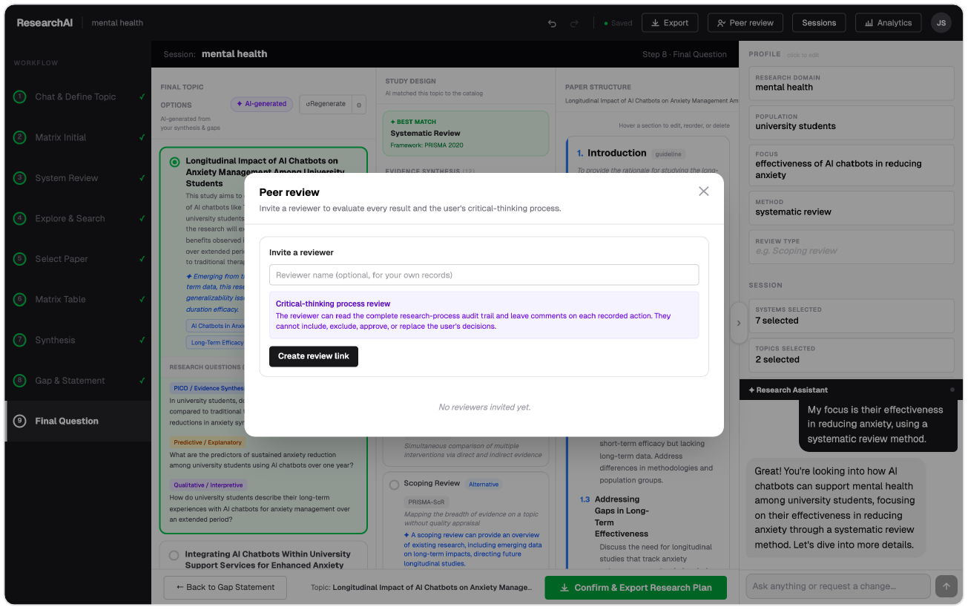
Figure A5. Peer-review access for inspecting workflow records and research artifacts.
Source note: Screenshots are from the Matrica project interface supplied with the project materials and show illustrative interface states available at the time captured.

Appendix B. Research AI Systems with Similarity Score 5
This appendix is derived directly from the ‘Competitor Matrix’ worksheet in Matrica_Competitor_Matrix_All_2026-08-26.xlsx. It includes every row whose ‘Similarity to Matrica’ value is 5, except Parsifal / ParsifalPro, which was excluded because its primary interface language is not English. The resulting set contains 17 products: Matrica and 16 comparison systems. Entries describe the workbook snapshot and may change as products evolve.

B.1 Product Overview
Product | Type | Focus | Closest Matrica module | Workbook description
Matrica | Web / Self-hosted | Multidisciplinary | Entire workflow | Open-source, end-to-end structured literature-review workflow with traceable literature and system matrices, synthesis, gap analysis, final research questions, study design, and paper structure.
Systematicly | Web | Multidisciplinary | Entire workflow | AI-native systematic-review platform spanning question formulation, search, screening, extraction, appraisal, synthesis, and reporting.
Paperguide | Web | Multidisciplinary | Matrix Table and Synthesis | AI research platform with systematic-review workflows, paper discovery, source-linked extraction tables, screening, synthesis, and writing.
Scholara | Web | Medical | Entire workflow | AI systematic-review product with PICO, PubMed and MeSH search, multi-model screening, extraction, RoB 2, meta-analysis, and PRISMA reporting.
Littview | Web | Multidisciplinary | Screening, Matrix Table and Reporting | Systematic-review workspace for importing, deduplicating, screening, conflict handling, extraction, bias assessment, evidence tables, and writing.
Elicit | Web | Multidisciplinary | Explore & Search through Synthesis | AI research assistant supporting literature search, screening, structured extraction, evidence tables, synthesis, and systematic-review reports.
DistillerSR | Web | Multidisciplinary | Protocol through Reporting | Enterprise systematic-review software for screening, extraction, quality appraisal, auditability, PRISMA, automation, and living reviews.
EPPI-Reviewer | Web | Multidisciplinary | Protocol through Synthesis | Comprehensive evidence-synthesis platform for searching, screening, coding, qualitative synthesis, meta-analysis, and evidence mapping.
Nested Knowledge | Web | Medical | Search, Screening, Extraction and Synthesis | Living evidence platform combining AutoLit search, screening, extraction, critical appraisal, synthesis, and interactive visualisation.
JBI SUMARI | Web | Medical | Protocol through Reporting | JBI's systematic-review platform for protocols, screening, appraisal, extraction, qualitative and quantitative synthesis, and reporting.
Rayyan | Web / Mobile | Multidisciplinary | Select Papers | Collaborative systematic-review tool with deduplication, AI-assisted screening, full-text review, extraction, auditability, and PRISMA support.
PICO Portal | Web | Medical | Screening and Appraisal | AI-assisted evidence-synthesis platform for screening, extraction, quality assessment, risk of bias, PRISMA, and collaboration.
Sysrev | Web | Multidisciplinary | Select Papers and Matrix Table | Collaborative review platform with custom labels, structured extraction, active learning, conflict resolution, public projects, and API access.
Axelium | Web | Medical | Entire workflow | AI evidence-synthesis platform with multi-database search, citation chasing, screening, extraction, RoB 2, GRADE, meta-analysis, and NMA.
EvidenceGrid.org | Web | Multidisciplinary | Matrix Table | AI evidence-matrix product that converts papers into custom tables with source passages, locations, cross-paper synthesis, and gap analysis.
Alfred Scholar Telescope | Web | Multidisciplinary | Matrix Table and Gap & Statement | Literature comparison matrix with one paper per row, one question per column, page-level citations, synthesis, and research-gap analysis.
PaperTrace | Web | Multidisciplinary | Matrix Table and Synthesis | AI literature-analysis platform with evidence tables, narrative synthesis, research gaps, source links, and citation graphs.
Table B1. Product overview for the similarity-5 subset. Product names link to the official URLs recorded in the workbook.

B.2 Workflow Capability Comparison
Product | Direct search | AI screening | Data extraction | Literature matrix | Qualitative synthesis | Gap identification | RQ generation
Matrica | Yes | Yes | Yes | Yes | Yes | Yes | Yes
Systematicly | Yes | Yes | Yes | Yes | Yes | Yes | Yes
Paperguide | Yes | Yes | Yes | Yes | Yes | Yes | Yes
Scholara | Yes | Yes | Yes | Yes | Yes | Yes | Yes
Littview | Partial | Partial | Yes | Partial | Partial | Partial | No
Elicit | Yes | Yes | Yes | Yes | Yes | Yes | Yes
DistillerSR | Partial | Partial | Yes | Partial | Partial | Partial | No
EPPI-Reviewer | Partial | Partial | Yes | Partial | Partial | Partial | No
Nested Knowledge | Partial | Partial | Yes | Partial | Partial | Partial | No
JBI SUMARI | Partial | Partial | Yes | Partial | Partial | Partial | No
Rayyan | Partial | Partial | Yes | Partial | Partial | Partial | No
PICO Portal | Partial | Partial | Yes | Partial | Partial | Partial | No
Sysrev | Partial | Partial | Yes | Partial | Partial | Partial | No
Axelium | Yes | Yes | Yes | Yes | Yes | Yes | Yes
EvidenceGrid.org | Partial | Partial | Yes | Yes | Yes | Yes | Partial
Alfred Scholar Telescope | Partial | Partial | Yes | Yes | Yes | Yes | Partial
PaperTrace | Partial | Partial | Yes | Yes | Yes | Yes | Partial
Table B2. Selected workflow capabilities exactly as coded in the workbook.

B.3 Provenance, Governance, and Reproducibility
Product | Evidence provenance | Human in loop | Decision journal | Version history | Audit trail | Reproducibility | Open source
Matrica | Yes | Yes | Yes | Yes | Yes | Yes | Yes
Systematicly | Yes | Yes | No | Partial | Partial | Partial | No
Paperguide | Yes | Yes | No | Partial | Partial | Partial | No
Scholara | Yes | Yes | No | Partial | Partial | Partial | No
Littview | Yes | No | No | Partial | Yes | Yes | No
Elicit | Yes | Yes | No | Partial | Partial | Partial | No
DistillerSR | Yes | No | No | Partial | Yes | Yes | No
EPPI-Reviewer | Yes | No | No | Partial | Yes | Yes | No
Nested Knowledge | Yes | No | No | Partial | Yes | Yes | No
JBI SUMARI | Yes | No | No | Partial | Yes | Yes | No
Rayyan | Yes | No | No | Partial | Yes | Yes | No
PICO Portal | Yes | No | No | Partial | Yes | Yes | No
Sysrev | Yes | No | No | Partial | Yes | Yes | Partial
Axelium | Yes | Yes | No | Partial | Partial | Partial | No
EvidenceGrid.org | Yes | No | No | Partial | No | Partial | No
Alfred Scholar Telescope | Yes | No | No | Partial | No | Partial | No
PaperTrace | Yes | No | No | Partial | No | Partial | No
Table B3. Provenance, governance, and reproducibility fields exactly as coded in the workbook.
Source: Matrica_Competitor_Matrix_All_2026-08-26.xlsx, ‘Competitor Matrix’ sheet, filtered to Similarity to Matrica = 5 and excluding Parsifal / ParsifalPro.

