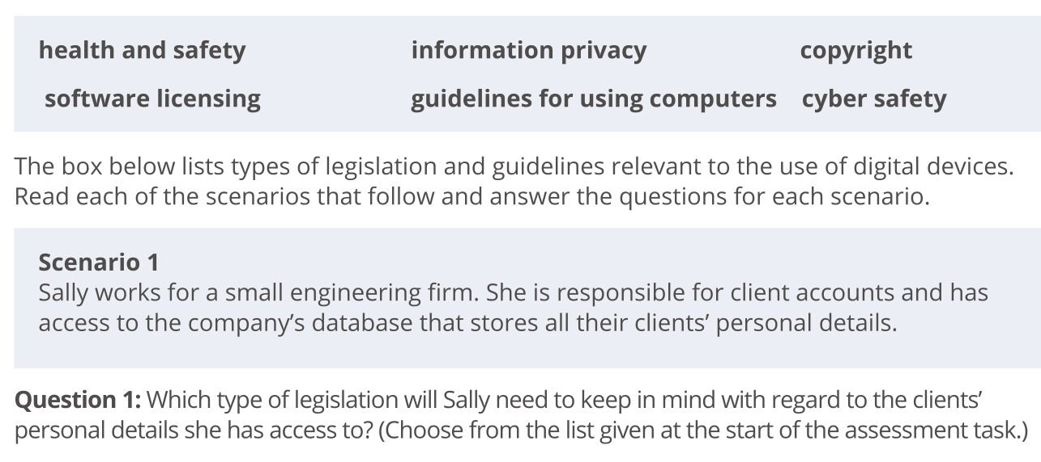
Name

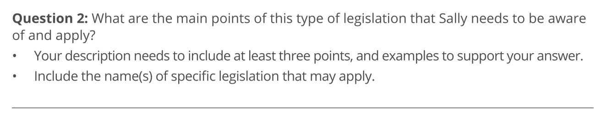

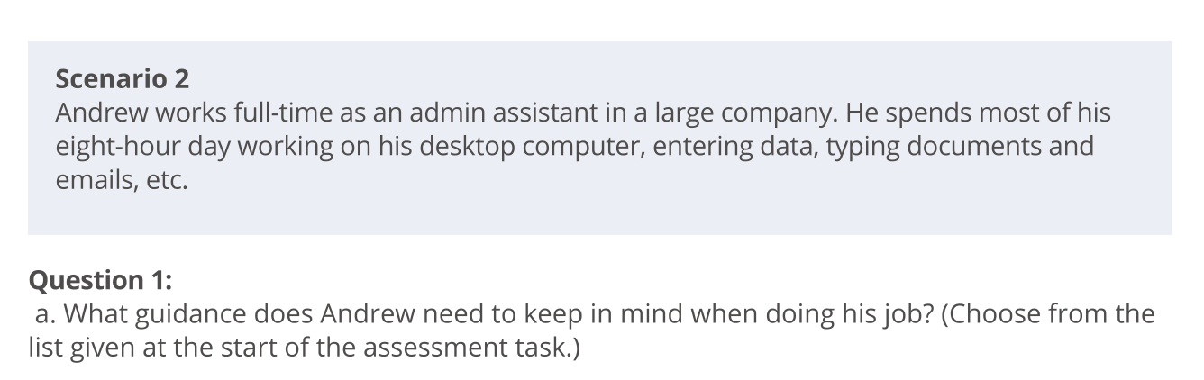

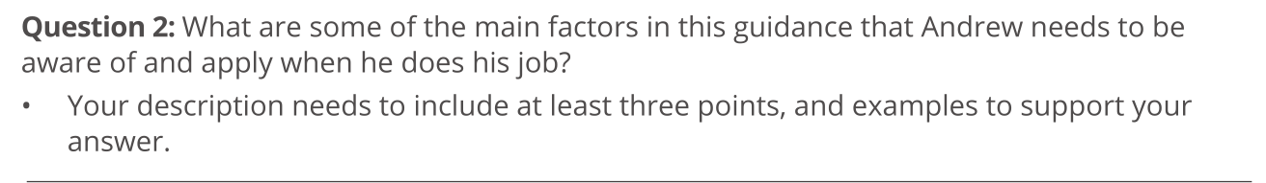

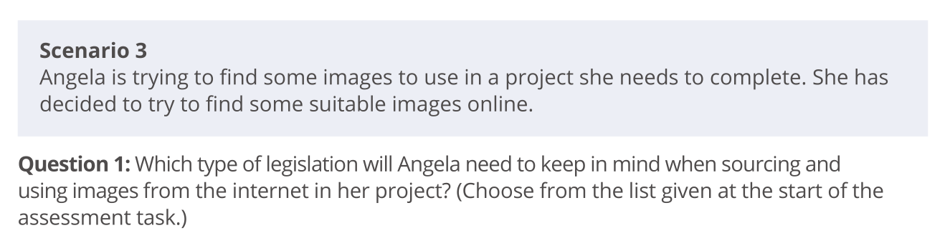

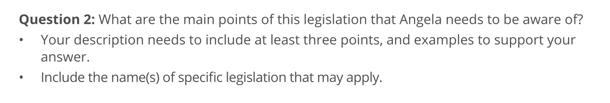

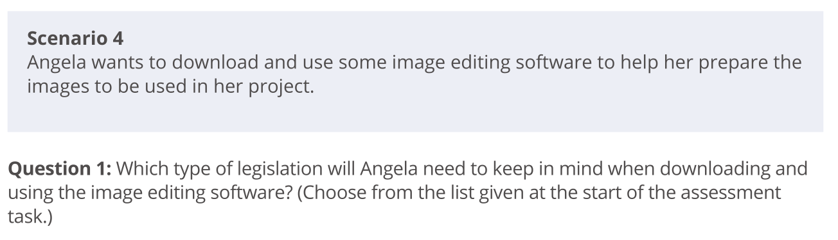

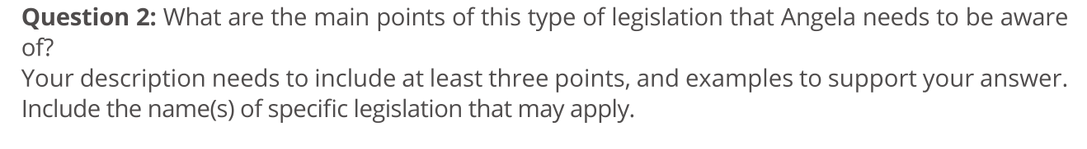

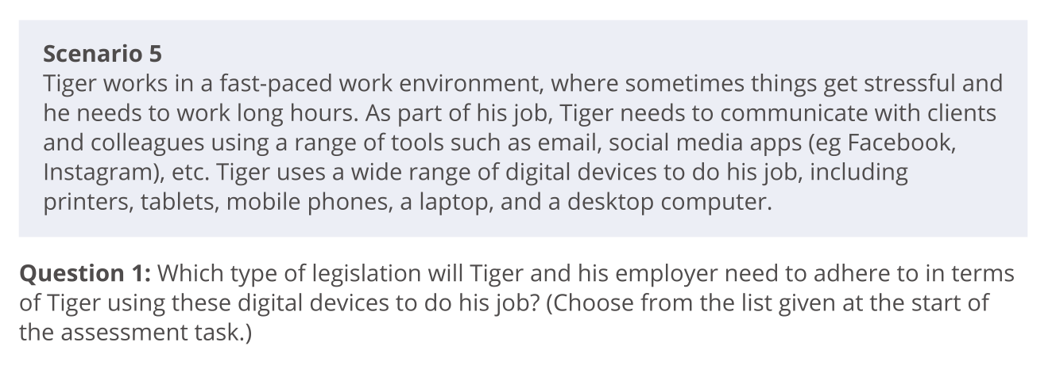

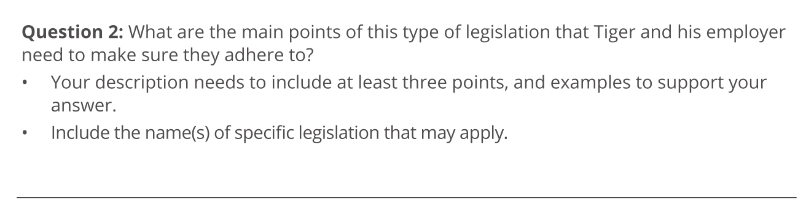

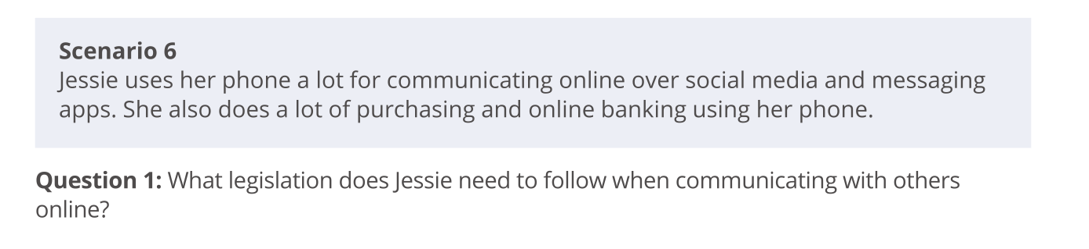

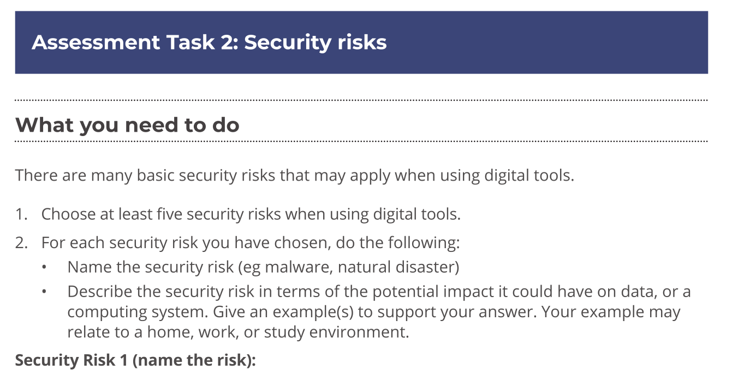



Security Risk 2 (name the risk):

Description of risk:

Security Risk 3 (name the risk):

Description of risk:

Security Risk 4 (name the risk):

Description of risk:

Security Risk 5 (name the risk):

Description of risk:

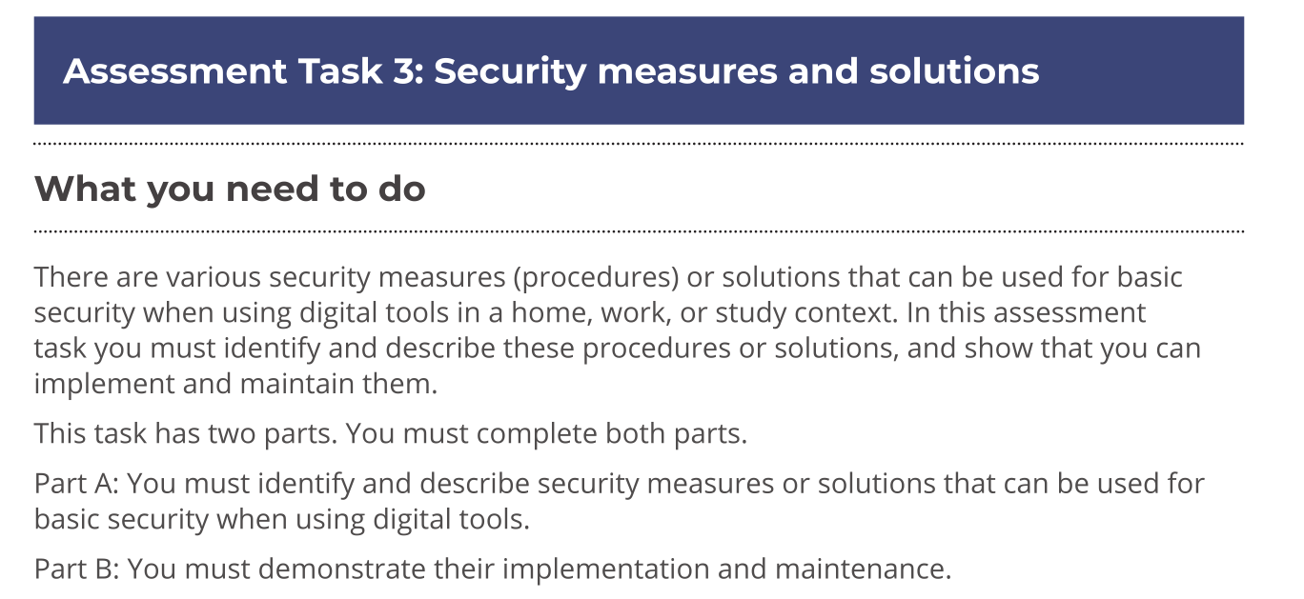

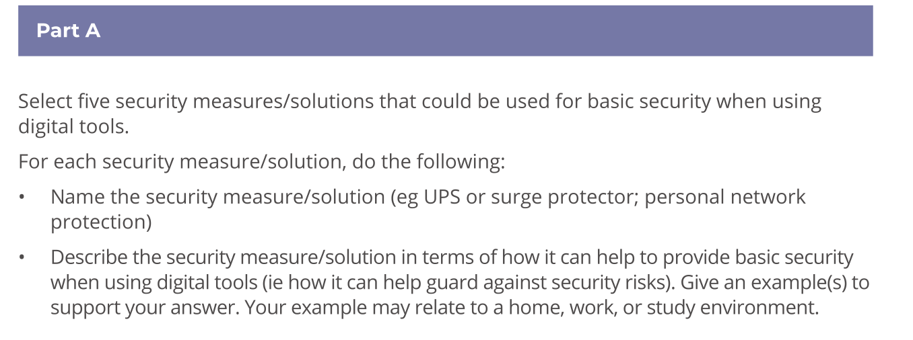

Security Procedure/Solution 1 (name the procedure/solution):

Description of procedure/solution:

Security Procedure/Solution 2 (name the procedure/solution):

Description of procedure/solution:

Security Procedure/Solution 3 (name the procedure/solution):

Description of procedure/solution:

Security Procedure/Solution 4 (name the procedure/solution):

Description of procedure/solution:

Security Procedure/Solution 5 (name the procedure/solution):

Description of procedure/solution:

