Introduction :

Internet of Things (IoT) is a network of interconnected devices or devices able to collect and exchange data. This concept is slowing emerging as a primary option in the future. This report, will help us understand how to pipeline to transmit and store data with the help Internet of Things (IoT) device which scans and captures heart rate, using IoT Core to transmit and publish data to a data warehouse with the help of query table.

* A Raspberry Pi connected with a heart rate sensor will be used for the IoT device. Using components of the Google Cloud Platform will create a specific data pipeline. After completing the steps below, we can graphically display heart rate data over time as data can be retrieved from the data warehouse, this warehouse is constantly supplied from a data pipeline.

[](https://user-images.githubusercontent.com/83789235/117398516-21deba80-aec4-11eb-9ef1-dcdfe1e6c86b.png)

1. **Hardware Components:**

* Raspberry Pi Zero W with power supply.
* SD memory card
* USB card reader
* Heartrate Sensor.

1. USB hub **Using IoT Core to Stream Heart Rate Data** :

* Using your google account sign up to the Google Cloud Platform console - console.cloud.google.com.
* Follow the below steps Using IoT Core to Stream the live Heart Rate Data by connecting your Raspberry Pi device.

**Steps:**

**1:** Create a new project with name ‘iot-heartrate’.

**2:** Enable API’s as shown below. Click on Enable APIs and Services

**3:** Create a Big Query table.

Big Query is a serverless, highly scalable, low-cost enterprise data warehouse. From the Cloud Console, select Big Query and then Create new dataset – “heartRateData"

[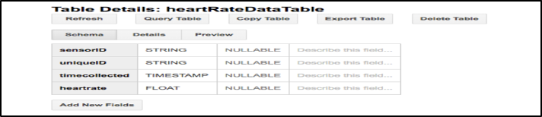](https://user-images.githubusercontent.com/83789235/117398546-328f3080-aec4-11eb-9671-e34f505d0246.png)

**Step 4:** Create a Pub/Sub topic and subscription:

Cloud Pub/Sub : It is a foundation for streaming data and event-driven computing systems.

* From the Cloud Console-select Pub/Sub then Topics.
* Click on the “Create a topic”.
* Enter "heartratedata" as the topic name and then click Create.
* Create a new subscription by clicking on the options next to the topic name as shown below.
* Enter "heartratedata" as the subscription name then click Create

**Step 5:** Use a Dataflow Template:

* From the Cloud Console, select Dataflow.
* Click on Create Job from Template. Give the job a name and select the Pub/Sub Subscription to Big/Query template. Click on Run Job.

[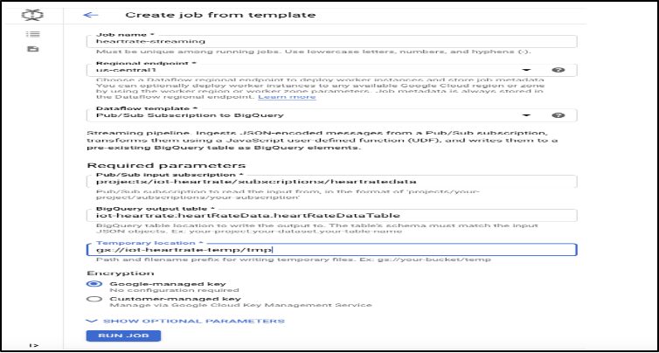](https://user-images.githubusercontent.com/83789235/117398606-4d61a500-aec4-11eb-9b0d-c9ff40393ebd.png)

**Step 6:** Create an IoT Core registry and Add the device to the IoT Core Registry:

[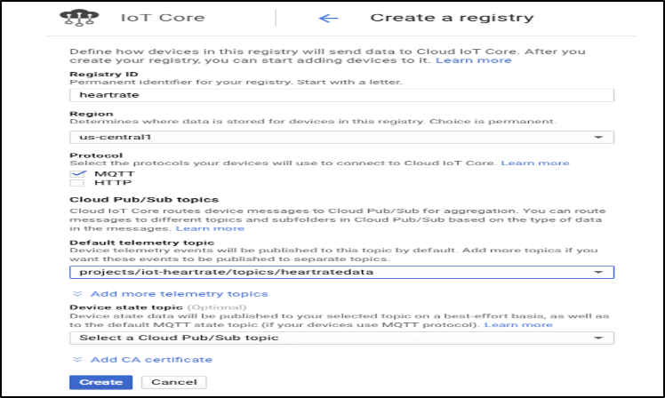](https://user-images.githubusercontent.com/83789235/117398621-53578600-aec4-11eb-8b6f-8f60d1de7f17.png)

**Step 7:**  Following steps on the terminal/cmd prompt and start the data .

[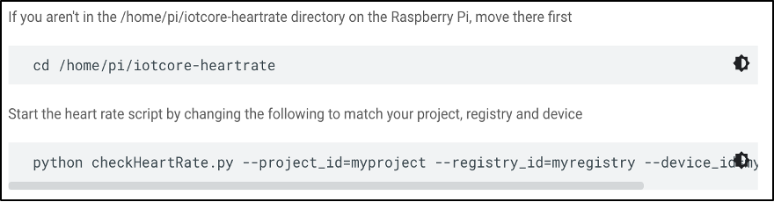](https://user-images.githubusercontent.com/83789235/117398628-59e5fd80-aec4-11eb-849f-74ec37637f39.png)

**Output:**

The results are visible when we execute the select query on the table.

Visualize the data using Google Sheets as shown below.

[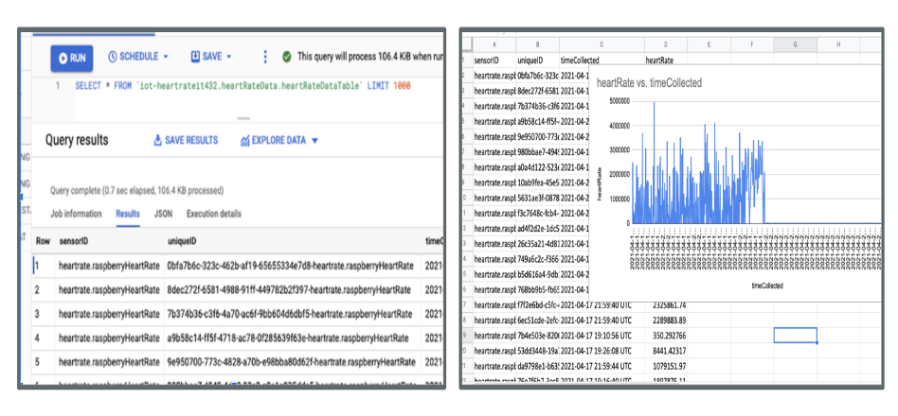](https://user-images.githubusercontent.com/83789235/117398644-623e3880-aec4-11eb-8cd4-df6bd066db9b.png)

**Summary:**

**This report summarises the steps taken to use the google cloud. It shows us how to create a Google Pub/sub, data pipeline, google cloud dataflow template and leverage google big query. We used Google Iot Core to secure Iot devices to allow dataflow into google pub/sub and pushed into Big Query and then used the integration with google sheets to perform a quick data visualization.**