Homework 4 by Timofei Podlorytov
4.1
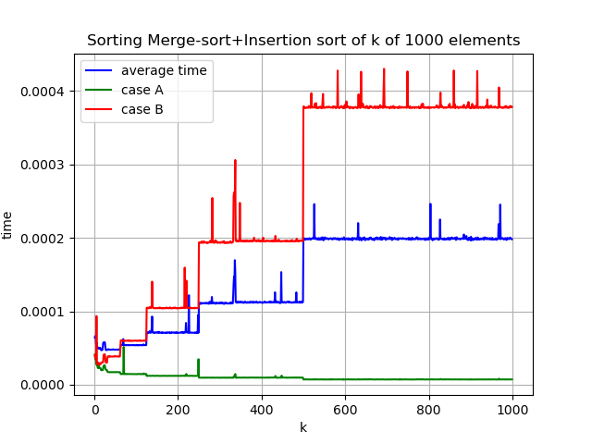
the graph above was created for sorting of 1000 elements and 30 sample size.
(a-b)
The algorithm for the task is in a p1.cpp file and the graph was created using the graph.py file which I also provide.

The best, worst and average cases are presented on the graph. I tested for different values of k which are shown on the x axis.
(c)
As we see here the graph is kinda like stairs and the jumps appear on k=2^(n) for the average and worst case. While the best case declines in time as we turn to using insertion sort faster and thus need to merge less lists together→ perform less operations and go to n complexity in insertion sort. When we have k=2^(n) we equally split the array and can do the merging for efficiently with the list of closer size.

The jumps happen between k=2^n and k=2^n-1 as I have proven by checking the values near those k in the python script. Currently they are commented out, but can be easily run, if needed.

(d)
We can clearly see the time increase for larger k as well as values of k=2^n-1 being good compared to the ones that come after. So, the best choice would be to choose a small k that equals 2^n-1. For instance, k=1 would work well.

4.2

Time complexity:
(a) (2 points) T (n) = 36T (n/6) + 2n,
(b) (2 points) T (n) = 5T (n/3) + 17n^1.2 ,
(c) (2 points) T (n) = 12T (n/2) + n^2 * lg n,
(d) (2 points) T (n) = 3T (n/5) + T (n/2) + 2^n ,
(e) (2 points) T (n) = T (2n/5) + T (3n/5) + Θ(n).

a)
T (n) = 36T (n/6) + 2n,
In this case the master theorem can be used as we have only one T(n) and all the values of a and b satisfy.

log_{b}a=log₆36=2 → f(n)=O(n^(2-1))=O(n) as f=2n→ first case and T(n)= Θ(n^(log₆36))=Θ(n^2)

b)
We follow a similar logic for this case.
T (n) = 5T (n/3) + 17n^1.2
Here we have log_{b}a=log₃5≈1.465.. while f=17n^1.2∈O(n^1.2) ∈O(n^(log₃5)) → first case and T(n)= Θ(n^(log₃5))

c)
T (n) = 12T (n/2) + n^2 * lg n
We can’t apply the master method here as n^2 lg n is not a polynomial and we have to use something else.

Let’s try using the tree: ⋀
n^2*lg(n) n^2*lg(n) |
| |||||| |
f(n/2) …… f(n/2) -12 kids 12*(n/2)^2*lg(n/2) | height=
| | log₂n
f(n/4) … 12^2 kids 12^2*(n/4)^2*lg(n/4) ⋁
….

T(n)=n^2*lg(n)+12*(n/2)^2*lg(n)-12*(n/2)^2*lg(2)+12^2*(n/4)^2*lg(n)-12^2*(n/4)^2*lg(4)…=
n^2*lg(n)+3*(n)^2*lg(n)-3*(n)^2*lg(2)+3^2*(n)^2*lg(n)-3^2*(n)^2*lg(2)*2+
+3^3/(2^6)*(n)/2^6lg(n)-3^3/(2^6)*(n)/2^6lg(2)*3=….

We get:
n^2*lg(n)(1+3+9+...)-n^2lg(2)(1+3+9*2+27*3+3^4*4…) in each sum we have log₂n elements

we know that n^2*lg(n) grows faster than n^2 so we can dismiss n^2 for the upper bound. Plus the sum is positive and
Now we get:
n^2lg(n)*(1-3^log₂n)/(1-3) which is Θ (n^2 * lg(n)*3^lg(n))

d)
T (n) = 3T (n/5) + T (n/2) + 2^n
here the master theorem won’t work as we have two separate function for T(n) inside the main one plus non polynomial as f(n).

Substitution:
let’s try 2^n.
Base step:
T(1)=2^1=O(2^n) true
Induction step:assume true for any k<n
T(n)=3T(n/5)+T(n/2)+2^n=3*2^(n/5)+2^(n/2)+2^n = 2*(2^n)-(2^n-3*2^(n/5)-2^(n/2))=
desired >0 residual>0 for n>=3

=c*2^n-residual>0 → O(2^n) true
◼
Is this the tightest fit though? If mot there must exist a tighter O(f(n))

O(n^{k})⊂O(2^{n})

Base case n=1
T(1)=2^1 ≠ 1^{k} we have an issue of an exponential component in the function in its root. Thus getting anything less will be impossible.

Θ(2^n)
e)
T (n) = T (2n/5) + T (3n/5) + Θ(n).
Master theorem won’t work here due to two recursive function calls of T(n) in T(n)

Let’s try a recursion tree:
Θ(n) 1 child 0
| |
Θ(2n/5) Θ(3n/5) 2 children 1
| | | |
Θ(4n/25) Θ(6n/25) Θ(6n/25) Θ(9n/25) 4 children 2
| | | | |
….. … ….
2^{n} children n

but as we know Θ(const*n)=Θ(n)→ in each step the expression is multiplied by a constant inside Θ
and we can simplify it in the following way
Θ(n) 1 child 0 Θ(n)
| |
Θ(n) Θ(n) 2 children 1 2Θ(n)
| | | |
Θ(n) Θ(n) Θ(n) Θ(n) 4 children 2 4Θ(n)
| | | | |
….. … ….
2^{n} children n 2^{n}Θ(n)

Overall sum is Θ(n)+2Θ(n)+4Θ(n)+8Θ(n)…...+2^{n} Θ(n)=
=Θ(n)(1+2+4+...2^k)=Θ(n)*(2^k-1)/1

the final n is the height of the tree which is log_{0.4}(n)
Θ(n*2^log_{0.4}(n))

