Bugs looked during Testing Execution with user *problem_user* and password

*secret_sauce* .

# Bug 1:

# Title: Inventory Home page – View of Product Selected is not matched with Product in Inventory list

Description: Through the Inventory Home page, when a User selects one product, an item page is shown but the information inside are not matched with the Product selected before. Specifically, the image, the title, the price and the description are different, it looks like another Product.

For example: Item selected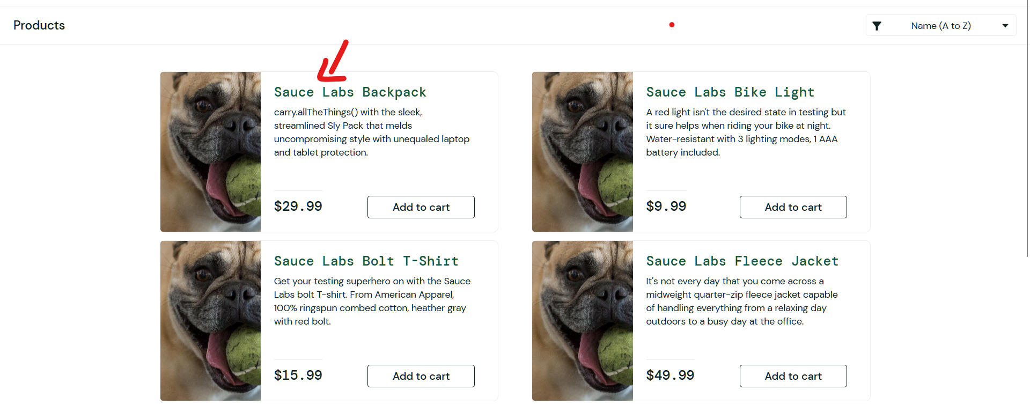

Item shown:

**Environment : Test**

**Severity: Critical**

**Priority: needs to do bug triage with Business Analyst**

# Bug 2:

# Title: Inventory Item View – Add to Cart button is not working properly

Description: in the Inventory Item View, after selecting one item in Inventory Home Page, when the user clicks on “Add to Cart” button, nothing happens. The behavior should be:

* The “Add to Cart” button should became “Remove” button
* The item should be added to the Shopping Card and the badge should increase to 1 value

**Environment: Test**

**Severity: High**

**Priority: needs to do bug triage with Business Analyst**

# Bug 3:

# Title: Inventory Home Page View – Remove button is not working properly

Description: In the home page View (inventory list of products), after added an item in the Shopping card, if the user clicks on “Remove” button, nothing happens. The behavior should be:

* The “Remove” button should became “Add to Cart” button
* The shopping card badge should decrease to 1 value

**Environment: Test**

**Severity: High**

**Priority: needs to do bug triage with Business Analyst**

# Bug 4

# Title: “About” link is not working properly

Description: When the user clicks on “About” link in burger menu presents at the left of the screen

Following page is shown: <https://saucelabs.com/error/404>

**Environment: Test**

**Severity: Low**

**Priority: Low (?)**

# Bug 5

# Title: Sorting feature in Inventory Home Page is not working

Description:

The features of Sorting is not working properly

All features :

1. Name (A to Z)
2. Name (Z to A)
3. Price (low to high)
4. Price (high to low)

Have this problem, after click on ones nothing happens.

**Environment: Test**

**Severity: Medium**

**Priority: needs to do bug triage with Business Analyst**

# Bug 6:

# Title: Checkout: Your Information – Writing Last Name field with problem

Description: when the user inserts a Fist Name and Zip Code , all right, below there is a screen with the fields filled.

While, when the user inserts a Last Name, the characters digited by keyboard is visible in First Name field and the last name area is still empty.  
Of course the First Name value inserted earlier is not there anymore.

Below there is a snap with example:

**Environment: Test**

**Severity: Critical**

**Priority: Critical**