**What is a Classifier?**

* It is a machine learning model which can be trained and predicts the output based on input datasets.

**Types of Classifiers:**

1. KNN (K-Nearest Neighbours)
2. HTM (Hierarchical Temporal Memory)
3. **KNN**: It is a distance-based classifier, supervised learning algorithm, used for classification and regression.

In **K-Nearest Neighbours (KNN)**, the **"K"** represents the number of nearest neighbours considered when making a classification or regression prediction.

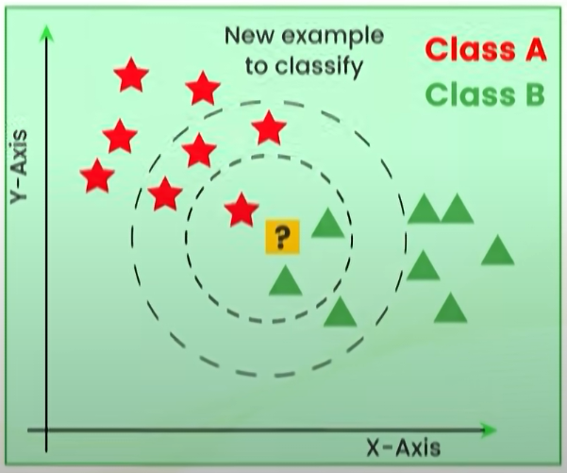

Figure 1: example of KNN

In the Figure 1, the inner circle and outer circle contains **3** and **7** nearest neighbours respectively.