CS333 Project3 **#README**

Tracy Quan

Platform: macOS version 10.12.6

Directory Layout:

Project3/

|

| |__/cstk.h

| |__/cstk.c

| |__/cstktest.c

| |__/cstktest

| |__/README.docx

|

|__/JavaScript/

| |

| |__/Task1.html

| |__/Task1.js

| |__/Task2.html

| |__/Task2.js

| |__/Task3.html

| |__/Task3.js

| |__/Extension4.html

|

|

|__/C++/

| |

| |__/Task1.cpp

| |__/Task1.out

| |__/Task2.cpp

| |__/Task2.out

| |__/Task3.cpp

| |__/Task3.out

|

|__/Bash/

| |

| |__/Extension1.sh

| |__/Extension2.sh

| |__/Extension3.sh

**Part I: C Syntax**

The purpose of this part is to understand the usage of .h and .c files, the keyword extern, and the concept of prototype in C.

**Task1:**

Create a cstk.h. The .h file should contain the necessary sturctures and the declarations of the member functions.

**Task2:**

Create a cstk.c file. This file should contain the implementation of the member functions declared in the cstk.h file.

**Task3:**

**Command line:**

gcc -o cstktest cstktest.c cstk.c

./cstktest

**Output:**

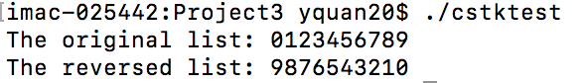

**Part II: Selected Language**

**1. JavaScript**

**Task1:**

Write an example program in each language that demonstrates the rules for identifier naming, variable declarations and identifier scoping.

**Instruction:**

Open the Task1.html and the outputs are in each alert window.

**Output:**

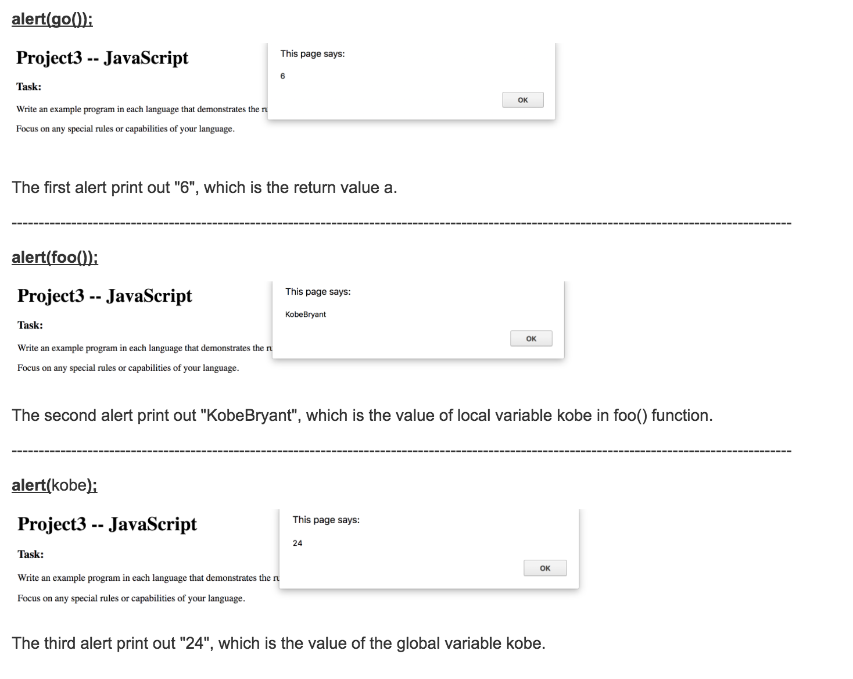

**Task2:**

Write an example program in each language that executes a binary search on a list or array of numbers. Make it a function/method, if possible.

**Instruction:**

Open the Task2.html and the outputs are in each alert window.

**Output:**

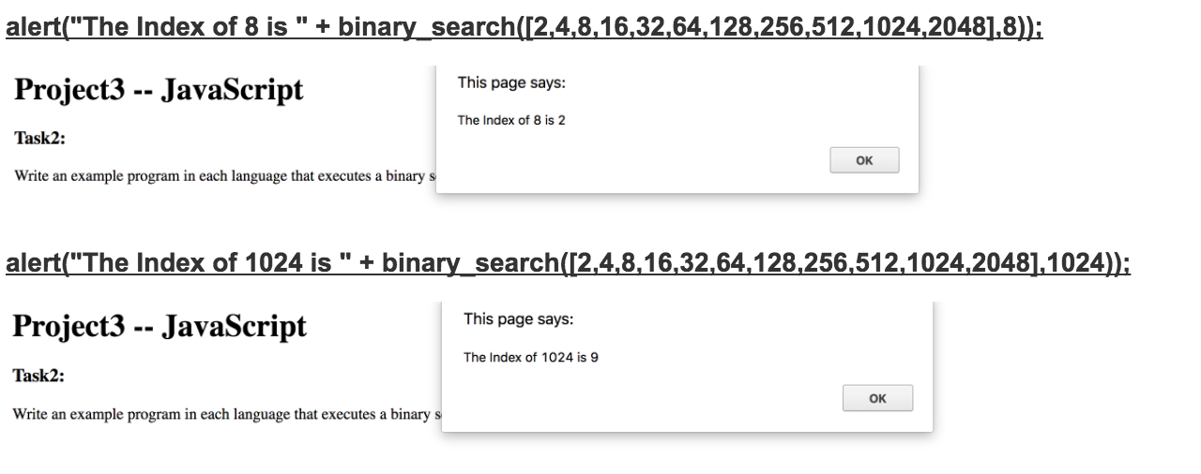

**Task3:**

Write an example program in each language that demonstrates all of the basic built-in types and how to construct aggregate types (e.g., records, classes or structures).

**Instruction:**

Open the Task3.html and the outputs are in each alert window.

**Output:**

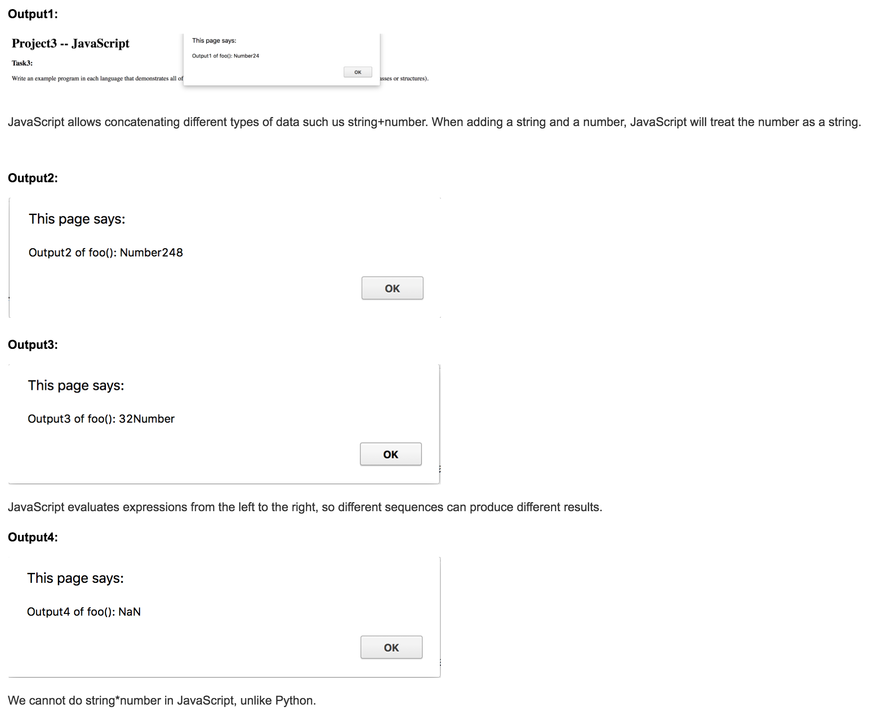

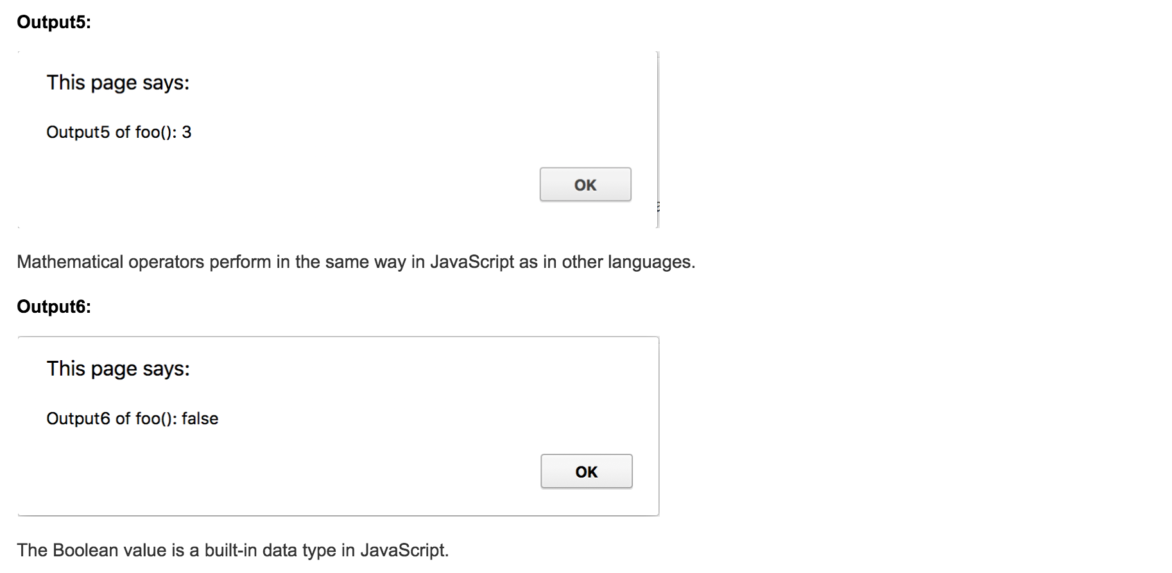



**2. C++**

**Task1:**

Write an example program in each language that demonstrates the rules for identifier naming, variable declarations and identifier scoping.

**Command Line:**

g++ -o Task1.out Task1.cpp

./Task1.out

**Output:**



**Task2:**

Write an example program in each language that executes a binary search on a list or array of numbers. Make it a function/method, if possible.

**Command Line:**

g++ -o Task2.out Task2.cpp

./Task2.out

**Output:**



**Task3:**

Write an example program in each language that demonstrates all of the basic built-in types and how to construct aggregate types (e.g., records, classes or structures).

**Command Line:**

g++ -o Task3.out Task3.cpp

./Task3.out

**Output:**



**Part III: Extensions**

**Extension1**

Variable Declarations, Identifiers Naming, Identifier Scope in Bash

**Command Line:**

./Extension1.sh

**Output:**



**Extension2**

Show unique features of the syntax, naming, or scoping in Bash.

**Command Line:**

./Extension2.sh

**Output:**



**The Uniqueness of Bash:**

* When we refer to the value of a variable, we have to use the dollar sign($). See line 14 and 15.
* When we assign a value to a reference, we cannot leave any whitespace. See line 5 and 6.
* The value of a variable cannot have whitespace, or we have to use quotation marks to put them in a string. See line 8 and 9.
* Other rules are shown in the following extension.

**Extension3**

Binary Search in Bash.

**Command Line:**

./Extension3.sh

**Output:**



**Extension3**

Assign a function to a variable in JavaScript.

**Instruction:**

Open Extension4.html in a web browser. Click the button in-line function.

**Output:**

