CS333 Project4 **#README**

Tracy Quan

Platform: macOS version 10.12.6

Directory Layout:

Project4/

|

| |__/CSemantics.c

| |__/CSemantics

| |__/README.docx

|

|__/JavaScript/

| |

| |__/Task1.html

| |__/Task2.html

| |__/Task3.html

| |__/Extension2.html

| |__/Extension3.html

|

|

|__/Bash/

| |

| |__/Task1.sh

| |__/Task2.sh

| |__/Task3.sh

|

|__/C++/

| |

| |__/Task1.cpp (Extension1.1)

| |__/Task1

| |__/Task2.cpp (Extension1.2)

| |__/Task2

**Part I: C Semantics**

Given an array of random integers, sort the array in a way that the even numbers apper first and the odd numbers apper later. The even numbers should be sorted in descending order and the odd numbers should be sorted in ascending order. For example, given [3, 8, 2, 9, 1, 6], the output of your program should be [8, 6, 2, 1, 3, 9].

**Command line:**

gcc -o CSemantics CSemantics.c

./CSemantics

**Output:**

The sorted array is: 12 10 8 6 4 2 0 1 3 5 7 9 11

**Part II: Selected Language**

**1. JavaScript**

**Task1:**

What control flow statements does the language provide? Write a program that uses all these control flow statements. Name the source file to task1.xx. For each of the statements, compare it with C if C also has it. Briefly describe the differences if there are any.

**Instruction:**

Open the Task1.html

**Output:**

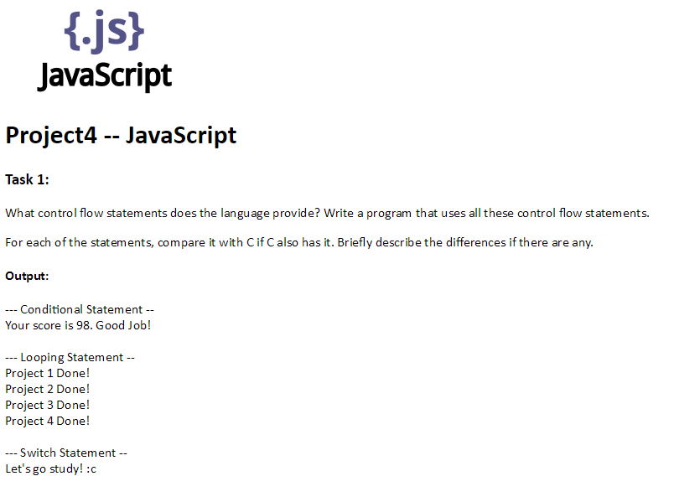

JavaScript and C have similar conditional statements, looping statements and switch statements.

**Task2:**

Function Type: write a program to shows how are functions treated in the language as a data type? Name the program to task2.xx. Can you assign a function to a variable? Can you pass a function to another function? If so, how do you then execute the function using the reference? Explain thes in your write-up.

**Instruction:**

Open the Task2.html

**Output:**

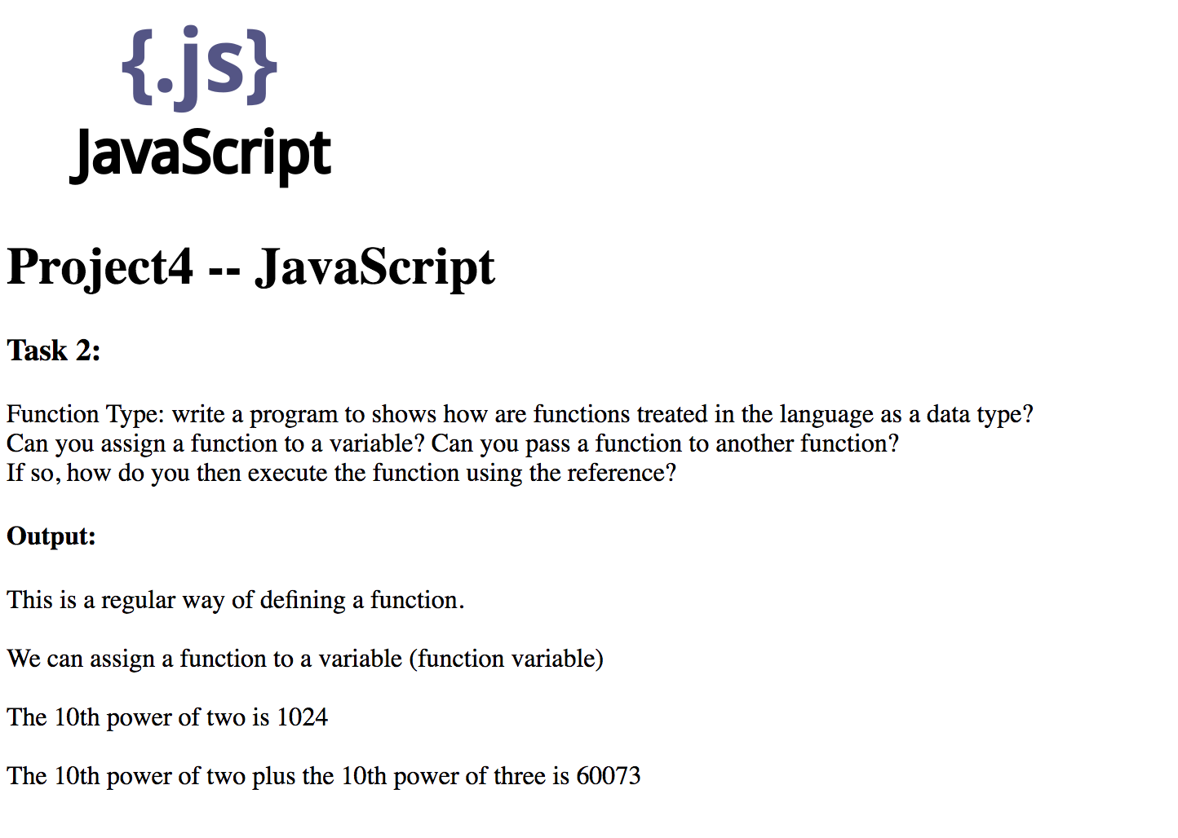

**Task3:**

Implement a general sort algorithm (e.g., quick sort, merge sort) that can be used for any type and can be used to obtain any desired order. Write a test program for your implementation, and demonstrate your algorithm works.

**Instruction:**

Open the Task3.html

**Output:**

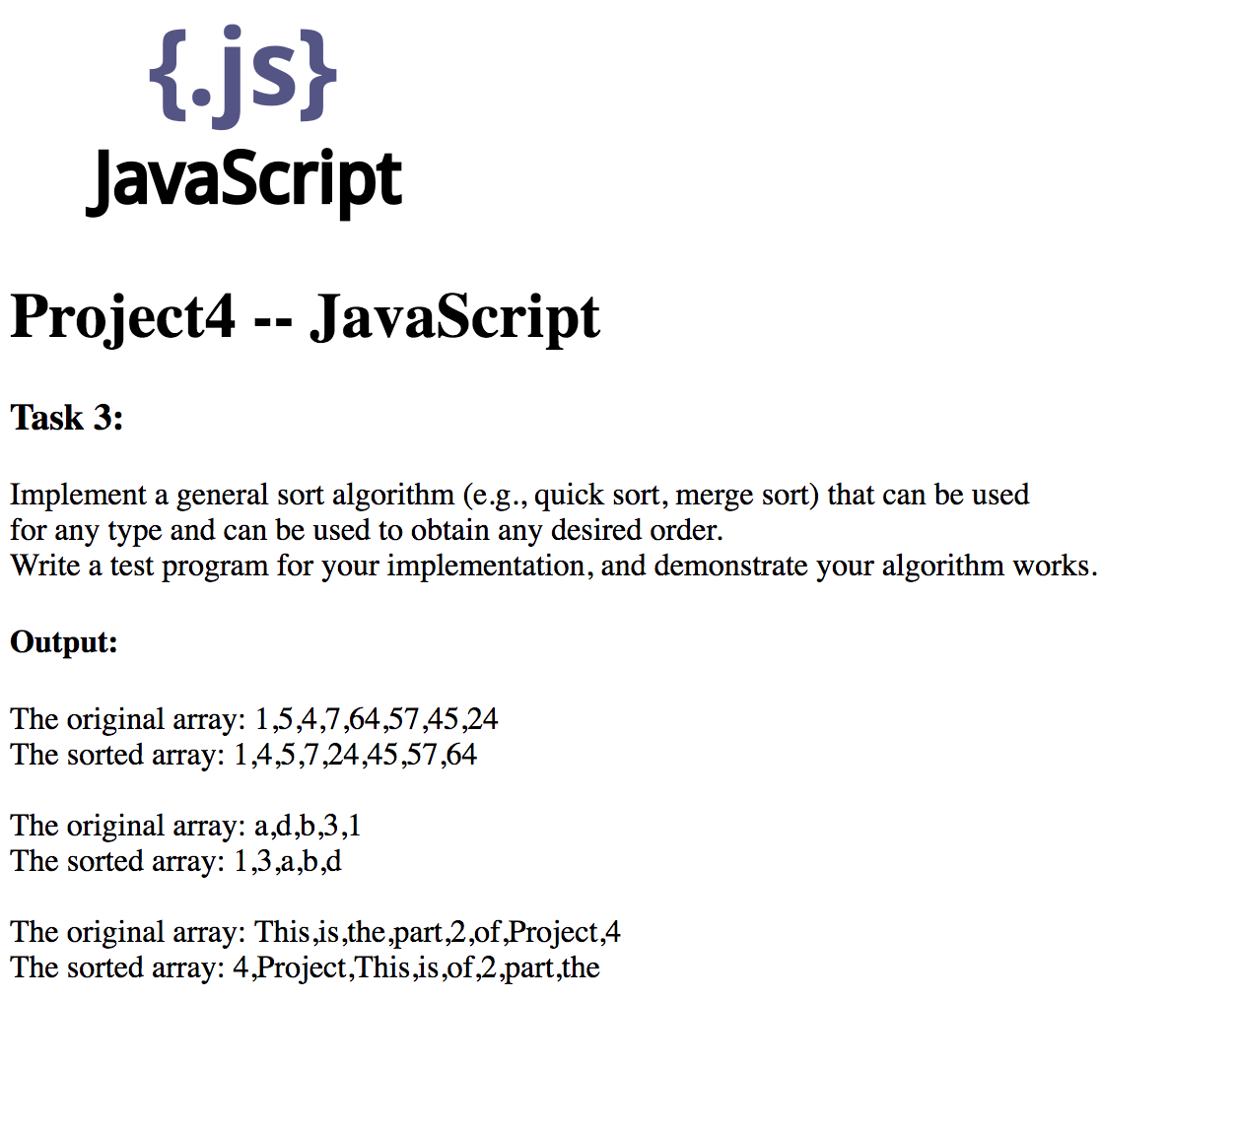

**2. Bash**

**Task1:**

What control flow statements does the language provide? Write a program that uses all these control flow statements. Name the source file to task1.xx. For each of the statements, compare it with C if C also has it. Briefly describe the differences if there are any.

**Instruction:**

./Task1.sh

**Output:**

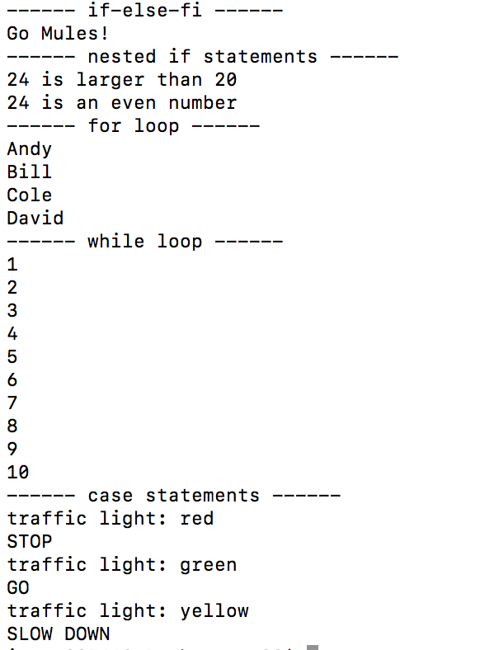

**Task2:**

Function Type: write a program to shows how are functions treated in the language as a data type? Name the program to task2.xx. Can you assign a function to a variable? Can you pass a function to another function? If so, how do you then execute the function using the reference? Explain thes in your write-up.

**Instruction:**

./Task2.sh

**Output:**

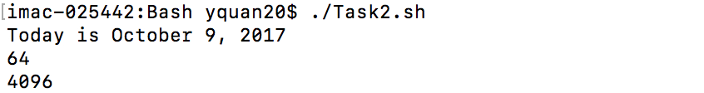

**Task3:**

Implement a general sort algorithm (e.g., quick sort, merge sort) that can be used for any type and can be used to obtain any desired order. Write a test program for your implementation, and demonstrate your algorithm works.

**Instruction:**

./Task3.sh

**Output:**

**C:\Users\tracy\AppData\Local\Microsoft\Windows\INetCache\Content.Word\Screen Shot 2017-10-10 at 11.28.40 PM.PNG**

***Part III: Extensions***

**Extension1.1**

Control flows in C++

**Command Line:**

g++ -o Task1 Task1.cpp

./Task1

**Output:**

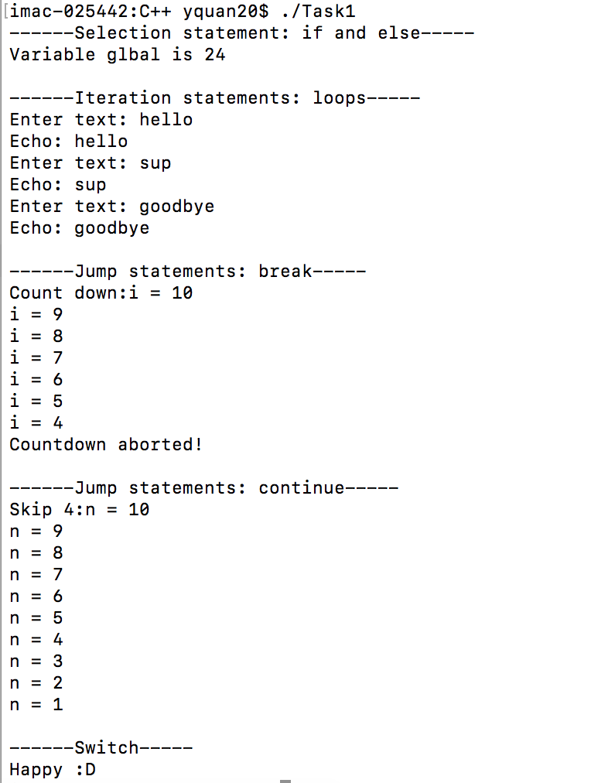

**Extension1.2**

Function type in C++

**Command Line:**

g++ -o Task2 Task2.cpp

./Task2

**Output:**

8 is smaller than 24

**Extension2**

Polymorphism in JavaScript.

**Instruction:**

Open Extension2.html

**Output:**

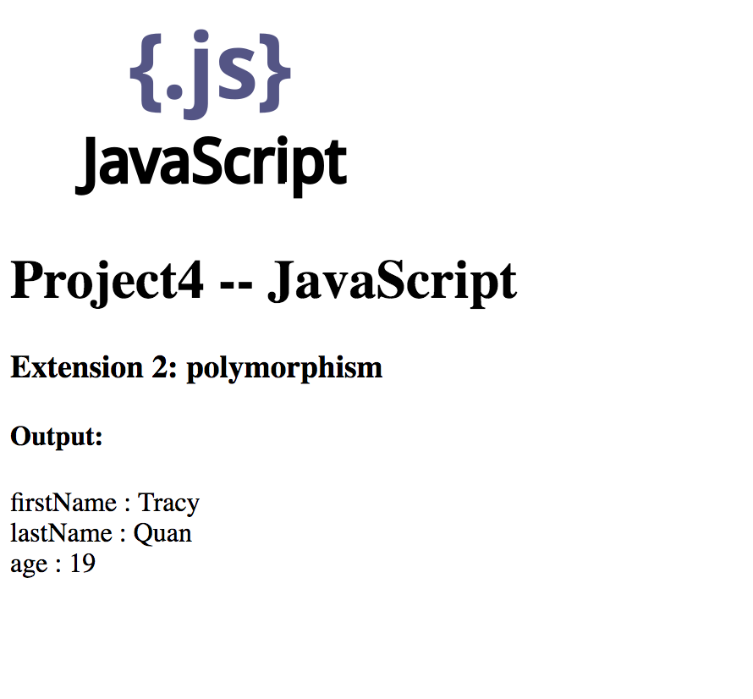

**Extension3**

Dynamic function in JavaScript

**Instruction:**

Open Extension3.html

**Output:**

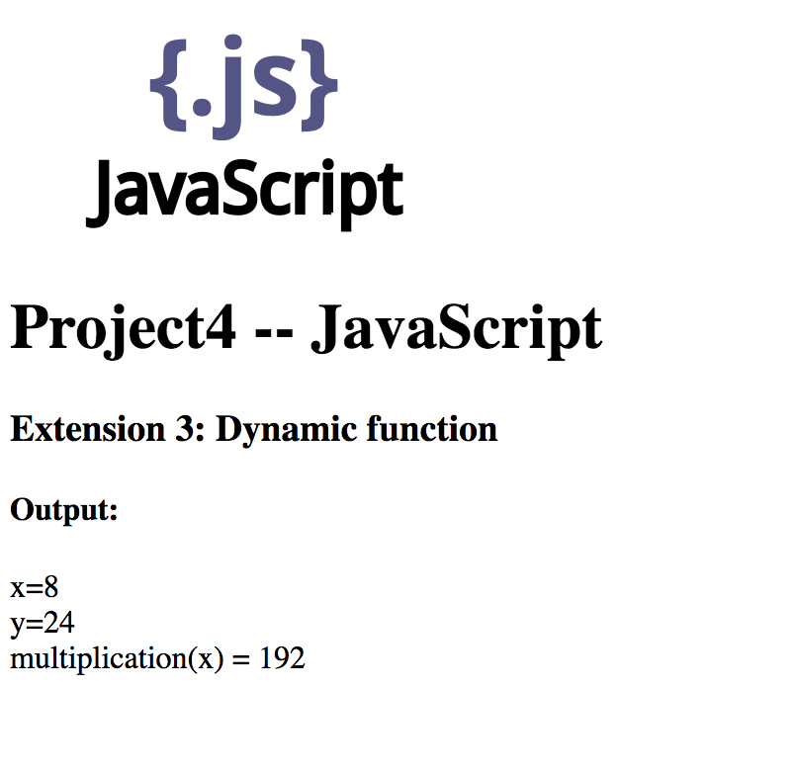

**Extension4**

Explore the precedence and semantics of the C memory operators like & and *, or look at whether your languages have similar capabilities.

**(See the wiki page of JavaScript and C++)**