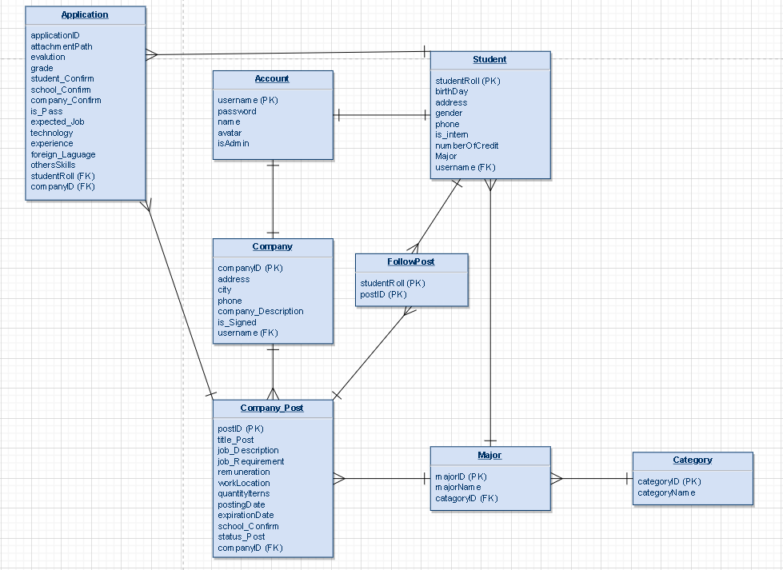

Account (username, password, isAdmin)

Student (studentCode, firstName, lastName, bithDay, address, gender, phone, is_itern, avatar, numberOfCredit)

Student_Account (username, studentCode)

Company (companyID, companyName, companyPhone, city, address, companyDescription, logo, is_Signed)

FollowJob (studentCode, companyID)

Company_Account (username, companyId)

Company_Post (PostID, titlePost, jobDescription, jobRequirement, remuneration, workLocation, quantityIterns, postingDate, expirationDate, school_Confirm, statusPost, companyID, Major_ID)

Category (Category_ID, categoryName)

Major (Major_ID, majorName, Category_ID)

Application (application_ID, attachmentPath, evalution, grade, student_confirm, school_Confirm, company_confirm, is_Pass, expected_Job, Technology, Experience, Foreign_Language, otherSkills postCompany_ID, student_ID)