# **Windows Forms + EntityFrameworkCore or ADO.NET Core**

Thiết kế form và thao tác với CSDL dùng EntityFrameworkCore hoặc ADO.NET – Không kết nối trực tiếp, kết nối thông qua Repositoty và ADO.NET.

1. You must **use Windows Forms application using 3-Layer architecture.**
2. Create your MS SQL database named **EmployeeJobTitle** by running code in script **EmployeeJobTitle.sql.**
3. Set the default form for your project as **Login** form.

Create an application using Windows Forms with .NET Core, C#, and ADO.NET (or Entity Framework Core). A MS SQL Server database will be created to persist the data and it will be used for reading and managing data.

**EmployeeJobTitle management database**

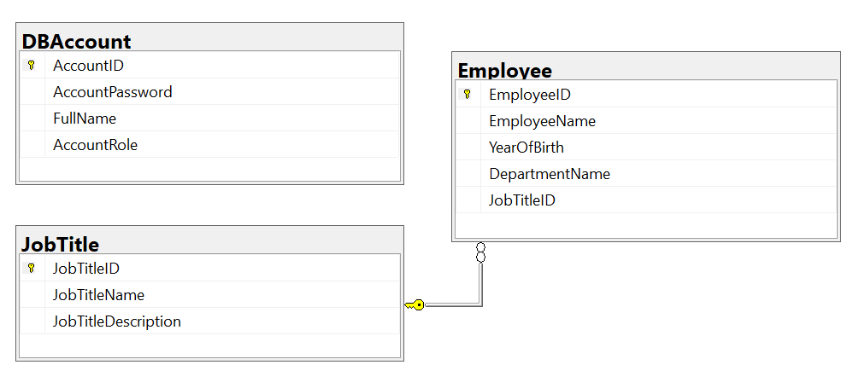

*Account role: Administrator = 1; Manager = 2; Staff = 3*

1. Design Login form includes UI controls for login function.
2. Design Management form, this form includes UI controls for CRUD actions with employee information. Note: The JobTitleID/Name will come from the JobTitle table. Design a form which allows you to view the list of records, create a new item, update the existing item, and delete a specific record.
3. Authentication function

If user with a *administrator role* logs in successfully, save this information to a temporary parameter. All CRUD actions are required with authentication. In the case login unsuccessfully, display *“You are not allowed to access this function!”*.

1. Check if login successfully, list all employees in **Employee** table.
2. Check if login successfully, search employees by Department Name.
3. Check if login successfully, delete the selected item with the confirmation then update the list of employees.
4. Check if login successfully, add new item with the r*equirements:*

* The JobTitleID/Name will come from the *JobTitle* table (you can use ComboBox UI control in this case)
* All fields are required.
* Value for Year of birth from 1960 - 2002.
* Value for Employee Name is greater than 10 characters. Each word of the Employee Name must begin with the capital letter.

1. Check if login successfully, update an existing item.

* You can use your different form or use the data grid for this update function. With update function, the *same validation requirements with* *Add*function.