Figure Method 1 - 1 + 2 + 3 + 4

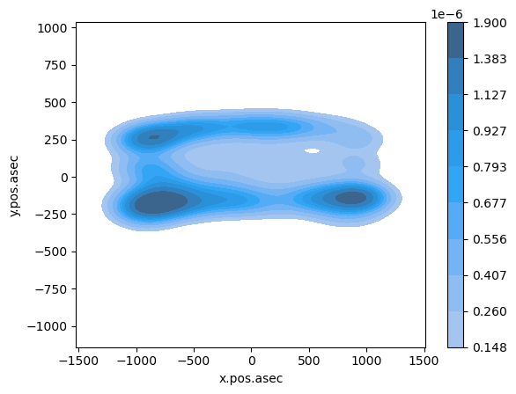

Figure 1 Method 1 - 1 + 2 + 3 + 4

Figure 2 Method 1 - 21 + 22 + 23 + 24

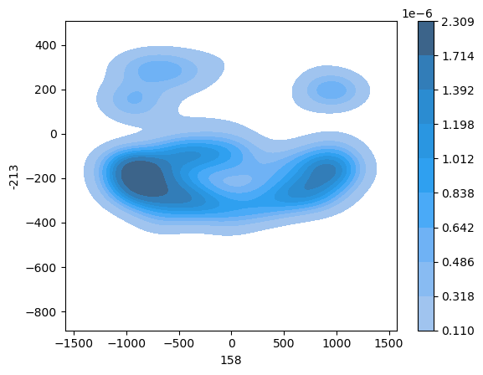

Figure 2 Method 1 - 21 + 22 + 23 + 24

Figure 3 Method 2 - 1 + 2 + 3 + 4



Figure 3 Method 2 - 1 + 2 + 3 + 4

Figure 4 Method 2 - 21 + 22 + 23 + 24



Figure 4 Method 2 - 21 + 22 + 23 + 24

Figure 1 and Figure 3 are incredibly similar. With the distancing between the densest points being about 2000. The densest areas are around -1000 and 1000. However, around -1000 there is a second dense area that is much smaller. However, using method 2 for 1 + 2 + 3 + 4 made the least dense areas even less dense, but it means the denser areas are more specific. There is a gap of around 600 in both figures which means that that area has absolutely no density at all. However, the 21 + 22 + 23 + 24 figures are much more interesting. There is a large gap to an island of density around 1000 which means that the density higher up on the y axis is suddenly higher than that lower on the y axis. However, the density in these two figures is less evenly distributed versus on the 1 + 2 + 3 + 4 figures. These two figures are closer to being placed randomly, but they are still quite close to each other, allowing the density to be quite together.