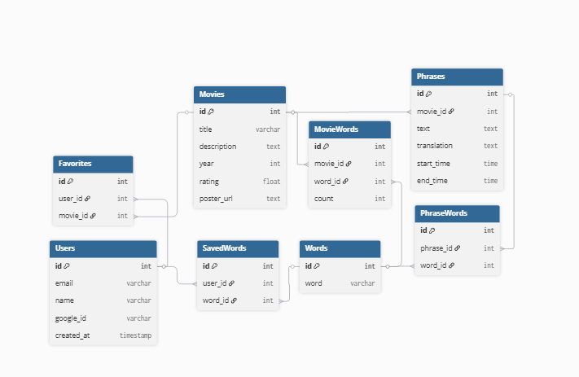
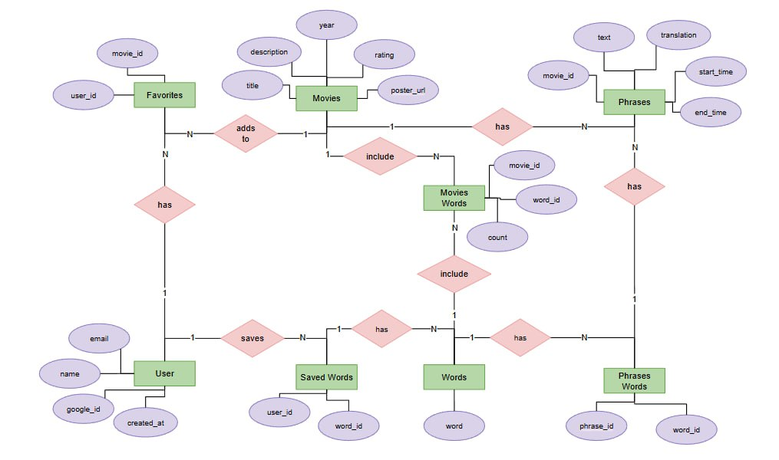

-- USERS
CREATE TABLE Users (
id SERIAL PRIMARY KEY,
email VARCHAR(255),
name VARCHAR(255),
google_id VARCHAR(255),
created_at TIMESTAMP
);

-- MOVIES
CREATE TABLE Movies (
id SERIAL PRIMARY KEY,
title VARCHAR(255),
description TEXT,
year INT,
rating FLOAT,
poster_url TEXT
);

-- PHRASES
CREATE TABLE Phrases (
id SERIAL PRIMARY KEY,
movie_id INT REFERENCES Movies(id),
text TEXT,
translation TEXT,
start_time TIME,
end_time TIME
);

-- WORDS
CREATE TABLE Words (
id SERIAL PRIMARY KEY,
word VARCHAR(255)
);

-- MOVIE_WORDS
CREATE TABLE MovieWords (
id SERIAL PRIMARY KEY,
movie_id INT REFERENCES Movies(id),
word_id INT REFERENCES Words(id),
count INT
);

-- PHRASE_WORDS
CREATE TABLE PhraseWords (
id SERIAL PRIMARY KEY,
phrase_id INT REFERENCES Phrases(id),
word_id INT REFERENCES Words(id)
);

-- FAVORITES
CREATE TABLE Favorites (
id SERIAL PRIMARY KEY,
user_id INT REFERENCES Users(id),
movie_id INT REFERENCES Movies(id)
);

-- SAVED_WORDS
CREATE TABLE SavedWords (
id SERIAL PRIMARY KEY,
user_id INT REFERENCES Users(id),
word_id INT REFERENCES Words(id)
);

