TEXT FILE MANAGEMENT

plan
- Presentation
- Features
- Compile
- Launching
- Tree structure
- Author

- Presentation
Our project is an application with c language that permits us to manage a stock of products. These features are:
Add product
Change product
Delete product
Search product
View product
Leave

Each functionality is important, my team and me built this project to execute with terminal and use structure to save data
features. The menu is :
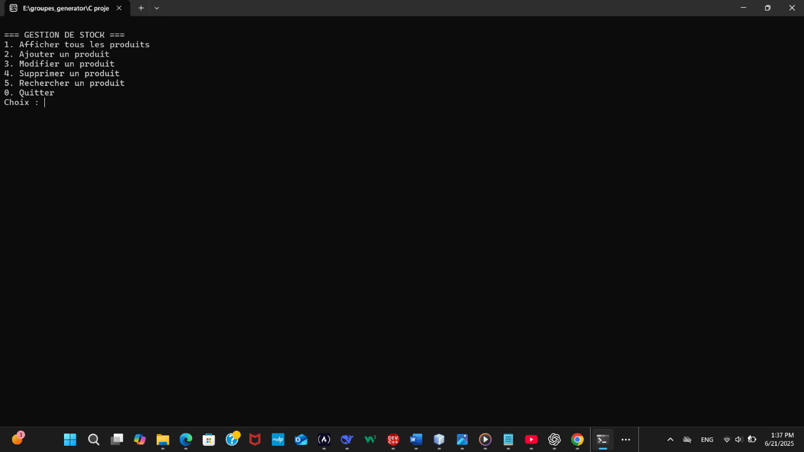
- Add product
The add, you must enter first the name of your project, the quantity and your tape input. The ID will genera automatedly.

- Change product
For this option, you must choose the ID that you want to change and after you enter the new name and quantity.
- Delete product
For that you must choose the option what you want, if you want to choose to delete by ID of product. The product will be deleted.
- Search product
You can search by ID or name of product, and you do input, the product that you choose will view.

- View product
It permits you to visualize the list of products
- Leave
It permits you to stop execution, and if you choose it the question concerning saving will ask you.
That is an example
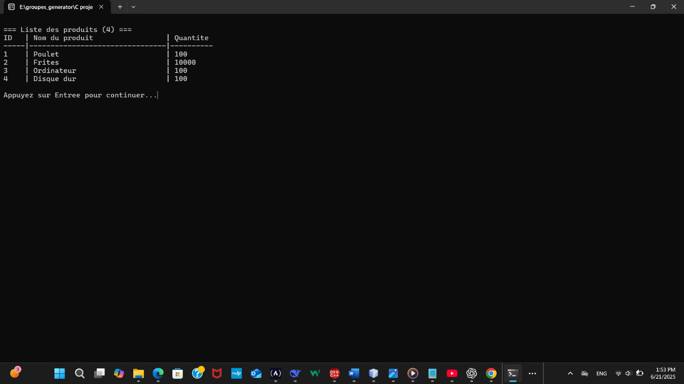
- Author
LAST NAME | FIRST NAME
TRAORE | Ramatou
NKUNA | Israel
NITIEMA | Eddy
SIMPORE | Alima
N ZOMBIE | Rodrigue

