Proiect
1. Creare colectii

create.js:

use('proiect');

db.customers.drop();
db.prices.drop();
db.tickets.drop();
db.movies.drop();

db.createCollection("customers");
db.createCollection("prices");
db.createCollection("tickets");
db.createCollection("movies");

2. Inserare Date

insert.js:

use('proiect');

db.customers.insertMany([
{
_id: 'c1',
first_name: 'john',
last_name: 'smith',
phone: '0711111111',
email: 'john.smith@gmail.com'
},
{
_id: 'c2',
first_name: 'anna',
last_name: 'brown',
phone: '0722222222',
email: 'anna.brown@gmail.com'
},
{
_id: 'c3',
first_name: 'mike',
last_name: 'johnson',
phone: '0733333333',
email: 'mike.johnson@gmail.com'
},
{
_id: 'c4',
first_name: 'lisa',
last_name: 'wilson',
phone: '0744444444',
email: 'lisa.wilson@gmail.com'
},
{
_id: 'c5',
first_name: 'alex',
last_name: 'taylor',
phone: '0755555555',
email: 'alex.taylor@gmail.com'
},
{
_id: 'c6',
first_name: 'emma',
last_name: 'anderson',
phone: '0766666666',
email: 'emma.anderson@gmail.com'
},
{
_id: 'c7',
first_name: 'daniel',
last_name: 'thomas',
phone: '0777777777',
email: 'daniel.thomas@gmail.com'
},
{
_id: 'c8',
first_name: 'sophia',
last_name: 'martin',
phone: '0788888888',
email: 'sophia.martin@gmail.com'
},
{
_id: 'c9',
first_name: 'chris',
last_name: 'lee',
phone: '0799999999',
email: 'chris.lee@gmail.com'
},
{
_id: 'c10',
first_name: 'olivia',
last_name: 'clark',
phone: '0700000000',
email: 'olivia.clark@gmail.com'
},
{
_id: 'c11',
first_name: 'andrew',
last_name: 'lewis',
phone: '0712345678',
email: 'andrew.lewis@gmail.com'
},
{
_id: 'c12',
first_name: 'mia',
last_name: 'walker',
phone: '0723456789',
email: 'mia.walker@gmail.com'
},
{
_id: 'c13',
first_name: 'james',
last_name: 'hall',
phone: '0734567890',
email: 'james.hall@gmail.com'
},
{
_id: 'c14',
first_name: 'isabella',
last_name: 'young',
phone: '0745678901',
email: 'isabella.young@gmail.com'
},
{
_id: 'c15',
first_name: 'robert',
last_name: 'king',
phone: '0756789012',
email: 'robert.king@gmail.com'
},
{
_id: 'c16',
first_name: 'amelia',
last_name: 'wright',
phone: '0767890123',
email: 'amelia.wright@gmail.com'
},
{
_id: 'c17',
first_name: 'david',
last_name: 'lopez',
phone: '0778901234',
email: 'david.lopez@gmail.com'
},
{
_id: 'c18',
first_name: 'charlotte',
last_name: 'hill',
phone: '0789012345',
email: 'charlotte.hill@gmail.com'
},
{
_id: 'c19',
first_name: 'kevin',
last_name: 'scott',
phone: '0790123456',
email: 'kevin.scott@gmail.com'
},
{
_id: 'c20',
first_name: 'eva',
last_name: 'green',
phone: '0701234567',
email: 'eva.green@gmail.com'
}
]);

db.movies.insertMany([
{
name: 'Anaconda',
length_minutes: 100,
minimum_age: 12,
genre: ['Action', 'Adventure', 'Comedy', 'Thriller', 'Horror'],
date: new Date("2026-01-30")
},
{
name: 'Avatar:Fire and Ash',
length_minutes: 197,
minimum_age: 12,
genre: ['Action', 'Adventure', 'Fantasy', 'Thriller'],
date: new Date("2025-12-19")
},
{
name: 'Bloody Chrismas',
length_minutes: 97,
minimum_age: 18,
genre: ['Horror'],
date: new Date('2025-12-12')
},
{
name: 'Cravata Galbena',
length_minutes: 145,
minimum_age: 0,
genre: ['Drama', 'Adventure', 'Musical'],
date: new Date('2025-11-14')
},
{
name: 'Colors of Time',
length_minutes: 124,
minimum_age: 12,
genre: ['Drama', 'Crime', 'Thriller', 'Comedy'],
date: new Date('2025-12-19')
},
{
name: 'Five nights at Freddy`s 2',
length_minutes: 104,
minimum_age: 15,
genre: ['Horror', 'Mistery', 'Thriller'],
date: new Date('2025-12-05')
},
{
name: 'The Housemaid',
length_minutes: 132,
minimum_age: 15,
genre: ['Thriller'],
date: new Date('2026-01-02')
},
{
name: 'I didn`t have a choice',
length_minutes: 139,
minimum_age: 15,
genre: ['Horror', 'Comedy', 'Crime', 'Thriller'],
date: new Date('2026-01-02')
},
{
name: 'Spongebob',
length_minutes: 96,
minimum_age: 0,
genre: ['Animation', 'Adventure', 'Familly', 'Comedy', 'Fantasy'],
date: new Date('2026-12-26')
},
{
name: 'Zootopia 2',
length_minutes: 107,
minimum_age: 0,
genre: ['Animation', 'Adventure', 'Familly'],
date: new Date('2025-11-28')
}
]);

db.prices.insertMany([
{
ticket_type: 'familly',
price: 30
},
{
ticket_type: 'student',
price: 25
},
{
ticket_type: 'senior',
price: 20
},
{
ticket_type: 'adult',
price: 45
},
{
ticket_type: 'child',
price: 20
}
]);

db.tickets.insertMany([
{
customer: 'c1',
movie: 'Anaconda',
ticket_type: 'adult',
date: new ISODate('2026-01-20T18:30:00Z'),
row: 5,
seat: 8,
room: 2,
cinema: { name: 'cinema1', city: 'Bucharest' }
},
{
customer: 'c2',
movie: 'Zootopia 2',
ticket_type: 'child',
date: new ISODate('2025-11-29T12:00:00Z'),
row: 3,
seat: 6,
room: 1,
cinema: { name: 'cinema2', city: 'Cluj' }
},
{
customer: 'c2',
movie: 'Spongebob',
ticket_type: 'familly',
date: new ISODate('2026-12-27T10:30:00Z'),
row: 4,
seat: 7,
room: 1,
cinema: { name: 'cinema2', city: 'Cluj' }
},
{
customer: 'c3',
movie: 'The Housemaid',
ticket_type: 'adult',
date: new ISODate('2026-01-05T20:00:00Z'),
row: 6,
seat: 11,
room: 3,
cinema: { name: 'cinema3', city: 'Timisoara' }
},
{
customer: 'c3',
movie: 'Colors of Time',
ticket_type: 'student',
date: new ISODate('2025-12-20T17:45:00Z'),
row: 2,
seat: 4,
room: 2,
cinema: { name: 'cinema3', city: 'Timisoara' }
},
{
customer: 'c4',
movie: 'Cravata Galbena',
ticket_type: 'senior',
date: new ISODate('2025-11-16T16:00:00Z'),
row: 1,
seat: 2,
room: 1,
cinema: { name: 'cinema1', city: 'Bucharest' }
},
{
customer: 'c4',
movie: 'Colors of Time',
ticket_type: 'adult',
date: new ISODate('2025-12-21T19:00:00Z'),
row: 7,
seat: 9,
room: 2,
cinema: { name: 'cinema1', city: 'Bucharest' }
},
{
customer: 'c5',
movie: 'Avatar:Fire and Ash',
ticket_type: 'adult',
date: new ISODate('2026-01-10T21:00:00Z'),
row: 8,
seat: 15,
room: 4,
cinema: { name: 'cinema4', city: 'Iasi' }
},
{
customer: 'c5',
movie: 'Anaconda',
ticket_type: 'adult',
date: new ISODate('2026-02-01T18:00:00Z'),
row: 6,
seat: 10,
room: 2,
cinema: { name: 'cinema4', city: 'Iasi' }
},
{
customer: 'c6',
movie: 'Spongebob',
ticket_type: 'familly',
date: new ISODate('2026-12-26T11:00:00Z'),
row: 2,
seat: 5,
room: 1,
cinema: { name: 'cinema2', city: 'Cluj' }
},
{
customer: 'c6',
movie: 'Zootopia 2',
ticket_type: 'familly',
date: new ISODate('2025-11-28T14:00:00Z'),
row: 3,
seat: 8,
room: 1,
cinema: { name: 'cinema2', city: 'Cluj' }
},
{
customer: 'c7',
movie: 'Five nights at Freddy`s 2',
ticket_type: 'student',
date: new ISODate('2025-12-06T22:00:00Z'),
row: 9,
seat: 18,
room: 5,
cinema: { name: 'cinema5', city: 'Brasov' }
},
{
customer: 'c7',
movie: 'I didn`t have a choice',
ticket_type: 'student',
date: new ISODate('2026-01-03T21:30:00Z'),
row: 8,
seat: 14,
room: 4,
cinema: { name: 'cinema5', city: 'Brasov' }
},
{
customer: 'c8',
movie: 'Spongebob',
ticket_type: 'child',
date: new ISODate('2026-12-26T11:00:00Z'),
row: 3,
seat: 4,
room: 1,
cinema: { name: 'cinema2', city: 'Cluj' }
},
{
customer: 'c9',
movie: 'Spongebob',
ticket_type: 'familly',
date: new ISODate('2026-12-26T11:00:00Z'),
row: 3,
seat: 5,
room: 1,
cinema: { name: 'cinema2', city: 'Cluj' }
},
{
customer: 'c10',
movie: 'Spongebob',
ticket_type: 'familly',
date: new ISODate('2026-12-26T11:00:00Z'),
row: 3,
seat: 6,
room: 1,
cinema: { name: 'cinema2', city: 'Cluj' }
},
{
customer: 'c11',
movie: 'Anaconda',
ticket_type: 'adult',
date: new ISODate('2026-01-20T18:30:00Z'),
row: 5,
seat: 9,
room: 2,
cinema: { name: 'cinema1', city: 'Bucharest' }
},
{
customer: 'c12',
movie: 'Anaconda',
ticket_type: 'student',
date: new ISODate('2026-01-20T18:30:00Z'),
row: 5,
seat: 10,
room: 2,
cinema: { name: 'cinema1', city: 'Bucharest' }
},
{
customer: 'c13',
movie: 'Avatar:Fire and Ash',
ticket_type: 'adult',
date: new ISODate('2026-01-10T21:00:00Z'),
row: 8,
seat: 16,
room: 4,
cinema: { name: 'cinema4', city: 'Iasi' }
},
{
customer: 'c14',
movie: 'Avatar:Fire and Ash',
ticket_type: 'student',
date: new ISODate('2026-01-10T21:00:00Z'),
row: 8,
seat: 17,
room: 4,
cinema: { name: 'cinema4', city: 'Iasi' }
},
{
customer: 'c15',
movie: 'Colors of Time',
ticket_type: 'adult',
date: new ISODate('2025-12-19T19:00:00Z'),
row: 7,
seat: 10,
room: 2,
cinema: { name: 'cinema1', city: 'Bucharest' }
},
{
customer: 'c16',
movie: 'Colors of Time',
ticket_type: 'senior',
date: new ISODate('2025-12-19T19:00:00Z'),
row: 7,
seat: 11,
room: 2,
cinema: { name: 'cinema1', city: 'Bucharest' }
},
{
customer: 'c17',
movie: 'Five nights at Freddy`s 2',
ticket_type: 'student',
date: new ISODate('2025-12-06T22:00:00Z'),
row: 9,
seat: 19,
room: 5,
cinema: { name: 'cinema5', city: 'Brasov' }
},
{
customer: 'c18',
movie: 'Five nights at Freddy`s 2',
ticket_type: 'adult',
date: new ISODate('2025-12-06T22:00:00Z'),
row: 9,
seat: 20,
room: 5,
cinema: { name: 'cinema5', city: 'Brasov' }
},
{
customer: 'c19',
movie: 'I didn`t have a choice',
ticket_type: 'adult',
date: new ISODate('2026-01-03T21:30:00Z'),
row: 8,
seat: 15,
room: 4,
cinema: { name: 'cinema5', city: 'Brasov' }
},
{
customer: 'c20',
movie: 'I didn`t have a choice',
ticket_type: 'child',
date: new ISODate('2026-01-03T21:30:00Z'),
row: 8,
seat: 16,
room: 4,
cinema: { name: 'cinema5', city: 'Brasov' }
}
]);

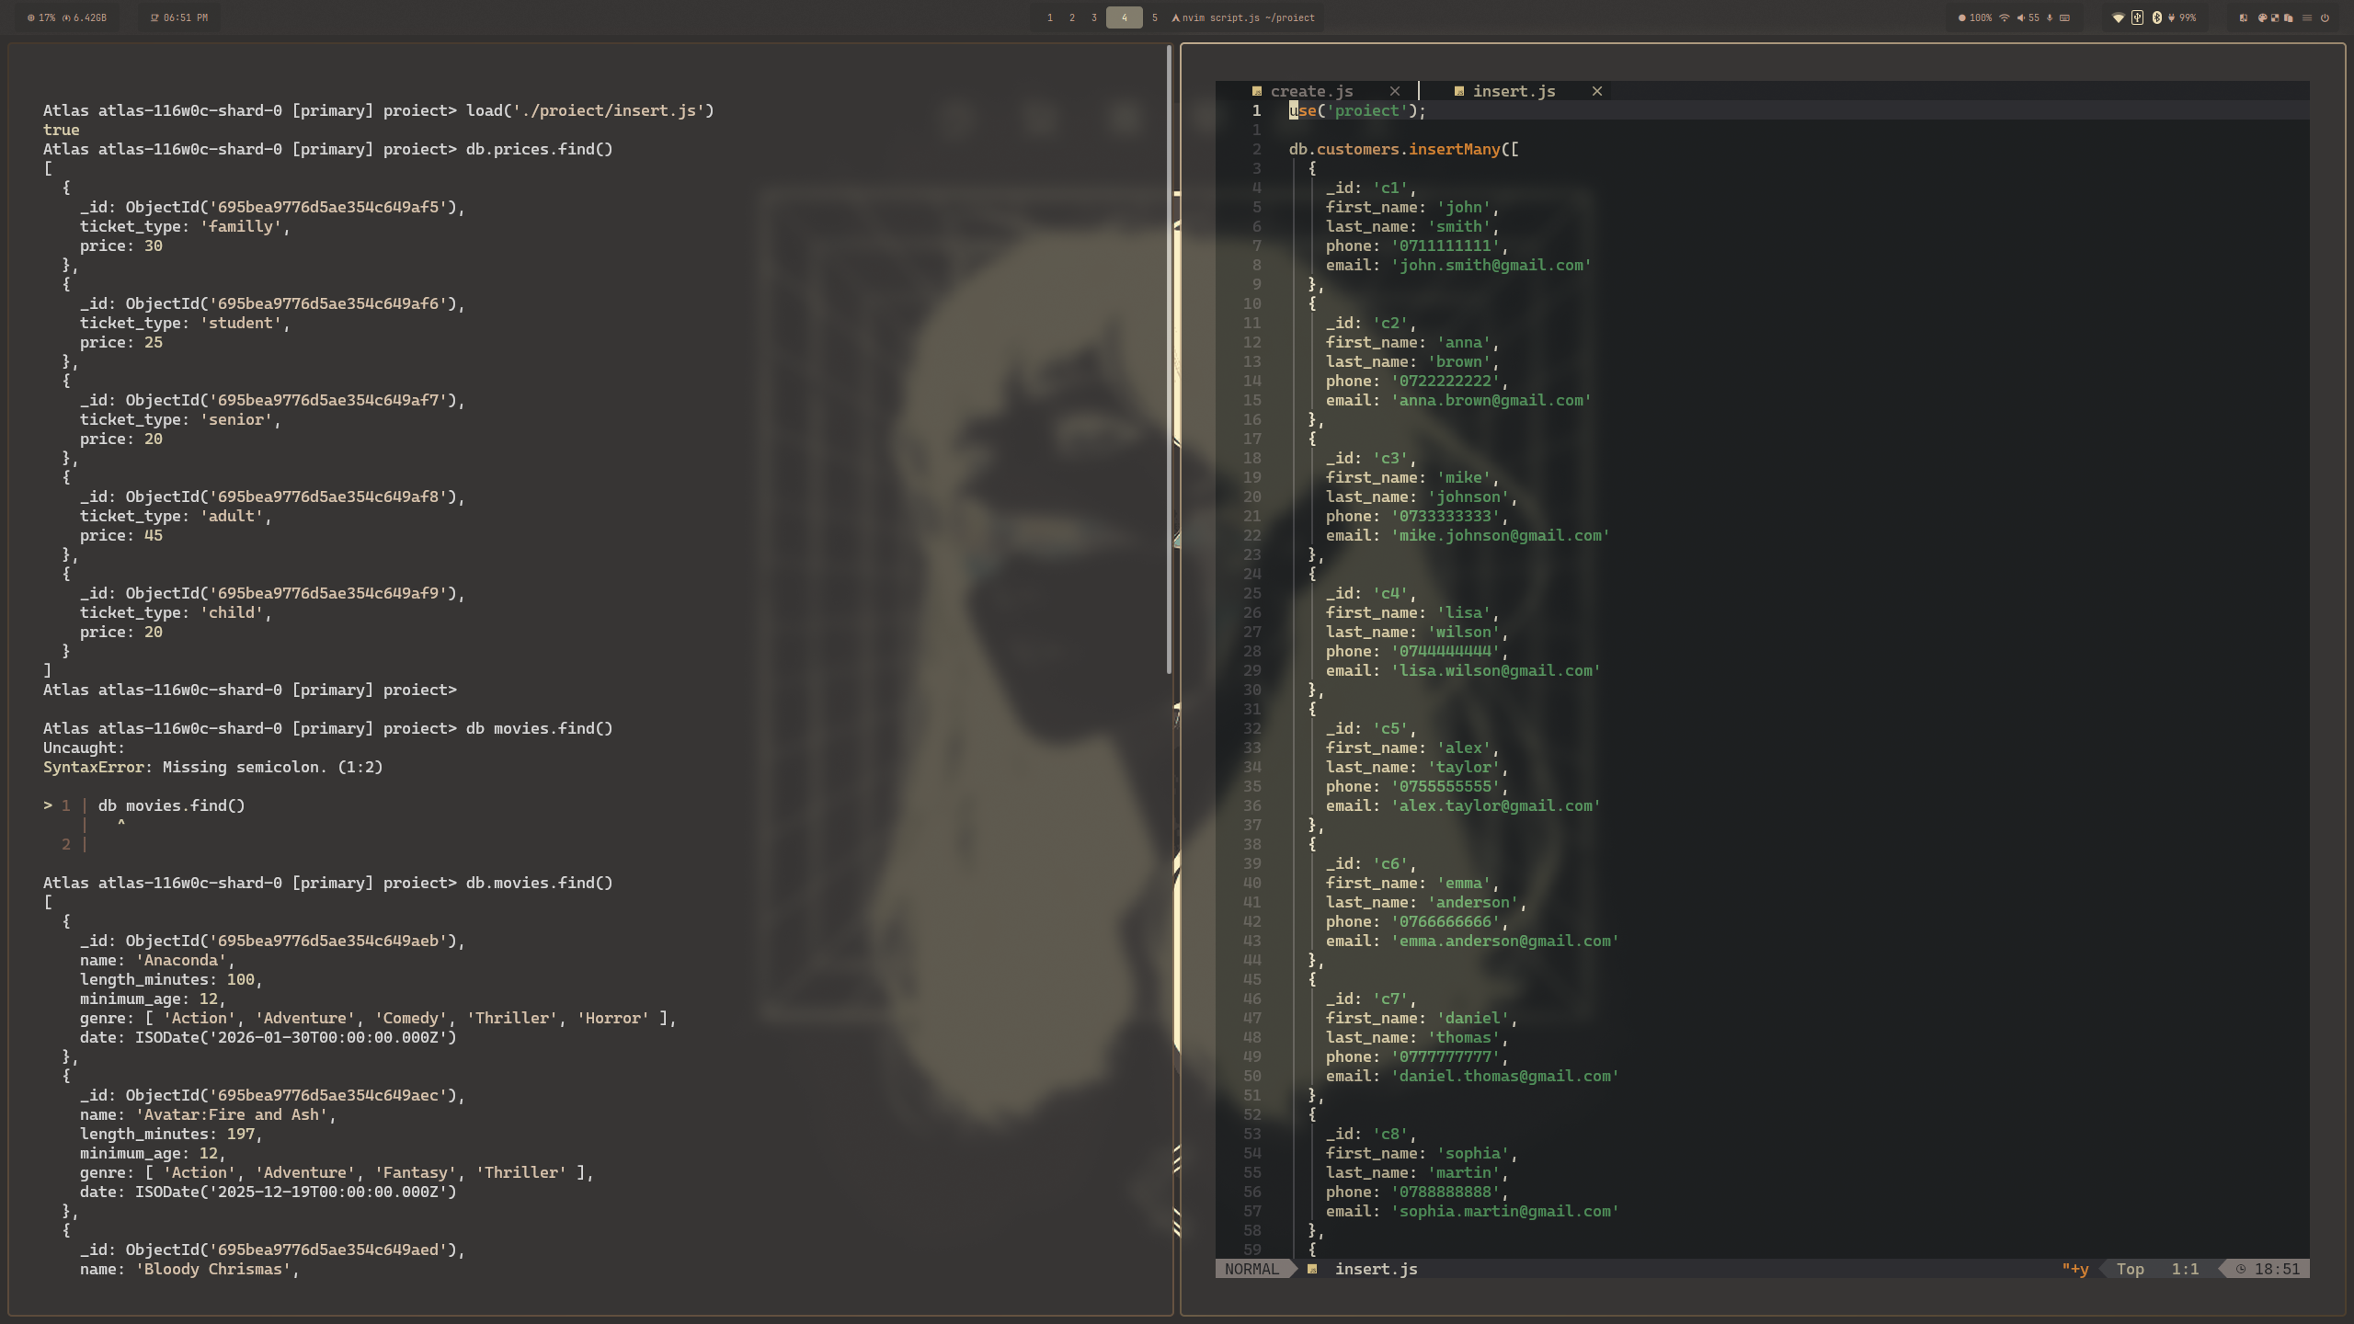
3. Total generat de film + Nr bilete vandute
use('proiect');

printjson(
db.tickets.aggregate(
{
$lookup: {
from: "prices",
localField: "ticket_type",
foreignField: "ticket_type",
as: "price"
}
},
{
$unwind: '$price'
},
{
$group:
{
_id: '$movie',
total: { $sum: '$price.price' },
nOfTickets: { $sum: 1 }
}
},
{
$project:
{
_id: 0,
total: 1,
nOfTickets: 1,
movie: '$_id'
}
}
));

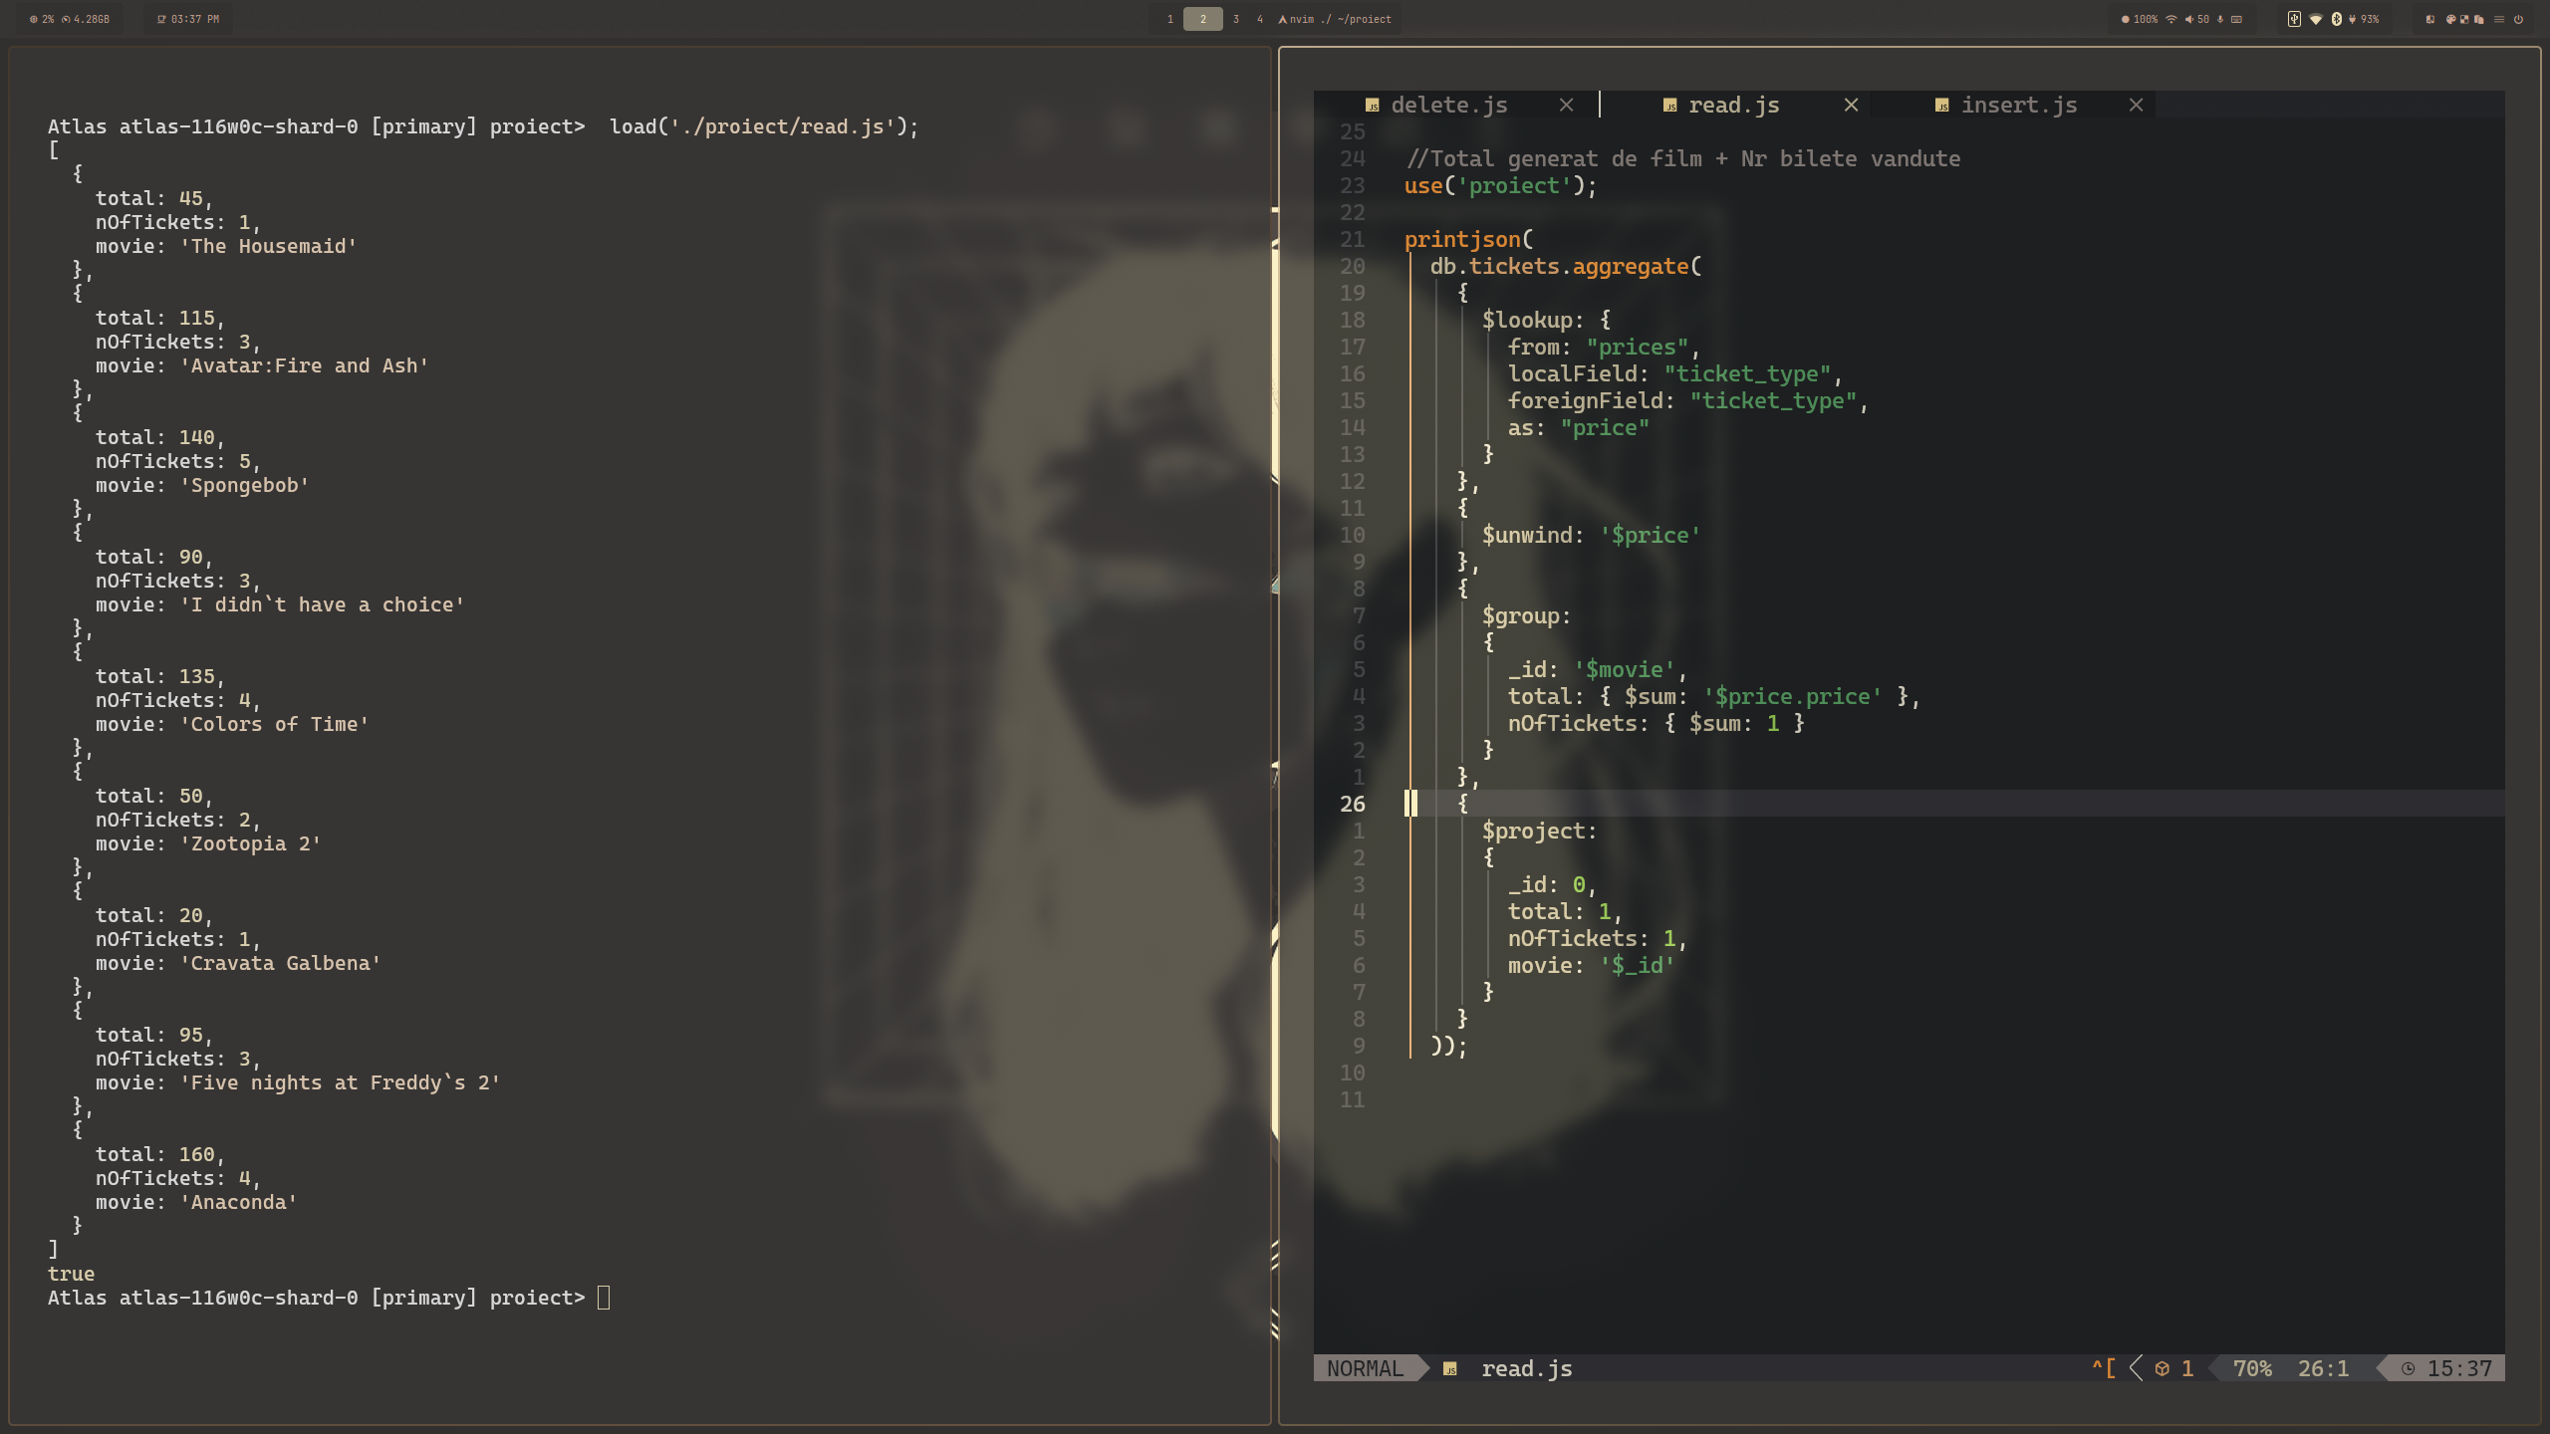
4. Movie Ranking

( sintaxa posibila doar pentru versiuni mai mari de 5.0, link: https://www.mongodb.com/docs/manual/reference/operator/aggregation/setWindowFields/ )

printjson(
db.tickets.aggregate([
{
$group: {
_id: "$movie",
totalTickets: { $sum: 1 }
}
},
{ $sort: { totalTickets: -1 } },

{
$setWindowFields: {
sortBy: { totalTickets: -1 },
output: {
rank: { $rank: {} }
}
}
}
])

);

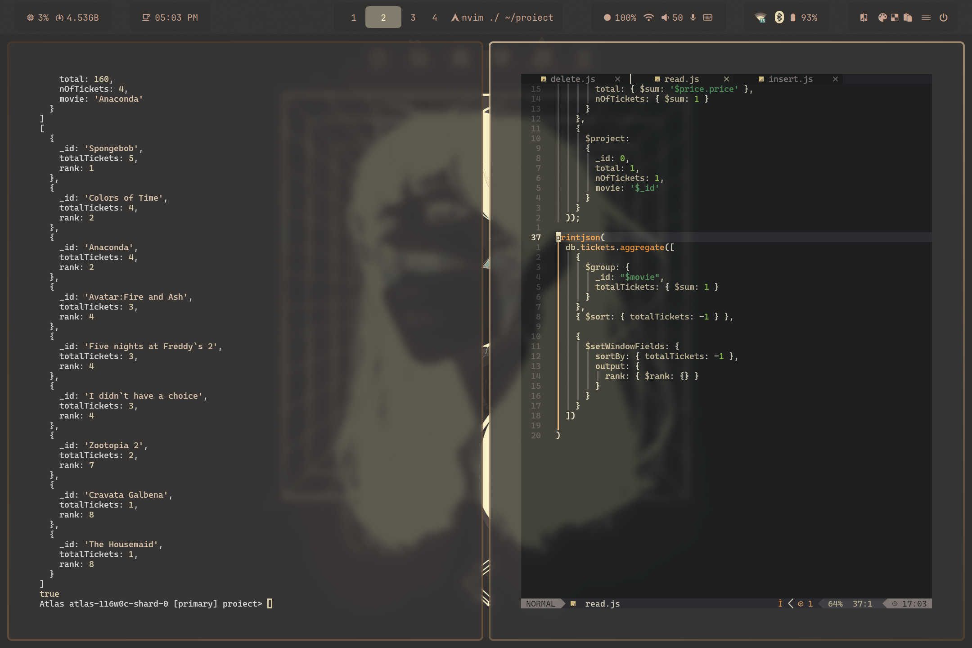
5. Profit si numarul de bilete per categorie
printjson(
db.tickets.aggregate(
{
$lookup: {
from: "prices",
localField: "ticket_type",
foreignField: "ticket_type",
as: "price"
}
},
{
$lookup: {
from: "movies",
localField: "movie",
foreignField: "name",
as: "movie"
}
},
{
$unwind: "$price"
},
{
$unwind: "$movie"
},
{
$unwind: "$movie.genre"
},
{
$group:
{
_id: "$movie.genre",
ticket_count: { $sum: 1 },
revenue: { $sum: '$price.price' }
}
},
{
$project:
{
_id: 0,
genre: '$_id',
ticket_count: 1,
revenue: 1
}
},
{
$sort: {
revenue: -1,
ticket_count: -1
}
}
)
);

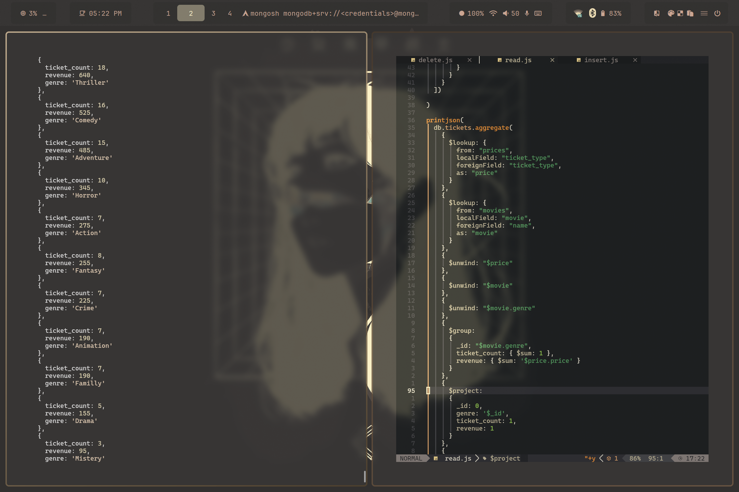

6. Clientul care a cumparat cele mai multe bilete
printjson(
db.tickets.aggregate(
{
$lookup: {
from: "customers",
localField: "customer",
foreignField: "_id",
as: "customer"
}
},
{
$unwind: "$customer"
},
{
$group:
{
_id: '$customer',
ticket_count: { $sum: 1 }
}
},
{
$addFields:
{
fullname: { $concat: ['$_id.first_name', ' ', '$_id.last_name'] }
}
},
{
$project:
{
_id: 0,
fullname: 1,
ticket_count: 1
}
},
{
$sort: {
ticket_count: -1
}
},
{
$limit: 1
}
)
)

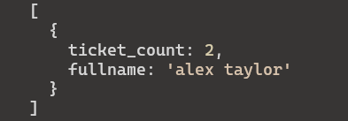
7. Stergere filme din anii anterior
use('proiect');

let toDelete = db.movies.find({
date: {
$lt: new Date(new Date().getFullYear(), 0, 1)
}
})
.toArray()
.map(m => m.name);

db.movies.deleteMany({
name: { $in: toDelete }
});

db.tickets.deleteMany({
movie: { $in: toDelete }
})

printjson(
db.movies.find()
);

printjson(
db.tickets.find()
)

load('./proiect/create.js')
load('./proiect/insert.js');

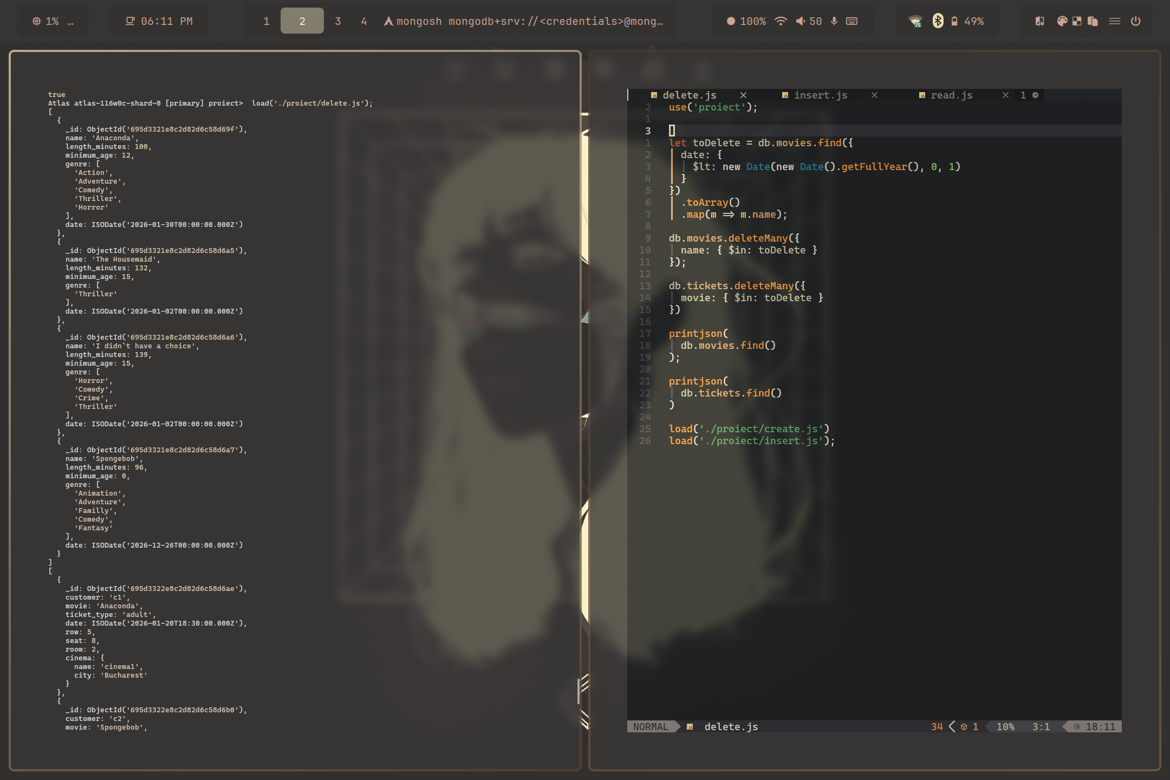

8. Reduceri pentru categoria care a vandut cele mai multe bilete

use('proiect');

let category = db.tickets.aggregate(
{
$group: {
_id: "$ticket_type",
ticket_count: { $sum: 1 }
}
},
{
$sort: {
ticket_count: -1
}
},
{
$limit: 1
},
{
$project: {
_id: 0,
type: "$_id"
}
}
)
.toArray()
.map(c => c.type);

printjson(
db.prices.find(
{
ticket_type: { $in: category }
}
));

db.prices.updateMany(
{
ticket_type: { $in: category }
},
[
{
$set: {
price: { $multiply: ["$price", 0.75] }
}
}
]
);

printjson(
db.prices.find(
{
ticket_type: { $in: category }
}
));

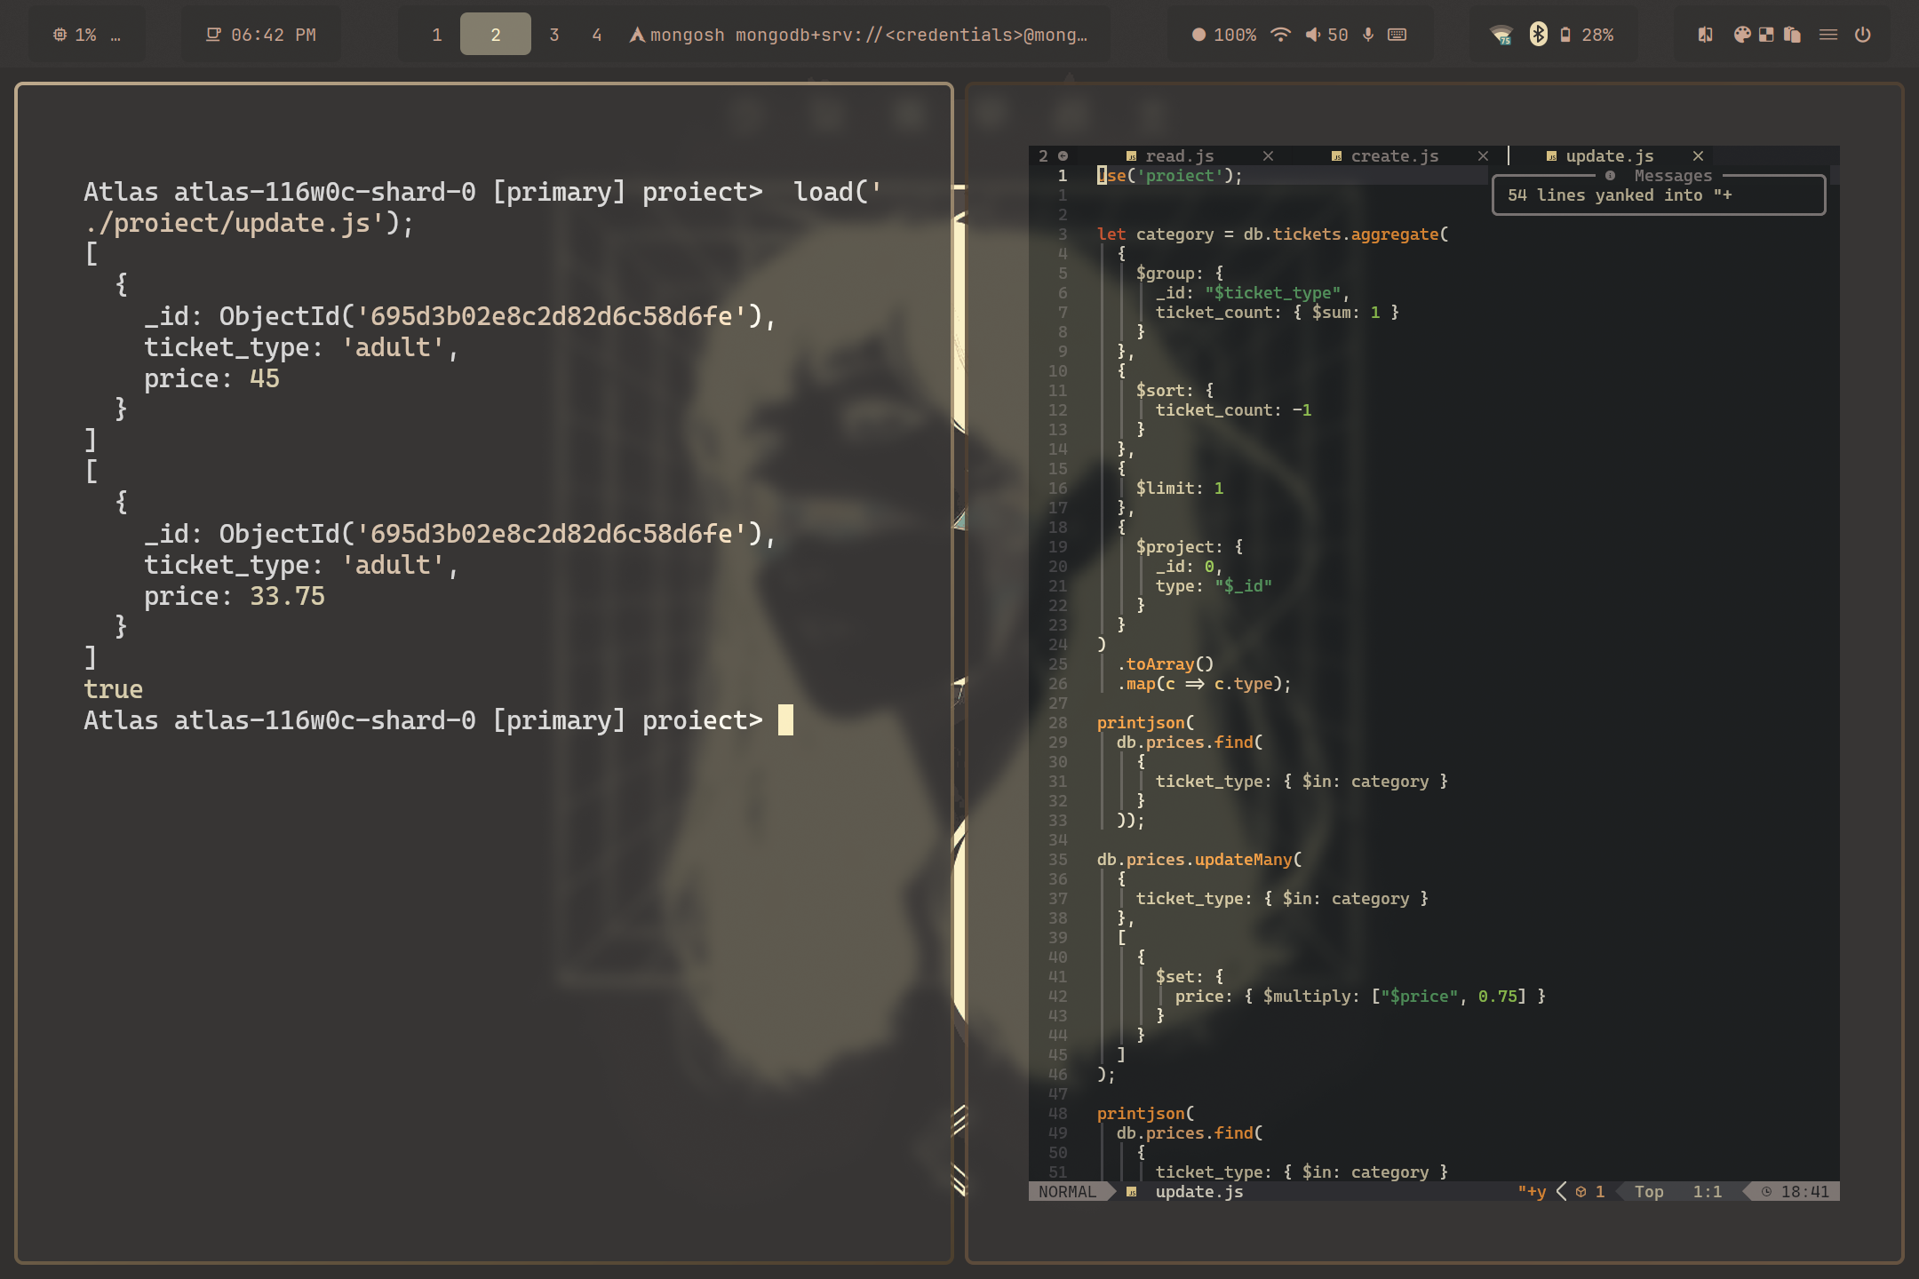
9. Ora la care se termina filmul

printjson(
db.tickets.aggregate([
{
$lookup: {
from: "movies",
localField: "movie",
foreignField: "name",
as: "movie"
}
},
{ $unwind: "$movie" },
{
$addFields: {
end_time: {
$add: [
"$date",
{ $multiply: ["$movie.length_minutes", 60 * 1000] }
]
}
}
},
{
$project: {
_id: 0,
customer: 1,
movie: "$movie.name",
start_time: "$date",
end_time: 1
}
}
])

)

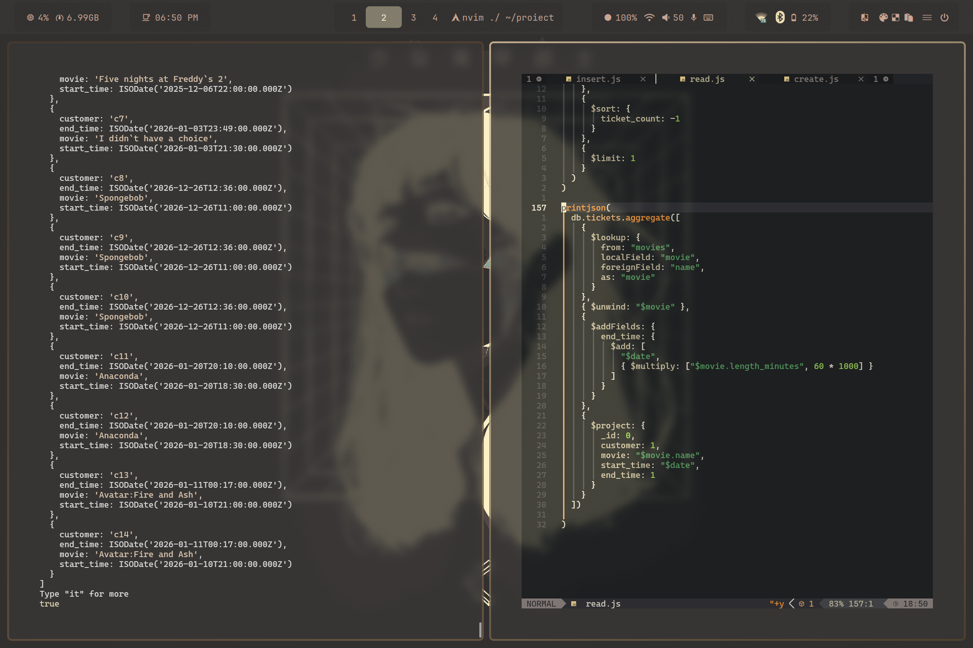
10. Stergere filme ce nu au vandut suficiente bilete

let bronzeMovies = db.tickets.aggregate([
{
$lookup: {
from: "prices",
localField: "ticket_type",
foreignField: "ticket_type",
as: "price"
}
},
{ $unwind: "$price" },
{
$group: {
_id: "$movie",
revenue: { $sum: "$price.price" }
}
},
{
$addFields: {
category: {
$switch: {
branches: [
{ case: { $lt: ["$revenue", 100] }, then: "bronze" },
{ case: { $lt: ["$totalRevenue", 200] }, then: "silver" },
],
default: "gold"
}
}
}
},
{ $match: { category: "bronze" } },
{
$project: {
_id: 0,
movie: "$_id",
totalRevenue: 1,
}
}
]).toArray().map(m => m.name);

db.movies.deleteMany({
name: { $in: bronzeMovies }
})

printjson(
db.movies.find()
);

load('./proiect/create.js')
load('./proiect/insert.js');



