Avail Sourcing Engine
Planning Blueprint & Cursor Handoff Package

Purpose | Generate explainable supplier leads for buyers to follow up and verify stock.
Core model | One lead per vendor per part, with many evidence items.
Scoring | Separate Lead Confidence from Vendor Safety.
Bundle contents | Planning doc, schemas, wireframes, prompts, QA, and decisions.

This document is intended to preserve product intent and reduce ambiguity during handoff to Cursor or an implementation team.

Overview
Purpose: Build a sourcing engine that helps purchasing agents find, prioritize, and safely evaluate vendor leads to contact and verify stock availability.
Primary users: Purchasing agents, sourcing managers, and operations/admin reviewers.
Success definition: A smaller number of strong, explainable leads that reduce manual search time and improve verified-stock follow-up rates.

Product Principles
Explainability over mystery: Every lead must show why it exists, what sources support it, and how fresh the evidence is.
Buyer usefulness over lead volume: A few strong, actionable leads are better than many weak ones.
Human review remains central: The system helps a buyer decide; it does not replace buyer judgment.
Preserve source attribution: Every merged lead must retain its source history and evidence.

Core Domain Model
Lead definition: One lead equals one vendor for one part. A lead may aggregate many evidence items from many sources.
Evidence definition: One evidence item equals one signal that supports or weakens a lead. Evidence should be attributable, time-stamped, and human-readable.

Lead Schema Summary
Category | Key fields | Purpose
Identity | lead_id, part_number_requested, vendor_name, vendor_name_normalized, match_type | Represent one vendor opportunity for one part
Source summary | primary_source_type, primary_source_name, source_reference, source_first_seen_at, source_last_seen_at | Preserve origin and freshness
Buyer usefulness | contact_name, contact_email, contact_phone, contact_url, location, suggested_next_action | Help buyers act quickly
Lead confidence | confidence_score, confidence_band, freshness_score, source_reliability_score, contactability_score, historical_success_score | Rank outreach priority
Explainability | reason_summary, risk_flags, evidence_count, corroborated | Show why the lead exists
Vendor safety | vendor_safety_score, vendor_safety_band, vendor_safety_summary, vendor_safety_flags | Warn buyers about risk
Workflow | buyer_status, buyer_owner_user_id, last_buyer_action_at, buyer_feedback_summary | Support follow-up and learning

Evidence Schema Summary
Category | Key fields | Purpose
Identity | evidence_id, lead_id | Attach multiple signals to one lead
Source | signal_type, source_type, source_name, source_reference | Capture where the signal came from
Observed details | part_number_observed, vendor_name_observed, observed_text, observed_at, freshness_age_days | Record what was seen
Scoring contribution | weight, confidence_impact, explanation | Keep scoring explainable
Verification | source_reliability_band, verification_state | Differentiate raw vs buyer-confirmed signals

Source Strategy
Source | Best use | Stock-confidence contribution | Safety contribution | Notes
API / posting sources | Direct stock-likelihood and freshness | High | Medium | Listing presence does not equal confirmed stock
ICSource / NetComponents | Part-specific discovery and corroboration | Medium-high | Medium | Freshness and legitimacy vary by vendor/listing
Salesforce history | Relationship memory and contact enrichment | Medium | High | Great for trust, weaker for current stock proof
Avail internal history | Internal sourcing memory and buyer learning | Medium | High | Useful for prioritization and feedback loops
AI/current web search | Discovery, enrichment, safety review | Low-medium | Medium | Do not let weak web evidence outrank stronger direct evidence

Scoring Model
Use two separate scoring streams:
- Lead Confidence — how likely the vendor may currently have stock
- Vendor Safety — how comfortable the buyer should feel contacting or relying on the vendor

Lead-confidence factors
- Positive: trusted source, exact/normalized part match, recent signal, multiple-source corroboration, historical vendor success, usable contact information, prior buyer-confirmed good outcomes
- Negative: stale signal, fuzzy-only match, no contact path, low-trust source, repeated bad-lead outcomes, repeated no-stock outcomes

Vendor-safety factors
- Positive: known vendor in Salesforce/Avail, consistent identity across sources, stable domain/contact information, valid business footprint, positive internal history
- Negative: conflicting identity/contact details, missing business footprint, suspicious domain or website patterns, public complaint signals, prior internal bad experiences

Deduplication Policy
- Objective: avoid showing the same vendor multiple times under slightly different identities.
- Auto-merge only on strong signals such as canonical vendor ID, same normalized domain, same normalized phone, or same normalized vendor name plus same part.
- Flag possible duplicates conservatively instead of forcing merges on weak evidence.
- Preserve all source attribution after any merge.

Buyer Workflow
Status | Meaning
New | Lead generated but not yet worked
Contacted | Buyer has made outreach
Replied | Vendor responded but outcome not finalized
No Stock | Buyer confirmed no current stock
Has Stock | Buyer confirmed current stock
Bad Lead | Low-quality, irrelevant, wrong, stale, or unusable
Do Not Contact | Vendor should not be pursued for this lead
Core actions: Mark Contacted, Mark Replied, Mark Has Stock, Mark No Stock, Mark Bad Lead, Mark Do Not Contact, Add Note.

Vendor Trust & Safety Review
Safety review is a decision aid, not an accusation engine. Use caution-oriented language and show supporting signals.
- Output: vendor_safety_band, vendor_safety_summary, vendor_safety_flags, evidence list, suggested caution action
- Recommended language: risk indicators found, identity consistency is weak, manual verification recommended
- Avoid definitive accusations or silent suppression based only on weak web/AI signals

Screen & Wireframe Spec

Sourcing Results View
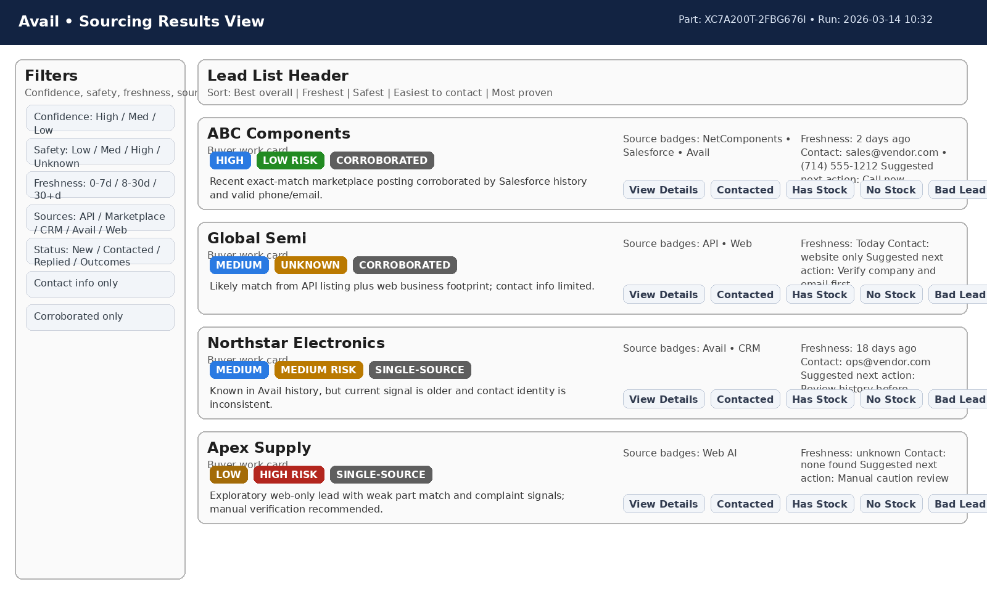
Purpose: Buyer work queue for a selected part, with confidence, safety, source badges, freshness, contact preview, suggested action, and quick actions.

Lead Detail View
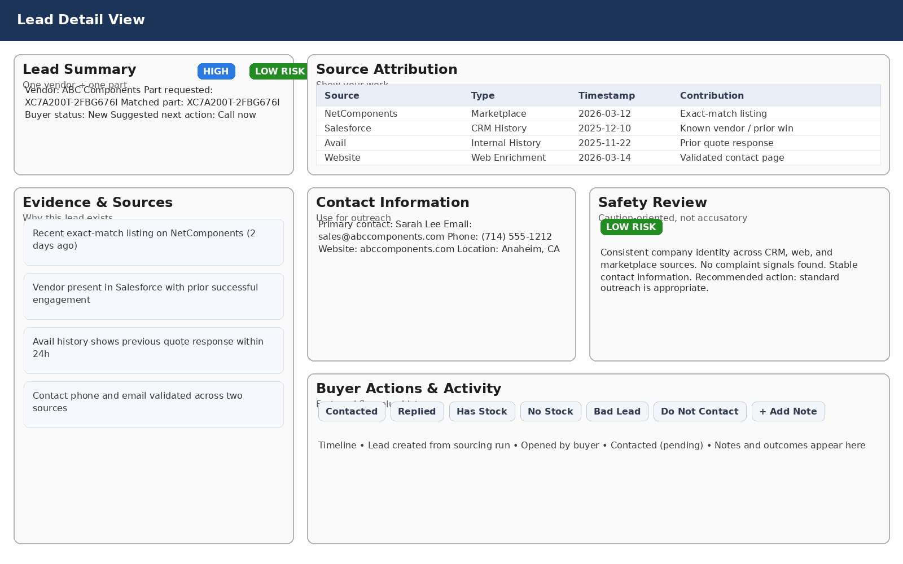
Purpose: Full evidence and decision support with source attribution, contact information, safety review, buyer actions, and activity timeline.

Buyer Follow-Up Queue
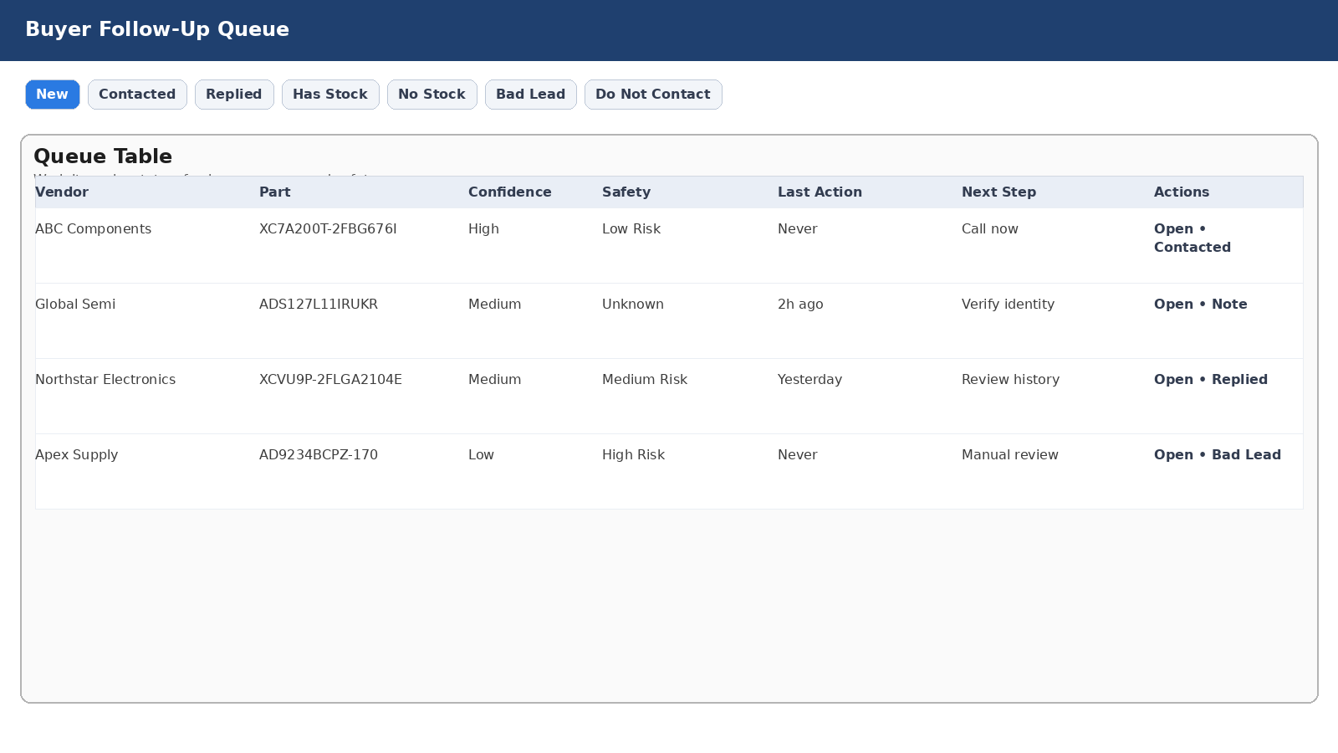
Purpose: Operational queue for buyers to work leads by status.

Safety Review Block
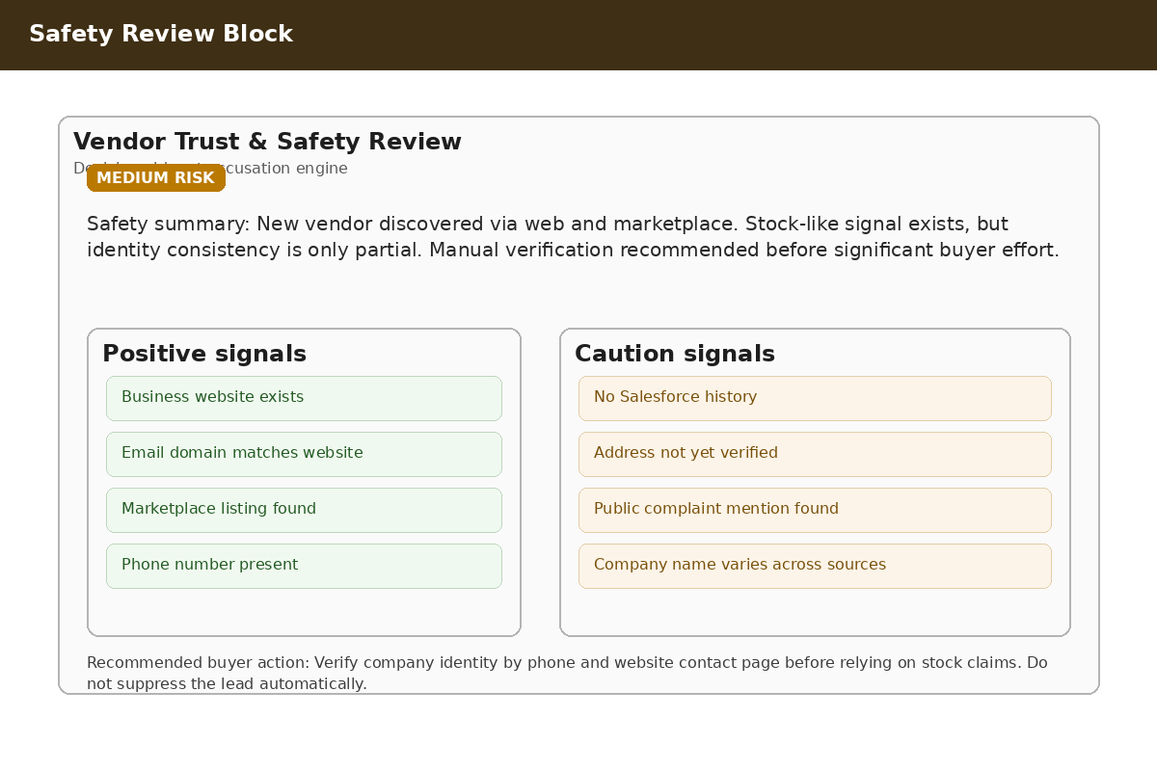
Purpose: Show caution signals and recommended manual verification without hiding leads.

Acceptance Criteria
- Multiple source types can contribute leads and preserve source attribution.
- One lead exists per vendor per part, with multiple evidence items underneath.
- Confidence and safety are stored and shown separately.
- Duplicates are materially reduced.
- Buyers can update status in one click plus optional note.
- Safety review is visible, explainable, and caution-oriented.

Phased Build Plan
Phase 1: Discovery and current-state mapping
Phase 2: Lead and evidence schema foundation
Phase 3: Scoring separation: confidence vs safety
Phase 4: Deduplication foundation
Phase 5: Buyer workflow and statuses
Phase 6: Feedback loop
Phase 7: Buyer-facing UI
Phase 8: Connector hardening and enrichment
Phase 9: QA and cleanup

Cursor Handoff Guidance
- Use the Markdown files for direct model context.
- Use the JSON/YAML schema files as implementation targets.
- Use the wireframes as the visual north star.
- Keep the agent constrained to one slice at a time and require tests/checks after each slice.
- Preserve the decision log and update it as new implementation decisions are made.

