ALI ABDULLAH AHMAD
20031246
CS600-Project
- For words present in both local and online pages:
  - Education
  - Gnu
  - Welcome
  - Wikipedia
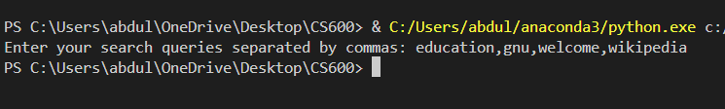
OUTPUT.txt :
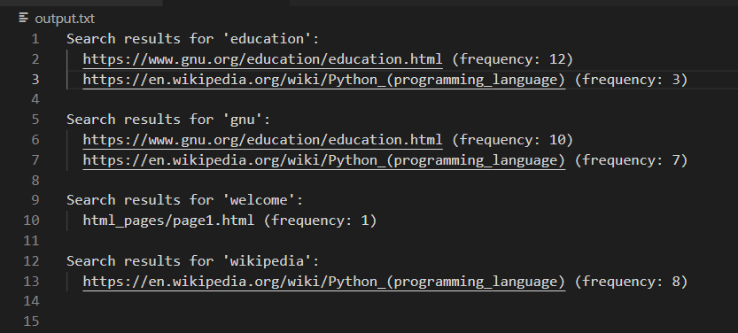
- For words present in neither of the pages:
  - Water
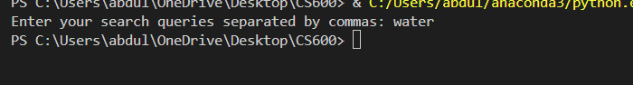
OUTPUT.txt
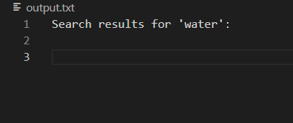
- For stop words:
  - The
  - Their
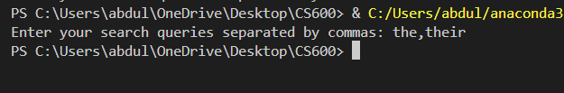
OUTPUT.txt :
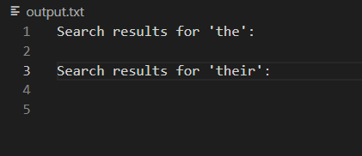
- For empty string:
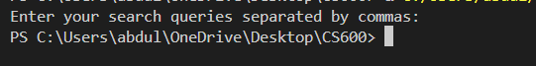
OUTPUT.txt :
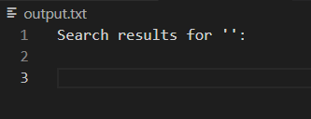

VIDEO DEMO:
https://www.youtube.com/watch?v=Sq9ScJiCIKk

