What is Kafka
A distributed event streaming platform that handles real-time data feeds with high throughput and low latency. Acts like a message queue where producers send data to topics, and consumers read from those topics.
Core Components of Apache Kafka
- Kafka Broker
- Producers
- Kafka Topic
- Consumers
- Zookeeper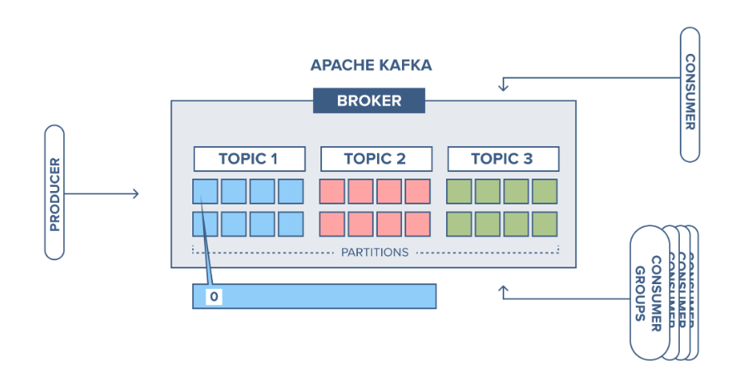
Kafka Broker
A Kafka Broker is basically a server in the Kafka system. It stores messages (data) inside topics. It receives data from producers and sends data to consumers. A Kafka cluster usually has multiple brokers so that the system can handle more data and avoid failure.
Producers
A Producer is any application that sends data to Kafka. Producers decide which topic to send data to. They can send messages continuously or whenever needed. They can also choose how messages should be “partitioned” inside a topic.
Kafka Topic
A Kafka Topic is like a folder or category where messages are stored. Messages are arranged in order in each topic. Topics can have multiple partitions, which helps to process data faster by splitting the load. Producers write to a topic, and consumers read from it.
Consumers
A Consumer is an application that reads data from Kafka topics. They read messages in the order they were stored. They can be grouped into Consumer Groups to share the workload. Each consumer keeps track of what it has already read using something called an offset.
Zookeeper
Zookeeper is a service that helps Kafka manage its cluster. It keeps track of broker details (like which broker is alive). Helps in electing the leader broker for partitions. Stores configuration and metadata.

Why use Kafka?
Multiple producers and consumers at any given time without interfering with each other. This is in contrast to many queuing system where one message is consumed by one client
Scalability − Kafka messaging system scales easily without down time.
Fast - Kafka is a good solution for applications that require a high throughput, low latency messaging solution. Kafka can write up to 2 million requests per second
High Performance: Excellent performance under high load.

How Apache Kafka Works
Apache Kafka moves data from one place to another in a smooth and reliable way. Here’s how it works in simple terms:
Step 1: Producers Send Data
Producers are applications that create data and send it to Kafka.This data can be anything—logs, transactions, user activities, or events. Kafka splits the data into smaller parts called partitions, making it easier to handle large amounts of information.
Step 2: Kafka Stores the Data
Kafka organizes the data into topics, where it is saved for a certain period. Even if a consumer reads the data, Kafka doesn’t delete it immediately. To prevent data loss, Kafka makes copies of the data and stores them on different servers.
Step 3: Consumers Read the Data
Consumers are applications that subscribe to topics and read messages. To manage the load, consumers are divided into consumer groups, so no message is processed twice. Consumers can choose where to start reading, whether from the newest message or an earlier point.
Step 4: Kafka Balances the Load
ZooKeeper helps Kafka manage which server is in charge of storing and distributing data. If a server goes down, Kafka automatically redirects the data to another server.
Step 5: Data is Processed and Used
Once consumers receive the data, they can store it in a database, analyze it, or trigger other events. Kafka can work with tools like Apache Spark, Flink, and Hadoop for deeper analysis.

