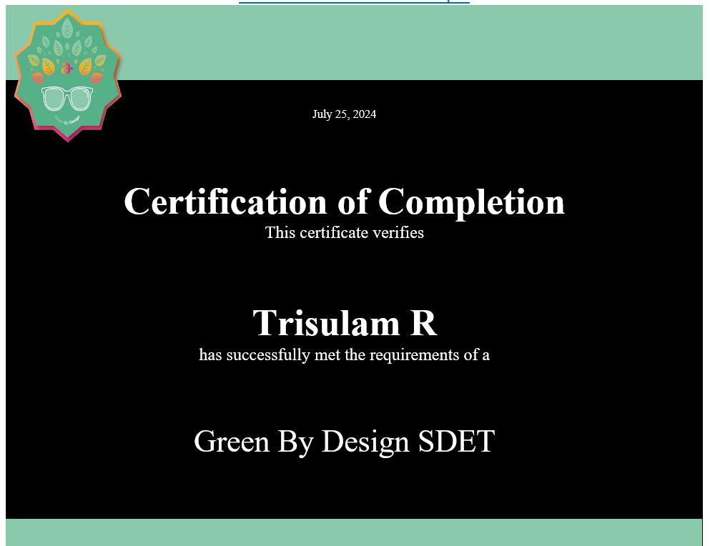
mhtml:file://C:\Users\rtrisul\AppData\Local\Microsoft\Windows\INetCache\Content.Outlook\2DRQK7UO\email.mht

