Fix internet connection problems on Android devices
If you can't access the Internet on your Android device, either through an app or a website, try these troubleshooting steps.

Signs of a bad connection
- Downloads don't start, time out, or remain at 0%.
- Google Play is stuck on "Loading..."
- You can't load web pages in a browser.

General troubleshooting tips for Android devices

- Restart your device. It might sound simple, but sometimes that's all it takes to fix a bad connection.
- If restarting doesn't work, switch between Wi-Fi and mobile data:
  - Open your Settings app and tap Network & internet or Connections. Depending on your device, these options may be different.
  - Turn Wi-Fi off and mobile data on, and check if there's a difference.
  - If not, turn mobile data off and Wi-Fi on and check again.
- Try the troubleshooting steps below.

Fix mobile data problems

Check that mobile data is turned on and you have a data connection
- Open your Settings app and tap Network & internet or Connections Mobile data or Cellular data.
  - On some devices, you may need to select Data usage before you find this.
- Turn Mobile data or Cellular data on. If it's already on, turn it off and on again.
- Check that there is a data indicator, like 2G, 3G, 4G, or H, next to the signal strength bars at the top of the screen .
- Sometimes this won't display if you have an active Wi-Fi connection. If this is the case, turn Wi-Fi off and check again.
If you don't get a signal data indicator, you may be in an area without coverage. If you can, move to a different area, or go outside, and check your signal again.
Tip: If this happens a lot, contact your mobile service provider.

Turn airplane mode on and off
- Open your Settings app and tap Network & internet or Connections Airplane Mode. Depending on your device, these options may be different.
- Turn Airplane mode on.
- Wait for 10 seconds.
- Turn Airplane mode off.
- Check if the connection problems have been solved.
If you still have problems after you complete these steps, contact your mobile service provider.
Fix Wi-Fi problems

Check that Wi-Fi is turned on and you're connected
- Open your Settings app and tap Network & Internet or Connections Wi-Fi. Depending on your device, these options may be different.
- Turn Wi-Fi on.
- Find the Wi-Fi connection indicator at the top of your screen .
- If this isn't displayed, or none of the bars are filled in, you may be out of range of a Wi-Fi network.
- Move closer to the router, check if you have a stronger Wi-Fi connection, and try again.

Restart your wireless router
If you are connecting to Wi-Fi at home, check your router's manual for instructions on how to reset it. Often you can:
- Unplug the router from the electrical outlet and make sure the lights on the router go out.
- Wait 30 seconds.
- Plug the router back in and wait 30 seconds for all the lights to come back on.
If you still have connectivity issues after you complete these steps, contact your internet service provider or the host of the Wi-Fi network.

How to fix issues with Android apps
Common problems with Android apps include crashing, freezing, or malfunctioning. Some apps can also cause conflict with each other.
try out these fixes for issues with Android apps.
- Reboot device
- Update the apps
- Force stop frozen or laggy apps and restart your phone
- Sign out & back in to your Google account
- Try Safe mode
- Clear app data and/or cache
- Check app settings
  - Reboot Device

2. Update the apps
Make sure you download the latest version of any app and keep it updated.

3. Force stop frozen and restart your phone
If an app freezes, go to Settings > Apps, select the app, and tap “Force Stop.” Even if it isn’t frozen, “rebooting” your app can be just as useful as rebooting your phone
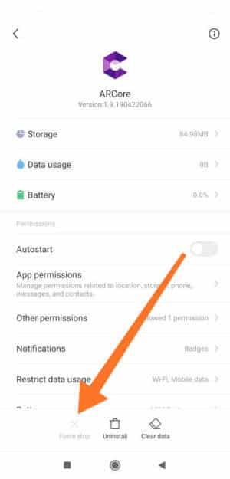

4. Sign out & back in to your Google account
Logging out and back in can help the app refresh data.
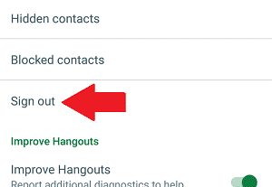

5. Clear app data &/or cache
If the problem seems to be with one application and that application alone, try clearing the cache and app data of that app first. To troubleshoot your Android phone, from apps, go to Settings, then Apps again. From the All tab, select the app. Choose “Clear Data” or “Clear Cache.“

6. Check app settings
Make sure that the problem you are experiencing can’t be solved with a simple change in settings. Explore your app settings just be certain and adjust the necessary fixes.
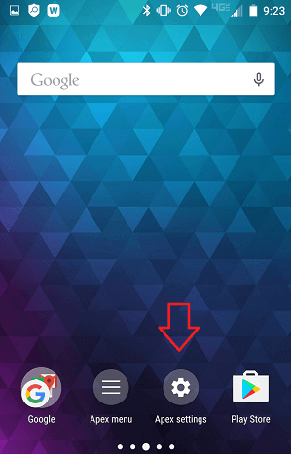

Installing the Android Mobile App
To install the Android mobile app please follow these steps:
- On an Android device, open the invitation in your email.
- When prompted, sign in with Google and accept the invitation to test the app.
- Once you accept an invitation, you're given access to install the application
- The App will be automatically added to your device home screen.
- Launch the application.
- What is Android build process?
The Android build system compiles app resources and source code, and packages them into APKs or Android App Bundles that you can test, deploy, sign, and distribute.

