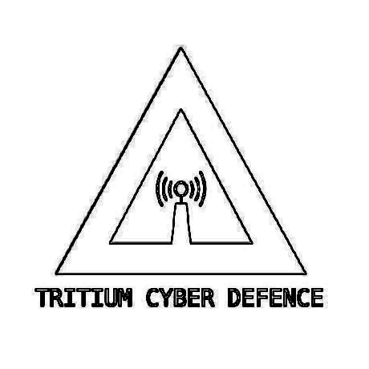
Styling Guide for Relating Documents to
TRITIUM CYBER DEFENCE

AUNA:Anthony Grace
AUID:MD01S01

This is a styling guide for documents pertaining to TRITIUM CYBER DEFENCE.

Documents shall contain a resource ID in the top left of the header section.
The resource ID is structured with the current date without hyphen or other seperation as ddmmyy, with a suffix of the number of the document created on that day. As example this document is the second Tritium related document created on this day thus it ends with a 2
Example given in the top right.

Main body text is in SourceCode Pro Medium size 12.
For lists and “bullet points” all of the headers for each list are to be in bold for readability.

EXAMPLE HERE:
- This is the main body of a bullet point list
- The title above is in bold

Emails do not have to follow this styling guide.

All Tritium Related documents must have the header as listed above as well as a footer containing the official document statement as below, as well as a page number in the bottom right. The footer is to be Helvicta Sans Serif size 10.

Styling Guide for Relating Documents to
TRITIUM CYBER DEFENCE

AUNA:Anthony Grace
AUID:MD01S01

All pages of general business documents must contain the title and logo_light, to the right as seen above for quick reference of what document a page pertains to. Especially in the case of hard copy documents.

As seen above, the title is to be in SourceCode pro Medium size 12
with the AUNA “Author name” and the AUID: “Author ID”
The AUID “Author ID” is structued as Gender/Role/Member Number/S/Section number. As for the author of this document, as an example it is;
AUNA:Anthony Grace
AUID:MD01S01

This ID is unchangeable except in the changing of roles or sections.

All documents must end with DOCUMENT END NO PTO as seen below. It is to be one size 12 space above the footer/ end of the document. This is especcially important for hard copy documents.

DOCUMENT END
NO PTO

