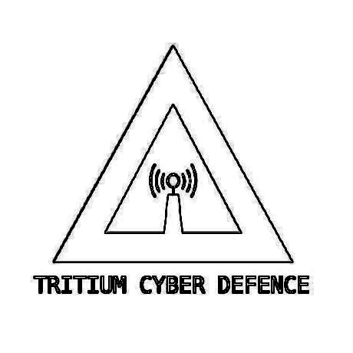
Membership Mandatory Sign Off Form

AUNA:Anthony Grace
AUID:MD01S01

I as a candidate for Tritium Cyber Defence state that I aggree completely and will comply completely with all items located in document 1012223 “General Policies Procedures and Rules for Tritium Cyber Defence”.

FOR THE APPLICANT:
NAME: | SIGNATURE: | DATE:
FOR THE WITNESS(JP):
NAME: | SIGNATURE: | DATE:

In the case of acceptance into Tritium Cyber Defence:
I as a member of Tritium Cyber Defence state that I will comply completely with all items located in document 1012223 “General Policies Procedures and Rules for Tritium Cyber Defence”.

FOR THE APPLICANT:
NAME: | SIGNATURE: | DATE:
FOR THE WITNESS(JP):
NAME: | SIGNATURE: | DATE:

