Business Overview Statement for
TRITIUM CYBER DEFENCE

AUNA:Anthony Grace
AUID:MD01S01



“Collaboration superseds competition”

Contents enclosed:
1. Title page
2. WHO WE ARE
3. WHAT WE DO
4. HOW WE DO IT

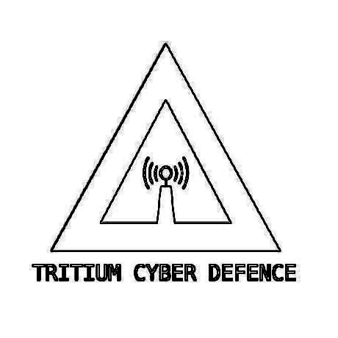
Business Overview Statement for
TRITIUM CYBER DEFENCE

AUNA:Anthony Grace
AUID:MD01S01

WHO WE ARE:

- We are a fired up team ready to take on the world.
- A group of bug bounty hunters and white hat hackers working together to develop ourselves and work as one.
- Our team each works on their own projects and bounties.
- Tritium is a place we come together as a group to put our heads together to build software, hardware, and tools, you name it.
- No one is employed by us, instead your payment comes though the sign up and effort you put in towards your own bounties.(With support from Tritium)
- Learning off of each other in a secure environment to get ahead of the competition and make cyberspace a safer place for everybody.

Business Overview Statement for
TRITIUM CYBER DEFENCE

AUNA:Anthony Grace
AUID:MD01S01

WHAT WE DO:
- Training Guidance Framework:
  - Within Tritium we have a learning framework for students to access training material, repositories, and various API's. Where they can undergo rigorous training and study in almost everything relating to cybersecurity. To advance, Tritium and our team further in their careers and advance efficiency in thier own bug bounties.
- Bug Bounties:
  - We are a free development and training group, operating as a business, where members work on thier own bug bounties and get paid though bounty platforms. The learning and development to do so comes from other Tritium members working together, to help each other.
- Advice and Consultation:
  - We also provide local organizations free, specialized advice on how to protect their business and their assets. Protecting the community from scams, fraud, and other related cyber crime. If you suspect you or someone you know is at risk of a scam or related cybercrime, you can contact us for advice and and expert opinion on the matter.

For all other inquiries and/ or, if the damage has been done, DO NOT hesitate to contact the ACSC and your local cyber-crime agencies for reporting and recovey.

Business Overview Statement for
TRITIUM CYBER DEFENCE

AUNA:Anthony Grace
AUID:MD01S01

HOW WE DO IT:
- Development:
  - We create software, hardware, and tools to test networks and locate bugs in systems.
- Reporting:
  - Once found they are reported to the appropriate authorities to be fixed and patched.
- Tools:
  - We also employ the use of industry standard technologies such as:
    - BlackArch LINUX
    - Burpsuite
    - Autopsy
    - Burpsuite
    - Splunk
- Teamwork:
  - We see cyber seurity as a race, there is a huge amount of competition. Not only from ethical hackers, but hackers and scammers operating for a nefarious purpose. This is why it is crucial for us to collaborate and put our heads together, creating new methods and cutting edge scripts to get ahead of the competition.

DOCUMENT END
NO PTO

