Timeline for TRITIUM CYBER DEFENCE
6 Month Business Growth Plan
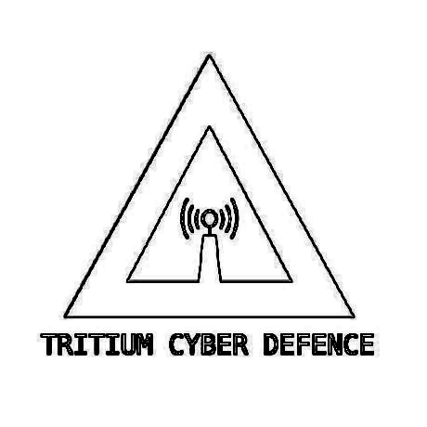

Privacy – Security - Liberty

AUNA:Anthony Grace
AUID:MD01S01

Timeline for TRITIUM CYBER DEFENCE
6 Month Business Growth Plan

DECEMBER 2022:
- 12/10/22 Formulating Business growth plan.
- Planning for upcoming AGM general meeting.
  - Disscusing future growth and business scope.
- Setup new IRC channels and or structure keybase.
- Setup Keybase repository / encrypted file storatge.
- Formulate general business documents.
- Onboard new members and related documents.
- Apply for ABN and appoint member roles.
- Deployment of member training and jobs with Hackerone and related entities.
JANURARY 2023:
- Complete cloud connected HPC Cluster.
- General NAS backup on HPC Cluster
- Complete projects: “MOONBEAM” and “EYE_SHELL” for penetration testing/ Store on Keybase Encrypted File storage.
- Hold monthly meeting for ideas and team structure.
- Discuss upcoming project “A-PET” with selected members.
- Business card creation and distribution. Possible ID card creation
FEBRUARY 2023:
- Check related tax receipts for write off.
- Hold monthly meeting for ideas and team structure.
- Begin planning stage on project “A-PET”
- Create encrypted GitHub for selected members for project “A-PET”

Timeline for TRITIUM CYBER DEFENCE
6 Month Business Growth Plan

APRIL 2023:
- Continue planning and procurement for project “A-PET”
- Start planning and procurement for projects discuessed
- Monthly meeting discussion for ideas and team structure.
MAY 2023:
- Start development for project “A-PET”
- Start development for projects planned prior.
MARCH 2023:
- Monthly meeting for ideas and team structure.
- Distribute LoRa and ITAK/ATAK systems to members for development.
- Continue planning and procurement for project “A-PET”

DOCUMENT END
NO PTO

