Jackson, Terrence. CMIS 141 7383. 12.10.2022.

|  | Input | Expected | Actual | Pass |
| --- | --- | --- | --- | --- |
| Test Case 1 | Enter your selection: 9 | Thank you for using this program. Goodbye! | Thank you for using this program. Goodbye! | Y |
| Test Case 2 | Enter your selection: 1  How many customers: 3  Customer 0:  ID: 10000  Name: Jessica Marshall  Total Sales: $1895.46  Customer 1:  ID: 10001  Name: Sarah Birch  Total Sales: $2159.56  Customer 2:  ID: 10002  Name: Jessica Smith  Total Sales: $1956.42  Enter your selection: 3  Enter your selection: 5  Lowest sales: $2000  Highest sales: $3000  Enter your selection: 9 | Customer 10000 (name: Jessica Marshall, sales: $1895.46)  Customer 10001 (name: Sarah Birch, sales: $2159.56)  Customer 10002 (name: Jessica Smith, sales: $1956.42)  Customer 10001 (name: Sarah Birch, sales: $2159.56)  Thank you for using this program. Goodbye! | Customer 10000 (name: Jessica Marshall, sales: $1895.46)  Customer 10001 (name: Sarah Birch, sales: $2159.56)  Customer 10002 (name: Jessica Smith, sales: $1956.42)  Customer 10001 (name: Sarah Birch, sales: $2159.56)  Thank you for using this program. Goodbye! | Y |
|  | Input | Expected | Actual | Pass |
| Test Case 3 | Enter your selection: 2  Customer:  ID: 10003  Name: David Overstreet  Total Sales: $1495.26  Enter your selection: 2  Customer:  ID: 10004  Name: Tony Petritch  Total Sales: $1689.47  Enter your selection: 4  ID: 10003  Enter your selection: 9 | Customer 10003 (name: David Overstreet, sales: $1495.26)  Thank you for using this program. Goodbye! | Customer 10003 (name: David Overstreet, sales: $1495.26)  Thank you for using this program. Goodbye! | Y |

Test Case 1:

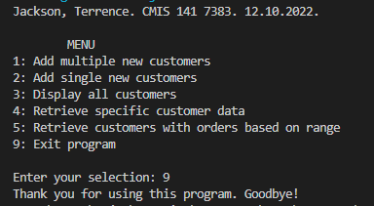

Test Case 2:

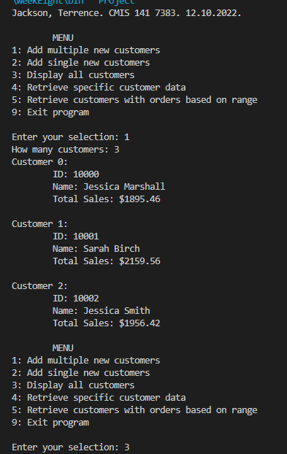

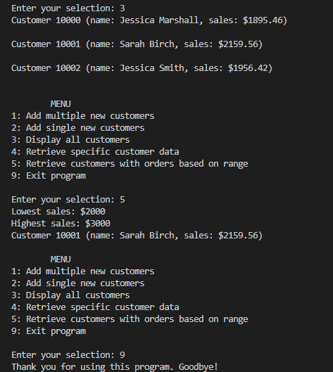

Test Case 3:

