Jackson, Terrence. CMIS 141 7383. 11.11.2022.

|  | Input | Expected | Actual | Pass |
| --- | --- | --- | --- | --- |
| Test Case 1 | Enter data? No | Thank you for using the Total XP calculation program! | Thank you for using the Total XP calculation program! | yes |
| Test Case 2 | Enter data? Yes  Name: John Doe  Scores: 10 20 30 40  Enter data? No | Gamer Name: John Doe L1=10 L2=20 L3=30 ES=40  Final XP score with bonuses=147  Do you want to enter gamer's data? Yes/No =>No  Thank you for using the Total XP calculation program! | Gamer Name: John Doe L1=10 L2=20 L3=30 ES=40  Final XP score with bonuses=147  Do you want to enter gamer's data? Yes/No =>No  Thank you for using the Total XP calculation program! | yes |
| Test Case 3 | Enter data? Yes  Name: David Jackson  Scores: 90 80 70 60  Enter data? Yes  Name: Raven Birch  Scores: 100 80 60 40  Enter data? No | Gamer Name: David Jackson L1=90 L2=80 L3=70 ES=60  Final XP score with bonuses=413  Do you want to enter gamer's data? Yes/No =>Yes  Enter gamer's name =>Raven Birch  Enter gamer's Level XP scores separated by space: L1 L2 L3 ES => 100 80 60 40  Gamer Name: Raven Birch L1=100 L2=80 L3=60 ES=40  Final XP score with bonuses=378  Do you want to enter gamer's data? Yes/No =>No  Thank you for using the Total XP calculation program! | Gamer Name: David Jackson L1=90 L2=80 L3=70 ES=60  Final XP score with bonuses=413  Do you want to enter gamer's data? Yes/No =>Yes  Enter gamer's name =>Raven Birch  Enter gamer's Level XP scores separated by space: L1 L2 L3 ES => 100 80 60 40  Gamer Name: Raven Birch L1=100 L2=80 L3=60 ES=40  Final XP score with bonuses=378  Do you want to enter gamer's data? Yes/No =>No  Thank you for using the Total XP calculation program! | yes |
| Test Case 4 | Enter data? Yes  Name: Thayer Birch  Scores: 200 83 40 76  Re-enter L1 100  Re-enter L2 80  Re-enter ES 75  Enter data? No | Invalid L1 score, must be between 10-100 and in increments of 5.  You input: 200  Please re-enter gamer's Level 1 XP score =>100  Invalid L2 score, must be between 10-100 and in increments of 5.  You input: 83  Please re-enter gamer's Level 2 XP score =>80  Invalid ES score, must be between 10-100 and in increments of 5.  You input: 76  Please re-enter gamer's Engagement score =>75  Gamer Name: Thayer Birch L1=100 L2=80 L3=40 ES=75  Final XP score with bonuses=404  Do you want to enter gamer's data? Yes/No =>No  Thank you for using the Total XP calculation program! | Invalid L1 score, must be between 10-100 and in increments of 5.  You input: 200  Please re-enter gamer's Level 1 XP score =>100  Invalid L2 score, must be between 10-100 and in increments of 5.  You input: 83  Please re-enter gamer's Level 2 XP score =>80  Invalid ES score, must be between 10-100 and in increments of 5.  You input: 76  Please re-enter gamer's Engagement score =>75  Gamer Name: Thayer Birch L1=100 L2=80 L3=40 ES=75  Final XP score with bonuses=404  Do you want to enter gamer's data? Yes/No =>No  Thank you for using the Total XP calculation program! | yes |

Test Case 1:

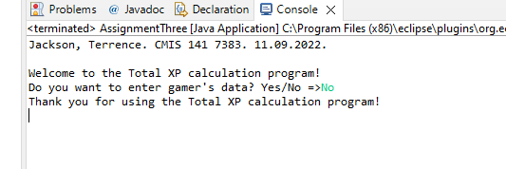

Test Case 2:

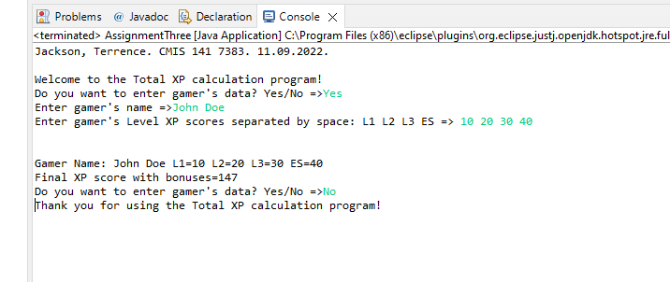

Test Case 3:

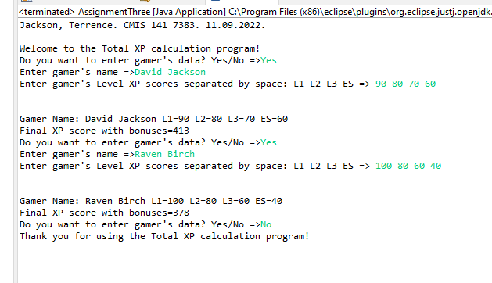

Test Case 4:

