Jackson, Terrence. CMIS 141 7383. 11.26.2022.

|  | Input | Expected | Actual | Pass |
| --- | --- | --- | --- | --- |
| Test Case 1 | How many teams? 5  Enter team's name: Leaping Leopards  Enter team's score (400-1000): 450  Enter team's name: Jolly Jupiters  Enter team's score (400-1000): 925  Enter team's name: Feisty Foxes  Enter team's score (400-1000): 680  Enter team's name: Running Racecars  Enter team's score (400-1000): 809  Enter team's name: Quirky Quarks  Enter team's score (400-1000): 555 | Leaping Leopards 450  Jolly Jupiters 925  Feisty Foxes 680  Running Racecars 809  Quirky Quarks 555  The Leaping Leopards have the lowest score at 450  The Jolly Jupiters have the highest score at 925 | Leaping Leopards 450  Jolly Jupiters 925  Feisty Foxes 680  Running Racecars 809  Quirky Quarks 555  The Leaping Leopards have the lowest score at 450  The Jolly Jupiters have the highest score at 925 | Yes |
| Test Case 2 | How many teams? 5  Enter team's name: Mitochondrias  Enter team's score (400-1000): 40  Error! Enter team's score (400-1000): 400  Enter team's name: Nuclei  Enter team's score (400-1000): 1005  Error! Enter team's score (400-1000): 1000 | Mitochondrias 400  Nuclei 1000  The Mitochondrias have the lowest score at 400  The Nuclei have the highest score at 1000 | Mitochondrias 400  Nuclei 1000  The Mitochondrias have the lowest score at 400  The Nuclei have the highest score at 1000 | Yes |

Test Case 1:

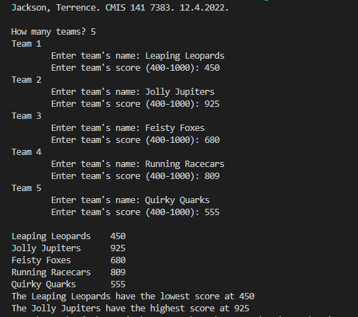

Test Case 2:

