Jackson, Terrence. CMIS 141 7383. 11.26.2022.

|  | Input | Expected | Actual | Pass |
| --- | --- | --- | --- | --- |
| Test Case 1 | Enter your selection: -1 | Thank you for using this program. Goodbye! | Thank you for using this program. Goodbye! | Yes |
| Test Case 2 | Enter your selection: -1  Enter cubic feet: 15  Enter your selection: 2  Enter miles: 15  Enter your selection: -1 | 15 cubic feet = 12.053460 US bushels  15 miles = 24.140100 km  Thank you for using this program. Goodbye! | 15 cubic feet = 12.053460 US bushels  15 miles = 24.140100 km  Thank you for using this program. Goodbye! | Yes |
| Test Case 3 | Enter your selection: -5  Error! Enter your selection: 17  Error! Enter your selection: 3  Enter GPA: 2.7  Enter your selection: 3  Enter GPA: 3.7  Enter your selection: -1 | Congratulations, you have graduated !  Congratulations, you have graduated Cum Laude!  Thank you for using this program. Goodbye! | Congratulations, you have graduated !  Congratulations, you have graduated Cum Laude!  Thank you for using this program. Goodbye! | Yes |
| Test Case 4 | Enter your selection: -1  Enter cubic feet: 1  Enter your selection: 3  Enter GPA: 3.8  Enter your selection: 2  Enter miles: 1  Enter your selection: -1 | 1 cubic feet = 0.803564 US bushels  Congratulations, you have graduated Magna Cum Laude!  1 miles = 1.609340 km  Thank you for using this program. Goodbye! | 1 cubic feet = 0.803564 US bushels  Congratulations, you have graduated Magna Cum Laude!  1 miles = 1.609340 km  Thank you for using this program. Goodbye! | Yes |

Test Case 1:

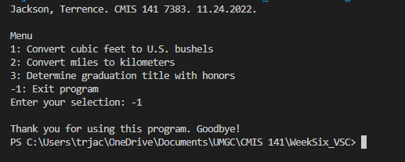

Test Case 2:

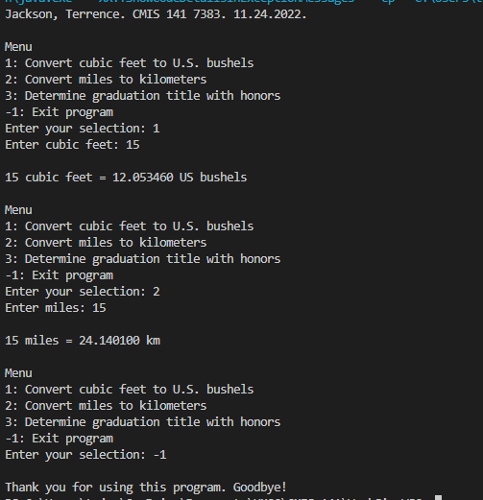

Test Case 3:

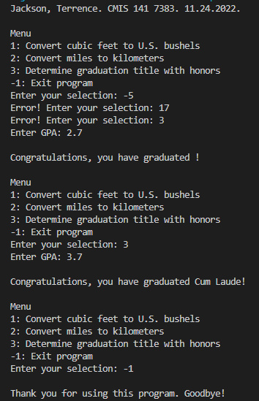

Test Case 4:

