|  | Input | Expected | Actual | Pass? |
| --- | --- | --- | --- | --- |
| Test Case 1 | Enter your selection: 9 | Thank you for using this program, goodbye! | Thank you for using this program, goodbye! | Yes |
| Test Case 2 | Enter your selection: 1  Enter the directory to read files from: .\\  Enter your selection: 2  Enter the title to find: Encanto  Enter your selection: 3  Enter the id to rent: 10  Enter your selection: 2  Enter the title to find: Encanto  Enter your selection: 9 | Media Loaded!  Movie DVD 7: 'Encanto' published 2021 and 2.07 megabytes. Available: true  Music CD 10: 'Encanto' published 2021 and 120 minutes long. Available: true  Rental fee for this media is 3.5  Movie DVD 7: 'Encanto' published 2021 and 2.07 megabytes. Available: true  Music CD 10: 'Encanto' published 2021 and 120 minutes long. Available: false  Thank you for using this program, goodbye! | Media Loaded!  Movie DVD 7: 'Encanto' published 2021 and 2.07 megabytes. Available: true  Music CD 10: 'Encanto' published 2021 and 120 minutes long. Available: true  Rental fee for this media is 3.5  Movie DVD 7: 'Encanto' published 2021 and 2.07 megabytes. Available: true  Music CD 10: 'Encanto' published 2021 and 120 minutes long. Available: false  Thank you for using this program, goodbye! | Yes |
| Test Case 3  Test Case 3 | Enter your selection: 1  Enter the directory to read files from: h  Enter your selection: 2  Enter the title to find: Test  Enter your selection: 3  Enter the id to rent: 1  Enter your selection: 9 | java.io.FileNotFoundException: No files found in given directory.  MediaNotFoundException : Media for title Test not found!  MediaNotFoundException : Media for id 1 not found!  Thank you for using this program, goodbye! | java.io.FileNotFoundException: No files found in given directory.  MediaNotFoundException : Media for title Test not found!  MediaNotFoundException : Media for id 1 not found!  Thank you for using this program, goodbye! | Yes |

Test Case 1:

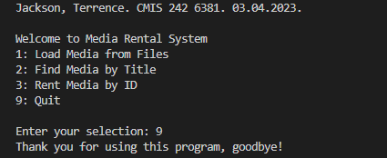

Test Case 2: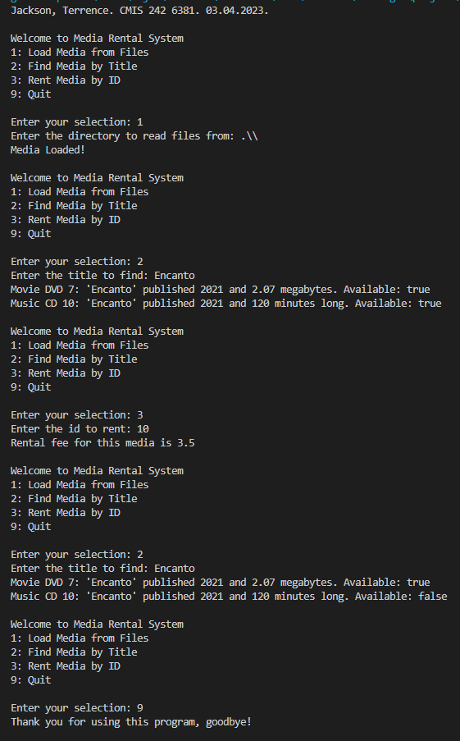

Test Case 3:

