|  | Input | Expected | Actual | Pass? |
| --- | --- | --- | --- | --- |
| Test Case 1 | Enter your selection: 2 | Thank you for using the program. Goodbye! | Thank you for using the program. Goodbye! | Yes |
| Test Case 2 | Enter your selection: 1  Do you want Fruit Snack (1) or Salty Snack (2): 1  What size do you want: S, M, or L: S  Do you want citrus fruit? true/false: true | You have chosen snack type citrus fruit snack.  Size = S, ID = FR0204S, Price = 25.98 | You have chosen snack type citrus fruit snack.  Size = S, ID = FR0204S, Price = 25.98 | Yes |
| Test Case 3 | Enter your selection: 1  Do you want Fruit Snack (1) or Salty Snack (2): 1  What size do you want: S, M, or L: M  Do you want citrus fruit? true/false: false | You have chosen snack type fruit snack.  Size = M, ID = FR0204M, Price = 29.99 | You have chosen snack type fruit snack.  Size = M, ID = FR0204M, Price = 29.99 | Yes |
| Test Case 4 | Enter your selection: 1  Do you want Fruit Snack (1) or Salty Snack (2): 1  What size do you want: S, M, or L: L  Do you want citrus fruit? true/false: false | You have chosen snack type fruit snack.  Size = L, ID = FR0204L, Price = 39.99 | You have chosen snack type fruit snack.  Size = L, ID = FR0204L, Price = 39.99 | Yes |
| Test Case 5 | Enter your selection: 1  Do you want Fruit Snack (1) or Salty Snack (2): 2  What size do you want: S, M, or L: S  Do you want citrus fruit? true/false: true | You have chosen snack type salty nut snack.  Size = S, ID = SA0204S, Price = 24.49 | You have chosen snack type salty nut snack.  Size = S, ID = SA0204S, Price = 24.49 | Yes |
| Test Case 6 | Enter your selection: 1  Do you want Fruit Snack (1) or Salty Snack (2): 2  What size do you want: S, M, or L: M  Do you want citrus fruit? true/false: false | You have chosen snack type salty snack.  Size = M, ID = SA0204M, Price = 29.99 | You have chosen snack type salty snack.  Size = M, ID = SA0204M, Price = 29.99 | Yes |

Test Case 1:

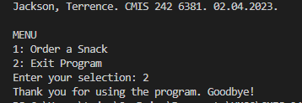

Test Case 2:

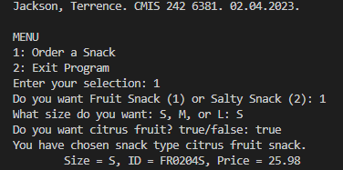

Test Case 3:

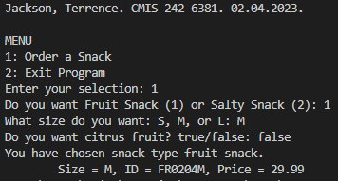

Test Case 4:

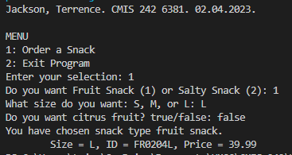

Test Case 5:

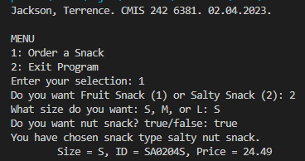

Test Case 6:

