|  | Input | Expected | Actual | Pass? |
| --- | --- | --- | --- | --- |
| Test Case 1 | Click exit button | GUI goes away, program done | GUI goes away, program done | Yes |
| Test Case 2 | Click Distance Converter button  Enter 10 | Input dialog pop up  Message dialog pop up, 16.09 km | Input dialog pop up  Message dialog pop up, 16.09 km | Yes |
| Test Case 3 | Click Temperature Converter button  Enter 98 | Input dialog pop up  Message dialog pop up, 36.67 C | Input dialog pop up  Message dialog pop up, 36.67 C | Yes |

Test Case 1:

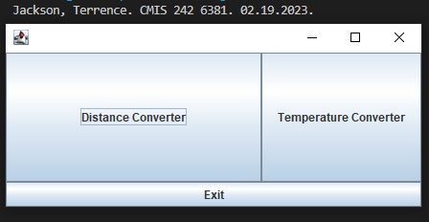



Test Case 2:

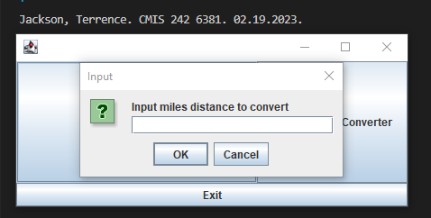

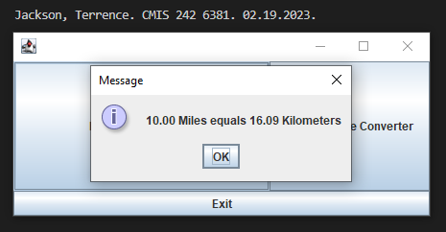

Test Case 3:

