Name: Terrence Jackson  
Date: August 31, 2024  
Course : CMSC 340 Web Programming  
Week: 3  
Assignment: Develop a PHP Script to Create and Manipulate a PHP Array of Course Objects

-----------------------------------------------------------------------------------------------------------------------------------

Rubric Criteria:  
Number of correctly implemented specifications using PHP scripting out of five (5) specifications   
(50%)  
  
Embed here (or submit separately) a copy of your PHP script file(s):

Submit separately

Copy and paste here the text of your PHP code:

<?php

/*

Create and Manipulate a PHP Array of Course Objects

============================================

Terrence Jackson

CMSC 430

Last Edited: Aug 31 2024

Due: Sept 3 2024

*/

// class of course objects

class Course

{

private $code;

private $title;

private $creditHours;

// constructor

public function __construct($code, $title, $credit_hours)

{

$this->code = $code;

$this->title = $title;

$this->creditHours = $credit_hours;

}

public function printCourse()

{

echo "Code = $this->code<br>

Title = $this->title<br>

Credit Hours = $this->creditHours<br><br>";

}

public function getCode()

{

return $this->code;

}

}

// array of Course objects

$objectArray = [

new Course("CMSC 335", "Object-Oriented Concurrent Programming", 3),

new Course("SDEV 300", "Building Secure Python Applications", 3),

new Course("WRTG 393", "Advanced Technical Writing", 3),

new Course("CMSC 307", "Artificial Intelligence Applications", 3),

new Course("CMSC 340", "Web Programming", 3),

new Course("CMSC 430", "Compiler Theory and Design", 3),

new Course("CMSC 451", "Design Computer Algorithms", 3),

];

// calc and display number of courses

$numCourses = count($objectArray);

echo "The number of UMGC courses I took over the last 3 terms = $numCourses<br><br>

These courses are:<br>";

// init variables for loop

$taken115 = false;

$i = 1;

// iterate over array

foreach ($objectArray as $course) {

// print/update course number

echo "Course $i information:<br>";

$i += 1;

// print this course

$course->printCourse();

// check if this course is CMSC 115

if ($course->getCode() == "CMSC 115") {

$taken115 = true;

}

}

// print if I have taken CMSC 115

echo $taken115 ? "Yes, I have" : "No, I have not";

echo " taken the CMSC 115 course.<br>";

Insert here a screenshot(s) of the result of executing your PHP script:

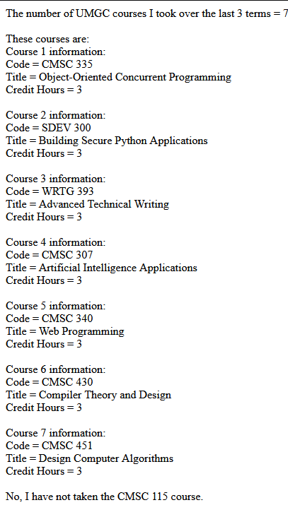

-----------------------------------------------------------------------------------------------------------------------------------

Rubric Criteria:  
Number of relevant explanations out of three (3) explanations of approach, design, and steps of completing the assignment  
(30%)

Your response here:

**Approach and Design**

In tackling this assignment, my primary goal was to create a well-structured and efficient PHP program that met all specified requirements while also allowing for flexibility and ease of use. The first step was defining the Course class. I designed the class with three private attributes: course code, course title, and course credit hours. To ensure these attributes could be easily utilized, I incorporated a constructor. This constructor allows for the straightforward instantiation of Course objects with the necessary values for each attribute, minimizing the risk of errors and ensuring consistency.

I also added a public method, printCourse(), to the class, which outputs the values of the object's attributes in a clear and readable format. Additionally, I introduced a getCode() method to provide controlled access to the private code attribute, enabling me to check whether a specific course, such as CMSC 115, was included in the array of courses.

Once the class was defined, I created an array of Course objects representing the courses I have taken over the last three terms at UMGC. The array structure allowed me to store and manipulate the course data efficiently.

**Steps**

1. I began by defining the Course class, ensuring that the attributes were private to encapsulate the data properly. The constructor and methods were then added to allow for easy instantiation and data access.
2. I instantiated the Course objects using the constructor and stored them in an array. This array was crucial for organizing the course data and enabled me to perform operations on the entire set of courses efficiently.
3. I used the count() function to determine the total number of courses in the array and printed this value. This straightforward operation confirmed that the array contained the correct number of courses.
4. I iterated over the array using a foreach loop, invoking the printCourse() method on each object to output its details. This loop also included logic to check if any of the courses matched CMSC 115 by comparing the course codes using the getCode() method.
5. Finally, I added a conditional statement to print whether CMSC 115 was included in the array. This check was made possible by the getCode() method, which allowed me to compare each course code against "CMSC 115".

-----------------------------------------------------------------------------------------------------------------------------------

Rubric Criteria:  
Number of objective self-evaluations out of three (3) self-evaluations of strengths, weaknesses, and areas of improvement of self-performance on the assignment  
(10%)

Your response here:

**Strengths**: One of my strengths in this assignment was my ability to write clear, concise, and well-structured code. The code is easy to read and understand, with each function and method serving a distinct purpose.

**Weaknesses**: A notable weakness is my current proficiency in PHP. Since I’m still learning the language, I spent more time than expected on seemingly simple tasks, such as adjusting <br> tags to get the spacing just right.

**Areas of Improvement:** While I didn’t encounter significant challenges, continuing to build my PHP skills will help me write even more efficient and effective code. Given that this assignment was relatively straightforward, future tasks might reveal areas where I can improve my understanding and application of PHP.

-----------------------------------------------------------------------------------------------------------------------------------

Rubric Criteria:  
Number of relevant reflections on the learning experience out of three (3) reflections of setbacks, triumphs, and lessons learned  
10%

Your Response here:

This assignment was a valuable learning experience, providing me with the opportunity to deepen my understanding of object-oriented programming in PHP. One of the main triumphs was successfully implementing the Course class and the associated methods, which allowed me to meet the assignment's requirements in a structured and efficient manner.

However, I did encounter some setbacks, particularly in determining the best way to access and manipulate the private attributes of the Course class. Initially, I considered making these attributes public for easier access, but quickly realized that doing so would compromise encapsulation, a key principle of OOP. This led me to introduce the getCode() method, which resolved the issue while maintaining the integrity of the class design.

Overall, this project was a positive learning experience. It gave me the opportunity to apply my coding skills in a new language, while also providing insight into areas where I can grow. The process of refining my code and ensuring it met all the requirements was both satisfying and educational, and I’m eager to continue developing my PHP proficiency.