Exercise 2: orbiting asteroid simulation

Tian-Ruei Kuan

Figure1:

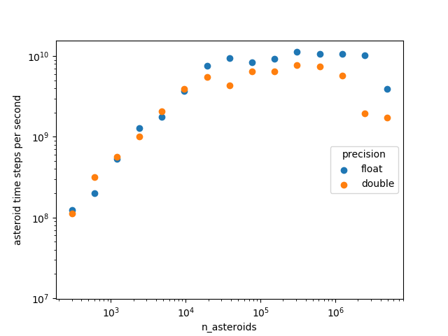

Figure2: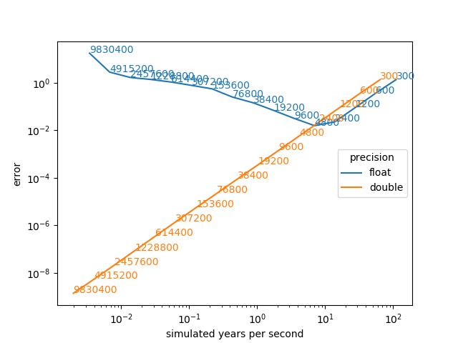

1. (5%) For each of float and double, find the largest value of asteroid time steps per second in figure 1, and determine what percentage of the peak Tflop/s of the node it achieves. (To figure this out, you will have to determine how many flops are in an asteroid time step. Estimate this by looking at the code in the timestep() function, which is where almost all of the time is spent.)

Number of flops in each asteroid time step is 22 (if count sqrt() as 1).

For float, the largest value of **asteroid time steps per second** is 1.12398e+10, when **n_asteroids** is 307200 and **n_steps** is 100000. Flop/s ≈ 1.12398e+10 * 22 ≈ 247 Gflop/s = 0.247 Tflop/s. Max possible flop/s is 2.8 Tflop/s. The percentage is 8.8%.

For double, the largest value of **asteroid time steps per second** is 7.7679e+09, when **n_asteroids** is 307200 and **n_steps** is 100000. Flop/s ≈ 7.7679e+09 * 22 ≈ 171 Gflop/s = 0.171 Tflop/s. Max possible flop/s is 1.5 Tflop/s. The percentage is 11.4%.

1. (5%) For each of float and double, look at the asteroid time steps per second of the largest number of asteroids you simulate and estimate what percentage of the peak Gbyte/s of bandwidth from main memory it achieves. (To figure this out, you will have to determine the number of bytes read and written in each asteroid time step.)

For float, the number of bytes read in each asteroid time step is 6 * 4 = 24 bytes. The number of bytes written in each asteroid time step is 6 * 4 = 24. Together, it is 48 bytes in each asteroid time step. The **asteroid time steps per second** of the largest number of asteroids is 3.91189e+09, when **n_asteroids** is 4915200 and **n_steps** is 100000. The bandwidth is 3.91189e+09 * 48 ≈ 188 GB/s. Max bandwidth possible is 200 GB/s. The percentage is 94%.

For double, the number of bytes read in each asteroid time step is 6 * 8 = 48 bytes. The number of bytes written in each asteroid time step is 6 * 8 = 48. Together, it is 96 bytes in each asteroid time step. The **asteroid time steps per second** of the largest number of asteroids is 1.72784e+09, when **n_asteroids** is 4915200 and **n_steps** is 100000. The bandwidth is 1.72784e+09 * 96 ≈ 165 GB/s. Max bandwidth possible is 200 GB/s. The percentage is 83%.

1. (5%) Look at figure 2 and give guidance to someone who want to use your simulation about when they should use single precision or double precision arithmetic.

Float is better than double when the error is larger than about 0.023 (2400 time steps). Between error of 0.023 to 0.016 (2400 to 4800 time steps), double starts to become more efficient than float. The lowest error possible using float is about 0.016. Double must be used if an error of less than 0.016 is desired.