Exercise 4: molecular dynamics simulation

Tian-Ruei Kuan

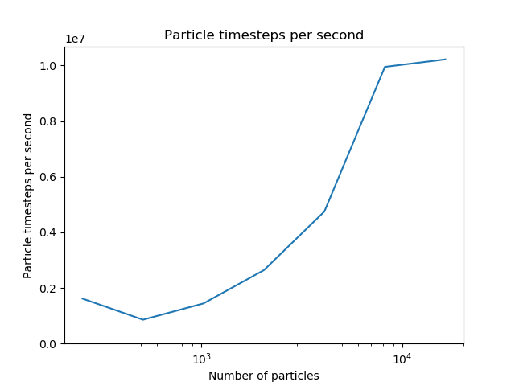

Optimizations:

1. Make **accelerate_indirect()** in a parallel region.

1. Parallelize most for loops in **accelerate_indirect()**, **bin_particles()**, and **unbin_particles()** with static schedule.



1. Collapse the triple for loop.

1. Apply nowait to velocity initialization because binning particles does not need velocity information.

1. In **bin_particles()**, use atomic capture when updating **particle_perm.**



1. In **bin_particles()**, keep prefix sum scan serial.

1. Add **need_rebin()** function to only perform particle binning when necessary.

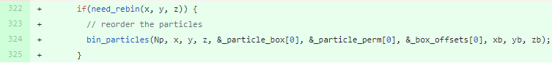

1. In **need_rebin()** function, it will keep track of the particle positions from the last time the particles are binned, and calculate the maximum distance to decide whether particle binning is necessary. A parallel reduction for loop is used to calculate the maximum distance.

