Exercise 6: MPI ring test

Tian-Ruei Kuan

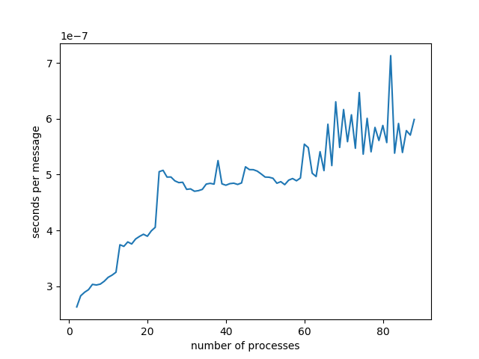

scatter_ring_test:

size: 4,

number of trips: 1000,

time (seconds): 0.00642633,

seconds per message: 1.60658e-06

ring_test:

size: 4,

number of trips: 1000,

time (seconds): 0.00115633,

seconds per message: 2.89083e-07

For scatter_ring_test, the message needs to go over a network to communicate to another node. As for ring_test, only inter-core communication is needed. So the latency for scatter_ring_test is higher.