MPI stencil performance

Tian-Ruei Kuan

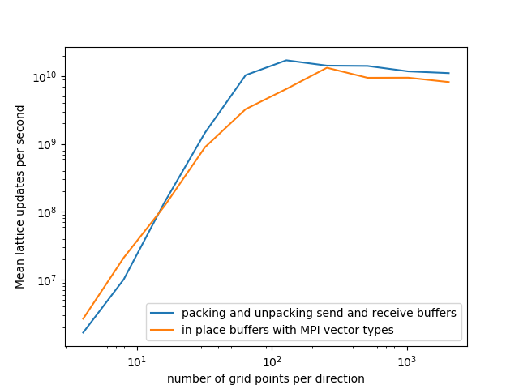

The variants I choose is packing and unpacking send and receive buffers vs. in place buffers with MPI vector types.

When N (grid points per direction) is small, MPI vector type can reduce the buffer packing/unpacking overhead, so it is faster than packing/unpacking manually. However, when N is larger, using MPI vector type become slower. This is because manual packing/unpacking the buffers may lead to some potential speed up for the compiler. For example, the complier may use SIMD to accelerate the packing and unpacking process. On the other hand, MPI vector type is configurable during runtime. Therefore, it is more generic and is eventually outran by compile time speedup.