find_stu_1.jsp

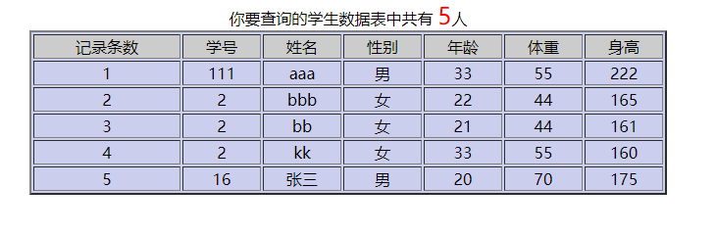

find_stu_3_tijiao.jsp

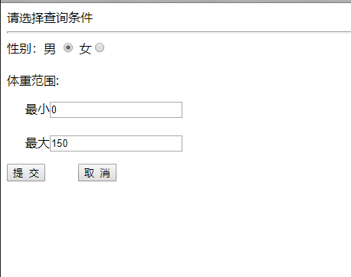

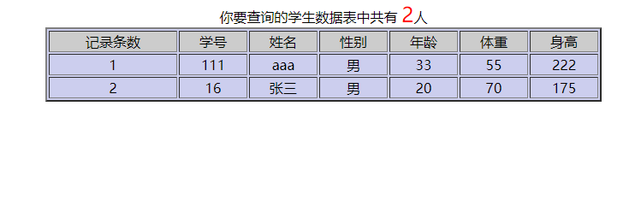

insert_stu_1.jsp



insert_stu_2_tijiao.jsp

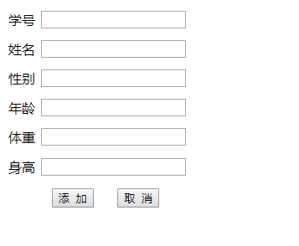

update_stu_2_tijiao.jsp

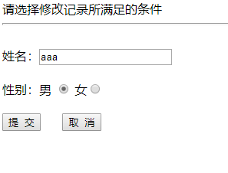

update_stu_2_edit.jsp

