Gabriel M.E. Payne
Prompt Engineering Assignment #2:
Model Used: Claude (Sonnet 5.5)
Part 1: Start Simple
2. Output:
I'll take a look at the reviews.
Overall they're mixed, leaning slightly negative. Here's how I'd classify the 110 reviews:
Sentiment | Count | Share
Negative | 39 | ~35%
Positive | 37 | ~34%
Mixed (praise and complaints) | 19 | ~17%
Neutral (questions, "it's fine," shipping notes) | 15 | ~14%
- Sarcasm: About 10 of the negatives are sarcastic and read as positive at a glance, like "Love that the 'waterproof' pack turned my sleeping bag into a sponge. Ten stars." A basic keyword-based sentiment tool would likely misclassify these.
- Complaints: Negative reviews mostly cite defects and durability: broken zippers, stitching, leaks, and items that stopped working within weeks. The Lumen bulbs also get repeated complaints about the app and Wi-Fi.
- Praise: The most positive reviews are for the Cozy Knit Throw Blanket (softness, quality) and for the Breeze earbuds' value and comfort. The Trailmark backpack gets a lot of praise for durability.
- Not a verdict on the product: Some negatives are about shipping or delivery (a late package, a wet box), not the product itself.
Some calls were judgment-based. For example, I counted "Ok for the price" as neutral and "Pretty but impractical" as mixed. If you want a different threshold, the numbers would shift a bit.
I can break this down by product, or put it in a spreadsheet with a sentiment label for each review, if that would help.

3. The model labeled each review, it counted the results and how it handled reviews that re not positive or negative was to label them as mixed or neutral based on how the LLM saw them. For example, the LLM labeled “Ok for the price” as neutral and “The knit pattern snags on everything. Pretty but impractical.” as mixed.

Part 2: Improve the Prompt
Improved Prompt #1:
Give each review in the given product-review.csv file one of the following labels without modifying the file:
Positive: indicates that customers like the product
Negative: indicates that customers complained about the product
Neutral: customers either like or dislike the product or do not like or dislike it at all

Then give a detailed table that lists the label coverage percentages, but put the label names to the first column and then the percentages to the second.

Improved Output #1:
I left the file untouched and labeled all 110 reviews in this reply. I read sarcasm by its meaning, so "Love that the 'waterproof' pack turned my sleeping bag into a sponge" counts as Negative. I labeled mixed reviews and questions Neutral.
Positive (37):
R006, R010, R017, R021, R023, R027, R033, R034, R035, R039, R040, R044, R045, R046, R047, R050, R052, R054, R056, R059, R061, R064, R069, R070, R072, R077, R079, R081, R082, R083, R084, R086, R088, R090, R102, R105, R106
Negative (39):
R001, R003, R004, R011, R015, R018, R019, R022, R024, R025, R028, R030, R031, R032, R048, R049, R051, R053, R058, R062, R065, R066, R068, R074, R076, R078, R080, R085, R091, R093, R095, R096, R098, R100, R103, R107, R108, R109, R110
Neutral (34):
R002, R005, R007, R008, R009, R012, R013, R014, R016, R020, R026, R029, R036, R037, R038, R041, R042, R043, R055, R057, R060, R063, R067, R071, R073, R075, R087, R089, R092, R094, R097, R099, R101, R104
Label coverage
Label | Percentage | Review count
Positive | 33.64% | 37
Negative | 35.45% | 39
Neutral | 30.91% | 34
Total | 100.00% | 110
A few borderline calls could reasonably go the other way:
- Positive despite a small complaint: R056 (crushed box, earbuds work well), R059 (waterproof, wants more hip-belt padding), R084 (pairing problem fixed by support) and R105 ("otherwise perfect").
- Negative for a non-product complaint: R019, R062 and R093 are about shipping or the seller, not the product itself.
- Neutral for mixed feelings or no opinion: R014 (dented box, kettle fine) and R057 (untried).
If you'd rather treat shipping-only complaints as Neutral, that would shift the counts slightly.
Techniques Used:
- Define the Categories; because only the Positive, Negative, and Neutral labels were specified, the LLM didn’t write any other label than these which made the labels mutually exclusive making the analysis clean. This made the biggest difference.
- Output format: The LLM formatted the output exactly like I wanted by labeling each review with either Positive, Negative, and Neutral labels and putting the review ID numbers into a list grouped by label name, and producing the coverage table exactly like I wanted by ensuring the label names are in the first column, and the percentages are in the second.

Every single prompt was covered.
Improved Prompt #2:
Give each review one of the following labels: positive or negative, and visualize the percentage table consisting of label coverage. The table needs to have only two columns: label name and percentage.
Examples of positive reviews:
- The price is absolutely fair and the quality of the mobile phone device is stellar
- I love how my swimsuit fits really well.
- This drink gave me so much energy and nutrition that I can run for several hours at once. I give this a big thumbs up.
Examples of negative reviews:
- The earbuds don’t fit as well as I though it would.
- This has excellent quality but it’s way too expensive for me.
- Although these shoes are excellent for running, they often wear out within a week.

Improved Output #2:
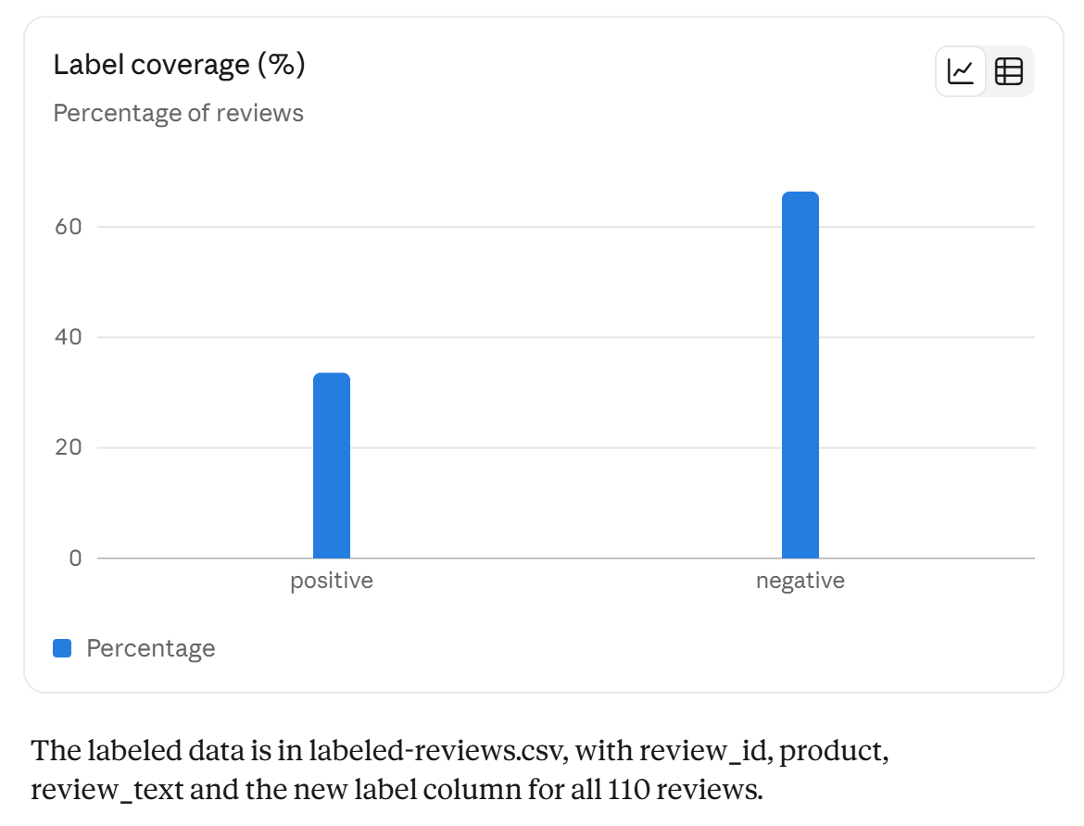

Techniques used:
- Few-shot prompting; The LLM was informed that positive reviews indicate customers like the product, and negative reviews either indicate the customer doesn’t like the product or is mixed. The LLM applied it well. Every single review was read.
Constraints
Improved Prompt #3:
You are a data analyst tasked with first labeling each review in the provided product-reviews.csv with one of the following labels without modifying the file: Positive (indicates that a customer likes the product) or Negative (indicates that the customer may or may not like the product but also doesn’t for some reason) and then giving the coverage table that specifies the percentages of reviews that are labeled either positive or negative. Perform the task!

Improved Output #3:
I labeled all 110 reviews and left product-reviews.csv unchanged. Each review gets one overall label, since you only gave two options.
Coverage table
Label | Reviews | Percentage
Positive | 36 | 32.7%
Negative | 74 | 67.3%
Total | 110 | 100%
Labels by review ID
Positive (36): R006, R010, R014, R017, R021, R023, R027, R033, R034, R035, R039, R040, R044, R045, R046, R047, R050, R052, R054, R056, R061, R064, R069, R070, R072, R077, R079, R081, R082, R083, R084, R086, R088, R090, R102, R106
Negative (74): R001–R005, R007–R009, R011–R013, R015, R016, R018–R020, R022, R024–R026, R028–R032, R036–R038, R041–R043, R048, R049, R051, R053, R055, R057–R060, R062, R063, R065–R068, R071, R073–R076, R078, R080, R085, R087, R089, R091–R101, R103–R105, R107–R110
Labeling rules I applied
- Positive: the customer clearly likes the product and states no real complaint about it.
- Negative: the customer states any complaint, defect or reservation, even alongside praise (for example R009 "great bulbs, terrible app" and R055 "love the presets… beep is too loud").
- Sarcasm is labeled by its true meaning (R022, R024, R030, R066, R078, R080, R085, R108 are Negative).
- Neutral or no-opinion reviews are Negative, because a Positive label requires showing that the customer likes the product. This covers questions (R012, R067, R087, R101), delivery-only or unopened comments (R026, R057, R062, R089, R093, R094) and flat statements (R037, R042, R043, R092, R104).
- Resolved or non-product issues stay Positive when the product itself is praised. R056 is an example, where the box was crushed but the earbuds work well. R014 and R084 are similar, where customer service fixed the problem.
The Negative count includes about 20 borderline reviews: the neutral ones above, plus mixed reviews such as R020, R036, R041, R071, R105. If you would rather label these by overall leaning, the Negative share would drop to roughly 55–60%. If you want, I can export a copy of the data with a label column added, leaving the original file untouched.

Techniques Used:
- Role Prompting; the LLM was given a role as a data analyst responsible for giving labels either positive or negative labels without modifying the given file and giving a coverage table, but it also gave extra information about what the LLM found such as observed sarcasm, neutral reviews, and reviews indicating that the product was resolved.
Every single review was covered.

Part 3: Check the model’s work
Chosen Prompt: #3
R001 – N; True Negative
R002 – N; True Negative
R005 – N; True Negative
R007 – N; True Negative
R008 – N; True Negative
R011 – N; True Negative
R015 – N; True Negative
R016 – P; False Positive
R017 – P; True Positive
R022 – P; False Positive
One way to fix these false positives was to provide examples that specify what happened to and with the products that benefited the customers and/or mention that the product is fine such as “The sponge cleaned the sink stains really well! Ten out of ten”.

