Super Reduced String - 2026 - 11 -13 - Java - HackerRank
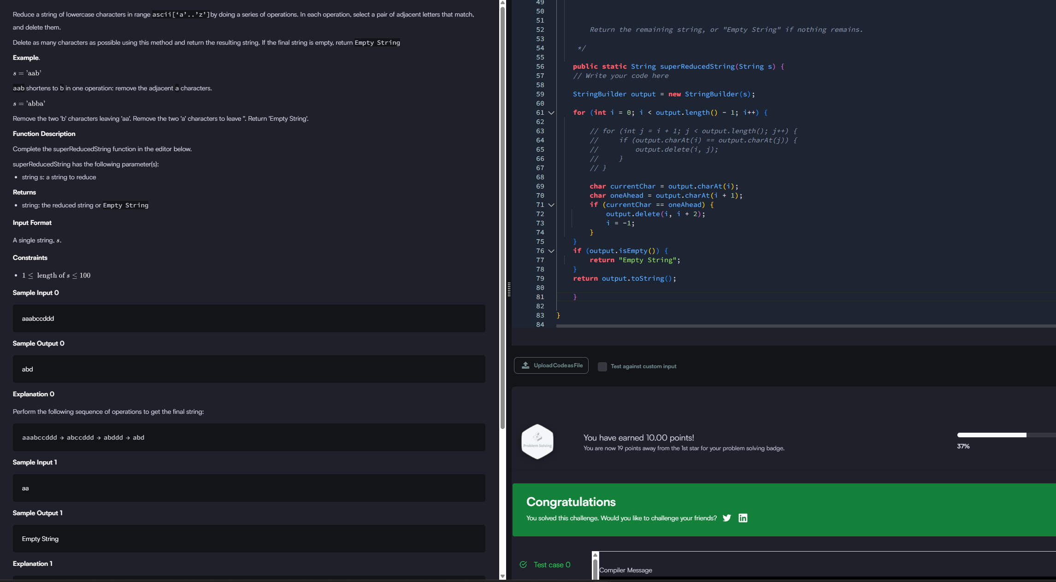
Two Sum - Easy - 2026-11-09 - Java - Leetcode



