Part 1: Start Simple

Upon providing the simple prompt “Write a product description for a water bottle”, the following response was provided by ChatGPT.

Version - 1
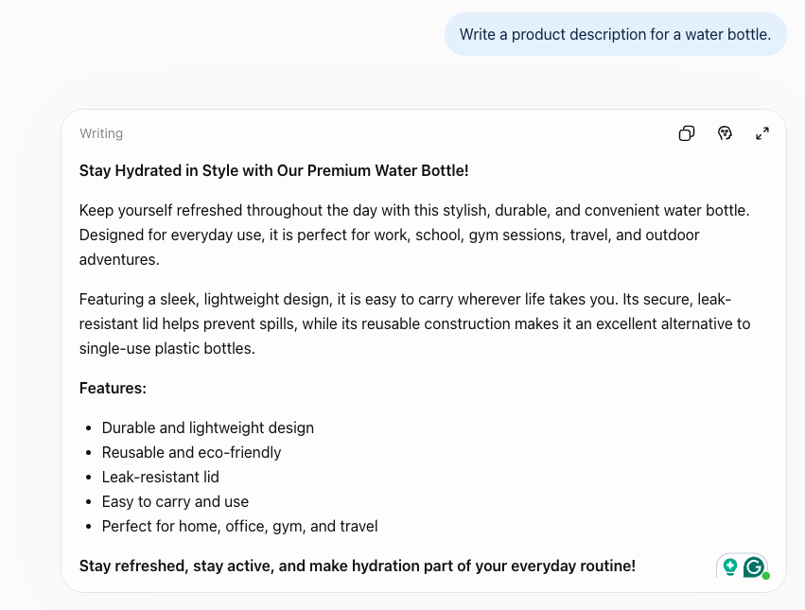
The description feels generic because it relies on stock phrases like “Stay Hydrated in Style” and “Premium” and on vague adjectives like “durable” and “convenient” that could describe any bottle.
Its use cases (work, school, gym, travel, outdoors) cover every occasion, so it does not speak to any situation. It seems to be written for undefined customer because it does not specifically mention to a person (such as athlete, commuter, student, hiker, etc.)
The key information is missing, such as material, capacity, dimensions, insulation, whether the lid is truly leakproof, color options, price, warranty, etc.

Part 2: Improve the prompt
- Using the given prompt “As an expert, write a product description for a water bottle”, the following response was provided by ChatGPT.

Version - 2
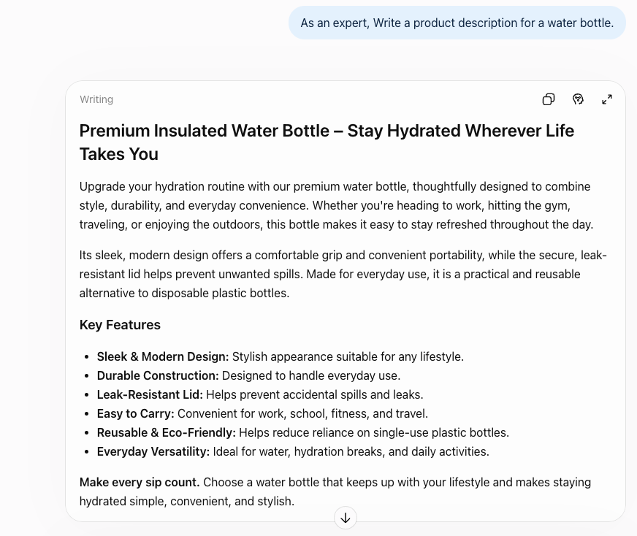
It generated almost the same thing but explained little bit more those features in bullet points.

- “As an expert, write a product description for a water bottle that will appear in Threads (social media platform), featuring a modern design, ideal for office workers, and easy to carry.”

Version - 3
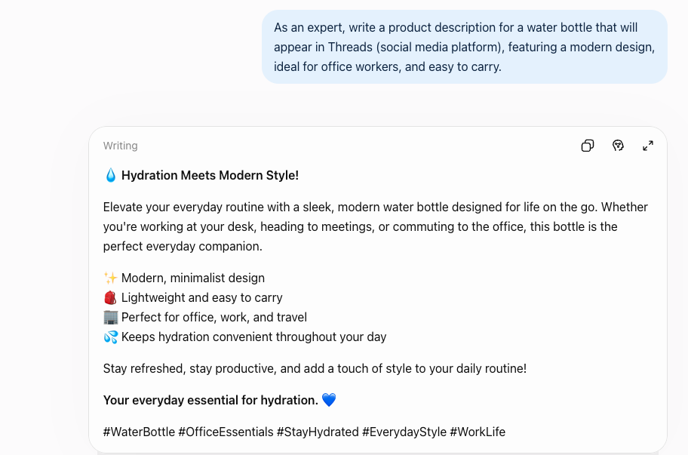
Now, it more focused on office employees and then narrowed down the description in a short and sweet way along with icons so that social media users can have better interactions.

- “As an expert, write a product description for a water bottle that will appear in Threads (a social media platform), featuring a modern design.
Audience: Office employees
Rules:
- 50-70 words
- calm, practical tone with no exclamation points
- no matter the outside, the inside should be steel, so hot water stays hot and cold water stays cold for a long period of time.

Here is an example for a coffee cup:
The ceramic coffee cup keeps things simple: a 12-ounce capacity, a thick-walled body that holds heat through a slow morning, and a matte glaze that feels good in the hand. The handle fits two fingers comfortably, and it's dishwasher-safe, so cleanup never becomes a chore. Best for people who like their coffee unhurried.”

Version - 4
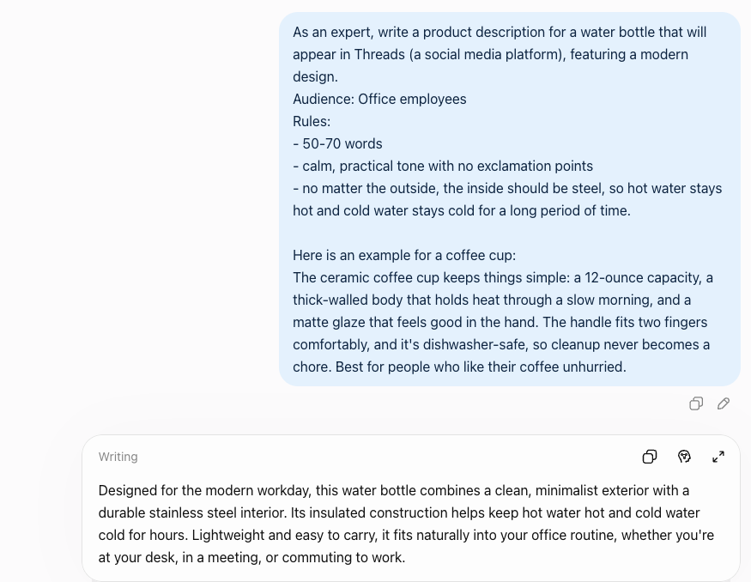

It is becoming more specific and targeted because the added context gave the LLM model something to work with. It speaks to office workers, names a real benefit (a stainless-steel interior) that keeps hot water hot and cold water cold), and keeps a calm, practical tone with no hype. It is short and focused rather than a generic catalog listing.
It still lacks specifics like capacity, weight, and exact hours of insulation.

- So, adding those lacked specifics along with the output format, I came with following prompt.
“As an expert, write a product description for a water bottle that will appear in Threads (a social media platform), featuring a modern design.
Audience: Office employees
Rules:
- 50-70 words in total, including the headline and bullets
- Calm, practical tone with no exclamation points
- No matter the outside, the inside should be steel, so hot water stays hot and cold water stays cold for a long period of time
Required specifics:
- Capacity: 20 oz
- Weight: 11 oz
- Insulation: 12 hours cold, 6 hours hot
Output format: A headline on the first line, followed by three bullet points (one each for design, insulation, and office use), and a one-sentence closing line.
Here is an example for a coffee cup:
The ceramic coffee cup keeps things simple: a 12-ounce capacity, a thick-walled body that holds heat through a slow morning, and a matte glaze that feels good in the hand. The handle fits two fingers comfortably, and it’s dishwasher-safe, so cleanup never becomes a chore. Best for people who like their coffee unhurried.”

Verison - 5
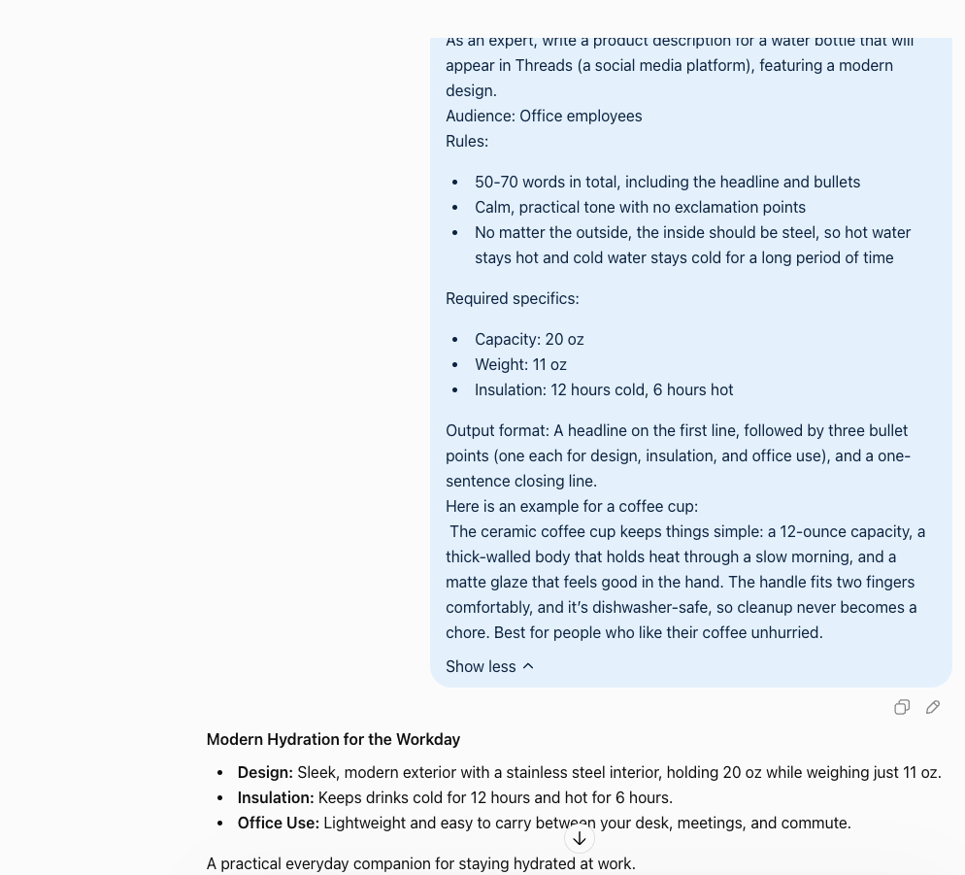

It became more specific where it covered design, material, weight, end users, useful for, and so on in short and sweet way. It also added a heading and provided result in expected output with the given prompt.

Prompt for Standing Desk

“As an expert, write a product description for a standing desk that will appear in Threads (a social media platform), featuring a modern design.
Audience: Office employees (Work from Home)
Rules:
- 50-70 words in total, including the headline and bullets
- Calm, practical tone with no exclamation points
- Material should be wood, desk should stay stable and wobble-free at any height
Required specifics:
- Desktop size: 48 x 24 inches
- Height range: 28 to 48 inches
- Weight capacity: 175 lbs
Output format: A headline on the first line, followed by three bullet points (one each for design, stability, and office use), and a one-sentence closing line.
Here is an example for a coffee cup:
The ceramic coffee cup keeps things simple: a 12-ounce capacity, a thick-walled body that holds heat through a slow morning, and a matte glaze that feels good in the hand. The handle fits two fingers comfortably, and it’s dishwasher-safe, so cleanup never becomes a chore. Best for people who like their coffee unhurried.”

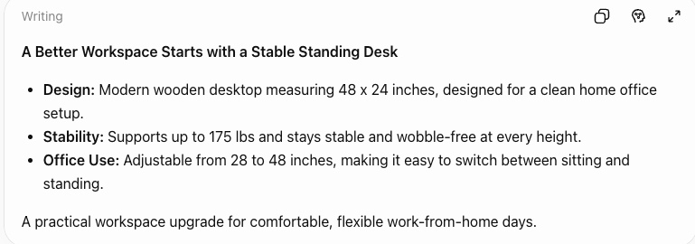

Prompt for Smart Thermostat
“As an expert, write a product description for a smart thermostat that will appear in facebook marketplace featuring a modern design.
Audience: Homeowners
Rules:
- 50-70 words in total, including the headline and bullets
- It should work with standard office HVAC systems and be controllable from a phone, so the temperature can be adjusted from anywhere
Required specifics:
- Display: 3.5-inch touchscreen
- Compatibility: works with most 24V systems
- Scheduling: up to 7 days of programmable settings
Here is an example for a coffee cup:
The ceramic coffee cup keeps things simple: a 12-ounce capacity, a thick-walled body that holds heat through a slow morning, and a matte glaze that feels good in the hand. The handle fits two fingers comfortably, and it’s dishwasher-safe, so cleanup never becomes a chore. Best for people who like their coffee unhurried.”
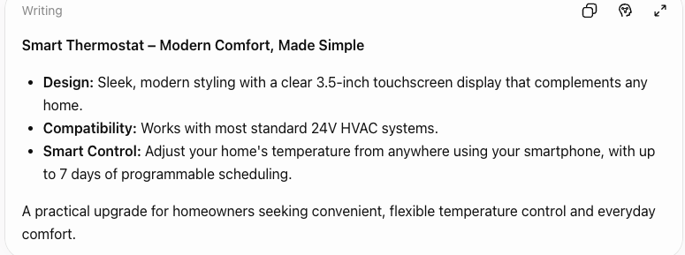
Analysis:
- Role Prompting: “As an expert” was the starting words in prompts.
- Audience and platform context: Audiences were office employees for water bottle and standing desk where homeowners were for smart thermostat.
- Constraints: I set a limit of 50-70 words and then later included headline and bullets, a calm and practical tone with no exclamation points. I also added the material such as steel for water bottle and wood for standing desk.
- Few-shot example: I gave the one-shot example (i.e., coffee cup) for all those three items.
- Output format: A headline, three labeled bullets and a one-sentence closing line.
- Requires specifics: I finally added the capacity, weight, and insulation hours for water bottle, desktop size, height range, and weight capacity for the standing desk, and display, compatibility, and scheduling for thermostat.
How each techniques affected the output:
- Adding audiences, tone rules, and constraints narrow down the results to specific group of people.
- Few-shot example gave an idea to the model on in which way the answer can be presented.
- The output format made the copy scannable and suited to threads and Facebook marketplace. Nothing was repeating anymore.
- Before giving required specifics, the output lacked capacity, weight, and insulation hours. After adding required specifics, the numbers appeared directly in the bullets.
Ignored Instructions and invented details
- I did ignore some instructions in first try so had to give the prompt twice.
Biggest Difference
Required specifics made the biggest difference. Audience and format improved how the copy read, but only the specifics fixed what it said. So, supplying real facts addressed both the vagueness and the made-up details.

