Flask

<https://www.youtube.com/watch?v=Aa-F6zqLmig>

second source

https://www.youtube.com/watch?v=dam0GPOAvVI

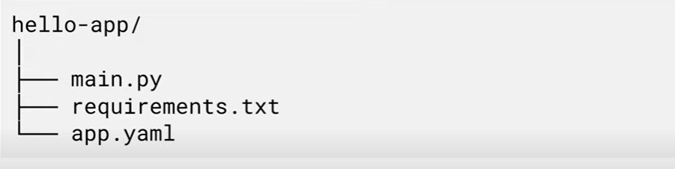

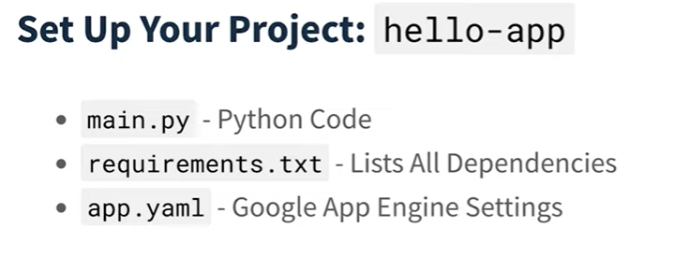

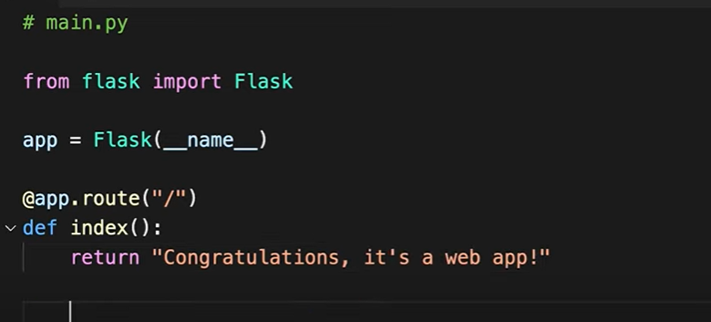

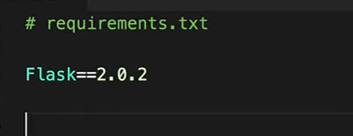

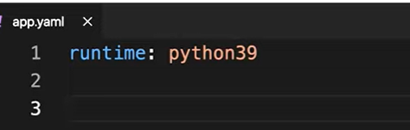

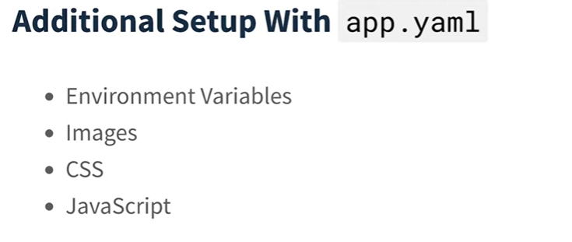

**Creating python virtual environment**

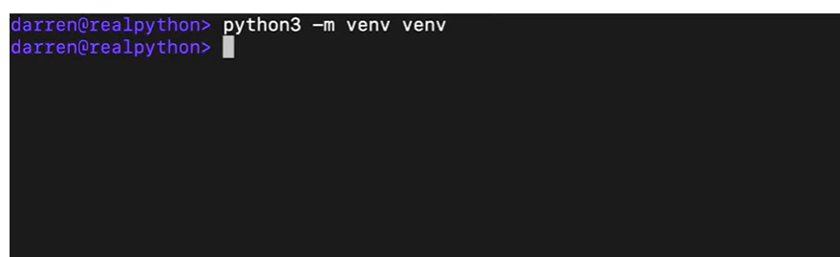

Activate virtual environment in windows

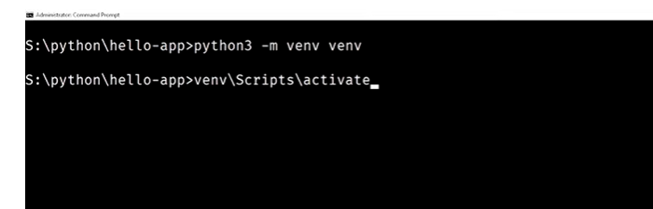

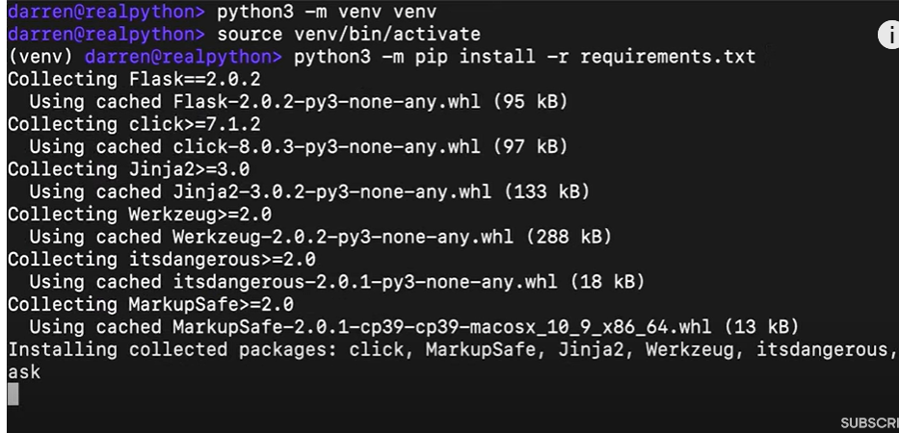

After above installation add the following 2 lines of code

