Lab 1 : Introduction to AWS IAM -

1. In the AWS Management Console, on the Services menu, select IAM.

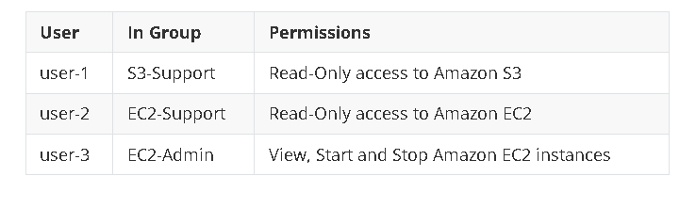

2. In the left navigation pane, choose **User groups**.

3. Choose **S3-Support** group > **Users** tab > **Add users** > User 1 > similarly add all 3 users.

4. Go to Dashbord > Copy link ( <https://299580632430.signin.aws.amazon.com/console> )

5. Sign in as User 1 > Login > choose S3 > S3 permission allowed but EC2 permission not allowed

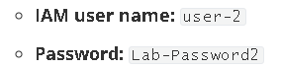

6. similarly login as user 2 > Ec2 permission allowed but cant stop instance .

7. similarly login as user 3 > Ec2 permission allowed and can stop instance .

END

Lab 2 : Build your VPC and Launch Web Server

1. Choose VPC > Create VPC > VPC and more >

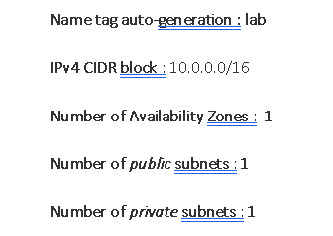

1. Choose Subnets > create subnet >

1. Create subnet > create 1 more subnet > created

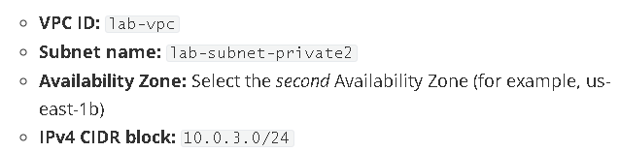

1. Choose Route table > Select the **lab-rtb-private1-us-east-1a >** Explicit subnet associations > Edit subnet association > leave l**ab-subnet-private1-us-east-1a** selected, but also select **lab-subnet-private2** > save association
2. Similarly choose **lab-rtb-public > do same and select lab-subnet-public2** > save
3. Choose security group >create security group

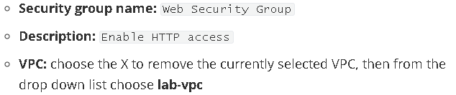

1. In inbound rules choose add rules >

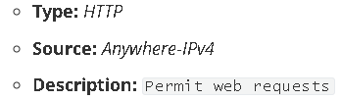

Create secrity group

1. Open EC2 >

Lab 3 : AWS Lambda

1. Open lambda > create function >

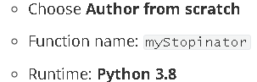

1. Create function > choose Add trigger > **Select a trigger** dropdown menu > EventBridge> **Create a new rule**

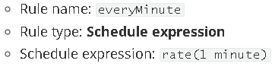

Choose Add

1. Choose code >

import boto3

region = 'us-east-1'

instances = ['[i-07a96826775796be3](https://us-east-1.console.aws.amazon.com/ec2/home?region=us-east-1#InstanceDetails:instanceId=i-07a96826775796be3)']

ec2 = boto3.client('ec2', region_name=region)

def lambda_handler(event, context):

   ec2.stop_instances(InstanceIds=instances)

   print('stopped your instances: ' + str(instances))

1. Now deploy > now the instance got stopped.

Lab 3 : Intro to amazon EC2

1. EC2 > Launch Instance >

instance name : web server

Instance type : t2.micro

Key pair name : vockey

VPC : Lab VPC

Firewall : Create security group

Security group name : Web Server security group

Description : Security group for my web server

Remove the rule

Advance :

**Termination protection** : **Enable**

#!/bin/bash

dnf install -y httpd

systemctl enable httpd

systemctl start httpd

echo '<html><h1>Hello From Your Web Server!</h1></html>' > /var/www/html/index.html

now Lunch

1. All Instance > wait for checks passed
2. Web Server > Details > open Public IPv4
3. Choose Security Group > Select Web server security group > Inbound rules > Edit > Add rule > type : HTTP , Source : Anywhere IPv4 > save