Wireless UI Creation Prompt
TSS2 Binder Reference implementation brief
Purpose. Use this prompt to begin creating and reviewing the Wireless tab in Unity. The objective is a clear, scenario-driven wireless configuration sheet that preserves the supplied visual style and makes the instructor-authored guidance distinct from generated training-run values.

Reference image
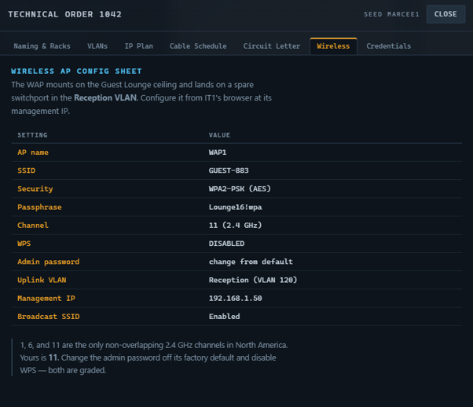
Wireless reference image

Implementation prompt
Create or refine the Wireless Binder Reference UI in the Unity TSS2 project. Use Assets/Prefabs/UI/TssWirelessTab.prefab as the target prefab and the supplied Wireless image as the visual reference. Keep the tab connected to the Binder Reference flow in TssRuntimeUi and keep the scenario as the source of authored content. Do not duplicate generated wireless values inside the prefab or create a second runtime data path.

Required visual structure
- Keep the existing dark technical Binder visual language and tab placement.
- Expose and preserve the hierarchy objects SectionTitle, ScenarioHeading, IntroParagraph, Table, and Note.
- Use a clear blue technical heading such as WIRELESS AP CONFIG SHEET.
- Keep ScenarioHeading available for the scenario name or identifier, for example WIRELESS - {ScenarioId}.
- Place IntroParagraph above the two-column configuration table and allow it to wrap cleanly.
- Use a readable SETTING / VALUE header row with distinct label and value columns.
- Keep generated rows compact but readable, with amber or gold labels and light technical values matching the reference.
- Keep Note beneath the table as a concise training instruction. It should support multiple lines without clipping.
- Preserve existing Binder spacing, font sizing, row heights, padding, and responsive behavior.

Scenario and runtime behavior
- Expose SectionTitle, ScenarioHeading, IntroParagraph, and Note through the scenario Binder Reference definition.
- Keep the wireless table values runtime-driven from TssNetworkRunProfile. Do not hard-code SSID, passphrase, channel, admin password, VLAN, or management IP values in the scenario asset.
- Use scenario content for authored wording and support tokens such as {ScenarioId}, {Ssid}, {WifiPassphrase}, {WirelessChannel}, {ApAdminPassword}, {ReceptionVlanName}, {ReceptionVlan}, and {ApManagementAddress}.
- Resolve generated values from the active training run so the UI changes with the selected scenario/run seed.
- Keep the existing fallback behavior for scenarios that do not yet define Wireless Binder Reference content.
- Preserve the existing SectionRow06 and TssBinderPanel prefab connection and the current presenter routing.

Expected scenario fields
Field | Purpose | Example
sectionTitle | Binder section label | Wireless
scenarioHeading | Scenario-specific heading | WIRELESS - {ScenarioId}
intro | Authored guidance above the table | The WAP mounts on the Guest Lounge ceiling...
note | Authored guidance below the table | 1, 6, and 11 are the only non-overlapping channels...

Generated wireless rows
- AP name: WAP1
- SSID: generated profile SSID
- Security: WPA2-PSK (AES)
- Passphrase: generated profile passphrase
- Channel: generated 2.4 GHz channel
- WPS: DISABLED
- Admin password: generated profile admin password
- Uplink VLAN: generated Reception VLAN name and ID
- Management IP: generated AP management address
- Broadcast SSID: Enabled

Acceptance checks
- The prefab contains SectionTitle, ScenarioHeading, IntroParagraph, Table, and Note with no missing references.
- The tab appears in the Binder Reference at SectionRow06 and opens without duplicate rows or stale content.
- A loaded scenario supplies the authored title, heading, introduction, and note.
- The active run profile supplies the SSID, passphrase, channel, admin password, VLAN, and management IP dynamically.
- Changing the scenario/run seed changes generated wireless values without changing authored guidance.
- Long intro or note text wraps cleanly and does not overlap the table.
- Unity compiles with no errors, and Play Mode shows the updated Wireless tab through the real Binder workflow.

Relevant project paths
- Assets/Prefabs/UI/TssWirelessTab.prefab
- Assets/Prefabs/UI/TssBinderPanel.prefab
- Assets/Scripts/TssRuntimeUi.cs
- Assets/Scripts/TssBinderReferenceTabPresenter.cs
- Assets/Scripts/TssScenarioDefinition.cs
- Assets/Data/TSS/Scenarios/Balanced_12_Piece_Lab.asset

