Shane Stacy

CIS 162 BabyNames

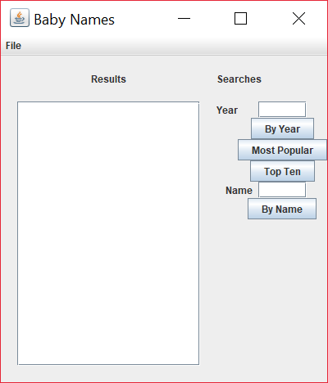

I pledge that this work is entirely mine, and mine alone (except for any code provided by my instructor).

____________________________________

I spent approximately 14 hours on this project from 10/31/17 to 11/9/17 working from and reverse engineering provided sample code in the Project 4 Baby Names.docx and putting together this cover page.